ĐỀ CƯƠNG ÔN TẬP HỌC KỲ 2 TIẾNG ANH 5
( Giới hạn kiến thức thi hết học kì 2 từ tuần 18-27 Theo ppct)

A. LANGUAGE CONTENTS ............................................................................................ 2
Unit 10: When will Sports Day be? .................................................................................... 2
Unit 11: What’s the matter with you? ................................................................................. 2
Unit 12: Don’t ride your bike too fast! ................................................................................ 3
Unit 13: What do you do in your free time? ....................................................................... 3
Unit 14: What happened in the story? ................................................................................. 3
Unit 15: What would you like to be in the future? .............................................................. 4
B.1. SAMPLE TEST (ORAL TEST) + INSTRUCTIONS + KEY .................................... 5
B.2. SAMPLE TEST (WRITTEN TEST) + INSTRUCTIONS + KEY ............................. 8

A. LANGUAGE CONTENTS
Unit 10: When will Sports Day be?

I. Vocabulary
● Sports Day, Teacher’s Day, Independence Day, Children’s Day, Monday → Sunday, play basketball/ football/ table tennis/ badminton, take part in singing contest, do boxing, cycle, celebrate, music festival

II. Grammar
● When will ____ be?
- It’ll be on ____. (‘ll = will)
● What are you/ they going to do on Sports Day?
- I’m/ We’re/ They’re going to ____.
● What is he/ she going to do on Sports Day?
- He’s/ She’s going to ____.
Unit 11: What’s the matter with you?

I. Vocabulary
● Vocabulary: have sore eyes/ backache/ stomachache/ a high fever/ an earache/a toothache/ a cold/ a fever/ a sore throat/ a cough/ a runny nose/ a broken leg/ a broken arm, allergy to flowers, get sunburn, sick, tired, take some medicine, drink hot/ cold water, use some eye drops II. Grammar
● What’s the matter with you/ him/ her/ Tony/ .... ?
- I/ We/ They have ____.
- He/ She has ____.
● How do you feel now?
- I feel tired. I have a headache.
● You should/ shouldn’t ___.
- Yes, I will. Thanks.
- OK, I won’t. Thanks.
● What should I do if I have backache?
- You should go to the doctor.
Unit 12: Don’t ride your bike too fast!

I. Vocabulary
● play with matches, ride your bike too fast, fall off your bike, climb the tree, run down the stairs, break your arm/ leg, play with the knife, cut yourself, play with the stove, get a burn, play with the kitten/ dog, scratch, bite, swing too fast, fall off the swing

II. Grammar
● Don’t ____. - OK, I won’t.
● Why shouldn’t I ____?
- Because you may ____.
● What is he/ she doing?
- He’s/ She’s playing with matches.
● What may happen to him/ her? - He/ She may ____.

Unit 13: What do you do in your free time?

I. Vocabulary
● watch cartoons, play computer games, listen to music, do gardening, read books, play the piano/ guitar, play sports, draw pictures II. Grammar
● What do you do in your free time?
- I often watch cartoons on Disney Channel.
● How often do you/ they .... go fishing?
- I/ We/ They go fishing once a week.
Unit 14: What happened in the story?

I. Vocabulary
● Titles of some stories: The Story of Mai An Tiem, The Golden Starfruit Tree, The Lion and the
Mouse, the Tortoise and the Hare, Snow White and the Seven Dwarfs, the Story of Tam and
Cam, intelligent, hard-working, greedy, kind, good nature, stupid, silly, careful, careless II. Grammar
● What happened in the story “The clever Fox and the Crow”? - First, ____. Then ____. Next, ____. In the end, ____.
● Which character do you like best?
- I like the fox. It’s very clever.
● What do you think of ____? - I think he’s/ she’s/ it’s ____.
Unit 15: What would you like to be in the future?

I. Vocabulary
● Review: a pilot, fly a plane, a doctor, a nurse, look after patients, design buildings, a writer, write stories for children, work in a factory/ school
● Vocabulary: work in the city/ countryside, work on a farm, work in a hospital, a teacher, teach young children, mechanic, soldier, vet, architect, secretary

II. Grammar
● What would you/ he/ she like to be in the future?
- I’d like to be a/an ____.
- He’d/ She’d like to be a/ an ____.
● Why would you/ he/ she like to be a/an ___?
- Because I/ he/ she’d like to ____.

B1. SAMPLE TEST (ORAL TEST)

❶ Interview. (1p) ( Students have to answer 4 out of 6 questions)

1. Hi. How are you? What’s your name? How old are you?
2. What do you do in your free time? /How often do you …? /Do you often watch TV….?
3. What would you like to be in the future? /Why would you like to be a (n) …?
4. What do you think of Snow White/ Mai An Tiem/...?
5. Why shouldn’t I play with a knife/ play with a strange dog/ …?
6. What should I do if I have a toothache/ a headache/ a cold ….?

❷ Look and answer the questions. (1.5ps)
Choose one of three pictures. Then answer any three questions.

PICTURES | SUGGESTED QUESTIONS
1.   | • How many people are there in the picture?  • Are they students? / What is his/ her name? (Point at...)  • When will Sports Day be?  • Is Lisa/ Tony going to play table tennis on Sports Day?  • What is Lisa/ Tony going to play on Sports Day?
2.  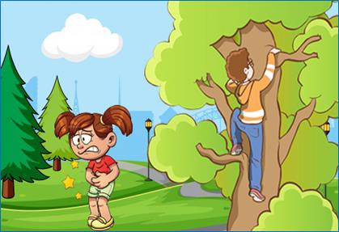 | • Where are the children? / Are they in/at the _____?  • What is the boy doing?  • What may happen to him?  • What’s the matter with the girl?  • What should she do?
3.  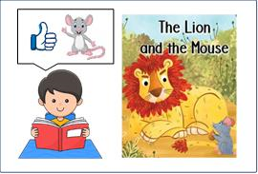 | • What does he do in his free time?  • What’s his favourite story?  • How many characters are there in the story? What are they called?  • Which character does he like best?  • What do you think of the mouse in this story?

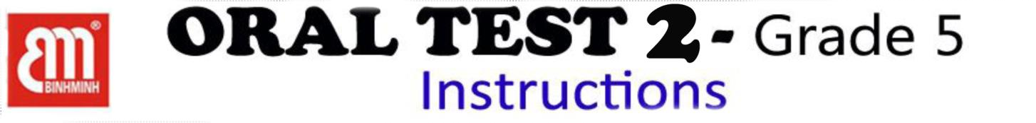

❖ AIM: This test is designed to test students’ oral language ability at the end of semester II.
❖ TESTER:
✓ All students will be tested by FOREIGN TEACHER.
✓ Vietnamese teaching assistant controls the class during the speaking test.
❖ TIME ALLOWANCE: Max: 3 mins/ a student (including 1 minute to prepare)
❖ PROCEDURE: The test is divided into 2 parts
❶ Interview. (1p) ➔ 0.25ps for each correct answer
• Students have to answer 4 out of 6 questions
❖ The teacher asks, and students answer, any four of the questions.
Example: T: What’s your address?
S: It’s 105, Hoa Binh Lane.
❖ Each student gets 1 point for each correct answer:
✓ 0.25 point for grammar,
✓ 0.25 point for pronunciation,
✓ 0.5 point for the best reaction with the greatest fluency
❷ Look and answer the questions (1.5ps) ➔ 0.5 ps for each correct answer.
• Students choose one of three pictures. Then answer any three questions.
• The teacher asks, and students answer, any three questions on the picture. (3 questions per picture)
❖ Students get 1.5 points for each correct answer:
✓ 0.5 point for grammar,
✓ 0.5 point for pronunciation,
✓ 0.5 point for the best reaction with the greatest fluency.
Example: Picture 1: T: What is her name?
S: Her name is Mary.
T: Is she a teacher?
S: No, she isn’t. She is a student.
NOTE: At the end of the speaking test, the teachers are required to:
✓ Write students’ scores in the score box ✓ Write your full name and sign your name
✓ Write some comments.

B2. SAMPLE TEST (WRITTEN TEST)

❶ Listen and number from 1 to 4. / Nghe và đánh số các tranh theo thứ tự được nhắc đến từ 1 đến 4. Có 1 tranh không dùng. (1p)
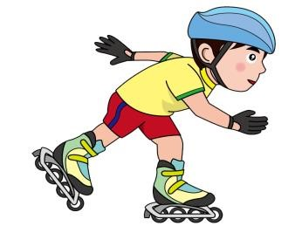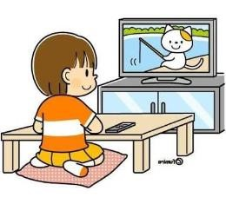

0

C

B

F

D

E

A

❷ Listen and circle the correct pictures. /Nghe và khoanh tròn tranh được nhắc đến.
(1p)
0.


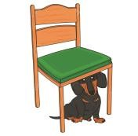

A C
B

5. 6.

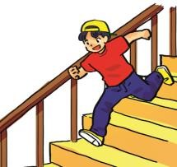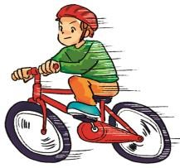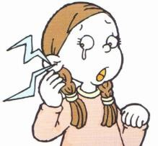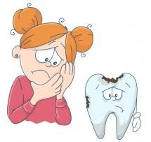

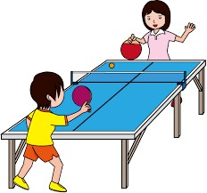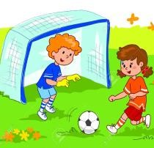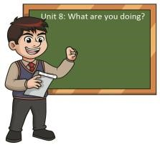

A

B

C

A

B

C

7
.

A

B
C

8
.

A
B
C

❸ Listen and fill in each blank with ONE WORD ONLY. / Nghe và điền một từ phù hợp vào mỗi chỗ trống. (0.5ps)

Mary: Hi, Tom. What do you do in your (0) free time?
Tom: I (9) ______________ listen to music. What about you, Mary?
Mary: I go to the library to read comic books.
Tom: How often do you go to the library?
Mary: (10)_______________ a week.
Tom: What is your favourite book?
Mary: I like reading “The story of Tam and Cam”. I think the story is meaningful and it gives me a lesson in life.

 PART B: READING

❶ Choose the word which has the underlined part pronounced
differently. /Chọn từ có phần gạch chân phát âm khác các từ còn lại. (0.5ps)

E.g. A. bike B. city C. big D. dinner
11. A. future B. lunch C. stupid D. music 12. A. watch B. children C. character D. teacher
❷ Circle the best answer A, B or C to complete each sentence.
/Khoanh tròn đáp án đúng A, B hoặc C để hoàn thành câu. (1p)

E.g. He ___________ a headache.
A. plays B. has C. is
13. Don’t _____________ your bike too fast.
A. watch B. drink C. ride
14. She ___________ a sore throat.
A. has B. have C. feel
15. When will Sports Day be? – It’ll be ____________ Sunday.
A. on B. in C. at
16. ____________ would you like to be in the future? – I’d like to be a vet.
A. How often B. When C. What

❸ Read the passage and write T (true) or F (false). / Đọc đoạn văn và xác định các câu sau đúng (T) hay sai (F). (1p)
Jenny is my best friend. She is a student in grade 5. Her birthday is on the second of July. She’s kind and clever. Her favourite sport is basketball and she plays it with her friends on Saturdays. She usually reads books in her free time. Her favourite book is “Snow White and the Seven Dwarfs”. She would like to be a writer in the future because she wants to write short stories for children.

0. Jenny is a ___________________.
A. teacher B. student  17. Her birthday is on _____________.  A. July 1st B. July 2nd  18. She likes playing ___________.  A. basketball B. football |  | C. nurse  C. July 3rd  C. volleyball
19. Her favourite book is _____________.
A. Tam Cam B. The clever Fox and Crow
C. Snow White and the Seven Dwarfs
20. Jenny would like to be a ___________ in the future.
A. writer B. nurse C. teacher

 PART C: WRITING

❶ Fill in each blank with ONE WORD ONLY. / Điền một từ phù hợp vào mỗi chỗ trống. (1p)

teacher | teach come | would | When

Hannah’s mother is a (0) teacher. She works at a primary school, which is near her

house. (21)___________ she arrives at work, she says “Hello” to her students and

checks their homework. She loves her job because she can (22) _________ young children. Hannah (23)_____________ like to be a teacher like her mother in the future. Hannah hopes her dream will (24) ____________ true.

❷ Look and write ONE WORD in each blank. / Nhìn tranh và viết một từ phù hợp vào mỗi chỗ trống. (0.5ps)



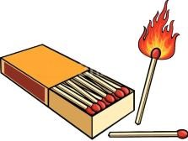
0. Jack would like to be a pilot.

26. Amy usually plays _____________________ in the afternoon.

27. You shouldn’t play with ___________________. You may get a burn.

❸ Reorder the words to make sentences. / Hãy sắp xếp các từ tạo thành câu hoàn chỉnh, bỏ dấu gạch chéo và không thêm, không bớt từ. (1p)

0. doctor/ a/ He/ is/.⇨ He is a doctor.
27. teacher/ children/ to/ I/ would/ be/ a/ because/ love/ I/ like/ teaching/. (12 words)
⇨ I……………………………………………………………………………………………………………............
28. shouldn’t /You/ the/ knife/ play /with/. (6 words)
⇨ You………………………………………………………………………………………………………………….
29. week / three / piano / My / times/ the / a / sister/ plays /. (9 words)
⇨ My .......................................................................................................................................................................
30. street/ of / pharmacy / corner / the / is / The / on / the /. (9 words)
⇨ The .....................................................................................................................................................................
GOOD LUCK!

FINAL TEST 2 – GRADE 5
Instruction and Answer key

A. TAPESCRIPT
➢ Have the students look through all of the questions / sentences in 1 or 2 minutes.
➢ Tell the students that they can listen to each part TWICE.
➢ Read the listening script TWICE with your NORMAL SPEED.
❶ Listen and number the pictures.
0. Tim is reading a book. (Picture D)
1. Lisa usually listens to music after school.
2. Alex usually goes swimming in his free time.
3. Amy usually watches cartoons in the evening.
4. My brother has a headache.
❷ Listen and circle the correct pictures.
0. Where’s the dog? – It’s under the table. (Picture B)
5. What’s the matter with her? – She has a sore throat.
6. What’s he doing? – He’s running down the stairs.
7. What would he like to be in the future? – He’d like to be a doctor.
8. What are they going to do on Sports Day? – They’re going to play basketball.
❸ Listen and fill in each blank with ONE WORD ONLY.

Mary: Hi, Tom. What do you do in your (0) free time?
Tom: I often listen to music. What about you, Mary?
Mary: I go to the library to read comic books.
Tom: How often do you go to the library?
Mary: Once a week.
Tom: What is your favourite book?
Mary: I like reading “The story of Tam and Cam”. I think the story is meaningful and it gives me a lesson in life.

After the students finish the listening part, let them do the rest of the test.

MARKING STUDENTS
✓ Total number of questions: 30 => 0.25ps/ a correct answer ✓ Total points: 7.5 pts

C. ANSWER KEY

1. E | 5. B | 9. often | 13. C | 17. B | 21. When
2. C | 6. C | 10. Once | 14. A | 18. A | 22. teach
3. B | 7. A | 11. B | 15. A | 19. C | 23. would
4. A | 8. C | 12. C | 16. C | 20. A | 24. come

25. badminton
26. matches
27. I would like to be a teacher because I love teaching children.
28. You shouldn’t play with the knife.
29. My sister plays the piano three times a week.
30. The pharmacy is on the corner of the street.

