ĐỀ KIỂM TRA GIỮA KÌ LỚP 5 – ĐỀ SỐ 1
A. LISTENING
I. Listen and complete.
1. My _______ live in a small village.
2. Does Linda like living in the _______?
3. The _______ is so big and beautiful!
4. My _______ is a factory worker.
5. We often go to the theatre at the _________.
II. Listen and decide if each statement is True (T) or Fasle (F).
1. James is living in Scotland.
2. James doesn’t want to make new friends at new school.
3. James and his friends speak English.
4. Mr. Paul and Mrs. Susan are very friendly.
5. Lewis and Amy are in secondary school.
B. VOCABULARY & GRAMMAR
I. Look and complete words.
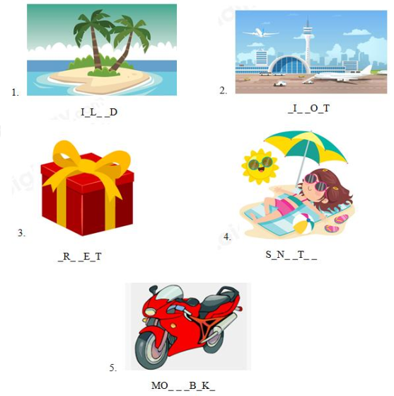
II. Choose the correct answer.
1. _______ do you visit your grandparents? – Once a week.
A. When B. How much C. How often D. Where
2. Where _________ she live?
A. is B. does C. do D. are
3. Do you _____ part in our school’s English club?
A. take B. make C. do D. play
4. What is ______ address? – It’s 56 Duy Tan street.
A. she B. he C. they D. her
5. ______ your favorite fruit? - Orange.
A. What’s B. When’s C. How’s D. Can’t
III. Give the correct form of verbs in the brackets.
1. Hoa (be) _______ a new student in this school.
2. Last summer holiday, we (go) _______ to Phu Quoc.
3. ______ you (come) ______ to Jenny’s birthday party tomorrow?
4. Dung (not like) _______ noodles.
5. Before I moved here, I (live) _______ in the countryside with my aunt.
IV. Read and complete.
invite bookstore played gave took
1. She _______________ lots of photos at the food festival yesterday.
2. Did Nga ____________ you to her birthday party?
3. My father bought some books at the _____________.
4. My friends __________ me some presents on my birthday.
5. Last Sunday, we __________ hide-and-seek at the park.
V. Make sentence.
1. Where / you / go / last summer?
2. Where / they / live?
3. She / often / go swimming / Sunday.
4. you / invite / Rei / your birthday party / last weekend?
5. They / stay / home / tomorrow.
VI. Read the passage and answer the question.
Her name is Lan. She lives in a house in the city. Near her house, there is a supermarket, a bank, a post office and a clinic. She is a student. She studies at Le Quy Don School. Her house is far from her school so she often goes to school by bike. She goes to school in the afternoon. There is a park in front of the school. There are a lot of trees and flowers in the park. Behind the school, there is a river.
1. Where is her house?
2. Is there any school near her house?
3. How does she go to school?
4. Does she go to school in the afternoon?
5. What is behind her school?

ĐÁP ÁN
I. Listen and complete.
1. parents 2. city 3. mountain 4. brother 5. weekend

II. Listen and decide if each statement is True (T) or Fasle (F).
1. T 2. F 3. T 4. T 5. F

B. VOCABULARY & GRAMMAR
I. Look and complete words.
1. ISLAND
2. AIRPORT
3. PRESENT
4. SUNBATHE
5. MOTORBIKE
II. Choose the correct answer.
1. C 2. B 3. A 4. D 5. A

III. Give the correct form of verbs in the brackets.
1. is 2. went 3. Will - come 4. doesn’t like 5. lived

IV. Read and complete.
1. took 2. invite 3. bookstore 4. gave 5. played

VI. Make sentences.
1. Where did you go last summer?
2. Where do they live?
3. She often goes swimming on Sunday.
4. Did you invite Rei to your birthday party last weekend?
5. They will stay at home tomorrow.
VI. Read the passage and answer the question.
1 - Her house is in the city.
2 - No, there isn't.
3 - She goes to school by bike.
4 - Yes, she does.
5 - There is a river behind her school.

