ĐỀ 1 | ĐỀ KIỂM TRA GIỮA HK2 NĂM HỌC 2024-2025  MÔN: TIẾNG ANH LỚP 12
Read the following advertisement and mark the letter A, B, C and D on your answer sheet to indicate the option that best fits each of the numbered blanks from 1 to 6
THE ROLE OF AI IN LEARNING
AI is playing an increasingly important role in learning, bringing significant improvements in teaching and learning methods.One important aspect is the ability (1)_______ AI to personalize learning experiences, adjusting content to match (2)_______student needs. By using machine learning algorithms, AI can predict the areas where students might need more help, making education more efficient. Many educational platforms, (3)_______ to enhance students' learning, use AI-powered systems to provide real-time feedback. Students can also (4)_______a promotion in their academic journey by excelling in courses powered by AI, as it allows for a (5)_________. Some AI-driven tools offer (6) _______ students with homework, research, or language learning, as seen in apps like Duolingo or Grammarly. Through the use of these technologies, learners have more flexibility and access to resources than ever before.
(Adapted from learning news)
Câu 1: A. of B. in C. by D. to
Câu 2: A. individually B. individual C. individualism D. individualist
Câu 3: A. which designing B. designing C. was designed D. designed
Câu 4: A. do B. make C. get D. catch
Câu 5: A. more tailored learning pace B. more learning pace tailored
C. more pace tailored learning D. more learning tailored pace
Câu 6: A. to helping B. help C. helping D. to help
Read the following leaflet and mark the letter A, B, C or D on your answer sheet to indicate the option that best fits each of the numbered blanks from 7 to 12.
Enhancing English Learning with AI
• Using AI to enhance English learning has become increasingly popular. (7)_______AI-driven platforms, learners can access personalized lessons and practice exercises anytime.
• A (8) _______ of tools, such as grammar checkers and vocabulary builders, help users improve their skills quickly and efficiently. AI. (9)_______ tailoring the learning experience to each individual, ensuring better results. (10) _______ technologies, like speech recognition systems and chatbots, offer additional support by allowing real-time (11) _______.
• This integration of AI in education creates a more dynamic and engaging learning (12) ________, leading to faster language acquisition and stronger language skills overall.
Câu 7. A. Thanks to B. In addition to C. On account of D. According to
Câu 8. A. portion B. item C. number D. amount
Câu 9. A. brings about B. stands out C. keeps up D. focuses on
Câu 10. A. Others B. Other C. The others D. Another
Câu 11. A. practice B. relaxation C. imagination D. integration
Câu 12. A. benefit B. skill C. environment D. service
Mark the letter A, B, C or D on your answer sheet to indicate the best arrangement of utterances or sentences to make a meaningful exchange or text in each of the following questions from 13 to 17.
Câu 13
a. Mark: Hi, Nam! Thanks. You look so tech-savvy, too. Have you been using AI for learning lately?
b. Nam: Hi, Mark! It's been such a long time. You look so smart!
c. Nam: Yes, I have. I use AI-driven platforms to practice English every day and get personalized lessons.
A. c-a-b B. b-c-a C. c-b-a D. b-a-c
Câu 14
a. Alex: Why AI-powered platforms?
b. Sue: I'm going to use AI-powered learning platforms.
c. Alex: I think AI-powered platforms are too complicated. I don't think I'll try them.
d. Sue: They provide personalized lessons and instant feedback, helping me learn more effectively and at my own pace.
e. Alex: How are you going to improve your learning skills?
A. e-b-a-d-c B. c-e-d-b-a C. d-b-a-e-c D. b-d-e-a-c
Câu 15
Hi Gemma,
a. Still, it was interesting to read about the potential of AI in improving study methods.
b. Thanks so much for sharing those articles about using AI for learning and education.
c. By the way, we should try using one of these AI tools together sometime. What do you think?
d. It’s fascinating how AI can support personalized learning experiences, but right now, I’m focusing more on my research projects, so I haven't had the chance to explore these tools in depth.
e. Thanks also for the recommendation about the AI-powered platforms for language learning — they seem much more engaging than the apps I’ve been using.
Write back soon.
Billy
A. d-b-a-c-e B. b-d-a-e-c C. a-d-b-c-e D. a-c-d-b-e
Câu 16
a. The ability to access tailored resources at any time has significantly enhanced my productivity and motivation, making my learning experience more dynamic and efficient.
b. While I still value traditional study methods, I believe that AI can complement them by providing instant feedback and adapting to my individual learning needs.
c. Over the past few months, I have incorporated AI-driven platforms into my study routine, where I use personalized content and assessments to boost my knowledge in various fields.
d. In conclusion, I am truly excited about the possibilities AI offers in education and am eager to continue using these tools to further my academic goals.
e. My fascination with technology and education has naturally guided me towards exploring the potential of AI in improving learning outcomes.
(Adapted from Bright)
A. e-c-a-b-d B. a-b-c-d-e C. b-c-d-a-e D. c-a-d-b-e
Câu 17
a. Traditional classroom learning has gradually been complemented by AI-powered platforms, which offer personalized lessons and real-time feedback, marking a shift towards more individualized education.
b. As a result of this technological growth, the number of students using AI-driven platforms has surged, leading to a broader adoption of these tools in schools and universities, though challenges remain, such as digital divides in certain regions.
c. The use of AI in education has evolved significantly over the past few years.
d. Nevertheless, in spite of these advancements, many educational institutions still face barriers in fully implementing AI, as resources and infrastructure remain limited in some areas.
e. This AI integration has also attracted new educational tools and resources, from language learning apps to smart tutors, enhancing the learning experience and making education more accessible to people worldwide.
(Adapted from i-Learn Smart World)
A. c-a-e-b-d B. d-c-a-b-e C. d-e-a-b-c D. d-e-b-c-a
Read the following passage about Urbanization and mark the letter A, B, C or D on your answer sheet to indicate the option that best fits each of the numbered blanks from 18 to 22.
Artificial Intelligence (AI) is revolutionizing industries by streamlining processes, improving efficiency, and creating new opportunities. In healthcare, AI-powered systems, such as Google and DeepMind (18) ________, including eye conditions and cancers, with remarkable accuracy. By analyzing large datasets of medical images, these systems can detect patterns (19) _________, providing early intervention that saves lives. In education, AI is transforming the learning experience, with platforms like Edmodo using AI (20) _______, enabling personalized learning paths. Furthermore, AI is reshaping the finance sector, (21) ___________. However, with AI’s rapid development comes ethical concerns, particularly regarding privacy and job displacement. A study by the McKinsey Global Institute predicts that up to 800 million jobs could be automated by 2030, (22) _________ . Thus, while AI holds immense promise, its challenges must be addressed responsibly.
. (Adapted from Friends Global)
Câu 18:
A. have made significant strides in diagnosing diseases
B. is making significant strides for diagnosing diseases
C. will be making some significant strides with diagnosing disease
D. has made significantly strides in diagnosing diseases
Câu 19:
A. that must be overlooking for human doctors B. that may be overlooked by human doctors
C. that will overlook by human doctors D. that should be overlooked with human doctors
Câu 20:
A. to be tailoring lessons which based on strengths and weaknesses from students
B. to tailoring lessons basing on students' strengths and weaknesses
C. to tailor lessons based on students' strengths and weaknesses
D. to be tailored lessons which bases on strengths and weaknesses of students
Câu 21:
A. that tools like Robo-Advisors helping individuals manage their investments more effectively.
B. whose tools like Robo-Advisors helps individuals manage their investments more effectively.
C. which tools like Robo-Advisors help to individuals manage their investments more effective.
D. where tools like Robo-Advisors help individuals manage their investments more effectively
Câu 22:
A. raising questions about the future of work B. raising questions to the future of work
C. raised questions about the future of work D. raising in the future of work questions
Read the following passage about AI and mark the letter A, B, C or D on your answer sheet to indicate the best answer to each of the following questions from 23 to 30.
Artificial Intelligence (AI) is transforming various industries by automating tasks, enhancing efficiency, and creating new opportunities. In healthcare, it is being used to develop advanced diagnostic tools, helping doctors to identify diseases more accurately and at earlier stages. AI-powered systems are analyzing vast amounts of medical data, such as X-rays and MRIs, to detect patterns that human doctors may miss. For instance, DeepMind, a subsidiary of Google, has developed AI systems capable of detecting eye diseases and certain cancers with remarkable accuracy.
In the field of education, AI is making significant strides by personalizing learning experiences. Platforms like Coursera and Khan Academy use AI to adapt to the individual needs of students, recommending lessons based on their learning pace and style. This has the potential to democratize education and make learning more accessible to people worldwide.
Despite its promising applications, AI also raises several concerns. One major concern is the potential loss of jobs due to automation. A report by McKinsey Global Institute predicts that up to 800 million jobs worldwide could be automated by 2030, displacing workers in industries such as manufacturing and retail. Another concern is the ethical implications of AI decision-making, especially when it comes to privacy and data security.
While AI presents challenges, it also offers many exciting possibilities for the future. Researchers are continually working on developing AI systems that are more transparent, ethical, and human-centered. As AI continues to evolve, it is crucial to find a balance between leveraging its capabilities and addressing its risks.
(Adapted from economynews)
Câu 23. Which of the following is NOT mentioned as an application of AI?
A. Diagnosing eye diseases B. Personalizing education
C. Raising several concerns D. Enhancing data security
Câu 24. The word “automating” in paragraph 1 is OPPOSITE in meaning to:
A. mechanizing B. hand-operated C. innovating D. enhancing
Câu 25. The word “it” in paragraph 1 refers to:
A. AI B. the use of education C. the education D. medical data
Câu 26. The word “potential” in paragraph 2 could be best replaced by:
A. limitation B. promise C. problem D. threat
Câu 27. Which of the following best paraphrases the underlined sentence in paragraph 3: “A report by McKinsey Global Institute predicts that up to 800 million jobs worldwide could be automated by 2030, displacing workers in industries such as manufacturing and retail”?
A. The number of jobs will drastically increase due to automation.
B. Many jobs in sectors like manufacturing may disappear by 2030.
C. The rise of automation will create new job opportunities by 2030.
D. Automation will not affect workers in retail and manufacturing industries.
Câu 28. Which of the following is TRUE according to the passage?
A. AI has only positive effects on all industries.
B. AI could potentially cause job losses in the coming years.
C. AI is already replacing workers in healthcare.
D. McKinsey Global Institute believes AI will not affect jobs by 2030.
Câu 29. In which paragraph does the writer mention ethical concerns related to AI?
A. Paragraph 1 B. Paragraph 2 C. Paragraph 3 D. Paragraph 4
Câu 30. In which paragraph does the writer explore the benefits of AI in education?
A. Paragraph 1 B. Paragraph 2 C. Paragraph 3 D. Paragraph 4
Read the following passage about using AI for English language development and mark the letter A, B, C or D on your answer sheet to indicate the best answer to each of the following questions from 31 to 40.
[I] The use of Artificial Intelligence (AI) in language learning has grown substantially in recent years, and it has become an essential tool in the development of English skills. [II] Experts predict that by 2030, the integration of AI in educational systems will be widespread, transforming the way English is taught and learned worldwide. [III] The use of AI offers both advantages and challenges in this context, shaping the learning experience in various ways. [IV]
AI can assist language learners in several ways, enhancing both the learning process and the efficiency of acquiring English. For instance, AI-powered apps and software can help learners practice pronunciation, vocabulary, and grammar through interactive exercises. Moreover, AI systems can offer personalized learning experiences, adapting to each learner’s specific needs and pace, making language learning more effective. On the other hand, AI also presents challenges. Over-reliance on AI tools can lead to the reduction of human interaction, which is crucial for language acquisition. Without real conversations, learners may not fully develop their speaking and listening skills.
In terms of learning outcomes, the impact of AI on students varies. While AI can help students learn new words and structures quickly, it may also encourage passivity, as some learners may prefer passive modes of learning, such as watching videos or listening to AI-generated audio, rather than actively engaging in conversations. This could potentially affect the development of practical communication skills. Another issue is the lack of emotional intelligence in AI-based systems. AI can provide accurate language correction but cannot offer the same level of emotional support or understanding that a human teacher can.
As AI continues to evolve, it is important to find a balance between using AI tools and maintaining essential face-to-face interaction. By integrating AI with traditional teaching methods, language learners can enjoy the benefits of both, achieving greater fluency and cultural understanding while still honing their practical skills.
. (Adapted from dailynews)
Câu 31. Where in paragraph I does the following sentence best fit?
"AI is revolutionizing language education, providing new opportunities and challenges for English learners."
A. [I] B. [II] C. [III] D. [IV]
Câu 32. The phrase "shaping the learning experience" in paragraph 1 could be best replaced by _____.
A. changing the structure B. influencing how students learn
C. simplifying learning methods D. ignoring learners' needs
Câu 33. The word "their" in paragraph 2 refers to _____.
A. students B. AI-powered apps C. learning outcomes D. learners
Câu 34. According to paragraph 2, which of the following is NOT a benefit of AI in language learning?
A. It helps learners practice pronunciation.
B. It adapts to each learner's needs.
C. It provides personalized learning experiences.
D. It encourages direct communication with native speakers.
Câu 35. Which of the following best summarises paragraph 3?
A. AI helps learners quickly acquire new vocabulary but may reduce interaction needed for speaking skills.
B. AI tools make language learning more passive, which hinders the development of communication skills.
C. The integration of AI into education leads to faster learning outcomes but prevents students from engaging fully with language.
D. AI's focus on vocabulary and grammar reduces the importance of listening and speaking in language learning.
Câu 36. The word "passivity" in paragraph 3 is OPPOSITE in meaning to _____
A. activity B. responsiveness C. enthusiasm D. interaction
Câu 37. Which of the following is TRUE according to the passage?
A. AI-based language tools can fully replace traditional teaching methods.
B. AI systems offer personalized language learning experiences, but cannot replace human teachers in providing emotional support.
C. AI tools lead to the development of excellent speaking skills without the need for face-to-face interaction.
D. AI has no impact on language learners' ability to engage in active conversations.
Câu 38. Which of the following best paraphrases the underlined sentence "It is important to find a balance between using AI tools and maintaining essential face-to-face interaction" in paragraph 4?
A. AI tools should be used as the primary method of language learning, with minimal face-to-face interaction.
B. A combination of AI and traditional methods is key to ensuring effective language learning.
C. Learners should only focus on face-to-face interaction and avoid using AI tools.
D. The balance between AI and human interaction is not necessary for successful language learning.
Câu 39. Which of the following can be inferred from the passage?
A. AI tools alone can guarantee language fluency without the need for human teachers.
B. AI-driven language learning applications can help learners, but overuse of them can hinder the development of practical communication skills.
C. Language learners prefer to rely solely on AI for improving their English.
D. AI-based systems can offer the same level of support as human teachers in terms of emotional understanding.
Câu 40. Which of the following best summarises the passage?
A. The integration of AI into language education can enhance learning outcomes but requires careful balance with traditional teaching methods to maintain practical skills.
B. AI tools are essential for learning English, but they should replace traditional teaching methods entirely.
C. AI’s role in language learning is growing, but it lacks the emotional intelligence needed for successful communication.
D. Language learning can be fully automated using AI without the need for human teachers or interaction.

ĐÁP ÁN VÀ LỜI GIẢI

Read the following advertisement and mark the letter A, B, C and D on your answer sheet to indicate the option that best fits each of the numbered blanks from 1 to 6

THE ROLE OF AI IN LEARNING
AI is playing an increasingly important role in learning, bringing significant improvements in teaching and learning methods.One important aspect is the ability (1) AI to personalize learning experiences, adjusting content to match (2) student needs. By using machine learning algorithms, AI can predict the areas where students might need more help, making education more efficient. Many educational platforms, (3) to enhance students' learning, use AI-powered systems to provide real-time feedback. Students can also (4) a promotion in their academic journey by excelling in courses powered by AI, as it allows for a (5) . Some AI-driven tools offer (6) students with homework, research, or language learning, as seen in apps like Duolingo or Grammarly. Through the use of these technologies, learners have more flexibility and access to resources than ever before.
(Adapted from learning news)
Câu 1: A. of B. in C. by D. to
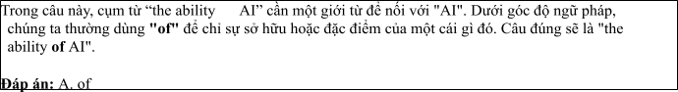
Câu 2: A. individually B. individual C. individualism D. individualist
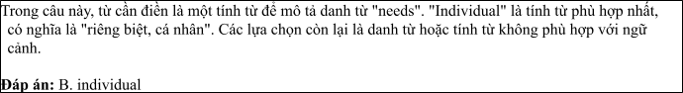
Câu 3: A. which designing B. designing C. was designed D. designed
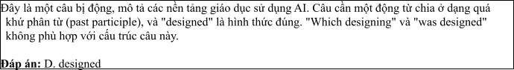
Câu 4: A. do B. make C. get D. catch
Câu 5: A. more tailored learning pace B. more learning pace tailored
C. more pace tailored learning D. more learning tailored pace
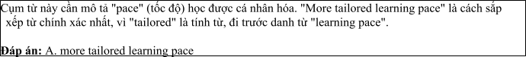
Câu 6: A. to helping B. help C. helping D. to help
Read the following leaflet and mark the letter A, B, C or D on your answer sheet to indicate the option that best fits each of the numbered blanks from 7 to 12.

Enhancing English Learning with AI
• Using AI to enhance English learning has become increasingly popular. (7) AI-driven platforms, learners can access personalized lessons and practice exercises anytime.
• A (8) of tools, such as grammar checkers and vocabulary builders, help users improve their skills quickly and efficiently. AI. (9) tailoring the learning experience to each individual, ensuring better results. (10) technologies, like speech recognition systems and chatbots, offer additional support by allowing real-time (11) .
• This integration of AI in education creates a more dynamic and engaging learning (12) , leading to faster language acquisition and stronger language skills overall.
Câu 7. A. Thanks to B. In addition to C. On account of D. According to
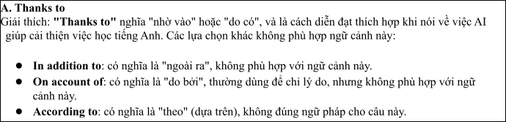
Câu 8. A. portion B. item C. number D. amount
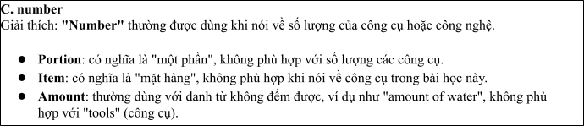
Câu 9. A. brings about B. stands out C. keeps up D. focuses on
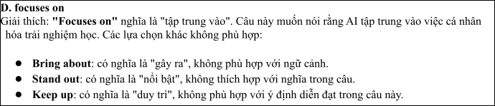
Câu 10. A. Others B. Other C. The others D. Another
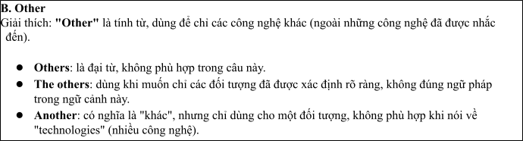
Câu 11. A. practice B. relaxation C. imagination D. integration
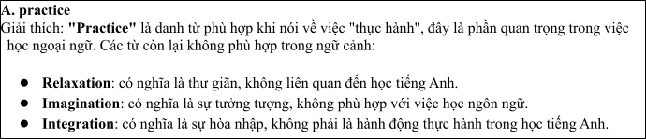
Câu 12. A. benefit B. skill C. environment D. service
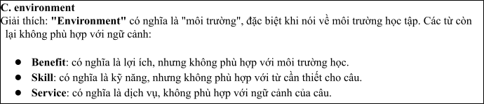
Mark the letter A, B, C or D on your answer sheet to indicate the best arrangement of utterances or sentences to make a meaningful exchange or text in each of thefollowing questions from 13 to 17.

Câu 13
1. Mark: Hi, Nam! Thanks. You look so tech-savvy, too. Have you been using AI for learning lately?
2. Nam: Hi, Mark! It's been such a long time. You look so smart!
3. Nam: Yes, I have. I use AI-driven platforms to practice English every day and get personalized lessons.
A. c-a-b B. b-c-a C. c-b-a D. b-a-c
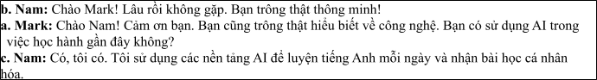

Câu 14
1. Alex: Why AI-powered platforms?
2. Sue: I'm going to use AI-powered learning platforms.
3. Alex: I think AI-powered platforms are too complicated. I don't think I'll try them.
4. Sue: They provide personalized lessons and instant feedback, helping me learn more effectively and at my own pace.
5. Alex: How are you going to improve your learning skills?
A. e-b-a-d-c B. c-e-d-b-a C. d-b-a-e-c D. b-d-e-a-c
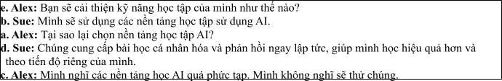

Câu 15
Hi Gemma,
1. Still, it was interesting to read about the potential of AI in improving study methods.
2. Thanks so much for sharing those articles about using AI for learning and education.
3. By the way, we should try using one of these AI tools together sometime. What do you think?
4. It’s fascinating how AI can support personalized learning experiences, but right now, I’m focusing more
on my research projects, so I haven't had the chance to explore these tools in depth.
5. Thanks also for the recommendation about the AI-powered platforms for language learning — they seem
much more engaging than the apps I’ve been using.
Write back soon. Billy
A. d-b-a-c-e B. b-d-a-e-c C. a-d-b-c-e D. a-c-d-b-e
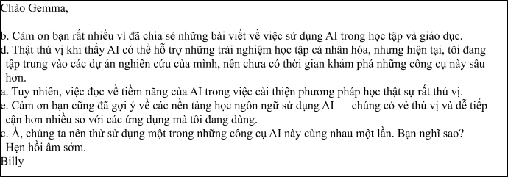

Câu 16
1. The ability to access tailored resources at any time has significantly enhanced my productivity and motivation, making my learning experience more dynamic and efficient.
2. While I still value traditional study methods, I believe that AI can complement them by providing instant feedback and adapting to my individual learning needs.
3. Over the past few months, I have incorporated AI-driven platforms into my study routine, where I use personalized content and assessments to boost my knowledge in various fields.
4. In conclusion, I am truly excited about the possibilities AI offers in education and am eager to continue using these tools to further my academic goals.
5. My fascination with technology and education has naturally guided me towards exploring the potential of AI in improving learning outcomes.
(Adapted from Bright)
A. e-c-a-b-d B. a-b-c-d-e C. b-c-d-a-e D. c-a-d-b-e
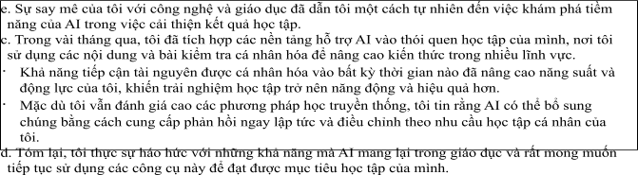

Câu 17
1. Traditional classroom learning has gradually been complemented by AI-powered platforms, which offer personalized lessons and real-time feedback, marking a shift towards more individualized education.
2. As a result of this technological growth, the number of students using AI-driven platforms has surged, leading to a broader adoption of these tools in schools and universities, though challenges remain, such as digital divides in certain regions.
3. The use of AI in education has evolved significantly over the past few years.
4. Nevertheless, in spite of these advancements, many educational institutions still face barriers in fully implementing AI, as resources and infrastructure remain limited in some areas.
5. This AI integration has also attracted new educational tools and resources, from language learning apps to smart tutors, enhancing the learning experience and making education more accessible to people worldwide.
(Adapted from i-Learn Smart World)
A. c-a-e-b-d B. d-c-a-b-e C. d-e-a-b-c D. d-e-b-c-a
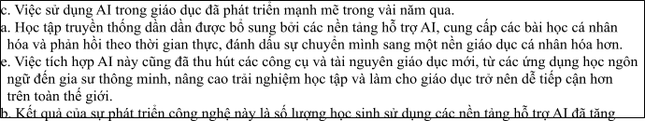
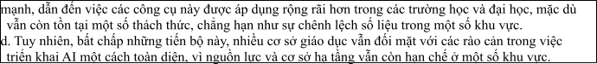
Read thefollowing passage about Urbanization and mark the letter A, B, C or D on your answer sheet to indicate the option that bestfits each of the numbered blanksfrom 18 to 22.
Artificial Intelligence (AI) is revolutionizing industries by streamlining processes, improving efficiency, and creating new opportunities. In healthcare, AI-powered systems, such as Google and DeepMind (18)
, including eye conditions and cancers, with remarkable accuracy. By analyzing large datasets of medical images, these systems can detect patterns (19) , providing early intervention that saves lives. In education, AI is transforming the learning experience, with platforms like Edmodo using AI (20)
, enabling personalized learning paths. Furthermore, AI is reshaping the finance sector, (21)
. However, with AI’s rapid development comes ethical concerns, particularly regarding privacy and job displacement. A study by the McKinsey Global Institute predicts that up to 800 million jobs could be automated by 2030, (22) . Thus, while AI holds immense promise, its challenges must be addressed responsibly.
. (Adapted from Friends Global)
Câu 18:
1. have made significant strides in diagnosing diseases
2. is making significant strides for diagnosing diseases
3. will be making some significant strides with diagnosing disease
4. has made significantly strides in diagnosing diseases
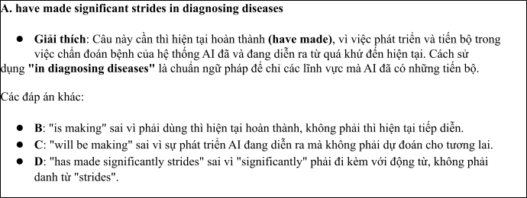

Câu 19:
A. that must be overlooking for human doctors B. that may be overlooked by human doctors
C. that will overlook by human doctors D. that should be overlooked with human doctors
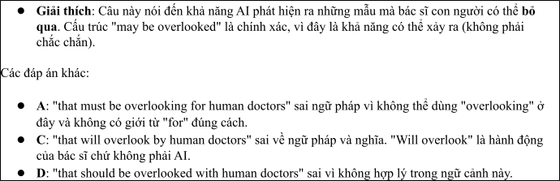

Câu 20:
1. to be tailoring lessons which based on strengths and weaknesses from students
2. to tailoring lessons basing on students' strengths and weaknesses
3. to tailor lessons based on students' strengths and weaknesses
4. to be tailored lessons which bases on strengths and weaknesses of students
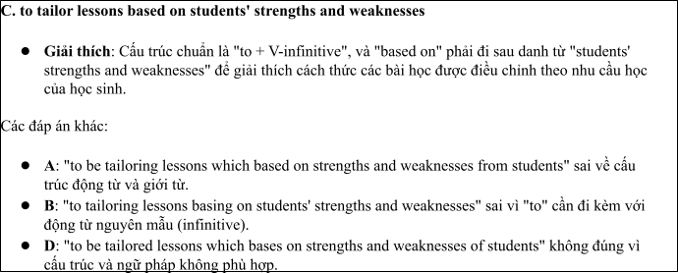

Câu 21:
1. that tools like Robo-Advisors helping individuals manage their investments more effectively.
2. whose tools like Robo-Advisors helps individuals manage their investments more effectively.
3. which tools like Robo-Advisors help to individuals manage their investments more effective.
4. where tools like Robo-Advisors help individuals manage their investments more effectively
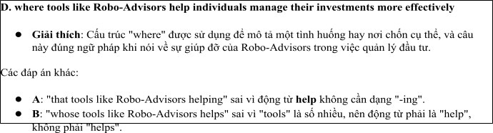

Câu 22:
A. raising questions about the future of work B. raising questions to the future of work
C. raised questions about the future of work D. raising in the future of work questions
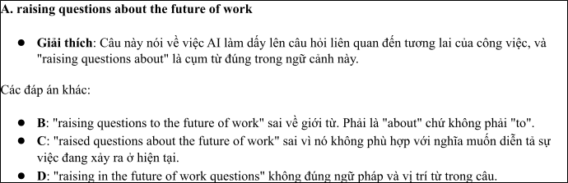
Read the following passage about AI and mark the letter A, B, C or D on your answer sheet to indicate the best answer to each of the following questions from 23 to 30.
Artificial Intelligence (AI) is transforming various industries by automating tasks, enhancing efficiency, and creating new opportunities. In healthcare, it is being used to develop advanced diagnostic tools, helping doctors to identify diseases more accurately and at earlier stages. AI-powered systems are analyzing vast amounts of medical data, such as X-rays and MRIs, to detect patterns that human doctors may miss. For instance, DeepMind, a subsidiary of Google, has developed AI systems capable of detecting eye diseases and certain cancers with remarkable accuracy.
In the field of education, AI is making significant strides by personalizing learning experiences. Platforms like Coursera and Khan Academy use AI to adapt to the individual needs of students, recommending lessons based on their learning pace and style. This has the potential to democratize education and make learning more accessible to people worldwide.
Despite its promising applications, AI also raises several concerns. One major concern is the potential loss of jobs due to automation. A report by McKinsey Global Institute predicts that up to 800 million jobs worldwide could be automated by 2030, displacing workers in industries such as manufacturing and retail. Another concern is the ethical implications of AI decision-making, especially when it comes to privacy and data security.
While AI presents challenges, it also offers many exciting possibilities for the future. Researchers are continually working on developing AI systems that are more transparent, ethical, and human-centered. As AI continues to evolve, it is crucial to find a balance between leveraging its capabilities and addressing its risks.
(Adapted from economynews) Câu 23. Which of the following is NOT mentioned as an application of AI?
A. Diagnosing eye diseases B. Personalizing education
C. Raising several concerns D. Enhancing data security
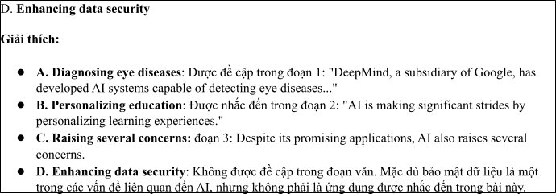
Câu 24. The word “automating” in paragraph 1 is OPPOSITE in meaning to:
A. mechanizing B. hand-operated C. innovating D. enhancing
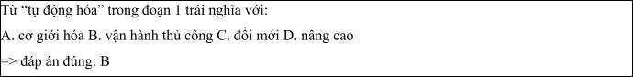
Câu 25. The word “it” in paragraph 1 refers to:
A. AI B. the use of education C. the education D. medical data
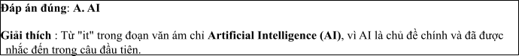
Câu 26. The word “potential” in paragraph 2 could be best replaced by:
A. limitation B. promise C. problem D. threat
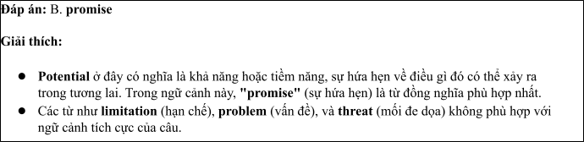
Câu 27. Which of the following best paraphrases the underlined sentence in paragraph 3: “A report by McKinsey Global Institute predicts that up to 800 million jobs worldwide could be automated by 2030, displacing workers in industries such as manufacturing and retail”?
1. The number of jobs will drastically increase due to automation.
2. Many jobs in sectors like manufacturing may disappear by 2030.
3. The rise of automation will create new job opportunities by 2030.
4. Automation will not affect workers in retail and manufacturing industries.
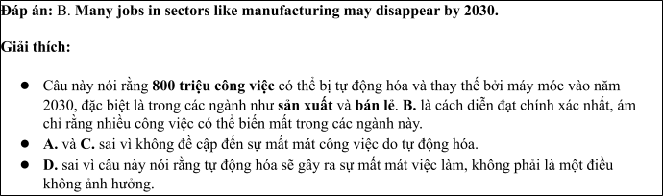
Câu 28. Which of the following is TRUE according to the passage?
1. AI has only positive effects on all industries.
2. AI could potentially cause job losses in the coming years.
3. AI is already replacing workers in healthcare.
4. McKinsey Global Institute believes AI will not affect jobs by 2030.
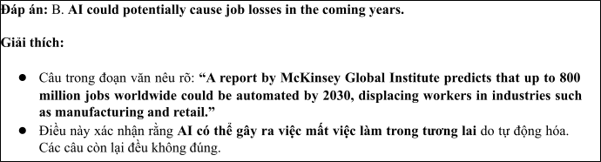
Câu 29. In which paragraph does the writer mention ethical concerns related to AI?
A. Paragraph 1 B. Paragraph 2 C. Paragraph 3 D. Paragraph 4
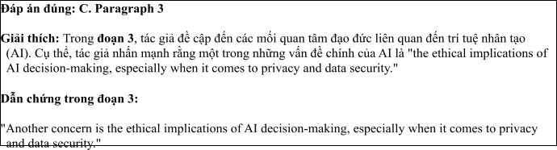
Câu 30. In which paragraph does the writer explore the benefits of AI in education?
A. Paragraph 1 B. Paragraph 2 C. Paragraph 3 D. Paragraph 4
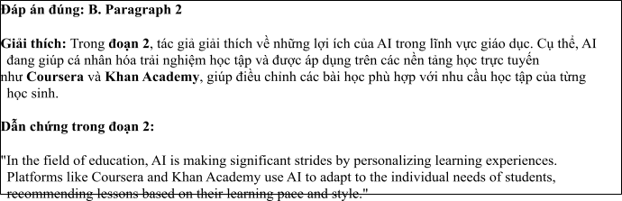
Read the following passage about using AI for English language development and mark the letter A, B, C or D on your answer sheet to indicate the best answer to each of the following questions from 31 to 40.
[I] The use of Artificial Intelligence (AI) in language learning has grown substantially in recent years, and it has become an essential tool in the development of English skills. [II] Experts predict that by 2030, the integration of AI in educational systems will be widespread, transforming the way English is taught and learned worldwide. [III] The use of AI offers both advantages and challenges in this context, shaping the learning experience in various ways. [IV]
AI can assist language learners in several ways, enhancing both the learning process and the efficiency of acquiring English. For instance, AI-powered apps and software can help learners practice pronunciation, vocabulary, and grammar through interactive exercises. Moreover, AI systems can offer personalized learning experiences, adapting to each learner’s specific needs and pace, making language learning more effective. On the other hand, AI also presents challenges. Over-reliance on AI tools can lead to the reduction of human interaction, which is crucial for language acquisition. Without real conversations, learners may not fully develop their speaking and listening skills.
In terms of learning outcomes, the impact of AI on students varies. While AI can help students learn new words and structures quickly, it may also encourage passivity, as some learners may prefer passive modes of learning, such as watching videos or listening to AI-generated audio, rather than actively engaging in conversations. This could potentially affect the development of practical communication skills. Another issue is the lack of emotional intelligence in AI-based systems. AI can provide accurate language correction but cannot offer the same level of emotional support or understanding that a human teacher can.
As AI continues to evolve, it is important to find a balance between using AI tools and maintaining essential face-to-face interaction. By integrating AI with traditional teaching methods, language learners
can enjoy the benefits of both, achieving greater fluency and cultural understanding while still honing their practical skills.
. (Adapted from dailynews) Câu 31. Where in paragraph I does the following sentence best fit?

"AI is revolutionizing language education, providing new opportunities and challenges for English learners."
A. [I] B. [II] C. [III] D. [IV]
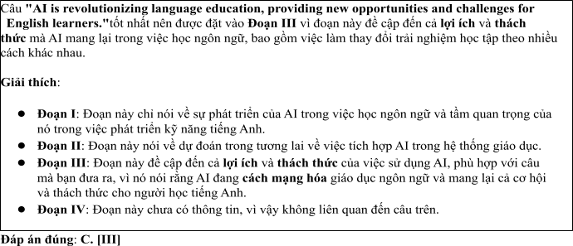
Câu 32. The phrase "shaping the learning experience" in paragraph 1 could be best replaced by .
1. changing the structure B. influencing how students learn
C. simplifying learning methods D. ignoring learners' needs
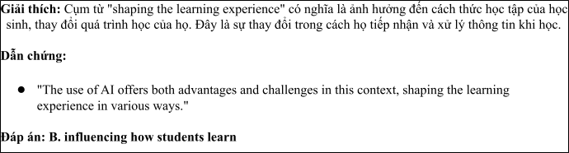
Câu 33. The word "their" in paragraph 2 refers to .
A. students B. AI-powered apps C. learning outcomes D. learners
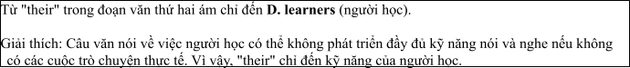
Câu 34. According to paragraph 2, which of the following is NOT a benefit of AI in language learning?
1. It helps learners practice pronunciation.
2. It adapts to each learner's needs.
3. It provides personalized learning experiences.
4. It encourages direct communication with native speakers.
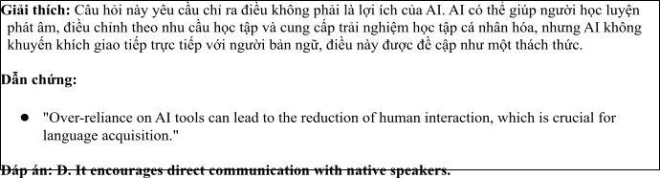
Câu 35. Which of the following best summarises paragraph 3?
1. AI helps learners quickly acquire new vocabulary but may reduce interaction needed for speaking skills.
2. AI tools make language learning more passive, which hinders the development of communication skills.
3. The integration of AI into education leads to faster learning outcomes but prevents students from engaging fully with language.
4. AI's focus on vocabulary and grammar reduces the importance of listening and speaking in language learning.
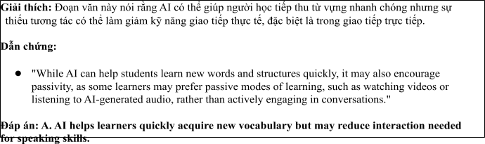
Câu 36. The word "passivity" in paragraph 3 is OPPOSITE in meaning to
A. activity B. responsiveness C. enthusiasm D. interaction
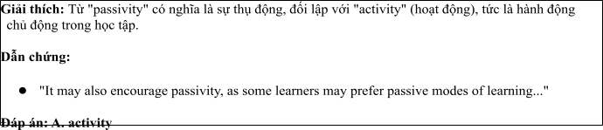
Câu 37. Which of the following is TRUE according to the passage?
1. AI-based language tools can fully replace traditional teaching methods.
2. AI systems offer personalized language learning experiences, but cannot replace human teachers in providing emotional support.
3. AI tools lead to the development of excellent speaking skills without the need for face-to-face interaction.
4. AI has no impact on language learners' ability to engage in active conversations.
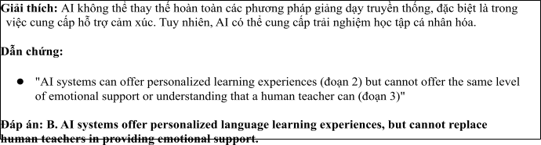
Câu 38. Which of the following best paraphrases the underlined sentence "It is important to find a balance between using AI tools and maintaining essential face-to-face interaction" in paragraph 4?
1. AI tools should be used as the primary method of language learning, with minimal face-to-face interaction.
2. A combination of AI and traditional methods is key to ensuring effective language learning.
3. Learners should only focus on face-to-face interaction and avoid using AI tools.
4. The balance between AI and human interaction is not necessary for successful language learning.
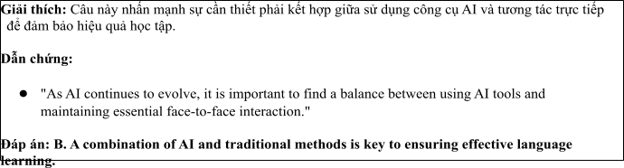
Câu 39. Which of the following can be inferred from the passage?
1. AI tools alone can guarantee language fluency without the need for human teachers.
2. AI-driven language learning applications can help learners, but overuse of them can hinder the development of practical communication skills.
3. Language learners prefer to rely solely on AI for improving their English.
4. AI-based systems can offer the same level of support as human teachers in terms of emotional understanding.
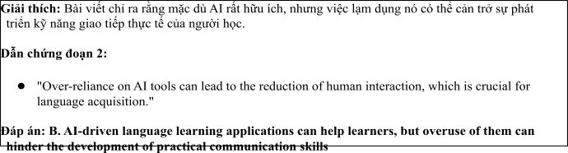
Câu 40. Which of the following best summarises the passage?
1. The integration of AI into language education can enhance learning outcomes but requires careful balance with traditional teaching methods to maintain practical skills.
2. AI tools are essential for learning English, but they should replace traditional teaching methods entirely.
3. AI’s role in language learning is growing, but it lacks the emotional intelligence needed for successful
communication.
4. Language learning can be fully automated using AI without the need for human teachers or interaction.
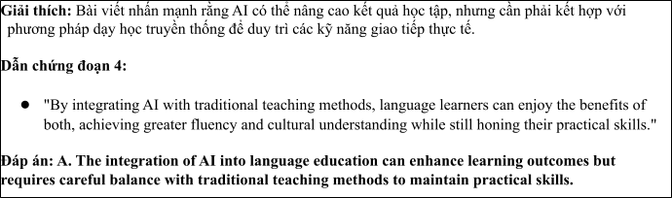

ĐỀ 2 | ĐỀ KIỂM TRA GIỮA HK2 NĂM HỌC 2024-2025  MÔN: TIẾNG ANH LỚP 12
Read the following advertisement and mark the letter A, B, C and D on your answer sheet to indicate the option that best fits each of the numbered blanks from 1 to 6
The Future of ChatGPT in 2025
In 2025, ChatGPT is expected to have evolved significantly, becoming an even more powerful tool for communication and problem-solving. With (1) ________, it will have been widely adopted across various industries, (2) _______ in everything from customer service to education. Improved algorithms will make ChatGPT more accurate and context-aware, allowing it (3) _______ and respond to complex queries with greater precision. Given advice on (4) _______ communication, the system will offer more personalized recommendations based on user preferences. By then, ChatGPT’s use of natural language processing will have been enhanced, (5) _______ conversations smoother and more intuitive. As technology advances, the model will likely be integrated (6) _______ many devices, further extending its reach and capabilities.
(Adapted from BBCnews)
Câu 1: A. its advanced capabilities B. its capabilities advanced
C. advanced its capabilities ` D. capabilities its advanced
Câu 2: A. which assisting B. assisted C. was assisting D. assisting
Câu 3: A. to understanding B. to understand C. understand D. to be understanding
Câu 4: A. effect B. effectively C. effective D. affect
Câu 5: A. coming B. making C. getting D. catching
Câu 6: A. of B. on C. from D. into
Read the following leaflet and mark the letter A, B, C or D on your answer sheet to indicate the option that best fits each of the numbered blanks from 7 to 12.
The Rapid Evolution of Artificial Intelligence
• In the modern era, the development of Artificial Intelligence (AI) has progressed at an unprecedented pace. (7) _______ technological advancements, AI is now integrated into almost every aspect of daily (8) _______, from healthcare to finance.
• The (9) _______ of data available for AI systems has increased exponentially, allowing them to learn and adapt more efficiently. As AI evolves, certain technologies stand out, particularly in natural language processing and image (10) ______.
• (11) _______ breakthrough has been the creation of AI-driven autonomous vehicles, which promise to revolutionize transportation. This growth in AI has (12) _______ significant changes in industries, creating new opportunities in fields like robotics and machine learning.
Câu 7. A. Thanks to B. In addition to C. On account of D. According to
Câu 8. A. life B. skill C. environment D. service
Câu 9. A. majority B. item C. number D. amount
Câu 10. A. separation B. recognition C. imagination D. integration
Câu 11. A. Others B. Other C. The others D. Another
Câu 12. A. led to B. come out C. gone up D. taken on
Mark the letter A, B, C or D on your answer sheet to indicate the best arrangement of utterances or sentences to make a meaningful exchange or text in each of the following questions from 13 to 17.
Câu 13
a. Mark: Hi, Nam! Thanks. You look really focused, too. Have you been studying a lot recently?
b. Nam: Hi, Mark! It's been such a long time. You look so smart!
c. Nam: Yes, I have. I study every evening and make sure to read more books.
A. c-a-b B. b-c-a C. c-b-a D. b-a-c
Câu 14
a. Why AI-powered apps?
b. They can offer personalized lessons and adapt to my learning pace, helping me improve faster. Plus, they provide instant feedback, which is great for practicing speaking and writing.
c. How are you going to improve your English?
d. That sounds interesting. Maybe I’ll give it a try too!
e. I'm going to try using AI-powered language learning apps.
A. c-e-a-b-d B. c-e-d-b-a C. d-b-a-e-c D. b-d-e-a-c
Câu 15
Hi Tom,
a. We should definitely chat about how these technologies could be applied to improving food security and reducing environmental impacts. What is your viewpoint?
b. It's inspiring to see how innovation can transform agriculture, but right now, I’m focused on my renewable energy work, so that's taking priority for the time being.
c. Thanks so much for the articles you sent me last week about sustainable farming techniques.
d. I also appreciate the recommendation for the free online courses — they look far more in-depth than the ones I’ve been following recently.
e. That said, it was really interesting to read about how technology is being integrated into farming practices to boost yields and sustainability.
Looking forward to hearing your thoughts,
Bill
A. d-b-a-c-e B. c-b-e-d-a C. a-d-b-c-e D. a-c-d-b-e
Câu 16
a. Overall, I am excited about the future of AI in education and how it can empower students to reach their full potential through customized learning experiences.
b. In the past year, I have worked on projects that use AI to develop individual learning experiences for students, allowing them to learn at their own pace and in the way that best meets their needs.
c. My desire to learn about how AI might improve student learning came from my interest in both technology and education.
d. Although maintaining accessibility and controlling data privacy are important obstacles, the potential advantages of AI in education, such better results and more effective learning, make the work worthwhile.
e. By enabling a more dynamic, tailored approach, AI integration in education improves learning effectiveness and engagement.
(Adapted from Bright)
A. c-b-e-d-a B. a-b-c-d-e C. b-c-d-a-e D. c-a-d-b-e
Câu 17
a. As a result of these advancements, the national defense sector has seen a surge in innovation and efficiency, with AI improving both response times and overall strategy in military operations.
b. Once reliant on traditional defense methods, countries are increasingly turning to AI-driven technologies for surveillance, cybersecurity, and intelligence gathering, shifting the focus towards digital defense.
c. This technological shift has led to the development of AI-powered drones, predictive analysis systems, and cyber defense networks, enhancing a country's ability to monitor threats and protect its borders.
d. Nothethless, in spite of these strides, the integration of AI in national defense also raises concerns about ethical issues, including privacy and the potential misuse of autonomous systems.
e. The role of AI in national security has evolved significantly in recent years.
(Adapted from i-Learn Smart World)
A. c-a-e-b-d B. d-c-a-b-e C. e-b-c-a-d D. d-e-b-c-a
Read the following passage about The Role of AI in Revolutionizing Student Learning and Research and mark the letter A, B, C or D on your answer sheet to indicate the option that best fits each of the numbered blanks from 18 to 22.
AI has increasingly become an invaluable tool for students in their research and learning. Students (18) _________, which is why many have found it to be a game-changer. For instance, AI-driven platforms like Google Scholar or ResearchGate, which organize academic articles, (19) _________. Additionally, AI can assist students in improving their writing skills. Tools like Grammarly or ChatGPT can suggest better sentence structures, offer grammar corrections, and even help generate ideas. (20) __________ in refining their work, making learning more efficient. In recent years, AI has also enabled personalized learning experiences, where students receive tailored recommendations for their studies based on their performance. However, (21) _________, it is important to remember that students should not rely solely on it. They (22) _________, which are essential for academic success. Overall, AI has transformed education, helping students achieve more in less time. .
(Adapted from Friends Global)
Câu 18:
A. who use AI-powered tools can access information faster than ever before
B. who are used AI-powered tools can be accessing faster information than ever before
C. who used AI-powered tools must access information faster than ever before
D. who have used AI-powered tools should access information faster than before ever
Câu 19:
A. give students to find relevant studies in the matter of seconds
B. help students find relevant studies in a matter of seconds
C. need students to find relevant studies within a matter of seconds
D. support more students find relevant studies with a matter of seconds
Câu 20:
A. These technologies have designed to support students
B. These technologies were designed to support students
C. These technologies are designed to support students
D. These technologies were being designed to support students
Câu 21:
A. because AI brought significant benefits B. as AI has brought significantly benefits
C. since AI has brought significantly benefits D. while AI has brought significant benefits
Câu 22:
A. must develop their critical thinking skills B. should develop their critical skills thinking
C. can develop critical thinking their skills D. may develop their thinking critical skills
Read the following passage about ChatGPT and mark the letter A, B, C or D on your answer sheet to indicate the best answer to each of the following questions from 23 to 30.
In recent years, AI tools like ChatGPT have become increasingly popular among students, helping them enhance their research and learning skills. ChatGPT, an advanced language model, can assist students by answering questions, summarizing articles, and generating ideas for research projects. With the ability to quickly process vast amounts of information, students can now access valuable insights faster than ever before. ChatGPT also provides personalized recommendations based on the student's query, making it a valuable resource for academic success.
However, while ChatGPT and similar tools can aid in research, it is essential for students to use them responsibly. Over-reliance on AI may lead to a lack of critical thinking and reduce students’ engagement with the material. To fully benefit from these tools, students should use them to complement, not replace, their own research and analysis.
In addition, some educational institutions are already incorporating AI tools like ChatGPT into their curriculum. For instance, many universities offer workshops to train students on how to use AI effectively in research. By learning how to utilize AI tools properly, students can develop stronger research skills, improve the quality of their work, and become more efficient researchers.
Technology also presents new ways for students to engage with academic content. AI-driven platforms can provide summaries of complex academic papers, enabling students to grasp key ideas quickly without having to read every detail. These technologies not only improve students' understanding but also help them focus on the most relevant information for their research projects.
(Adapted from Ielts reading practice)
Câu 23. Which of the following is NOT mentioned as a benefit of using ChatGPT for students' research?
A. It helps students generate ideas for research projects.
B. It allows students to access valuable insights quickly.
C. It can replace the need for traditional textbooks.
D. It can summarize academic articles.
Câu 24. The word “valuable” in paragraph 1 is OPPOSITE in meaning to
A. independent B. priceless C. beneficial D. worthless
Câu 25. The word “their” in paragraph 3 refers to
A. students B. AI tools C. educational institutions D. research projects
Câu 26. The word “responsibly” in paragraph 2 could be best replaced by
A. carelessly B. responsibly C. effectively D. independently
Câu 27. Which of the following best paraphrases the underlined sentence "Over-reliance on AI may lead to a lack of critical thinking" in paragraph 2?
A. Relying solely on AI helps develop critical thinking.
B. Not using AI may result in poor research.
C. Excessive use of AI could reduce students' critical thinking skills.
D. ChatGPT can improve critical thinking skills.
Câu 28. Which of the following is TRUE according to the passage?
A. ChatGPT can replace traditional research methods entirely.
B. AI tools should only be used for completing assignments, not for research.
C. Universities are offering workshops to help students use AI effectively.
D. ChatGPT is not available to students at any universities.
Câu 29. In which paragraph does the writer mention a potential negative consequence of using AI tools?
A. Paragraph 1 B. Paragraph 2 C. Paragraph 3 D. Paragraph 4
Câu 30. In which paragraph does the writer describe how AI tools are being incorporated into education?
A. Paragraph 1 B. Paragraph 2 C. Paragraph 3 D. Paragraph 4
Read the following passage about the world of technology in the modern era and mark the letter A, B, C or D on your answer sheet to indicate the best answer to each of the following questions from 31 to 40.
[I] The world has entered a new era driven by rapid technological advancements, transforming nearly every aspect of daily life. [II] Digital technologies, artificial intelligence, and the rise of the internet of things (IoT) have reshaped industries, economies, and social interactions. [III] However, this technological revolution also brings about a variety of challenges and concerns that require careful consideration. [IV]
One of the main driving forces behind this technological growth is the demand for more efficient systems and processes. For instance, businesses increasingly rely on automation and AI to streamline operations, reduce costs, and increase productivity. Moreover, the widespread use of smartphones and smart devices has enabled individuals to stay connected to the world 24/7, transforming communication, work, and entertainment. However, the rapid expansion of digital technologies also creates risks such as cybersecurity threats, privacy concerns, and the digital divide.
In the process of digital transformation, the world faces several long-term effects on both society and the environment. First, the growth of digital infrastructure has led to increased energy consumption, as data centers and cloud computing facilities require vast amounts of electricity. This has contributed to the global energy crisis and rising carbon emissions. Second, the shift towards digital work environments has resulted in job displacement for many people, particularly in traditional industries that are being replaced by automation. In some regions, workers without access to the necessary digital skills face challenges in finding stable employment.
Technological progress is a complex phenomenon with far-reaching implications for both individuals and society. To harness its benefits while minimizing its negative effects, governments and industries must collaborate to create sustainable practices, promote digital literacy, and ensure that technology serves the greater good of society without leaving anyone behind.
(Adapted from Bright)
Câu 31. Where in paragraph I does the following sentence best fit?
The increasing reliance on technology is revolutionizing both the economy and the way people live.
A. [I] B. [II] C. [III] D. [IV]
Câu 32. The phrase “stay connected to” in paragraph 2 could best be replaced by _____.
A. remain in touch with B. lose touch with C. contributes to D. break contact with
Câu 33. The word “This” in paragraph 2 refers to _____.
A. digital transformation B. the use of smart devices
C. the rise of artificial intelligence D. the rapid expansion of digital technologies
Câu 34. According to paragraph 2, which of the following is NOT a risk associated with rapid technological growth?
A. cybersecurity threats B. privacy concerns
C. job displacement D. improved communication
Câu 35. Which of the following best summarises paragraph 3?
A. Digital transformation improves productivity but also brings environmental and social challenges.
B. The rise of digital technologies is causing global energy shortages and unemployment.
C. The benefits of digital transformation are undeniable, but its negative consequences cannot be ignored.
D. Technological growth leads to environmental harm and job losses, which require urgent attention.
Câu 36. The word “displacement” in paragraph 3 is OPPOSITE in meaning to _____.
A. relocation B. replacement C. dislocation D. employment
Câu 37. Which of the following is TRUE according to the passage?
A. The rise of digital technologies has solved the global energy crisis.
B. Many industries are adopting automation and AI for improved productivity.
C. Privacy concerns are no longer a significant issue in the digital age.
D. Digital technologies have eliminated the digital divide across the world.
Câu 38. Which of the following best paraphrases the underlined sentence “Technological progress is a complex phenomenon, with far-reaching implications for both individuals and society” in paragraph 4?
A. The process of technological progress is simple but has wide-reaching effects on society.
B. Technological progress, despite its complexity, has significant consequences for people and society.
C. Understanding technological progress requires a thorough study of its far-reaching consequences.
D. It is essential to understand the broad impact of technological progress on individuals and society.
Câu 39. Which of the following can be inferred from the passage?
A. The benefits of technology are more important than its social and environmental costs.
B. Technological advancement is expected to improve job opportunities for all workers.
C. Without proper regulation and planning, rapid technological growth could exacerbate social inequality and environmental damage.
D. The digital divide is disappearing as more people gain access to technology.
Câu 40. Which of the following best summarises the passage?
A. Driven by the need for efficiency, technological advancements are transforming economies and lifestyles, but they require careful management to minimize environmental damage and social inequality.
B. The digital revolution has significantly improved living standards globally, but it brings with it considerable challenges, including energy consumption and job losses.
C. As digital technologies reshape industries, their widespread adoption is causing significant societal changes, but also creating risks like cybersecurity issues and job displacement.
D. Technological progress is primarily focused on economic growth, but its environmental and social consequences should not be overlooked.

ĐÁP ÁN VÀ LỜI GIẢI

Read the following advertisement and mark the letter A, B, C and D on your answer sheet to indicate the option that best fits each of the numbered blanks from 1 to 6

The Future of ChatGPT in 2025
In 2025, ChatGPT is expected to have evolved significantly, becoming an even more powerful tool for communication and problem-solving. With (1) , it will have been widely adopted across various industries, (2) in everything from customer service to education. Improved algorithms will make ChatGPT more accurate and context-aware, allowing it (3) and respond to complex queries with greater precision. Given advice on (4) communication, the system will offer more personalized recommendations based on user preferences. By then, ChatGPT’s use of natural language processing will have been enhanced, (5) conversations smoother and more intuitive. As technology advances, the model will likely be integrated (6) many devices, further extending its reach and capabilities.
(Adapted from BBCnews)
Câu 1: A. its advanced capabilities B. its capabilities advanced
C. advanced its capabilities ` D. capabilities its advanced
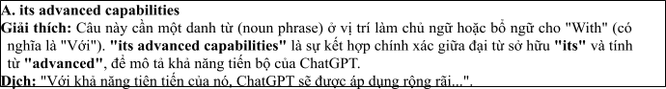
Câu 2: A. which assisting B. assisted C. was assisting D. assisting
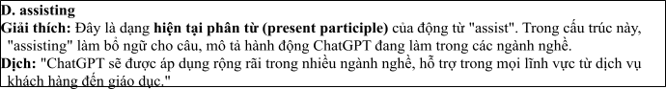
Câu 3: A. to understanding B. to understand C. understand D. to be understanding
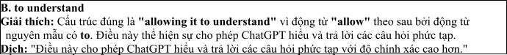
Câu 4: A. effect B. effectively C. effective D. affect
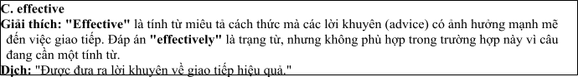
Câu 5: A. coming B. making C. getting D. catching
Câu 6: A. of B. on C. from D. into
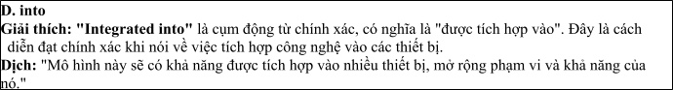
Read the following leaflet and mark the letter A, B, C or D on your answer sheet to indicate the option that best fits each of the numbered blanks from 7 to 12.

The Rapid Evolution of Artificial Intelligence
• In the modern era, the development of Artificial Intelligence (AI) has progressed at an unprecedented pace. (7) technological advancements, AI is now integrated into almost every aspect of daily
(8) , from healthcare to finance.
• The (9) of data available for AI systems has increased exponentially, allowing them to learn and adapt more efficiently. As AI evolves, certain technologies stand out, particularly in natural language processing and image (10) .
• (11) breakthrough has been the creation of AI-driven autonomous vehicles, which promise to revolutionize transportation. This growth in AI has (12) significant changes in industries, creating new opportunities in fields like robotics and machine learning.
Câu 7. A. Thanks to B. In addition to C. On account of D. According to
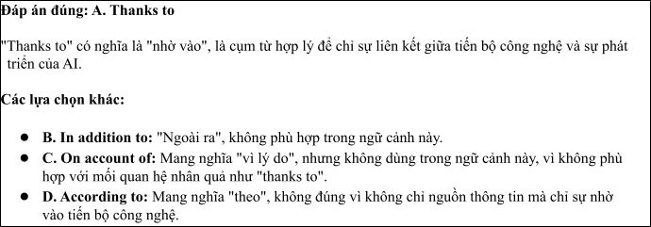
Câu 8. A. life B. skill C. environment D. service
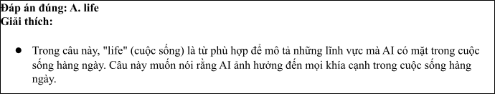
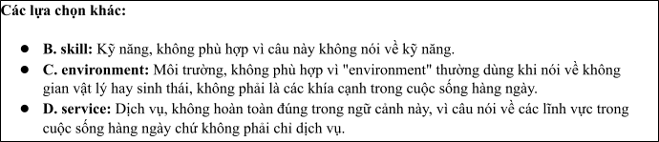
Câu 9. A. majority B. item C. number D. amount
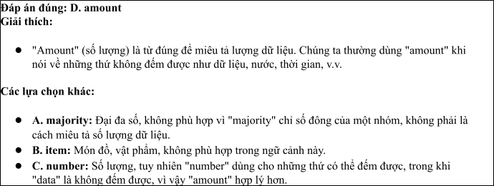
Câu 10. A. separation B. recognition C. imagination D. integration
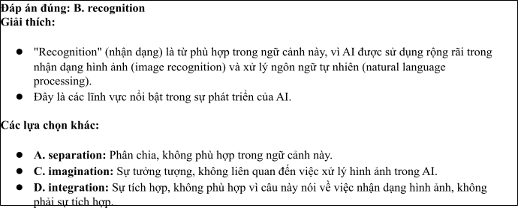
Câu 11. A. Others B. Other C. The others D. Another
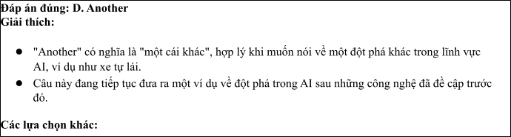
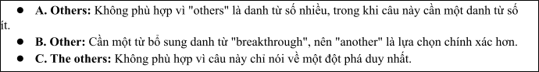
Câu 12. A. led to B. come out C. gone up D. taken on
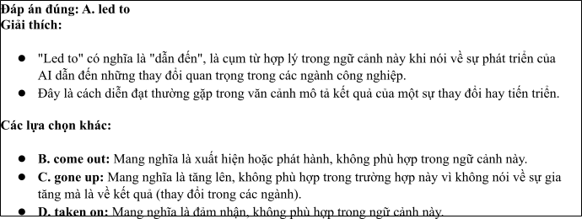
Mark the letter A, B, C or D on your answer sheet to indicate the best arrangement of utterances or sentences to make a meaningful exchange or text in each of the following questions from 13 to 17.

Câu 13
1. Mark: Hi, Nam! Thanks. You look really focused, too. Have you been studying a lot recently?
2. Nam: Hi, Mark! It's been such a long time. You look so smart!
3. Nam: Yes, I have. I study every evening and make sure to read more books.
A. c-a-b B. b-c-a C. c-b-a D. b-a-c
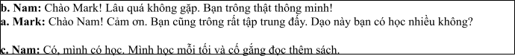

Câu 14
1. Why AI-powered apps?
2. They can offer personalized lessons and adapt to my learning pace, helping me improve faster. Plus, they provide instant feedback, which is great for practicing speaking and writing.
3. How are you going to improve your English?
4. That sounds interesting. Maybe I’ll give it a try too!
5. I'm going to try using AI-powered language learning apps.
A. c-e-a-b-d B. c-e-d-b-a C. d-b-a-e-c D. b-d-e-a-c
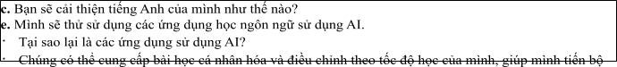

Câu 15
Hi Tom,
1. We should definitely chat about how these technologies could be applied to improving food security and reducing environmental impacts. What is your viewpoint?
2. It's inspiring to see how innovation can transform agriculture, but right now, I’m focused on my
renewable energy work, so that's taking priority for the time being.
3. Thanks so much for the articles you sent me last week about sustainable farming techniques.
4. I also appreciate the recommendation for the free online courses — they look far more in-depth than the
ones I’ve been following recently.
5. That said, it was really interesting to read about how technology is being integrated into farming practices to boost yields and sustainability.
Looking forward to hearing your thoughts, Bill
A. d-b-a-c-e B. c-b-e-d-a C. a-d-b-c-e D. a-c-d-b-e
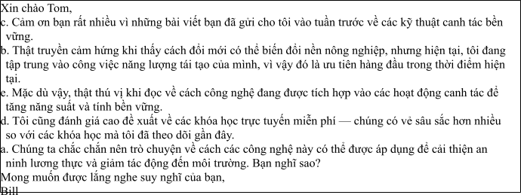

Câu 16
1. Overall, I am excited about the future of AI in education and how it can empower students to reach their full potential through customized learning experiences.
2. In the past year, I have worked on projects that use AI to develop individual learning experiences for students, allowing them to learn at their own pace and in the way that best meets their needs.
3. My desire to learn about how AI might improve student learning came from my interest in both technology and education.
4. Although maintaining accessibility and controlling data privacy are important obstacles, the potential advantages of AI in education, such better results and more effective learning, make the work worthwhile.
5. By enabling a more dynamic, tailored approach, AI integration in education improves learning effectiveness and engagement.
(Adapted from Bright)
A. c-b-e-d-a B. a-b-c-d-e C. b-c-d-a-e D. c-a-d-b-e
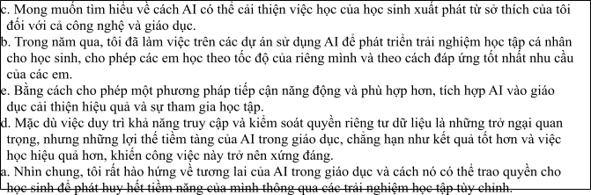

Câu 17
1. As a result of these advancements, the national defense sector has seen a surge in innovation and efficiency, with AI improving both response times and overall strategy in military operations.
2. Once reliant on traditional defense methods, countries are increasingly turning to AI-driven technologies for surveillance, cybersecurity, and intelligence gathering, shifting the focus towards digital defense.
3. This technological shift has led to the development of AI-powered drones, predictive analysis systems, and cyber defense networks, enhancing a country's ability to monitor threats and protect its borders.
4. Nothethless, in spite of these strides, the integration of AI in national defense also raises concerns about ethical issues, including privacy and the potential misuse of autonomous systems.
5. The role of AI in national security has evolved significantly in recent years.
(Adapted from i-Learn Smart World)
A. c-a-e-b-d B. d-c-a-b-e C. e-b-c-a-d D. d-e-b-c-a
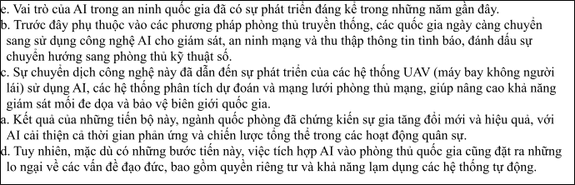
Read thefollowing passage about The Role of AI in Revolutionizing Student Learning and Research and mark the letter A, B, C or D on your answer sheet to indicate the option that bestfits each of the numbered blank sfrom 18 to 22.
AI has increasingly become an invaluable tool for students in their research and learning. Students (18)
, which is why many have found it to be a game-changer. For instance, AI-driven platforms like Google Scholar or ResearchGate, which organize academic articles, (19) . Additionally, AI can assist students in improving their writing skills. Tools like Grammarly or ChatGPT can suggest better sentence structures, offer grammar corrections, and even help generate ideas. (20) in refining
their work, making learning more efficient. In recent years, AI has also enabled personalized learning experiences, where students receive tailored recommendations for their studies based on their performance. However, (21) , it is important to remember that students should not rely solely on it. They (22)
, which are essential for academic success. Overall, AI has transformed education, helping students achieve more in less time. .
(Adapted from Friends Global)
Câu 18:
1. who use AI-powered tools can access information faster than ever before
2. who are used AI-powered tools can be accessing faster information than ever before
3. who used AI-powered tools must access information faster than ever before
4. who have used AI-powered tools should access information faster than before ever
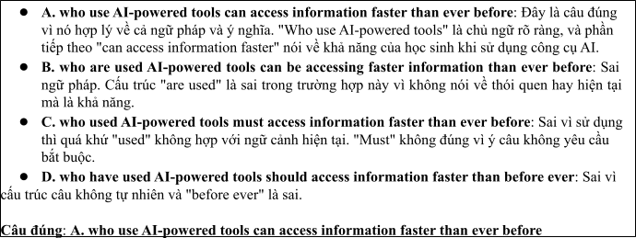

Câu 19:
1. give students to find relevant studies in the matter of seconds
2. help students find relevant studies in a matter of seconds
3. need students to find relevant studies within a matter of seconds
4. support more students find relevant studies with a matter of seconds
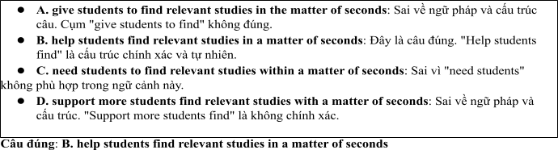

Câu 20:
1. These technologies have designed to support students
2. These technologies were designed to support students
3. These technologies are designed to support students
4. These technologies were being designed to support students
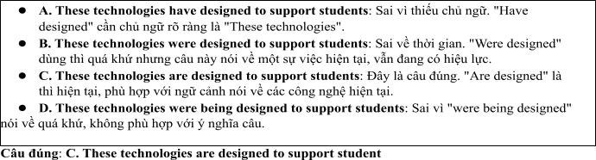

Câu 21:
A. because AI brought significant benefits B. as AI has brought significantly benefits
C. since AI has brought significantly benefits D. while AI has brought significant benefits
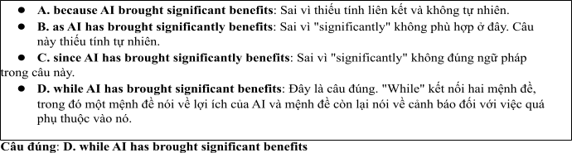

Câu 22:
A. must develop their critical thinking skills B. should develop their critical skills thinking
C. can develop critical thinking their skills D. may develop their thinking critical skills
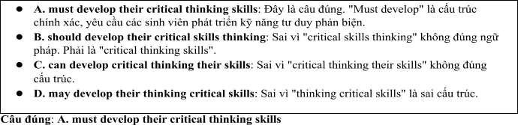
Read the following passage about ChatGPT and mark the letter A, B, C or D on your answer sheet to indicate the best answer to each of the following questionsfrom 23 to 30.
In recent years, AI tools like ChatGPT have become increasingly popular among students, helping them enhance their research and learning skills. ChatGPT, an advanced language model, can assist students by answering questions, summarizing articles, and generating ideas for research projects. With the ability to quickly process vast amounts of information, students can now access valuable insights faster than ever before. ChatGPT also provides personalized recommendations based on the student's query, making it a valuable resource for academic success.
However, while ChatGPT and similar tools can aid in research, it is essential for students to use them responsibly. Over-reliance on AI may lead to a lack of critical thinking and reduce students’ engagement with the material. To fully benefit from these tools, students should use them to complement, not replace, their own research and analysis.
In addition, some educational institutions are already incorporating AI tools like ChatGPT into their curriculum. For instance, many universities offer workshops to train students on how to use AI effectively in research. By learning how to utilize AI tools properly, students can develop stronger research skills, improve the quality of their work, and become more efficient researchers.
Technology also presents new ways for students to engage with academic content. AI-driven platforms can provide summaries of complex academic papers, enabling students to grasp key ideas quickly without having to read every detail. These technologies not only improve students' understanding but also help them focus on the most relevant information for their research projects.
(Adapted from Ielts reading practice)
Câu 23. Which of the following is NOT mentioned as a benefit of using ChatGPT for students' research?
1. It helps students generate ideas for research projects.
2. It allows students to access valuable insights quickly.
3. It can replace the need for traditional textbooks.
4. It can summarize academic articles.
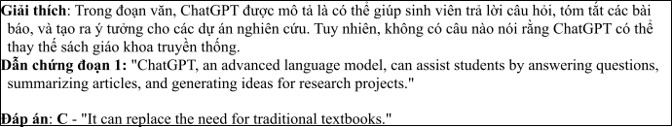
Câu 24. The word “valuable” in paragraph 1 is OPPOSITE in meaning to
A. independent B. priceless C. beneficial D. worthless
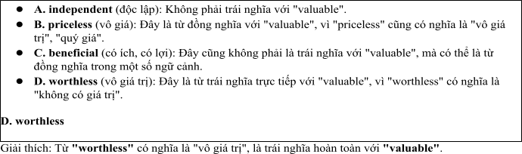
Câu 25. The word “their” in paragraph 3 refers to
A. students B. AI tools C. educational institutions D. research projects
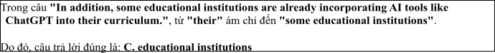
Câu 26. The word “responsibly” in paragraph 2 could be best replaced by
A. carelessly B. responsibly C. effectively D. independently
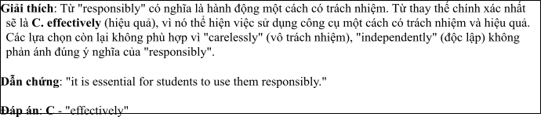
Câu 27. Which of the following best paraphrases the underlined sentence "Over-reliance on AI may lead to a lack of critical thinking" in paragraph 2?
1. Relying solely on AI helps develop critical thinking.
2. Not using AI may result in poor research.
3. Excessive use of AI could reduce students' critical thinking skills.
4. ChatGPT can improve critical thinking skills.
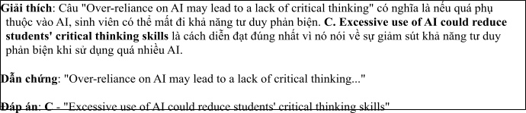
Câu 28. Which of the following is TRUE according to the passage?
1. ChatGPT can replace traditional research methods entirely.
2. AI tools should only be used for completing assignments, not for research.
3. Universities are offering workshops to help students use AI effectively.
4. ChatGPT is not available to students at any universities.
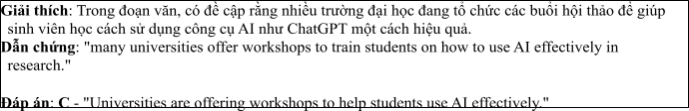
Câu 29. In which paragraph does the writer mention a potential negative consequence of using AI tools?
A. Paragraph 1 B. Paragraph 2 C. Paragraph 3 D. Paragraph 4
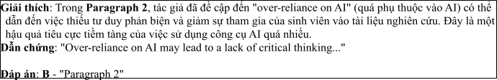
Câu 30. In which paragraph does the writer describe how AI tools are being incorporated into education?
A. Paragraph 1 B. Paragraph 2 C. Paragraph 3 D. Paragraph 4
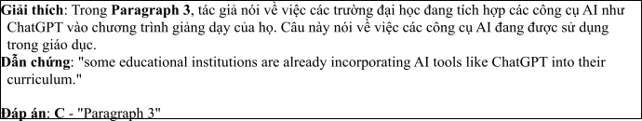
Read the following passage about the world of technology in the modern era and mark the letter A, B, C or D on your answer sheet to indicate the best answer to each of the following questions from 31 to 40.
[I] The world has entered a new era driven by rapid technological advancements, transforming nearly every aspect of daily life. [II] Digital technologies, artificial intelligence, and the rise of the internet of things (IoT) have reshaped industries, economies, and social interactions. [III] However, this technological revolution also brings about a variety of challenges and concerns that require careful consideration. [IV]
One of the main driving forces behind this technological growth is the demand for more efficient systems and processes. For instance, businesses increasingly rely on automation and AI to streamline operations, reduce costs, and increase productivity. Moreover, the widespread use of smartphones and smart devices has enabled individuals to stay connected to the world 24/7, transforming communication, work, and entertainment. However, the rapid expansion of digital technologies also creates risks such as cybersecurity threats, privacy concerns, and the digital divide.
In the process of digital transformation, the world faces several long-term effects on both society and the environment. First, the growth of digital infrastructure has led to increased energy consumption, as data centers and cloud computing facilities require vast amounts of electricity. This has contributed to the global energy crisis and rising carbon emissions. Second, the shift towards digital work environments has resulted in job displacement for many people, particularly in traditional industries that are being replaced by
automation. In some regions, workers without access to the necessary digital skills face challenges in finding stable employment.
Technological progress is a complex phenomenon with far-reaching implications for both individuals and society. To harness its benefits while minimizing its negative effects, governments and industries must collaborate to create sustainable practices, promote digital literacy, and ensure that technology serves the greater good of society without leaving anyone behind.
(Adapted from Bright)
Câu 31. Where in paragraph I does the following sentence best fit?

The increasing reliance on technology is revolutionizing both the economy and the way people live.
A. [I] B. [II] C. [III] D. [IV]
• Đoạn [I]: “The world has entered a new era driven by rapid technological advancements, transforming nearly every aspect of daily life.”
• Đoạn này đang mô tả một sự thay đổi lớn do sự tiến bộ công nghệ tạo ra, ảnh hưởng đến gần như mọi khía cạnh trong cuộc sống hàng ngày. Câu này là một câu mở đầu, nói chung về sự thay đổi do công nghệ.
• Đoạn [II]: “Digital technologies, artificial intelligence, and the rise of the internet of things (IoT) have reshaped industries, economies, and social interactions.”
• Đoạn này chi tiết hơn về các công nghệ cụ thể (công nghệ số, trí tuệ nhân tạo, IoT) và ảnh hưởng của chúng đến các ngành công nghiệp, nền kinh tế, và các mối quan hệ xã hội.
Câu "The increasing reliance on technology is revolutionizing both the economy and the way people live." có ý nói về sự phụ thuộc ngày càng tăng vào công nghệ đang thay đổi nền kinh tế và cách sống của con người, điều này khá tương đồng với nội dung trong đoạn [II], vì đoạn này đã nói về tác động của công nghệ đến các ngành công nghiệp và nền kinh tế, đồng thời có ảnh hưởng sâu rộng đến các mối quan hệ xã hội.
Đáp án đúng: B. [II]. Lý do là vì câu này miêu tả về sự thay đổi cách sống và nền kinh tế, phù hợp với những gì được đề cập trong đoạn [II], khi nói về công nghệ và sự biến đổi mà nó mang lại cho nền kinh tế và xã hội.
Câu 32. The phrase “stay connected to” in paragraph 2 could best be replaced by .
A. remain in touch with B. lose touch with C. contributes to D. break contact with
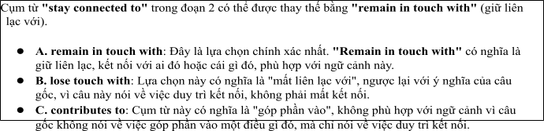
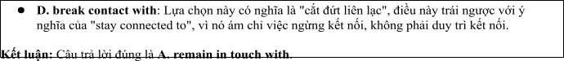
Câu 33. The word “This” in paragraph 2 refers to .
1. digital transformation B. the use of smart devices
C. the rise of artificial intelligence D. the rapid expansion of digital technologies
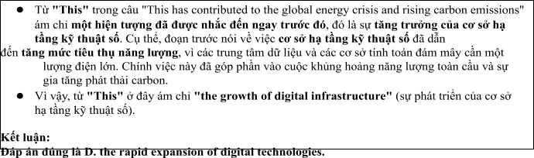
Câu 34. According to paragraph 2, which of the following is NOT a risk associated with rapid technological growth?
A. cybersecurity threats B. privacy concerns
C. job displacement D. improved communication
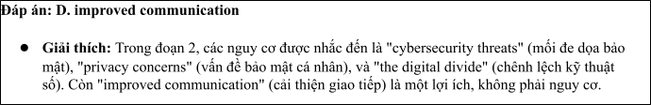
Câu 35. Which of the following best summarises paragraph 3?
1. Digital transformation improves productivity but also brings environmental and social challenges.
2. The rise of digital technologies is causing global energy shortages and unemployment.
3. The benefits of digital transformation are undeniable, but its negative consequences cannot be ignored.
4. Technological growth leads to environmental harm and job losses, which require urgent attention.
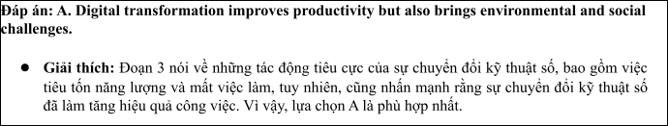
Câu 36. The word “displacement” in paragraph 3 is OPPOSITE in meaning to .
A. relocation B. replacement C. dislocation D. employment
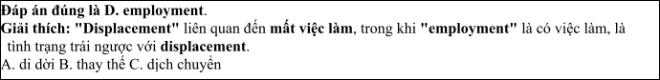
Câu 37. Which of the following is TRUE according to the passage?
1. The rise of digital technologies has solved the global energy crisis.
2. Many industries are adopting automation and AI for improved productivity.
3. Privacy concerns are no longer a significant issue in the digital age.
4. Digital technologies have eliminated the digital divide across the world.
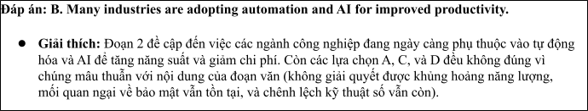
Câu 38. Which of the following best paraphrases the underlined sentence “Technological progress is a complex phenomenon, with far-reaching implications for both individuals and society” in paragraph 4?
1. The process of technological progress is simple but has wide-reaching effects on society.
2. Technological progress, despite its complexity, has significant consequences for people and society.
3. Understanding technological progress requires a thorough study of its far-reaching consequences.
4. It is essential to understand the broad impact of technological progress on individuals and society.
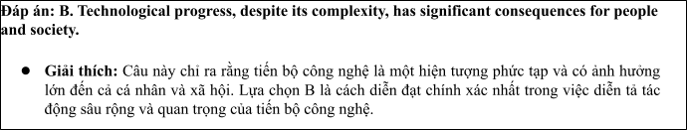
Câu 39. Which of the following can be inferred from the passage?
1. The benefits of technology are more important than its social and environmental costs.
2. Technological advancement is expected to improve job opportunities for all workers.
3. Without proper regulation and planning, rapid technological growth could exacerbate social inequality and environmental damage.
4. The digital divide is disappearing as more people gain access to technology.
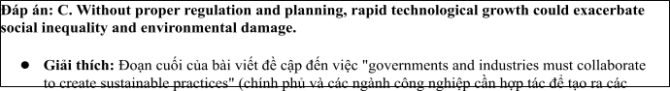
Câu 40. Which of the following best summarises the passage?
1. Driven by the need for efficiency, technological advancements are transforming economies and lifestyles, but they require careful management to minimize environmental damage and social inequality.
2. The digital revolution has significantly improved living standards globally, but it brings with it considerable challenges, including energy consumption and job losses.
3. As digital technologies reshape industries, their widespread adoption is causing significant societal changes, but also creating risks like cybersecurity issues and job displacement.
4. Technological progress is primarily focused on economic growth, but its environmental and social consequences should not be overlooked.
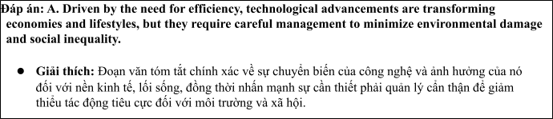

ĐỀ 3 | ĐỀ KIỂM TRA GIỮA HK2 NĂM HỌC 2024-2025  MÔN: TIẾNG ANH LỚP 12
Read the following advertisement and mark the letter A, B, C and D on your answer sheet to indicate the option that best fits each of the numbered blanks from 1 to 6
The Growing Impact of Artificial Intelligence in Daily Life
Artificial intelligence (AI) is becoming an indispensable part of everyday life. AI helps improve work performance, from automating processes to assisting (1) _______ important decisions. AI used in healthcare has already shown (2) _______ potential in diagnosing diseases early. With the rapid advancement of technology, many experts promise (3) _______ AI to address pressing global challenges, such as climate change. AI’s integration into education is exciting, (4) _______ students to learn in personalized ways.This technology has the power to (5) _______ awareness about environmental issues by providing accurate data and predictions. The role of AI in (6) ________ continues to grow, bringing both opportunities and challenges.
(Adapted from discovery news)
Câu 1: A. at B. on C. for D. in
Câu 2: A. signify B. significance C. significant D. significantly
Câu 3: A. to using B. to use C. use D. to be used
Câu 4: A. which enabled B. enabled C. was enabling D. enabling
Câu 5: A. raise B. make C. come D. get
Câu 6: A. our daily routines B. our routines daily
C. routines our daily ` D. daily our routines
Read the following leaflet and mark the letter A, B, C or D on your answer sheet to indicate the option that best fits each of the numbered blanks from 7 to 12.
The Impact of AI on Searching Study Materials
Using AI for searching study materials has become increasingly popular. (7) _______recent studies, AI can significantly enhance the way students find relevant resources online.
The (8) ________ of educational tools powered by AI, such as smart search engines and learning platforms, has grown rapidly in recent years. Related (9) ________ like machine learning and natural language processing are essential for improving search accuracy and relevancy.
(10)________ applications include AI-driven tutoring systems and content recommendation engines that tailor resources to individual learning styles. Students can (11) _______ AI to assist them in finding study materials that match their needs and academic goals. With continuous (12) _______, AI is set to revolutionize the way we approach learning and research.
Câu 7. A. Due to B. Irrespective of C. On account of D. According to
Câu 8. A. majority B. item C. number D. amount
Câu 9. A. technologies B. machines C. skills D. services
Câu 10. A. Others B. Other C. The others D. Another
Câu 11. A. rely on B. hang out C. differ from D. cut on
Câu 12. A. applications B. improvements C. technologies D. studies
Mark the letter A, B, C or D on your answer sheet to indicate the best arrangement of utterances or sentences to make a meaningful exchange or text in each of the following questions from 13 to 17.
Câu 13
a. Thanks to AI, students can receive instant feedback and improve their learning skills more effectively.
b. Using AI in education helps optimize the learning process by providing tools like lecture summaries and explanations of difficult concepts.
c. AI can personalize the learning experience by adjusting content and pace according to the learner's needs.
A. c-a-b B. b-c-a C. c-b-a D. b-a-c
Câu 14
a. Alex: How exactly can AI help in agriculture?
b. Sue: AI can analyze data on weather patterns, soil quality, and crop health to optimize farming practices.
c. Alex: How do you think AI can help in developing our country?
d. Sue: I believe AI can improve many sectors, such as healthcare, education, and agriculture.
e. Alex: That sounds great! AI could really boost productivity and support sustainable development in our country.
A. c-d-a-b-e B. c-e-d-b-a C. d-b-a-e-c D. b-d-e-a-c
Câu 15
Hi Gemma,
a. Thanks also for recommending the AI tools for language learning – they are much better than the ones I’ve tried before.
b. It's really fascinating how AI can be used to improve education and help us learn faster, but I'm a bit concerned about its impact on jobs in the long term.
c. I think it would be great if we could discuss how AI can be applied to help develop our country. What do you think?
d. Thanks a lot for sharing those AI resources for learning new skills.
e. Still, it's great to see how AI can make learning more accessible and effective.
Looking forward to hearing from you soon.
Billy
A. d-b-a-c-e B. d-b-e-a-c C. a-d-b-c-e D. a-c-d-b-e
Câu 16
a. Definitely! The app suggests resources and tutorials that match my learning pace, so I can focus more on areas where I struggle.
b. Yes, I’ve started using an AI-powered study app recently. It helps me with personalized learning plans and quizzes based on my progress.
c. I should try that! AI seems like a great way to make studying more efficient and tailored to individual needs.
d. Hi, I’ve been reading about how AI is being used in education. Have you ever tried any AI tools to help with your studies?
e. That sounds really helpful! Does it actually improve your understanding of the subjects?
(Adapted from Bright)
A. d-b-e-a-c B. a-b-c-d-e C. b-c-d-a-e D. c-a-d-b-e
Câu 17
a. However, despite these advancements, there are concerns about the potential for AI to be hacked or malfunction during critical operations.
b. AI-driven systems have significantly improved the efficiency of border patrols, detecting intrusions and potential threats more effectively than human personnel alone.
c. The integration of AI in defense has also allowed for faster decision-making, with machines analyzing data in real-time to aid military strategies.
d. Nonetheless, many experts argue that AI remains essential for securing national borders, especially as the threat landscape continues to evolve.
e. In recent years, Artificial Intelligence has played a pivotal role in national defense, providing advanced surveillance and strategic capabilities.
(Adapted from i-Learn Smart World)
A. c-a-e-b-d B. d-c-a-b-e C. e-b-c-a-d D. d-e-b-c-a
Read the following passage about The Impact of Artificial Intelligence on Global Economic Growth and Research and mark the letter A, B, C or D on your answer sheet to indicate the option that best fits each of the numbered blanks from 18 to 22.
The development of Artificial Intelligence (AI) has been a driving force in the global economy, revolutionizing industries and creating new opportunities for growth. Over the past decade, AI (18) ___________ such as manufacturing, healthcare, and finance. AI systems, (19) ___________, have allowed businesses to make more informed decisions and improve efficiency. In the near future, AI (20) _________, helping companies reduce costs and increase productivity. What impact will AI have on small businesses as it continues to evolve? Many companies have already embraced AI which considers (21) __________. With AI continuing to develop, it is clear that its potential in shaping the global economy is enormous. This technology has already been used to create new jobs in data science, machine learning, and robotics, and will continue to drive economic growth. The widespread adoption of AI could (22) __________, making it a crucial part of future economic strategies. .
(Adapted from Friends Global)
Câu 18:
A. has been increasingly used to optimize processes in sectors
B. has increasingly been used optimize processes in sectors.
C. has increasingly been using optimize processes in sectors.
D. has been increasingly optimize processes used in sectors.
Câu 19:
A. that can be analyzed the vast amounts of data in the real time
B. which can analyze vast amounts of data in real time
C. which can be analyzed vast of amounts of data in real the ime
D. that can analyze vast amounts of data within the real time
Câu 20:
A. should be integrated into even more sectors B. must be integrated with even more sectors
C. will be integrated into even more sectors D. will be integrating into even more sectors
Câu 21:
A. to be automated routine tasks to improve their bottom line
B. automate routine tasks to be improved their bottom line
C. to automating routine tasks to have improvement their bottom line
D. automating routine tasks to improve their bottom line
Câu 22:
A. lead to the transformation of entire industries B. leading to development of the industries entire.
C. lead with the transformations of entire industries D. lead to the diversity of entire industries
Read the following passage about The Role of Technology in Economic Growth and Small Business Development and mark the letter A, B, C or D on your answer sheet to indicate the best answer to each of the following questions from 23 to 30.
The rapid advancement of technology has significantly influenced global economies over the past few decades. Technologies such as artificial intelligence (AI), automation, and data analytics are transforming industries and opening new opportunities for growth. However, while larger economies are rapidly adopting these technologies, there are concerns about how developing countries will adapt. According to a report by the World Economic Forum, the adoption of AI could add $15.7 trillion to the global economy by 2030. But, many small businesses in developing regions may face challenges in keeping up with these innovations.
In fact, technology has already led to substantial shifts in the job market. Automation, for example, has already replaced many manual jobs in sectors such as manufacturing and agriculture. While this has led to efficiency gains, it has also resulted in job losses. The fear is that many low-skilled workers will be left behind as businesses transition to more automated operations. On the other hand, technology also creates new jobs, especially in fields like software development, data science, and digital marketing.
Governments and international organizations are working together to help businesses and workers adapt to these changes. Some countries have established digital infrastructure to support businesses in rural areas, enabling them to connect with global markets. Furthermore, education and training programs are being developed to help workers acquire skills that align with the demands of the modern economy.
One promising example is the use of mobile technology in Africa, which has transformed various sectors. Mobile banking, for instance, has enabled millions of people in sub-Saharan Africa to access financial services for the first time. This has helped small businesses grow by giving them easier access to loans and facilitating transactions. Similarly, blockchain technology is revolutionizing supply chain management by making it more transparent and efficient.
In conclusion, while technology has brought both challenges and opportunities, it is clear that its role in economic development will only continue to grow. For countries that embrace these changes, technology could be a key driver of economic prosperity in the future.
(Adapted from the asean news)
Câu 23: Which of the following is NOT mentioned as a technology influencing the global economy?
A. Artificial intelligence B. Blockchain
C. Mobile technology D. Nuclear power
Câu 24: The word "substantial" in paragraph 2 is OPPOSITE in meaning to
A. minor B. critical C. essential D. minimal
Câu 25: The word "them" in paragraph 3 refers to
A. businesses B. workers C. businesses and workers D. governments
Câu 26: The word "promising" in paragraph 4 could be best replaced by
A. Encouraging B. Discouraging C. Pessimistic D. Unfavorable
Câu 27: Which of the following best paraphrases the underlined sentence "Governments and international organizations are working together to help businesses and workers adapt to these changes" in paragraph 3?
A. Governments and organizations are trying to stop the development of new technologies.
B. Governments and organizations are supporting businesses and workers to cope with technological changes.
C. Governments are working on banning new technologies to protect workers.
D. Governments are looking for ways to prevent businesses from using technology.
Câu 28: Which of the following is TRUE according to the passage?
A. Technology will not affect economies in developing countries.
B. Automation has resulted in job creation, not job losses.
C. Mobile banking has helped millions of people in sub-Saharan Africa.
D. Digital infrastructure is not important for business growth.
Câu 29: In which paragraph does the writer discuss the impact of technology on the job market?
A. Paragraph 1 B. Paragraph 2 C. Paragraph 3 D. Paragraph 4
Câu 30: In which paragraph does the writer explore the role of technology in small business growth?
A. Paragraph 1 B. Paragraph 2 C. Paragraph 3 D. Paragraph 4
Read the following passage about The Role of Artificial Intelligence in National Security in the Modern Age and mark the letter A, B, C or D on your answer sheet to indicate the best answer to each of the following questions from 31 to 40.
[I] In recent years, the role of artificial intelligence (AI) in national security has grown significantly, becoming an essential tool for governments worldwide. [II] As AI technology advances, its applications are increasingly relied upon to enhance defense capabilities, intelligence gathering, and public safety. By 2030, it is predicted that AI will be a central component of most national security strategies, reshaping how governments approach defense and cybersecurity. [III] Various factors contribute to the growing reliance on AI in this field, leading to both opportunities and challenges. [IV]
AI offers several advantages in national security. One key benefit is its ability to process vast amounts of data quickly and accurately, which can help in detecting threats, monitoring suspicious activities, and analyzing patterns for preventive measures. Additionally, AI systems can assist in automating tasks such as surveillance, reducing the need for human intervention, and enhancing efficiency in response times. However, AI also poses significant risks. The use of AI in cyber warfare, for instance, can potentially enable hostile states or organizations to carry out attacks that are harder to trace and defend against.
One of the most significant challenges in using AI for national security is ensuring the ethical use of the technology. For instance, AI-powered surveillance systems could be used to infringe on privacy rights, raising concerns about civil liberties and government overreach. Another concern is the potential for AI to make autonomous decisions in military operations, where the risk of unintended consequences could be catastrophic.
AI is also reshaping the way national security agencies recruit and train personnel. Modern security forces are increasingly seeking individuals with expertise in AI, data analysis, and machine learning. This shift requires a rethinking of traditional recruitment processes and the development of specialized training programs to ensure personnel are equipped to handle the complexities of AI-driven operations.
As AI continues to evolve, it is crucial that governments balance its use in national security with strict regulatory frameworks, transparency, and accountability. This will ensure that the benefits of AI can be harnessed without compromising democratic values or public trust.
(Adapted from daily news)
Câu 31. Where in paragraph I does the following sentence best fit?
AI has become a crucial part of modern national security systems, playing an important role in defense and intelligence gathering.
A. [I] B. [II] C. [III] D. [IV]
Câu 32. The phrase “concerns about” in paragraph 3 could be best replaced by ____ .
A. contributes to B. leads to C. worries about D. believes in
Câu 33. The word “its” in paragraph 2 refers to ____ .
A. cybersecurity’s B. government’s C. AI’s D. state’s
Câu 34. According to paragraph 2, which of the following is NOT a benefit of using AI for national security?
A. AI can process vast amounts of data quickly.
B. AI can automate surveillance and improve efficiency.
C. AI can reduce the need for human intervention in defense operations.
D. AI makes it harder to trace and defend against cyberattacks.
Câu 35. Which of the following best summarizes paragraph 3?
A. AI presents several challenges, especially related to its ethical use and potential impact on privacy and military decisions.
B. The use of AI in national security requires greater transparency to avoid unintended consequences.
C. Autonomous AI decisions in defense operations could prevent human error and improve military response.
D. The use of AI in defense systems poses no significant risk to national security or privacy.
Câu 36. The word “catastrophic” in paragraph 3 is OPPOSITE in meaning to ____ .
A. disastrous B. severe C. beneficial D. alarming
Câu 37. Which of the following is TRUE according to the passage?
A. AI has no significant drawbacks when used in national security.
B. AI systems have no role in cybersecurity or defense operations.
C. AI is becoming increasingly essential in national security strategies.
D. National security agencies have no concerns about the ethical use of AI.
Câu 38. Which of the following best paraphrases the underlined sentence “As AI continues to evolve, it is crucial that governments balance its use in national security with strict regulatory frameworks, transparency, and accountability” in paragraph 4?
A. As AI becomes more advanced, governments must prioritize regulation and transparency in its use for national security.
B. Governments need to focus on increasing the use of AI while ensuring its ethical application in national security.
C. AI should be used freely by governments in national security without much oversight.
D. Strict regulations are unnecessary as AI continues to evolve in the national security sector.
Câu 39. Which of the following can be inferred from the passage?
A. AI's primary application in national security is focused on improving privacy protections.
B. Governments are increasingly concerned with ensuring AI does not harm civil liberties or lead to overreach.
C. The primary role of AI in national security is to replace human soldiers and officers in military operations.
D. There is no significant demand for AI specialists in national security agencies.
Câu 40. Which of the following best summarizes the passage?
A. AI is transforming national security by enhancing data processing and surveillance capabilities, but raises ethical and privacy concerns that require careful regulation.
B. As AI advances, it will completely replace human personnel in national security roles, improving efficiency without ethical risks.
C. AI's role in national security is only focused on improving military operations and cybersecurity, with minimal concern for civil liberties.
D. The adoption of AI in national security is a simple solution to combat emerging threats without any significant risks or ethical considerations.
ĐÁP ÁN VÀ LỜI GIẢI
Read the following advertisement and mark the letter A, B, C and D on your answer sheet to indicate the option that best fits each of the numbered blanks from 1 to 6

The Growing Impact of Artificial Intelligence in Daily Life
Artificial intelligence (AI) is becoming an indispensable part of everyday life. AI helps improve work performance, from automating processes to assisting (1) important decisions. AI used in healthcare has already shown (2) potential in diagnosing diseases early. With the rapid advancement of technology, many experts promise (3) AI to address pressing global challenges, such as climate change. AI’s integration into education is exciting, (4) students to learn in personalized ways.This technology has the power to (5) awareness about environmental issues by providing accurate data and predictions. The role of AI in (6) continues to grow, bringing both opportunities and challenges.
(Adapted from discovery news)
Câu 1: A. at B. on C. for D. in
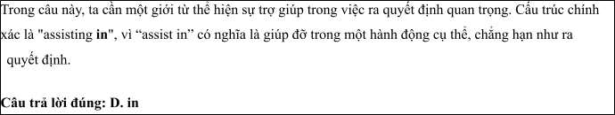
Câu 2: A. signify B. significance C. significant D. significantly
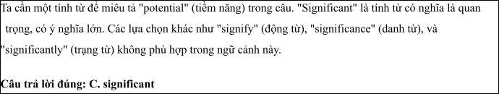
Câu 3: A. to using B. to use C. use D. to be used

Câu 4: A. which enabled B. enabled C. was enabling D. enabling
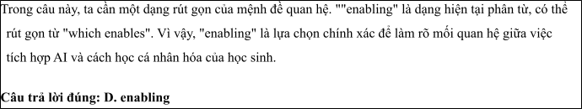
Câu 5: A. raise B. make C. come D. get
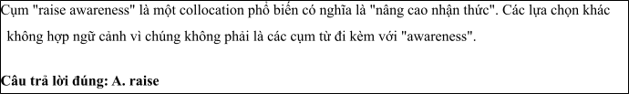
Câu 6: A. our daily routines B. our routines daily
C. routines our daily ` D. daily our routines
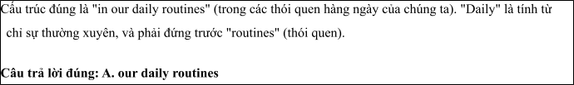
Read the following leaflet and mark the letter A, B, C or D on your answer sheet to indicate the option that best fits each of the numbered blanks from 7 to 12.

The Impact of AI on Searching Study Materials
Using AI for searching study materials has become increasingly popular. (7) recent studies, AI can significantly enhance the way students find relevant resources online.
The (8) of educational tools powered by AI, such as smart search engines and learning platforms, has grown rapidly in recent years. Related (9) like machine learning and natural language processing are essential for improving search accuracy and relevancy.
(10) applications include AI-driven tutoring systems and content recommendation engines that tailor resources to individual learning styles. Students can (11) AI to assist them in finding study materials that match their needs and academic goals. With continuous (12) , AI is set to revolutionize the way we approach learning and research.
Câu 7. A. Due to B. Irrespective of C. On account of D. According to
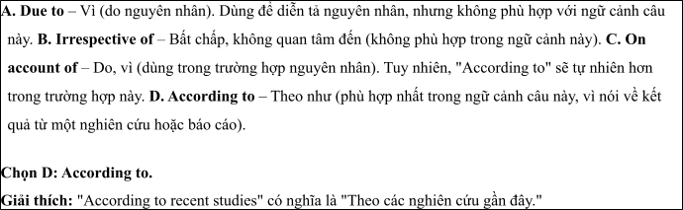
Câu 8. A. majority B. item C. number D. amount
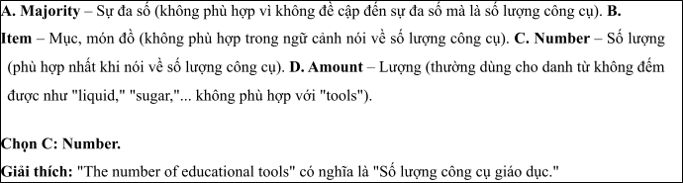
Câu 9. A. technologies B. machines C. skills D. services
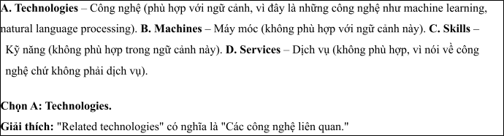
Câu 10. A. Others B. Other C. The others D. Another
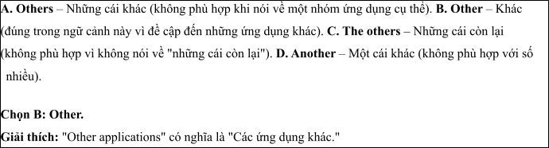
Câu 11. A. rely on B. hang out C. differ from D. cut on
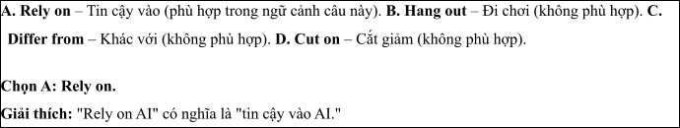
Câu 12. A. applications B. improvements C. technologies D. studies
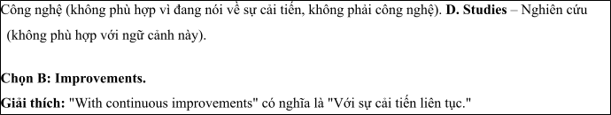
Mark the letter A, B, C or D on your answer sheet to indicate the best arrangement of utterances or sentences to make a meaningful exchange or text in each of the following questions from 13 to 17.

Câu 13
1. Thanks to AI, students can receive instant feedback and improve their learning skills more effectively.
2. Using AI in education helps optimize the learning process by providing tools like lecture summaries and explanations of difficult concepts.
3. AI can personalize the learning experience by adjusting content and pace according to the learner's needs.
A. c-a-b B. b-c-a C. c-b-a D. b-a-c
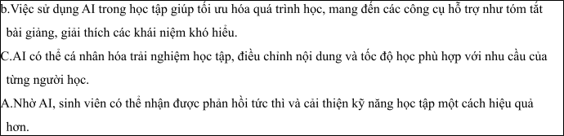

Câu 14
1. Alex: How exactly can AI help in agriculture?
2. Sue: AI can analyze data on weather patterns, soil quality, and crop health to optimize farming practices.
3. Alex: How do you think AI can help in developing our country?
4. Sue: I believe AI can improve many sectors, such as healthcare, education, and agriculture.
5. Alex: That sounds great! AI could really boost productivity and support sustainable development in our country.
A. c-d-a-b-e B. c-e-d-b-a C. d-b-a-e-c D. b-d-e-a-c
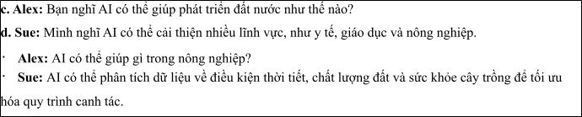

Câu 15
Hi Gemma,
1. Thanks also for recommending the AI tools for language learning – they are much better than the ones
I’ve tried before.
2. It's really fascinating how AI can be used to improve education and help us learn faster, but I'm a bit concerned about its impact on jobs in the long term.
3. I think it would be great if we could discuss how AI can be applied to help develop our country. What do you think?
4. Thanks a lot for sharing those AI resources for learning new skills.
5. Still, it's great to see how AI can make learning more accessible and effective. Looking forward to hearing from you soon.
Billy
A. d-b-a-c-e B. d-b-e-a-c C. a-d-b-c-e D. a-c-d-b-e
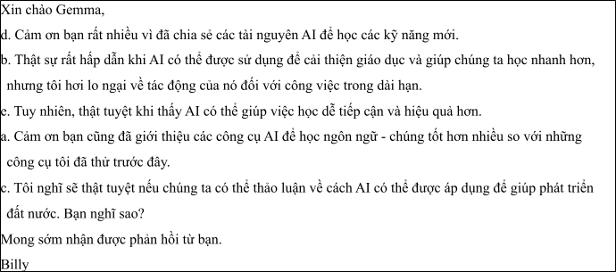

Câu 16
1. Definitely! The app suggests resources and tutorials that match my learning pace, so I can focus more on areas where I struggle.
2. Yes, I’ve started using an AI-powered study app recently. It helps me with personalized learning plans and quizzes based on my progress.
3. I should try that! AI seems like a great way to make studying more efficient and tailored to individual needs.
4. Hi, I’ve been reading about how AI is being used in education. Have you ever tried any AI tools to help
with your studies?
5. That sounds really helpful! Does it actually improve your understanding of the subjects?
(Adapted from Bright)
A. d-b-e-a-c B. a-b-c-d-e C. b-c-d-a-e D. c-a-d-b-e
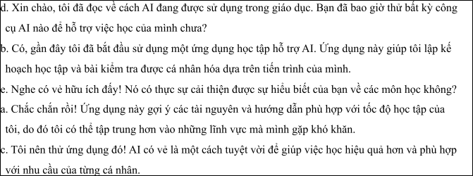

Câu 17
1. However, despite these advancements, there are concerns about the potential for AI to be hacked or malfunction during critical operations.
2. AI-driven systems have significantly improved the efficiency of border patrols, detecting intrusions and potential threats more effectively than human personnel alone.
3. The integration of AI in defense has also allowed for faster decision-making, with machines analyzing data in real-time to aid military strategies.
4. Nonetheless, many experts argue that AI remains essential for securing national borders, especially as the threat landscape continues to evolve.
5. In recent years, Artificial Intelligence has played a pivotal role in national defense, providing advanced surveillance and strategic capabilities.
(Adapted from i-Learn Smart World)
A. c-a-e-b-d B. d-c-a-b-e C. e-b-c-a-d D. d-e-b-c-a
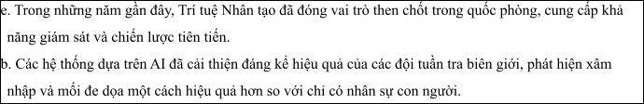
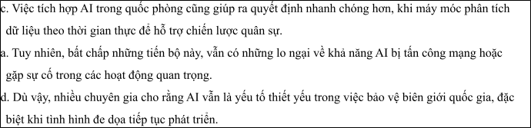
Read thefollowing passage about The Impact of Artificial Intelligence on Global Economic Growth and Research and mark the letter A, B, C or D on your answer sheet to indicate the option that best fits each of the numbered blanks from 18 to 22.
The development of Artificial Intelligence (AI) has been a driving force in the global economy, revolutionizing industries and creating new opportunities for growth. Over the past decade, AI (18)
such as manufacturing, healthcare, and finance. AI systems, (19) , have allowed businesses to make more informed decisions and improve efficiency. In the near future, AI (20) , helping companies reduce costs and increase productivity. What impact will AI have on small businesses as it continues to evolve? Many companies have already embraced AI which considers (21) . With AI continuing to develop, it is clear that its potential in shaping the global economy is enormous. This technology has already been used to create new jobs in data science, machine learning, and robotics, and will continue to drive economic growth. The widespread adoption of AI could (22) , making it a crucial part of future economic strategies. .
(Adapted from Friends Global)
Câu 18:
1. has been increasingly used to optimize processes in sectors
2. has increasingly been used optimize processes in sectors.
3. has increasingly been using optimize processes in sectors.
4. has been increasingly optimize processes used in sectors.
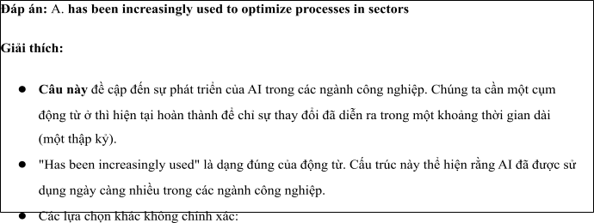
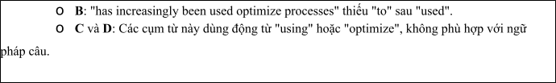

Câu 19:
1. that can be analyzed the vast amounts of data in the real time
which can analyze vast amounts of data in real time
2. which can be analyzed vast of amounts of data in real the ime
3. that can analyze vast amounts of data within the real time
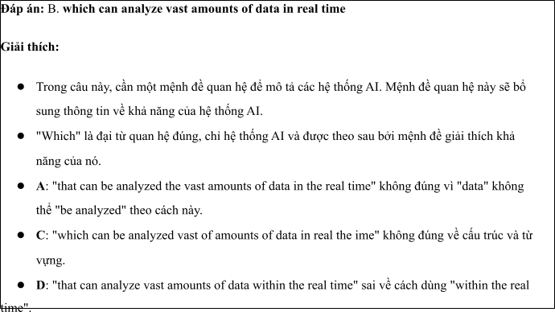

Câu 20:
A. should be integrated into even more sectors B. must be integrated with even more sectors
C. will be integrated into even more sectors D. will be integrating into even more sectors
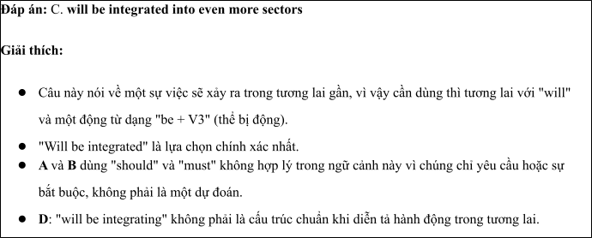

Câu 21:
1. to be automated routine tasks to improve their bottom line
2. automate routine tasks to be improved their bottom line
3. to automating routine tasks to have improvement their bottom line
4. automating routine tasks to improve their bottom line
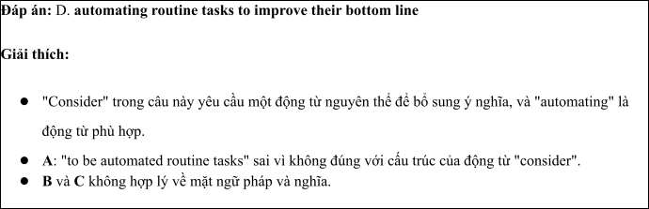

Câu 22:
1. lead to the transformation of entire industries
2. leading to development of the industries entire.
3. lead with the transformations of entire industries
4. lead to the diversity of entire industries
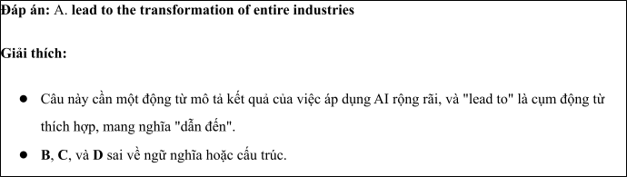
Read the following passage about The Role of Technology in Economic Growth and Small Business Development and mark the letter A, B, C or D on your answer sheet to indicate the best answer to each of the following questionsfrom 23 to 30.
The rapid advancement of technology has significantly influenced global economies over the past few decades. Technologies such as artificial intelligence (AI), automation, and data analytics are transforming industries and opening new opportunities for growth. However, while larger economies are rapidly adopting these technologies, there are concerns about how developing countries will adapt. According to a report by the World Economic Forum, the adoption of AI could add $15.7 trillion to the global economy by 2030. But, many small businesses in developing regions may face challenges in keeping up with these innovations.
In fact, technology has already led to substantial shifts in the job market. Automation, for example, has already replaced many manual jobs in sectors such as manufacturing and agriculture. While this has led to efficiency gains, it has also resulted in job losses. The fear is that many low-skilled workers will be left behind as businesses transition to more automated operations. On the other hand, technology also creates new jobs, especially in fields like software development, data science, and digital marketing.
Governments and international organizations are working together to help businesses and workers adapt to these changes. Some countries have established digital infrastructure to support businesses in rural areas, enabling them to connect with global markets. Furthermore, education and training programs are being developed to help workers acquire skills that align with the demands of the modern economy.
One promising example is the use of mobile technology in Africa, which has transformed various sectors. Mobile banking, for instance, has enabled millions of people in sub-Saharan Africa to access financial services for the first time. This has helped small businesses grow by giving them easier access to loans and facilitating transactions. Similarly, blockchain technology is revolutionizing supply chain management by making it more transparent and efficient.
In conclusion, while technology has brought both challenges and opportunities, it is clear that its role in economic development will only continue to grow. For countries that embrace these changes, technology could be a key driver of economic prosperity in the future.
(Adapted from the asean news)
Câu 23: Which of the following is NOT mentioned as a technology influencing the global economy?
A. Artificial intelligence B. Blockchain
C. Mobile technology D. Nuclear power
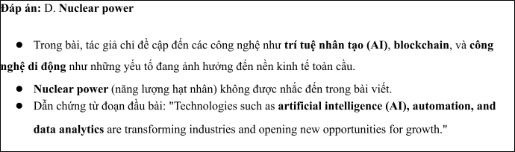
Câu 24: The word "substantial" in paragraph 2 is OPPOSITE in meaning to
A. minor B. critical C. essential D. minimal
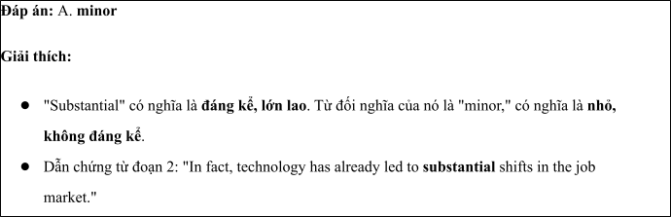
Câu 25: The word "them" in paragraph 3 refers to
A. businesses B. workers C. businesses and workersD. governments
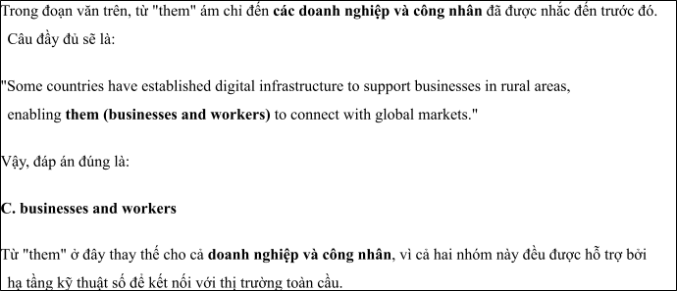
Câu 26: The word "promising" in paragraph 4 could be best replaced by
A. Encouraging B. Discouraging C. Pessimistic D. Unfavorable
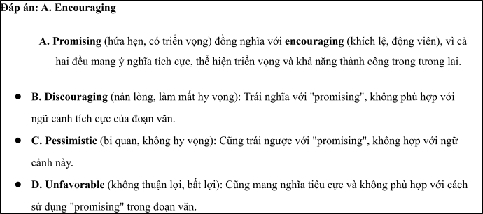
Câu 27: Which of the following best paraphrases the underlined sentence "Governments and international organizations are working together to help businesses and workers adapt to these changes" in paragraph 3?
1. Governments and organizations are trying to stop the development of new technologies.
2. Governments and organizations are supporting businesses and workers to cope with technological changes.
3. Governments are working on banning new technologies to protect workers.
4. Governments are looking for ways to prevent businesses from using technology.
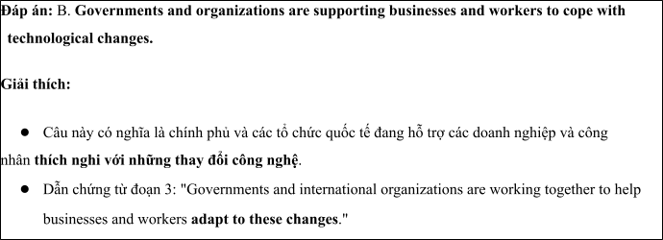
Câu 28: Which of the following is TRUE according to the passage?
1. Technology will not affect economies in developing countries.
2. Automation has resulted in job creation, not job losses.
3. Mobile banking has helped millions of people in sub-Saharan Africa.
4. Digital infrastructure is not important for business growth.
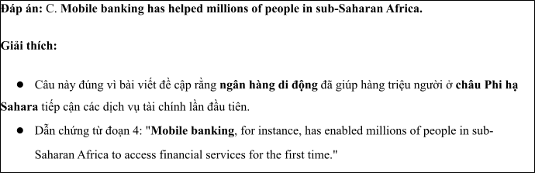
Câu 29: In which paragraph does the writer discuss the impact of technology on the job market?
A. Paragraph 1 B. Paragraph 2 C. Paragraph 3 D. Paragraph 4
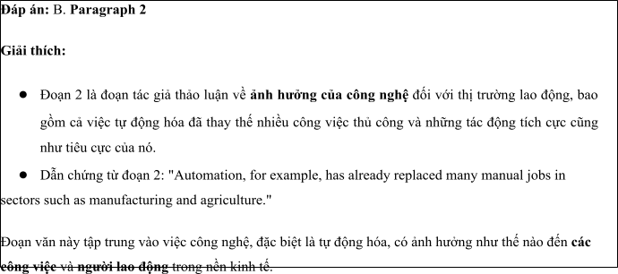
Câu 30: In which paragraph does the writer explore the role of technology in small business growth?
A. Paragraph 1 B. Paragraph 2 C. Paragraph 3 D. Paragraph 4
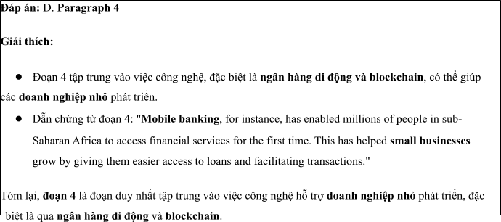
Read the following passage about The Role of Artificial Intelligence in National Security in the Modern Age and mark the letter A, B, C or D on your answer sheet to indicate the best answer to each of the following questions from 31 to 40.
1. In recent years, the role of artificial intelligence (AI) in national security has grown significantly, becoming an essential tool for governments worldwide. [II] As AI technology advances, its applications are increasingly relied upon to enhance defense capabilities, intelligence gathering, and public safety. By 2030, it is predicted that AI will be a central component of most national security strategies, reshaping how governments approach defense and cybersecurity. [III] Various factors contribute to the growing reliance on AI in this field, leading to both opportunities and challenges. [IV]
AI offers several advantages in national security. One key benefit is its ability to process vast amounts of data quickly and accurately, which can help in detecting threats, monitoring suspicious activities, and analyzing patterns for preventive measures. Additionally, AI systems can assist in automating tasks such as surveillance, reducing the need for human intervention, and enhancing efficiency in response times. However, AI also poses significant risks. The use of AI in cyber warfare, for instance, can potentially enable hostile states or organizations to carry out attacks that are harder to trace and defend against.
One of the most significant challenges in using AI for national security is ensuring the ethical use of the technology. For instance, AI-powered surveillance systems could be used to infringe on privacy rights, raising concerns about civil liberties and government overreach. Another concern is the potential for AI to make autonomous decisions in military operations, where the risk of unintended consequences could be catastrophic.
AI is also reshaping the way national security agencies recruit and train personnel. Modern security forces are increasingly seeking individuals with expertise in AI, data analysis, and machine learning. This shift requires a rethinking of traditional recruitment processes and the development of specialized training programs to ensure personnel are equipped to handle the complexities of AI-driven operations.
As AI continues to evolve, it is crucial that governments balance its use in national security with strict regulatory frameworks, transparency, and accountability. This will ensure that the benefits of AI can be harnessed without compromising democratic values or public trust.
(Adapted from daily news) Câu 31. Where in paragraph I does the following sentence best fit?

AI has become a crucial part of modern national security systems, playing an important role in defense and intelligence gathering.
A. [I] B. [II] C. [III] D. [IV]
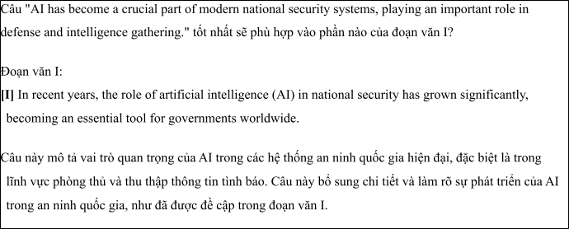
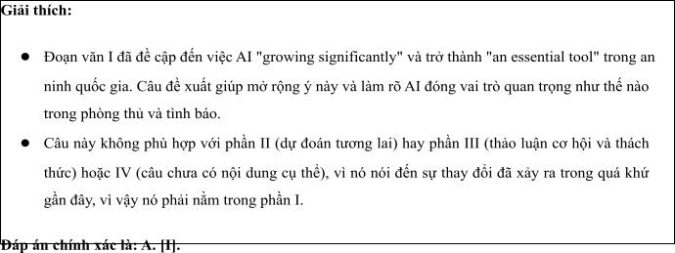
Câu 32. The phrase “concerns about” in paragraph 3 could be best replaced by .
A. contributes to B. leads to C. worries about D. believes in
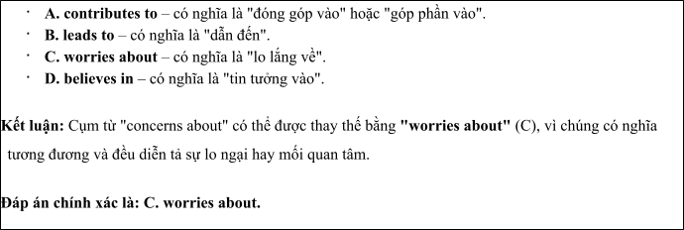
Câu 33. The word “its” in paragraph 2 refers to .
A. cybersecurity’s B. government’s C. AI’s D. state’s
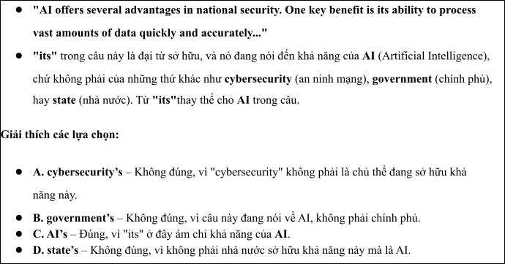
Câu 34. According to paragraph 2, which of the following is NOT a benefit of using AI for national security?
1. AI can process vast amounts of data quickly.
2. AI can automate surveillance and improve efficiency.
3. AI can reduce the need for human intervention in defense operations.
4. AI makes it harder to trace and defend against cyberattacks.
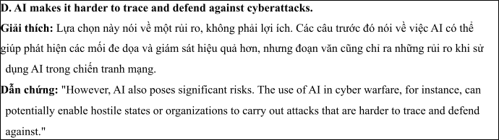
Câu 35. Which of the following best summarizes paragraph 3?
1. AI presents several challenges, especially related to its ethical use and potential impact on privacy and military decisions.
2. The use of AI in national security requires greater transparency to avoid unintended consequences.
3. Autonomous AI decisions in defense operations could prevent human error and improve military response.
4. The use of AI in defense systems poses no significant risk to national security or privacy.
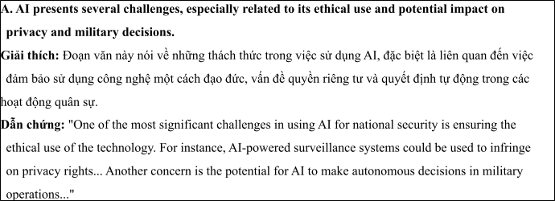
Câu 36. The word “catastrophic” in paragraph 3 is OPPOSITE in meaning to .
A. disastrous B. severe C. beneficial D. alarming
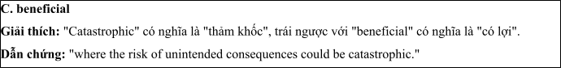
Câu 37. Which of the following is TRUE according to the passage?
1. AI has no significant drawbacks when used in national security.
2. AI systems have no role in cybersecurity or defense operations.
3. AI is becoming increasingly essential in national security strategies.
4. National security agencies have no concerns about the ethical use of AI.
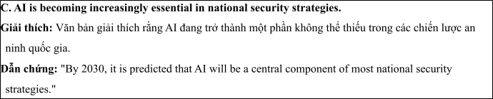
Câu 38. Which of the following best paraphrases the underlined sentence “As AI continues to evolve, it is crucial that governments balance its use in national security with strict regulatory frameworks, transparency, and accountability” in paragraph 4?
1. As AI becomes more advanced, governments must prioritize regulation and transparency in its use for national security.
2. Governments need to focus on increasing the use of AI while ensuring its ethical application in national security.
3. AI should be used freely by governments in national security without much oversight.
4. Strict regulations are unnecessary as AI continues to evolve in the national security sector.
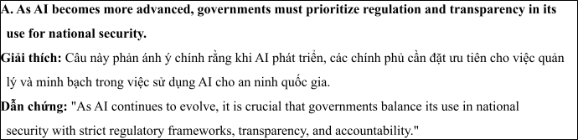
Câu 39. Which of the following can be inferred from the passage?
1. AI's primary application in national security is focused on improving privacy protections.
2. Governments are increasingly concerned with ensuring AI does not harm civil liberties or lead to overreach.
3. The primary role of AI in national security is to replace human soldiers and officers in military operations.
4. There is no significant demand for AI specialists in national security agencies.
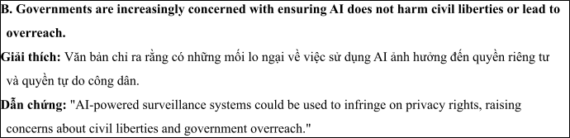
Câu 40. Which of the following best summarizes the passage?
1. AI is transforming national security by enhancing data processing and surveillance capabilities, but raises ethical and privacy concerns that require careful regulation.
2. As AI advances, it will completely replace human personnel in national security roles, improving efficiency without ethical risks.
3. AI's role in national security is only focused on improving military operations and cybersecurity, with minimal concern for civil liberties.
4. The adoption of AI in national security is a simple solution to combat emerging threats without any significant risks or ethical considerations.
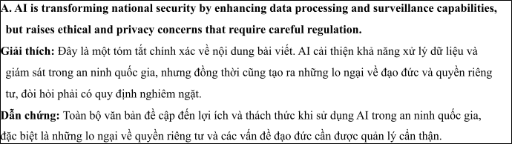

ĐỀ 4 | ĐỀ KIỂM TRA GIỮA HK2 NĂM HỌC 2024-2025  MÔN: TIẾNG ANH LỚP 12
Read the following advertisement and mark the letter A, B, C and D on your answer sheet to indicate the option that best fits each of the numbered blanks from 1 to 6
The Impact of Mass Media on Society and Public Opinion
The world of mass media plays a crucial role in shaping public opinion and influencing society. It includes television, radio, newspapers, and, more recently, (1) ________. With the rapid development of technology, the reach of mass media has expanded globally, connecting people across different continents. In this ever-changing landscape, people need (2) ________ informed to understand current events. Media professionals, (3) ________ their skills, often (4) ______ well in adapting to new trends and technologies. Mass media has become an essential part of daily life, offering information (5) ______ various topics. However, with regard to its influence, some argue that it can distort facts. The way media organizations present (6) _______ also affects the public’s perception of events.
(Adapted from discovery news)
Câu 1: A. social media platforms B. social platforms media
C. platforms social media ` D. media social platforms
Câu 2: A. to staying B. to stay C. stay D. to be stayed
Câu 3: A. which having honed B. had honed C. was having honed D. having honed
Câu 4: A. do B. make C. come D. get
Câu 5: A. from B. on C. for D. at
Câu 6: A. inform B. informatively C. information D. informative
Read the following leaflet and mark the letter A, B, C or D on your answer sheet to indicate the option that best fits each of the numbered blanks from 7 to 12.
The Evolution of Mass Media
• The development of the world of mass media has transformed the way we communicate and consume information. (7) _______ geographic boundaries, mass media has created a global network that connects people across the world.
• The (8) _______ of people today rely on various forms of media, such as television, newspapers, and social media, to stay informed. (9) _________ significant aspect is the rapid growth of digital platforms, which has revolutionized how information is shared and consumed.
• The influence of mass media on public (10) _______ has become undeniable, as it shapes people's perceptions of events. Moreover, the rise of new technologies has (11) _______ significant changes in the media (12) _______, enabling faster communication and greater access to information worldwide.
Câu 7. A. Due to B. Irrespective of C. On account of D. According to
Câu 8. A. majority B. item C. number D. amount
Câu 9. A. Others B. Other C. The others D. Another
Câu 10. A. arguement B. viewpoint C. opinion D. service
Câu 11. A. brought about B. put up C. taken up D. cut off
Câu 12. A. game B. landscape C. technology D. venue
Mark the letter A, B, C or D on your answer sheet to indicate the best arrangement of utterances or sentences to make a meaningful exchange or text in each of the following questions from 13 to 17.
Câu 13
a. Sarah: Hi, Nam! Yes, I have. It's such an exciting field, and there’s always something new happening.
b. Nam: Hi, Sarah! How have you been? I heard you've been working in the media industry.
c. Nam: That sounds amazing! How do you keep up with all the fast changes in the world of mass media?
A. c-a-b B. b-c-a C. c-b-a D. b-a-c
Câu 14
a. Alex: Mass media has become an essential part of our daily lives.
b. Alex: But do you think it always provides accurate and reliable news?
c. Sue: Not always. Sometimes it can be biased or sensationalized to grab attention.
d. Alex: That’s why it’s important to verify information from different sources.
e. Sue: Yes, it's how we get most of our information and stay connected to the world.
A. a-e-b-c-d B. c-e-d-b-a C. d-b-a-e-c D. b-d-e-a-c
Câu 15
Hi Anna,
a. Thanks also for the news site recommendation — it’s way more balanced than the ones I’ve been following.
b. It’s really eye-opening to see how media can change the way we perceive events, but I’ve been busy with personal matters lately, so I haven’t had much time to dive into it.
c. But the points made in the article were really thought-provoking.
d. We should definitely talk more about how media affects news, I’d love to hear your thoughts.
e. Thanks for sending me the article on how mass media shapes news coverage.
Write back soon.
Mark
A. d-b-a-c-e B. e-b-c-a-d C. a-d-b-c-e D. a-c-d-b-e
Câu 16
a. Ultimately, I am passionate about using mass media to revolutionize education and make knowledge available to everyone.
b. For the past year, I have worked with educational organizations to develop online platforms that make learning more accessible through mass media.
c. My fascination with both media and education led me to explore the intersection of these fields for positive change.
d. While there are challenges in ensuring accessibility for all students, the opportunity to improve education through media is incredibly fulfilling.
e. The flexibility of using multimedia content, such as videos and podcasts, to enhance the learning experience is one of the key reasons I enjoy this work.
(Adapted from Bright)
A. c-b-e-d-a B. a-b-c-d-e C. b-c-d-a-e D. c-a-d-b-e
Câu 17
a. However, there are still challenges in ensuring that all students, particularly those in underserved communities, have access to the necessary media tools for their education.
b. The development of mass media has greatly impacted the education system over the past few years.
c. This shift has created opportunities for lifelong learning and has helped bridge the gap between rural and urban education.
d. Additionally, the availability of online resources has led to a growing number of students engaging in self-directed learning, reducing the traditional dependency on formal schooling.
e. Educational TV programs, online courses, and educational apps have revolutionized how students access knowledge, making learning more flexible and accessible.
(Adapted from i-Learn Smart World)
A. c-a-e-b-d B. d-c-a-b-e C. b-e-c-d-a D. d-e-b-c-a
Read the following passage about The Development of Mass Media and Research and mark the letter A, B, C or D on your answer sheet to indicate the option that best fits each of the numbered blanks from 18 to 22.
The development of mass media has significantly shaped modern society, transforming the way we communicate and access information. In the past, newspapers, radio, and television (18) __________. However, with the advent of the internet and digital platforms, the media landscape has evolved dramatically. Today, people (19) __________, a revolution that has connected the world in unprecedented ways. The internet, (20) __________, is now a central platform for both personal expression and global news dissemination. Traditional forms of media, such as printed newspapers, (21) ___________. Many of these platforms are designed to engage audiences through interactive content, such as polls and comment sections. While mass media plays a vital role in informing the public, it is sometimes criticized (22) __________. It is crucial that media literacy is taught in schools to ensure people can differentiate between credible sources and unreliable information. .
(Adapted from friends Global)
Câu 18:
A. were the primary sources of news and entertainment
B. were the primary of news and sources entertainment
C. have been the primary sources of news and entertainment
D. had been the sources of news and primary entertainment
Câu 19:
A. must access news, watch videos, and communicated instantly through social media
B. can access news, watch videos, and communicate instantly through social media
C. should access news, watched videos, and communicating instantly through social media.
D. might access news, watch videos, and communicate instant through social medias.
Câu 20:
A. who was initially a tool of information sharing
B. whom was initial a tool for information sharing
C. which was initially a tool for information sharing
D. whose was initially a tool for information sharing
Câu 21:
A. are often bening replaced by online publications that were updated in real-time
B. had been often replaced by online publications that were updated in real-time
C. were often replaced by online publications that are being updated in real-time
D. are often replaced by online publications that are updated in real-time
Câu 22:
A. for spreading misinformation quickly B. on the spreading misinformation quickly
C. for spreading quickly misinformation D. from quickly spreading misinformation
Read the following passage about development of mass media and mark the letter A, B, C or D on your answer sheet to indicate the best answer to each of the following questions from 23 to 30.
The development of mass media has dramatically transformed the way people communicate, share information, and engage with the world. From the invention of the printing press in the 15th century to the rise of television and, more recently, the internet and social media, the means by which we consume news and entertainment have evolved at an unprecedented rate. Today, traditional forms of mass media such as newspapers, radio, and television still play a significant role, but the digital revolution has shifted the landscape toward online platforms.
Social media, in particular, has become one of the dominant forms of communication, enabling people to connect globally in real-time. Platforms like Facebook, Twitter, and Instagram allow users to share opinions, experiences, and media with vast audiences. The spread of digital media has also had a profound impact on journalism, with citizen journalism becoming increasingly prevalent. People no longer rely solely on professional reporters to provide news; instead, they can report and share stories themselves.
However, the rise of digital media has also raised concerns about misinformation. The speed at which information spreads on social media can result in false or misleading stories being shared rapidly, sometimes causing harm before corrections can be made. Additionally, the dominance of certain large corporations in the media industry has led to concerns about the concentration of media ownership and its impact on diversity and fairness in reporting.
Despite these challenges, mass media continues to evolve. The introduction of new technologies, such as artificial intelligence and virtual reality, promises to further change how we interact with media in the coming years. As the media landscape continues to evolve, it remains to be seen how it will shape public opinion, political discourse, and our understanding of the world.
(Adapted from CNN news)
Câu 23. Which of the following is NOT mentioned as one of the traditional forms of mass media?
A. Newspapers B. Radio C. Television D. Social media
Câu 24. The word "prevalent" in paragraph 2 is OPPOSITE in meaning to:
A. Rare B. Common C. Important D. New
Câu 25. The word "they" in paragraph 2 refers to:
A. Citizens B. Reporters C. people D. Journalists
Câu 26. The word "concerns" in paragraph 3 could be best replaced by:
A. Questions B. Problems C. Benefits D. Ideas
Câu 27. Which of the following best paraphrases the underlined sentence "The rise of digital media has also raised concerns about misinformation" in paragraph 3?
A. The increase in digital media has helped spread more accurate information.
B. Digital media has contributed to the spread of false information.
C. There are no concerns about misinformation with the rise of digital media.
D. Digital media has stopped the spread of fake news.
Câu 28. Which of the following is TRUE according to the passage?
A. The internet has fully replaced traditional forms of mass media.
B. Social media allows people to share their opinions with global audiences.
C. The development of new technologies will have no effect on mass media.
D. Misinformation is not a problem associated with social media.
Câu 29. In which paragraph does the writer mention a future prediction about mass media?
A. Paragraph 1 B. Paragraph 2 C. Paragraph 3 D. Paragraph 4
Câu 30. In which paragraph does the writer discuss the negative effects of mass media?
A. Paragraph 1 B. Paragraph 2 C. Paragraph 3 D. Paragraph 4
Read the following passage about The Development of Mass Media and mark the letter A, B, C or D on your answer sheet to indicate the best answer to each of the following questions from 31 to 40.
[I] The growth of mass media in recent decades has been one of the most transformative phenomena in global communication. From traditional print media to digital platforms, the evolution of mass media has reshaped how people receive and share information. [II] Today, mass media encompasses various forms, including newspapers, radio, television, and, increasingly, online platforms such as social media and streaming services. By 2030, experts predict that digital media will dominate, overtaking traditional media in terms of global consumption. [III] Several factors have driven this rapid growth, but the consequences, both positive and negative, are still unfolding. [IV]
One key factor behind the growth of mass media is technological advancement. Innovations such as the internet and smartphones have allowed people to access information instantly, anywhere, and anytime. This has made digital media more accessible and appealing, especially to younger audiences. Additionally, the increasing use of social media platforms has provided a space for individuals to participate in content creation, leading to a democratization of information. On the other hand, traditional media, such as print newspapers and broadcast television, have struggled to maintain their audience base.
However, the rise of mass media has also brought challenges. One significant issue is the spread of misinformation. With the ease of sharing content online, false or misleading information can quickly go viral, leading to widespread confusion. Another concern is the growing concentration of media ownership, where a few large corporations control a substantial portion of the media landscape. This can limit the diversity of viewpoints and result in biased reporting.
In conclusion, while mass media has revolutionized the way we communicate and access information, it has also created challenges that require careful management to ensure its positive impact on society.
(Adapted from daily news)
Câu 31. Where in paragraph I does the following sentence best fit?
The evolution of mass media has radically transformed how information is shared across the globe.
A. [I] B. [II] C. [III] D. [IV]
Câu 32. The phrase "has reshaped" in paragraph 1 could best be replaced by ____
A. has improved B. has altered C. has ignored D. has prevented
Câu 33. The word "democratization" in paragraph 2 refers to ____
A. the restriction of information
B. the increased accessibility to information for everyone
C. the consolidation of media ownership
D. the decline of traditional media
Câu 34. According to paragraph 2, which of the following is NOT a factor contributing to the rise of mass media?
A. The growth of digital platforms
B. The decline of traditional media
C. The invention of the internet
D. The increase in media monopolies
Câu 35. Which of the following best summarises paragraph 3?
A. The rise of mass media has made it easier for people to access information but has also led to the spread of misinformation and media monopolies.
B. Misinformation and concentration of media ownership are the only challenges posed by the development of mass media.
C. Technological advancements in mass media have only positive effects on society.
D. Social media platforms are the main cause of misinformation in modern media.
Câu 36. The word "concentration" in paragraph 3 is OPPOSITE in meaning to
A. distribution B. expansion C. decentralization D. centralization
Câu 37. Which of the following is TRUE according to the passage?
A. The growth of mass media is only due to technological advancements.
B. Digital platforms are becoming the dominant form of mass media, surpassing traditional media.
C. Media ownership is becoming more fragmented, with many companies controlling media outlets.
D. Misinformation is not a significant issue in the current media landscape.
Câu 38. Which of the following best paraphrases the underlined sentence in paragraph 4: Mass media has revolutionized the way we communicate and access information, but it has also created challenges that require careful management.
A. The changes brought by mass media are mostly positive and require no further management.
B. While mass media has made communication easier, it also creates challenges that need to be addressed.
C. The growth of mass media has been entirely beneficial for society.
D. Managing the rise of mass media is not necessary because its impacts are all positive.
Câu 39. Which of the following can be inferred from the passage?
A. The rise of mass media is solely driven by the spread of social media.
B. Misinformation is a growing problem due to the speed at which content spreads online.
C. The concentration of media ownership has led to a more diverse range of viewpoints.
D. The impact of mass media has had no effect on traditional forms of media like print newspapers.
Câu 40. Which of the following best summarises the passage?
A. The rapid growth of mass media, driven by technological innovations and shifts in consumer behavior, has transformed communication but also created challenges such as misinformation and media monopolies.
B. Mass media has democratized access to information and made it more accessible, but its growth has led to fewer options for media consumers.
C. The decline of traditional media and the rise of digital platforms have resulted in significant changes to global communication and the spread of misinformation.
D. Media monopolies and misinformation are the main issues caused by the development of mass media, requiring new forms of regulation.

ĐÁP ÁN VÀ LỜI GIẢI

Read the following advertisement and mark the letter A, B, C and D on your answer sheet to indicate the option that best fits each of the numbered blanks from 1 to 6

The Impact of Mass Media on Society and Public Opinion
The world of mass media plays a crucial role in shaping public opinion and influencing society. It includes television, radio, newspapers, and, more recently, (1) . With the rapid development of tecnology, the reach of mass media has expanded globally, connecting people across different continents. In this ever- changing landscape, people need (2) informed to understand current events. Media professionals,
(3) their skills, often (4) well in adapting to new trends and technologies. Mass media has become an essential part of daily life, offering information (5) various topics. However, with regard to its influence, some argue that it can distort facts. The way media organizations present (6) also affects the public’s perception of events.
(Adapted from discovery news)
Câu 1: A. social media platforms B. social platforms media
C. platforms social media ` D. media social platforms
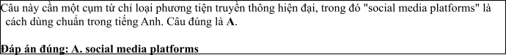
Câu 2: A. to staying B. to stay C. stay D. to be stayed
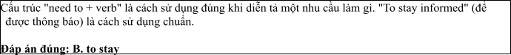
Câu 3: A. which having honed B. had honed C. was having honed D. having honed
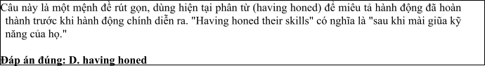
Câu 4: A. do B. make C. come D. get
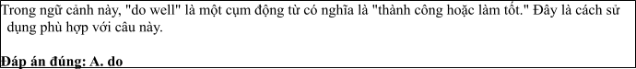
Câu 5: A. from B. on C. for D. at
Câu 6: A. inform B. informatively C. information D. informative
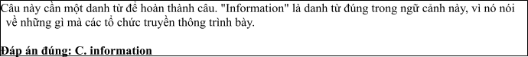
Read the following leaflet and mark the letter A, B, C or D on your answer sheet to indicate the option that best fits each of the numbered blanks from 7 to 12.

The Evolution of Mass Media
• The development of the world of mass media has transformed the way we communicate and consume information. (7) geographic boundaries, mass media has created a global network that connects people across the world.
• The (8) of people today rely on various forms of media, such as television, newspapers, and social media, to stay informed. (9) significant aspect is the rapid growth of digital platforms, which has revolutionized how information is shared and consumed.
• The influence of mass media on public (10) has become undeniable, as it shapes people's perceptions of events. Moreover, the rise of new technologies has (11) significant changes in the media (12) , enabling faster communication and greater access to information worldwide.
Câu 7. A. Due to B. Irrespective of C. On account of D. According to
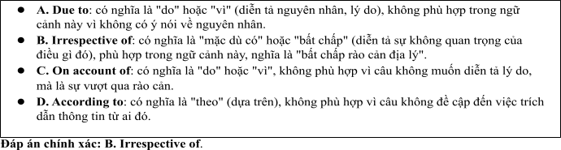
Câu 8. A. majority B. item C. number D. amount
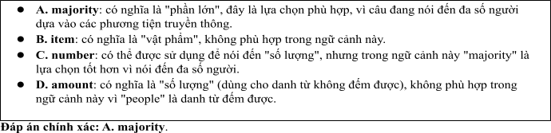
Câu 9. A. Others B. Other C. The others D. Another
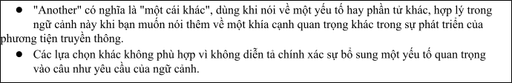
Câu 10. A. arguement B. viewpoint C. opinion D. service
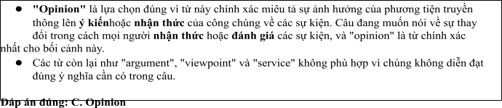
Câu 11. A. brought about B. put up C. taken up D. cut off
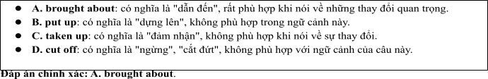
Câu 12. A. game B. landscape C. technology D. venue
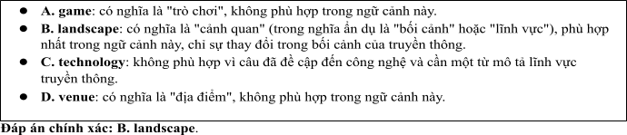
Mark the letter A, B, C or D on your answer sheet to indicate the best arrangement of utterances or sentences to make a meaningful exchange or text in each of thefollowing questions from 13 to 17.

Câu 13
1. Sarah: Hi, Nam! Yes, I have. It's such an exciting field, and there’s always something new happening.
2. Nam: Hi, Sarah! How have you been? I heard you've been working in the media industry.
3. Nam: That sounds amazing! How do you keep up with all the fast changes in the world of mass media?
A. c-a-b B. b-c-a C. c-b-a D. b-a-c
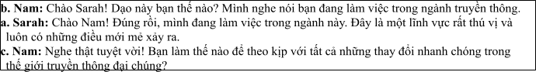

Câu 14
1. Alex: Mass media has become an essential part of our daily lives.
2. Alex: But do you think it always provides accurate and reliable news?
3. Sue: Not always. Sometimes it can be biased or sensationalized to grab attention.
4. Alex: That’s why it’s important to verify information from different sources.
5. Sue: Yes, it's how we get most of our information and stay connected to the world.
A. a-e-b-c-d B. c-e-d-b-a C. d-b-a-e-c D. b-d-e-a-c
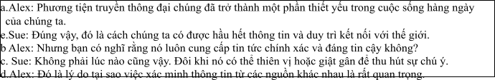

Câu 15
Hi Anna,
1. Thanks also for the news site recommendation — it’s way more balanced than the ones I’ve been
following.
2. It’s really eye-opening to see how media can change the way we perceive events, but I’ve been busy with personal matters lately, so I haven’t had much time to dive into it.
3. But the points made in the article were really thought-provoking.
4. We should definitely talk more about how media affects news, I’d love to hear your thoughts.
5. Thanks for sending me the article on how mass media shapes news coverage. Write back soon.
Mark
A. d-b-a-c-e B. e-b-c-a-d C. a-d-b-c-e D. a-c-d-b-e
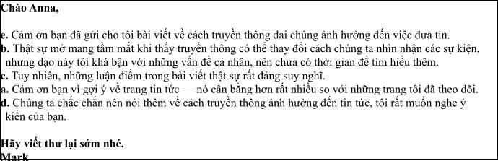

Câu 16
1. Ultimately, I am passionate about using mass media to revolutionize education and make knowledge available to everyone.
2. For the past year, I have worked with educational organizations to develop online platforms that make learning more accessible through mass media.
3. My fascination with both media and education led me to explore the intersection of these fields for positive change.
4. While there are challenges in ensuring accessibility for all students, the opportunity to improve education through media is incredibly fulfilling.
5. The flexibility of using multimedia content, such as videos and podcasts, to enhance the learning experience is one of the key reasons I enjoy this work.
(Adapted from Bright)
A. c-b-e-d-a B. a-b-c-d-e C. b-c-d-a-e D. c-a-d-b-e
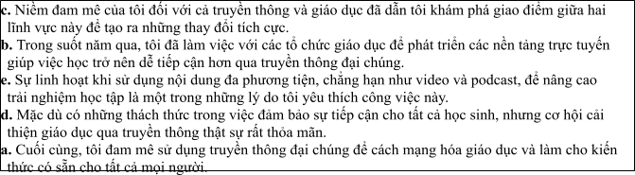

Câu 17
1. However, there are still challenges in ensuring that all students, particularly those in underserved communities, have access to the necessary media tools for their education.
2. The development of mass media has greatly impacted the education system over the past few years.
3. This shift has created opportunities for lifelong learning and has helped bridge the gap between rural and urban education.
4. Additionally, the availability of online resources has led to a growing number of students engaging in self-directed learning, reducing the traditional dependency on formal schooling.
5. Educational TV programs, online courses, and educational apps have revolutionized how students access knowledge, making learning more flexible and accessible.
(Adapted from i-Learn Smart World)
A. c-a-e-b-d B. d-c-a-b-e C. b-e-c-d-a D. d-e-b-c-a
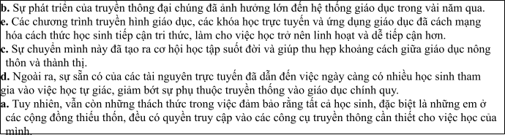
Read thefollowing passage about The Development of Mass Media and Research and mark the letter A, B, C or D on your answer sheet to indicate the option that bestfits each of the numbered blanksfrom 18 to 22.
The development of mass media has significantly shaped modern society, transforming the way we communicate and access information. In the past, newspapers, radio, and television (18) . However, with the advent of the internet and digital platforms, the media landscape has evolved dramatically. Today, people (19) , a revolution that has connected the world in unprecedented ways. The internet, (20) , is now a central platform for both personal expression and global news dissemination. Traditional forms of media, such as printed newspapers, (21) . Many of these platforms are designed to engage audiences through interactive content, such as polls and comment sections. While mass media plays a vital role in informing the public, it is sometimes criticized (22) . It is crucial that media literacy is taught in schools to ensure people can differentiate between credible sources and unreliable information. .
(Adapted from friends Global)
Câu 18:
1. were the primary sources of news and entertainment
2. were the primary of news and sources entertainment
3. have been the primary sources of news and entertainment
4. had been the sources of news and primary entertainment
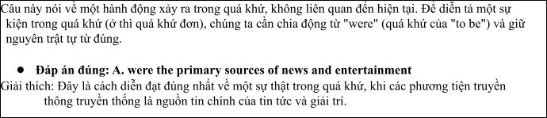

Câu 19:
1. must access news, watch videos, and communicated instantly through social media
2. can access news, watch videos, and communicate instantly through social media
3. should access news, watched videos, and communicating instantly through social media.
4. might access news, watch videos, and communicate instant through social medias.
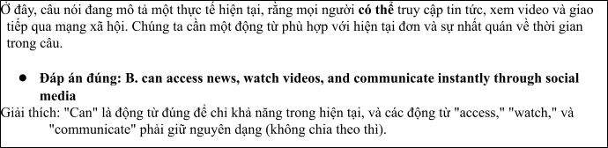

Câu 20:
1. who was initially a tool of information sharing
2. whom was initial a tool for information sharing
3. which was initially a tool for information sharing
4. whose was initially a tool for information sharing
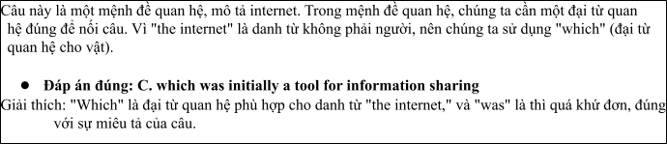

Câu 21:
1. are often bening replaced by online publications that were updated in real-time
2. had been often replaced by online publications that were updated in real-time
3. were often replaced by online publications that are being updated in real-time
4. are often replaced by online publications that are updated in real-time
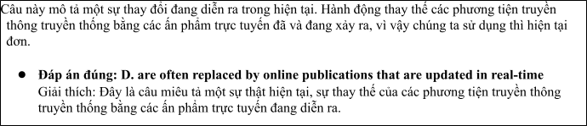

Câu 22:
A. for spreading misinformation quickly B. on the spreading misinformation quickly
C. for spreading quickly misinformation D. from quickly spreading misinformation
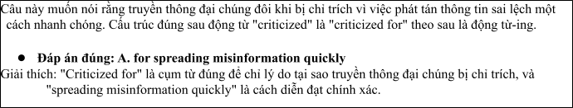
Read the following passage about development of mass media and mark the letter A, B, C or D on your answer sheet to indicate the best answer to each of the following questionsfrom 23 to 30.
The development of mass media has dramatically transformed the way people communicate, share information, and engage with the world. From the invention of the printing press in the 15th century to the rise of television and, more recently, the internet and social media, the means by which we consume news and entertainment have evolved at an unprecedented rate. Today, traditional forms of mass media such as newspapers, radio, and television still play a significant role, but the digital revolution has shifted the landscape toward online platforms.
Social media, in particular, has become one of the dominant forms of communication, enabling people to connect globally in real-time. Platforms like Facebook, Twitter, and Instagram allow users to share opinions, experiences, and media with vast audiences. The spread of digital media has also had a profound impact on journalism, with citizen journalism becoming increasingly prevalent. People no longer rely solely on professional reporters to provide news; instead, they can report and share stories themselves.
However, the rise of digital media has also raised concerns about misinformation. The speed at which information spreads on social media can result in false or misleading stories being shared rapidly, sometimes causing harm before corrections can be made. Additionally, the dominance of certain large corporations in the media industry has led to concerns about the concentration of media ownership and its impact on diversity and fairness in reporting.
Despite these challenges, mass media continues to evolve. The introduction of new technologies, such as artificial intelligence and virtual reality, promises to further change how we interact with media in the coming years. As the media landscape continues to evolve, it remains to be seen how it will shape public opinion, political discourse, and our understanding of the world.
(Adapted from CNN news)
Câu 23. Which of the following is NOT mentioned as one of the traditional forms of mass media?
A. Newspapers B. Radio C. Television D. Social media
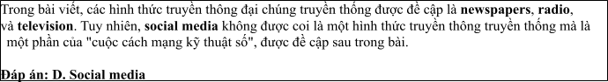
Câu 24. The word "prevalent" in paragraph 2 is OPPOSITE in meaning to:
A. Rare B. Common C. Important D. New
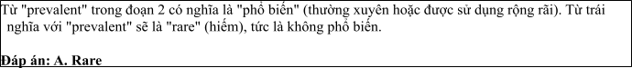
Câu 25. The word "they" in paragraph 2 refers to:
A. Citizens B. Reporters C. people D. Journalists
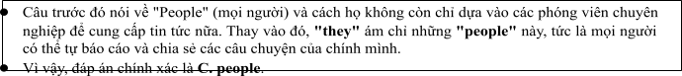
Câu 26. The word "concerns" in paragraph 3 could be best replaced by:
A. Questions B. Problems C. Benefits D. Ideas
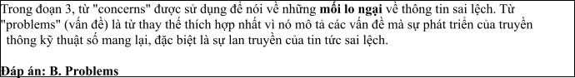
Câu 27. Which of the following best paraphrases the underlined sentence "The rise of digital media has also raised concerns about misinformation" in paragraph 3?
1. The increase in digital media has helped spread more accurate information.
2. Digital media has contributed to the spread of false information.
3. There are no concerns about misinformation with the rise of digital media.
4. Digital media has stopped the spread of fake news.
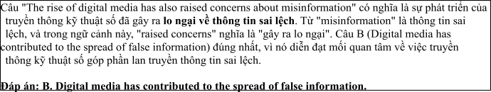
Câu 28. Which of the following is TRUE according to the passage?
1. The internet has fully replaced traditional forms of mass media.
2. Social media allows people to share their opinions with global audiences.
3. The development of new technologies will have no effect on mass media.
4. Misinformation is not a problem associated with social media.
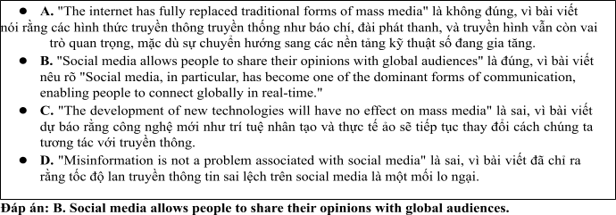
Câu 29. In which paragraph does the writer mention a future prediction about mass media?
A. Paragraph 1 B. Paragraph 2 C. Paragraph 3 D. Paragraph 4
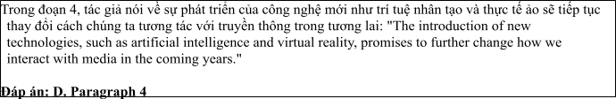
Câu 30. In which paragraph does the writer discuss the negative effects of mass media?
A. Paragraph 1 B. Paragraph 2 C. Paragraph 3 D. Paragraph 4
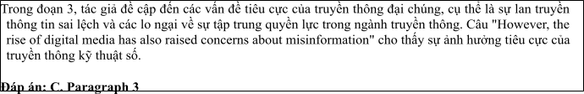
Read the following passage about The Development of Mass Media and mark the letter A, B, C or D on your answer sheet to indicate the best answer to each of the following questions from 31 to 40.
[I] The growth of mass media in recent decades has been one of the most transformative phenomena in global communication. From traditional print media to digital platforms, the evolution of mass media has reshaped how people receive and share information. [II] Today, mass media encompasses various forms, including newspapers, radio, television, and, increasingly, online platforms such as social media and streaming services. By 2030, experts predict that digital media will dominate, overtaking traditional media in terms of global consumption. [III] Several factors have driven this rapid growth, but the consequences, both positive and negative, are still unfolding. [IV]
One key factor behind the growth of mass media is technological advancement. Innovations such as the internet and smartphones have allowed people to access information instantly, anywhere, and anytime. This has made digital media more accessible and appealing, especially to younger audiences. Additionally, the increasing use of social media platforms has provided a space for individuals to participate in content creation, leading to a democratization of information. On the other hand, traditional media, such as print newspapers and broadcast television, have struggled to maintain their audience base.
However, the rise of mass media has also brought challenges. One significant issue is the spread of misinformation. With the ease of sharing content online, false or misleading information can quickly go viral, leading to widespread confusion. Another concern is the growing concentration of media ownership, where a few large corporations control a substantial portion of the media landscape. This can limit the diversity of viewpoints and result in biased reporting.
In conclusion, while mass media has revolutionized the way we communicate and access information, it has also created challenges that require careful management to ensure its positive impact on society.
(Adapted from daily news) Câu 31. Where in paragraph I does the following sentence best fit?

The evolution of mass media has radically transformed how information is shared across the globe.
A. [I] B. [II] C. [III] D. [IV]
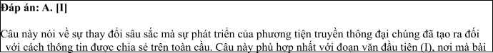
Câu 32. The phrase "has reshaped" in paragraph 1 could best be replaced by
A. has improved B. has altered C. has ignored D. has prevented
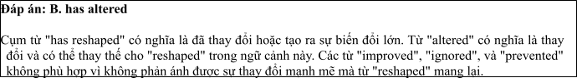
Câu 33. The word "democratization" in paragraph 2 refers to
1. the restriction of information
2. the increased accessibility to information for everyone
3. the consolidation of media ownership
4. the decline of traditional media
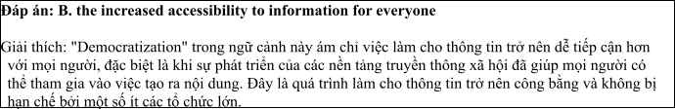
Câu 34. According to paragraph 2, which of the following is NOT a factor contributing to the rise of mass media?
1. The growth of digital platforms
2. The decline of traditional media
3. The invention of the internet
4. The increase in media monopolies
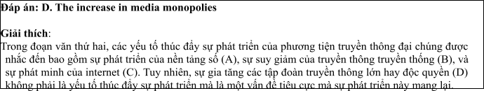
Câu 35. Which of the following best summarises paragraph 3?
1. The rise of mass media has made it easier for people to access information but has also led to the spread of misinformation and media monopolies.
2. Misinformation and concentration of media ownership are the only challenges posed by the development of mass media.
3. Technological advancements in mass media have only positive effects on society.
4. Social media platforms are the main cause of misinformation in modern media.
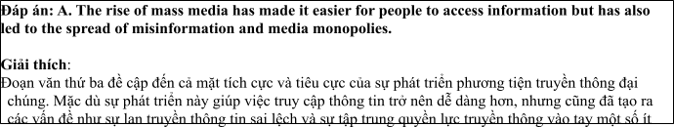
Câu 36. The word "concentration" in paragraph 3 is OPPOSITE in meaning to
A. distribution B. expansion C. decentralization D. centralization
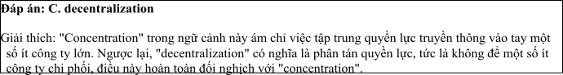
Câu 37. Which of the following is TRUE according to the passage?
1. The growth of mass media is only due to technological advancements.
2. Digital platforms are becoming the dominant form of mass media, surpassing traditional media.
3. Media ownership is becoming more fragmented, with many companies controlling media outlets.
4. Misinformation is not a significant issue in the current media landscape.
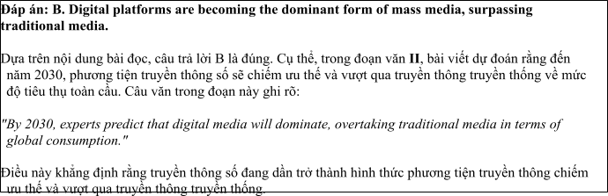
Câu 38. Which of the following best paraphrases the underlined sentence in paragraph 4: Mass media has revolutionized the way we communicate and access information, but it has also created challenges that require careful management.
1. The changes brought by mass media are mostly positive and require no further management.
2. While mass media has made communication easier, it also creates challenges that need to be addressed.
3. The growth of mass media has been entirely beneficial for society.
4. Managing the rise of mass media is not necessary because its impacts are all positive.
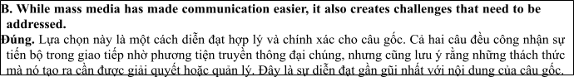
Câu 39. Which of the following can be inferred from the passage?
1. The rise of mass media is solely driven by the spread of social media.
2. Misinformation is a growing problem due to the speed at which content spreads online.
3. The concentration of media ownership has led to a more diverse range of viewpoints.
4. The impact of mass media has had no effect on traditional forms of media like print newspapers.
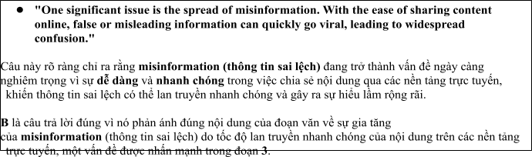
Câu 40. Which of the following best summarises the passage?
1. The rapid growth of mass media, driven by technological innovations and shifts in consumer behavior, has transformed communication but also created challenges such as misinformation and media monopolies.
2. Mass media has democratized access to information and made it more accessible, but its growth has led to fewer options for media consumers.
3. The decline of traditional media and the rise of digital platforms have resulted in significant changes to global communication and the spread of misinformation.
4. Media monopolies and misinformation are the main issues caused by the development of mass media, requiring new forms of regulation.
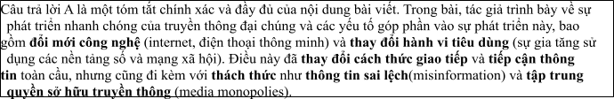

ĐỀ 5 | ĐỀ KIỂM TRA GIỮA HK2 NĂM HỌC 2024-2025  MÔN: TIẾNG ANH LỚP 12
Read the following advertisement and mark the letter A, B, C and D on your answer sheet to indicate the option that best fits each of the numbered blanks from 1 to 6
The Evolution of Mass Media
The development of mass media has drastically transformed how people access information. With the rise of digital platforms, including (1) _______ media and streaming services, traditional forms like print newspapers and television have struggled to keep up. (2) _______ to reach vast audiences, mass media now plays (3) ________ in shaping public opinion and culture. People have learned (4) ______ various digital tools effectively, gaining instant access to news and entertainment. In relation to this shift, new technologies have made it easier to connect (5) ______ others globally. As society continues to embrace digital media, we can observe how mass media is (6) _______ progress in influencing global communication.
(Adapted from discovery news)
Câu 1: A. social B. socialize C. society D. sociable
Câu 2: A. Which designed B. Designing C. Was designed D. Designed
Câu 3: A. a critical role B. critical a role
C. a role critical ` D. role a critical
Câu 4: A. to using B. to use C. use D. to be using
Câu 5: A. to B. on C. with D. at
Câu 6: A. doing B. making C. coming D. catching
Read the following leaflet and mark the letter A, B, C or D on your answer sheet to indicate the option that best fits each of the numbered blanks from 7 to 12.
The Mass Media
• The development of mass media has revolutionized the way we communicate and consume information. (7) ________ technological advancements, digital platforms such as social media and streaming services have become dominant forces in the media landscape.
• The (8) _______ of online content creators has surged in recent years, reflecting a shift towards user-generated content. (9) ______ forms of traditional media, like newspapers and television, have struggled to maintain relevance in this digital (10) _______.
• The impact of mass media on public (11) _______ and culture is profound, shaping how societies perceive various issues. To understand this, researchers (12) ______ studies to analyze the effects of media on behavior. Overall, mass media plays a central role in the dissemination of information globally.
Câu 7. A. Due to B. Thanks to C. On account of D. According to
Câu 8. A. majority B. item C. number D. amount
Câu 9. A. Others B. Other C. The others D. Another
Câu 10. A. age B. moment C.number D. service
Câu 11. A. connection B. relation C. behaviour D. opinion
Câu 12. A. carry out B. put off C. go up D. stand out
Mark the letter A, B, C or D on your answer sheet to indicate the best arrangement of utterances or sentences to make a meaningful exchange or text in each of the following questions from 13 to 17.
Câu 13
a. Nam: Hi, Mark! It's been ages since we last met. You seem to be doing great!
b. Nam: Yes, I have. I keep up with current events every day and try to stay informed through different platforms.
c. Mark: Hi, Nam! Thanks! You look fantastic too. Have you been following the latest news on social media lately?
A. a-c-b B. b-c-a C. c-b-a D. b-a-c
Câu 14
a. Sue: I follow several social media accounts that post updates every day.
b. Sue: It's faster and more interactive. I can comment and share my opinions easily.
c. Alex: How do you usually keep up with the news?
d. Alex: I think social media can spread misinformation. I prefer reading newspapers to stay informed.
e. Alex: Why do you prefer social media for news?
A. a-e-b-c-d B. c-e-d-b-a C. d-b-a-e-c D. c-a-e-b-d
Câu 15
Hi Anna,
a. Sarah: Yes, I have! It seems like everyone is talking about it these days.
b. Sarah: I totally understand. I’ve read a lot of negative stories about data breaches on social media.
c. John: Hi, Sarah! Have you heard the latest news about the new social media platform?
d. John: Yeah, it’s tough to know which platforms are really safe. What do you think?
e. John: I know! I’ve been thinking about joining, but I’m worried about privacy concerns.
Write back soon.
Mark
A. d-b-a-c-e B. c-a-e-b-d C. a-d-b-c-e D. a-c-d-b-e
Câu 16
a. It’s amazing how quickly information spreads online. Sometimes, it’s hard to tell what’s true.
b. That’s a big issue with the mass media today—misinformation can spread just as fast as accurate news.
c. Yes, I agree. Social media platforms like Facebook and Twitter have become the primary sources of news for many people.
d. I think we need more media literacy programs to help people navigate this problem.
e. The rise of digital media has completely changed how we consume information.
(Adapted from Bright)
A. e-c-a-b-d B. a-b-c-d-e C. b-c-d-a-e D. c-a-d-b-e
Câu 17
a. Streaming services like Netflix and Hulu have made traditional cable TV less appealing. People prefer on-demand content.
b. How has the rise of streaming services changed the traditional television industry?
c. But do you think this will affect how we consume news and current events?
d. Yes, more people may turn to streaming platforms for news shows, which could change how news is delivered in the future.
e. That’s true. It’s more convenient to watch what you want, when you want, rather than waiting for a specific time slot.
(Adapted from i-Learn Smart World)
A. c-a-e-b-d B. d-c-a-b-e C. b-a-e-c-d D. d-e-b-c-a
Read thefollowing passage about The Development of Mass Media and Research and mark the letter A, B, C or D on your answer sheet to indicate the option that best fits each of the numbered blanks from 18 to 22.
In recent years, social media has experienced tremendous growth, transforming the way we communicate, share information, and connect with others. Platforms like Facebook, Instagram, Twitter, and TikTok have become integral parts of daily life. So far, (18) _________ to stay informed, interact with friends, and even promote businesses. Many of these platforms provide features (19) ________ making it easier than ever to share experiences in real time. (20) ________ for networking and learning, it has also brought challenges, such as the spread of misinformation and the negative impact on mental health. For example, some influencers have faced criticism (21) _________. Social media platforms continue to evolve, (22) _________ to keep users engaged, encouraging them to spend more time on these apps.
(Adapted from friends Global)
Câu 18:
A. Social media has been used by billions of people worldwide
B. Social media was used by billions of people worldwide
C. Social media is used by billions of people worldwide
D. Social media was being used by billions of people worldwide
Câu 19:
A. which allows users to post photos, videos, and even broadcasts live,
B. which allow users to post photos, videos, and even live broadcasts,
C. who allow users to posting photos, videos, and even live broadcasts,
D. whose allowed users to post photos, videos, and even broadcasts live,
Câu 20:
A. However social media has been provided incredible opportunities
B. Because social media will have provided incredible opportunities
C. Although social media has provided incredible opportunities
D. Since social media has been provided incredible opportunities
Câu 21:
A. on promoted unrealistic beauty standardize or misleading advertisements
B. for promoting unrealistically beauty standards or misled advertisements
C. on promoting unrealistic beautifully standards or misleading advertisements
D. for promoting unrealistic beauty standards or misleading advertisements
Câu 22:
A. constantly introducing new tools like Stories and Reels
B. constant introducing new tools as Stories and Reels
C. constantly introducing new tools like Stories or Reels
D. constantly introduced new tools neither Stories nor Reels
Read the following passage about development of communication and mark the letter A, B, C or D on your answer sheet to indicate the best answer to each of the following questions from 23 to 30.
Communication has undergone significant changes over the years, especially with the advent of new technologies. In ancient times, humans communicated primarily through oral traditions and written symbols, like cave paintings or early scripts. However, these methods were often limited to local areas. The invention of the printing press by Johannes Gutenberg in the 15th century marked the beginning of mass communication, allowing books and newspapers to be widely distributed and giving people access to new ideas.
In the 20th century, the development of radio and television brought communication to a global audience. For the first time, people could receive information from all over the world without leaving their homes. Radio, initially used for news broadcasts and entertainment, became an important tool for education, while television added a visual element, making it more engaging. These technologies revolutionized how people shared and consumed information.
In the 21st century, the rise of the internet has completely transformed communication once again. The internet has made it easier for people to connect with one another regardless of their location. Social media platforms, email, and instant messaging have revolutionized both personal and professional communication. The internet has also opened up new possibilities for education, allowing people to learn from online resources and virtual classrooms.
However, the rapid growth of digital communication has brought with it several challenges. One of the major concerns is the spread of misinformation and fake news. With the ability to instantly share information with millions of people, it has become easier for inaccurate or misleading content to spread quickly. Additionally, not everyone has equal access to the internet, creating a digital divide between those who have access to the latest technologies and those who do not. Efforts are being made to address these issues, but the challenges remain significant.
(Adapted from daily news)
Câu 23. Which of the following is NOT mentioned as a development in communication?
A. The invention of the printing press B. The rise of social media platforms
C. The use of cave paintings D. The development of radio and television
Câu 24. The word “revolutionized” in paragraph 2 is OPPOSITE in meaning to:
A. Simplified B. Stabilized C. Interrupted D. Neglected
Câu 25. The word “their” in paragraph 3 refers to:
A. Radio and television’s B. people’
C. Technologies’ D. News broadcasts’
Câu 26. The word “divide” in paragraph 4 could be best replaced by:
A. Connection B. Gap C. Solution D. Bridge
Câu 27. Which of the following best paraphrases the underlined sentence “Efforts are being made to address these issues” in paragraph 4?
A. People are struggling to solve these problems.
B. There is no way to solve these issues.
C. Solutions are being developed to tackle these problems.
D. Efforts to resolve these issues have failed.
Câu 28. Which of the following is TRUE according to the passage?
A. Television was the first global communication tool.
B. The internet has made communication faster and more accessible.
C. People are no longer concerned with misinformation.
D. Communication in ancient times was limited to face-to-face interactions.
Câu 29. In which paragraph does the writer mention a past causal relationship?
A. Paragraph 1 B. Paragraph 2 C. Paragraph 3 D. Paragraph 4
Câu 30. In which paragraph does the writer explore modern methods for maintaining communication?
A. Paragraph 1 B. Paragraph 2 C. Paragraph 3 D. Paragraph 4
Read the following passage about the Development of Multinational Media and mark the letter A, B, C or D on your answer sheet to indicate the best answer to each of the following questions from 31 to 40.
In recent years, the rise of multinational media companies has had a significant impact on global communication. [I] With advances in technology and the growth of the internet, media organizations have expanded beyond national borders, reaching audiences worldwide. [II] By 2050, experts predict that a majority of media content will be produced by a few large global corporations, allowing them to shape cultural trends, public opinion, and political discourse. [III] There are several factors that have contributed to the rise of multinational media corporations, which also pose various challenges. [IV]
The main push factors behind the growth of multinational media include the increasing demand for diverse content, the growth of international markets, and advancements in technology. As populations become more interconnected, people demand media that reflects their varied cultures and interests, which can be met by global media companies. Moreover, these corporations can tap into emerging markets in developing countries, creating new revenue streams. The internet and digital platforms have further facilitated the expansion of multinational media by breaking down geographical barriers and allowing content to reach a global audience instantly.
However, this globalisation of media comes with both positive and negative consequences. On the one hand, multinational media companies provide access to information and entertainment from around the world, helping to promote cultural exchange. On the other hand, the concentration of media ownership raises concerns about media diversity and the potential for these companies to dominate public discourse. Additionally, the expansion of multinational media often leads to the overshadowing of local media outlets, which may struggle to compete with the financial resources and global reach of their multinational counterparts.
To ensure that multinational media development is beneficial, it is essential to carefully regulate the industry and promote a balanced flow of information that respects both global and local interests.
Câu 31: Where in paragraph I does the following sentence best fit?
The rise of multinational media has expanded communication on a global scale.
A. [I] B. [II] C. [III] D. [IV]
Câu 32: The phrase "poses various challenges" in paragraph 1 could be best replaced by ____.
A. brings about benefits B. creates difficulties
C. stimulates growth D. fosters competition
Câu 33: The word "which" in paragraph 2 refers to ____
A. education B. entertainment C. radio D. media
Câu 34: According to paragraph 3, which of the following is NOT a negative consequence of multinational media?
A. domination of public discourse B. overshadowing local media outlets
C. cultural exchange D. concentration of media ownership
Câu 35: Which of the following best summarises paragraph 3?
A. Multinational media has positive effects on global communication but raises concerns about media diversity.
B. The expansion of multinational media companies promotes cultural exchange but reduces local media coverage.
C. While multinational media provides information, it also leads to greater competition and regulation.
D. Multinational media has financial resources that help it dominate the global market.
Câu 36: The word "overshadowing" in paragraph 3 is OPPOSITE in meaning to
A. dominating B. diminishing C. highlighting D. supporting
Câu 37: Which of the following is TRUE according to the passage?
A. Multinational media companies are increasing access to global information.
B. All countries have benefited equally from the growth of multinational media.
C. The growth of multinational media has led to a decrease in global communication.
D. Local media outlets have successfully competed with multinational companies.
Câu 38: Which of the following best paraphrases the underlined sentence: “To ensure that multinational media development is beneficial, it is essential to carefully regulate the industry” in paragraph 4?
A. Regulating the multinational media industry will ensure that its development is harmful.
B. Multinational media should be left unregulated to allow for its natural development.
C. Carefully regulating multinational media is necessary for positive development.
D. It is unnecessary to regulate the multinational media industry as it will develop naturally.
Câu 39: Which of the following can be inferred from the passage?
A. The dominance of multinational media companies benefits developing countries the most.
B. Local media outlets are often unable to compete with the global reach of multinational corporations.
C. Technology advancements have led to a decline in the need for global media companies.
D. Multinational media companies struggle to enter emerging markets.
Câu 40: Which of the following best summarises the passage?
A. The rise of multinational media is reshaping global communication but requires careful regulation to avoid negative impacts on local media and diversity.
B. Multinational media has transformed global communication, making it easier to access diverse content while reducing local competition.
C. As multinational media companies grow, they create cultural exchange and new markets, though they also raise concerns about media concentration.
D. The rise of multinational media is beneficial for developing countries, but it comes at the cost of local media outlets.

ĐÁP ÁN VÀ LỜI GIẢI

Read the following advertisement and mark the letter A, B, C and D on your answer sheet to indicate the option that best fits each of the numbered blanks from 1 to 6

The Evolution of Mass Media
The development of mass media has drastically transformed how people access information. With the rise of digital platforms, including (1) media and streaming services, traditional forms like print newspapers and television have struggled to keep up. (2) to reach vast audiences, mass media now plays (3) in shaping public opinion and culture. People have learned (4) various digital tools effectively, gaining instant access to news and entertainment. In relation to this shift, new technologies have made it easier to connect (5) others globally. As society continues to embrace digital media, we can observe how mass media is (6) progress in influencing global communication.
(Adapted from discovery news)
Câu 1: A. social B. socialize C. society D. sociable
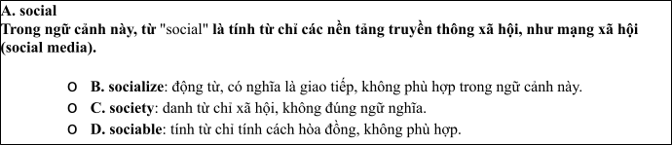
Câu 2: A. Which designed B. Designing C. Was designed D. Designed
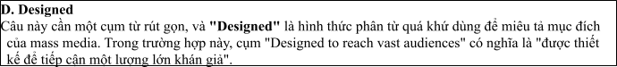
Câu 3: A. a critical role B. critical a role
C. a role critical ` D. role a critical
Câu 4: A. to using B. to use C. use D. to be using
Câu 5: A. to B. on C. with D. at
Câu 6: A. doing B. making C. coming D. catching
Read the following leaflet and mark the letter A, B, C or D on your answer sheet to indicate the option that best fits each of the numbered blanks from 7 to 12.
The Mass Media
• The development of mass media has revolutionized the way we communicate and consume information. (7) technological advancements, digital platforms such as social media and streaming services have become dominant forces in the media landscape.
• The (8) of online content creators has surged in recent years, reflecting a shift towards user- generated content. (9) forms of traditional media, like newspapers and television, have struggled to maintain relevance in this digital (10) .
• The impact of mass media on public (11) and culture is profound, shaping how societies perceive various issues. To understand this, researchers (12) studies to analyze the effects of media on behavior. Overall, mass media plays a central role in the dissemination of information globally.
Câu 7. A. Due to B. Thanks to C. On account of D. According to
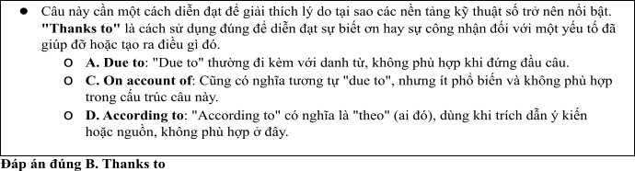
Câu 8. A. majority B. item C. number D. amount
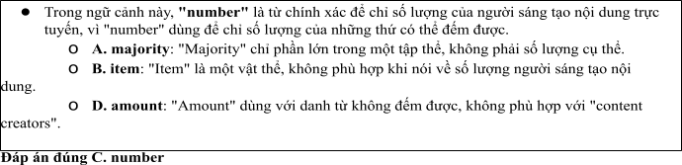
Câu 9. A. Others B. Other C. The others D. Another
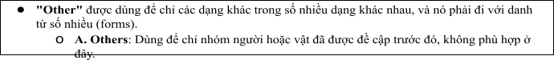
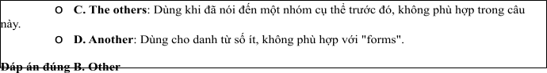
Câu 10. A. age B. moment C.number D. service
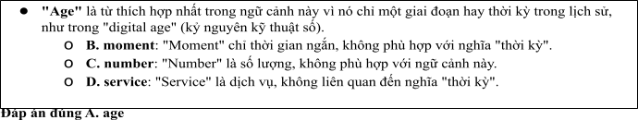
Câu 11. A. connection B. relation C. behaviour D. opinion
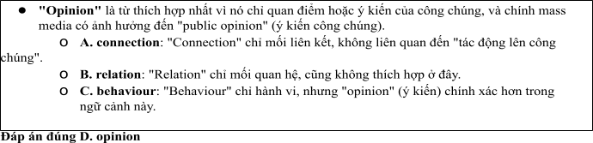
Câu 12. A. carry out B. put off C. go up D. stand out
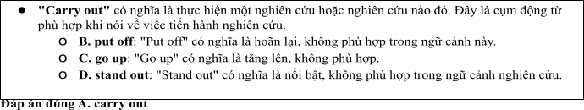
Mark the letter A, B, C or D on your answer sheet to indicate the best arrangement of utterances or sentences to make a meaningful exchange or text in each of the following questions from 13 to 17.

Câu 13
1. Nam: Hi, Mark! It's been ages since we last met. You seem to be doing great!
2. Nam: Yes, I have. I keep up with current events every day and try to stay informed through different platforms.
3. Mark: Hi, Nam! Thanks! You look fantastic too. Have you been following the latest news on social media lately?
A. a-c-b B. b-c-a C. c-b-a D. b-a-c
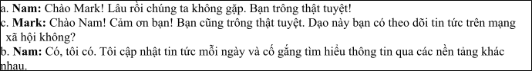

Câu 14
1. Sue: I follow several social media accounts that post updates every day.
2. Sue: It's faster and more interactive. I can comment and share my opinions easily.
3. Alex: How do you usually keep up with the news?
4. Alex: I think social media can spread misinformation. I prefer reading newspapers to stay informed.
5. Alex: Why do you prefer social media for news?
A. a-e-b-c-d B. c-e-d-b-a C. d-b-a-e-c D. c-a-e-b-d
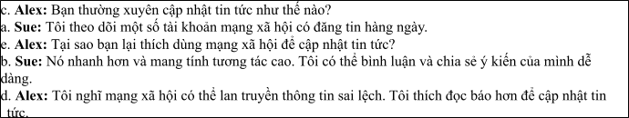

Câu 15
Hi Anna,
1. Sarah: Yes, I have! It seems like everyone is talking about it these days.
2. Sarah: I totally understand. I’ve read a lot of negative stories about data breaches on social media.
3. John: Hi, Sarah! Have you heard the latest news about the new social media platform?
4. John: Yeah, it’s tough to know which platforms are really safe. What do you think?
5. John: I know! I’ve been thinking about joining, but I’m worried about privacy concerns.
Write back soon. Mark
A. d-b-a-c-e B. c-a-e-b-d C. a-d-b-c-e D. a-c-d-b-e
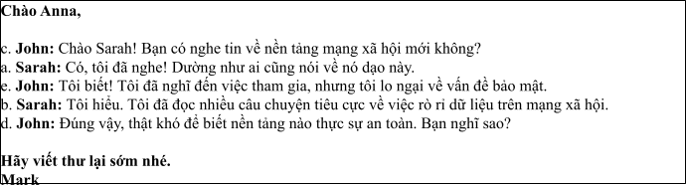

Câu 16
1. It’s amazing how quickly information spreads online. Sometimes, it’s hard to tell what’s true.
2. That’s a big issue with the mass media today—misinformation can spread just as fast as accurate news.
3. Yes, I agree. Social media platforms like Facebook and Twitter have become the primary sources of news for many people.
4. I think we need more media literacy programs to help people navigate this problem.
5. The rise of digital media has completely changed how we consume information.
(Adapted from Bright)
A. e-c-a-b-d B. a-b-c-d-e C. b-c-d-a-e D. c-a-d-b-e
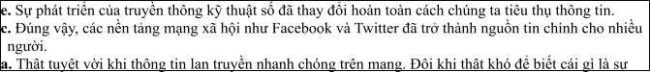
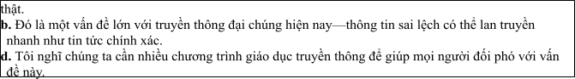

Câu 17
1. Streaming services like Netflix and Hulu have made traditional cable TV less appealing. People prefer on-demand content.
2. How has the rise of streaming services changed the traditional television industry?
3. But do you think this will affect how we consume news and current events?
4. Yes, more people may turn to streaming platforms for news shows, which could change how news is delivered in the future.
5. That’s true. It’s more convenient to watch what you want, when you want, rather than waiting for a
specific time slot.
(Adapted from i-Learn Smart World)
A. c-a-e-b-d B. d-c-a-b-e C. b-a-e-c-d D. d-e-b-c-a
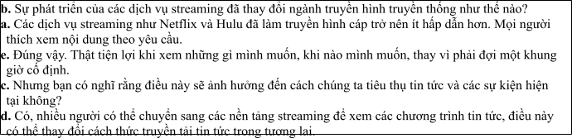
Read thefollowing passage about The Development of Mass Media and Research and mark the letter A, B, C or D on your answer sheet to indicate the option that best fits each of the numbered blanks from 18 to 22.
In recent years, social media has experienced tremendous growth, transforming the way we communicate, share information, and connect with others. Platforms like Facebook, Instagram, Twitter, and TikTok have become integral parts of daily life. So far, (18) to stay informed, interact with friends, and even promote businesses. Many of these platforms provide features (19) making it easier than ever to share experiences in real time. (20) for networking and learning, it has also brought challenges, such as the spread of misinformation and the negative impact on mental health. For example, some influencers have faced criticism (21) . Social media platforms continue to evolve, (22) to keep users engaged, encouraging them to spend more time on these apps.
(Adapted from friends Global)
Câu 18:
1. Social media has been used by billions of people worldwide
2. Social media was used by billions of people worldwide
3. Social media is used by billions of people worldwide
4. Social media was being used by billions of people worldwide

A. Social media has been used by billions of people worldwide
Giải thích:
• Câu hỏi yêu cầu một câu sử dụng thì hiện tại hoàn thành (Present Perfect) vì từ "So far" (Cho đến nay) chỉ ra rằng hành động bắt đầu trong quá khứ và kéo dài đến hiện tại. Thì hiện tại hoàn thành được dùng để diễn tả hành động hoặc trạng thái bắt đầu ở quá khứ và vẫn còn tiếp diễn đến hiện tại.
• A. "Social media has been used by billions of people worldwide" là đúng vì "has been used" là hiện tại hoàn thành, phù hợp với nghĩa của câu yêu cầu.
Các lựa chọn khác đều sai vì:
• B. "Social media was used by billions of people worldwide": Dùng thì quá khứ đơn, không phù hợp với ngữ cảnh "So far" (cho đến nay).
• C. "Social media is used by billions of people worldwide": Dùng thì hiện tại đơn, nhưng không phù hợp với "So far", vì hành động này bắt đầu trong quá khứ và vẫn kéo dài.
• D. "Social media was being used by billions of people worldwide": Dùng thì quá khứ tiếp diễn, không phù hợp vì hành động này không chỉ diễn ra tại một thời điểm trong quá khứ mà vẫn tiếp diễn đến hiện tại.

Câu 19:
1. which allows users to post photos, videos, and even broadcasts live,
2. which allow users to post photos, videos, and even live broadcasts,
3. who allow users to posting photos, videos, and even live broadcasts,
4. whose allowed users to post photos, videos, and even broadcasts live,
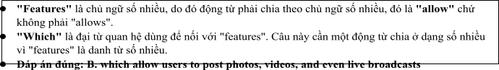

Câu 20:
1. However social media has been provided incredible opportunities
2. Because social media will have provided incredible opportunities
3. Although social media has provided incredible opportunities
4. Since social media has been provided incredible opportunities
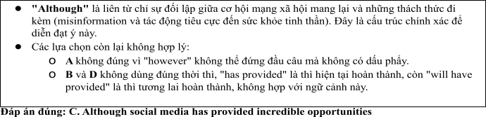

Câu 21:
1. on promoted unrealistic beauty standardize or misleading advertisements
2. for promoting unrealistically beauty standards or misled advertisements
3. on promoting unrealistic beautifully standards or misleading advertisements
4. for promoting unrealistic beauty standards or misleading advertisements
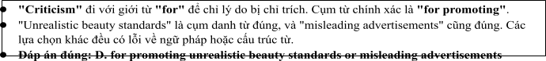

Câu 22:
1. constantly introducing new tools like Stories and Reels
2. constant introducing new tools as Stories and Reels
3. constantly introducing new tools like Stories or Reels
4. constantly introduced new tools neither Stories nor Reels
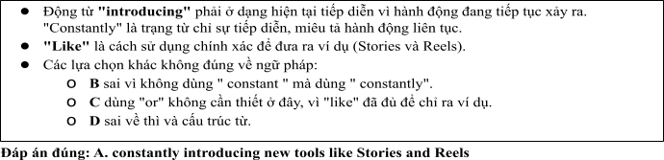
Read the following passage about development of communication and mark the letter A, B, C or D on your answer sheet to indicate the best answer to each of the following questions from 23 to 30.
Communication has undergone significant changes over the years, especially with the advent of new technologies. In ancient times, humans communicated primarily through oral traditions and written symbols, like cave paintings or early scripts. However, these methods were often limited to local areas. The invention of the printing press by Johannes Gutenberg in the 15th century marked the beginning of mass communication, allowing books and newspapers to be widely distributed and giving people access to new ideas.
In the 20th century, the development of radio and television brought communication to a global audience. For the first time, people could receive information from all over the world without leaving their homes. Radio, initially used for news broadcasts and entertainment, became an important tool for education, while television added a visual element, making it more engaging. These technologies revolutionized how people shared and consumed information.
In the 21st century, the rise of the internet has completely transformed communication once again. The internet has made it easier for people to connect with one another regardless of their location. Social media platforms, email, and instant messaging have revolutionized both personal and professional communication. The internet has also opened up new possibilities for education, allowing people to learn from online resources and virtual classrooms.
However, the rapid growth of digital communication has brought with it several challenges. One of the major concerns is the spread of misinformation and fake news. With the ability to instantly share information with millions of people, it has become easier for inaccurate or misleading content to spread quickly. Additionally, not everyone has equal access to the internet, creating a digital divide between those who have access to the latest technologies and those who do not. Efforts are being made to address these issues, but the challenges remain significant.
(Adapted from daily news)
Câu 23. Which of the following is NOT mentioned as a development in communication?
A. The invention of the printing press B. The rise of social media platforms
C. The use of cave paintings D. The development of radio and television
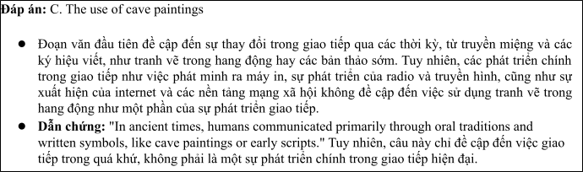
Câu 24. The word “revolutionized” in paragraph 2 is OPPOSITE in meaning to:
A. Simplified B. Stabilized C. Interrupted D. Neglected
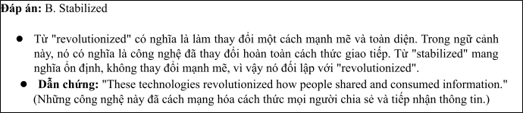
Câu 25. The word “their” in paragraph 3 refers to:
A. Radio and television’s B. people’
C. Technologies’ D. News broadcasts’
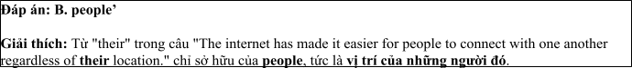
Câu 26. The word “divide” in paragraph 4 could be best replaced by:
A. Connection B. Gap C. Solution D. Bridge
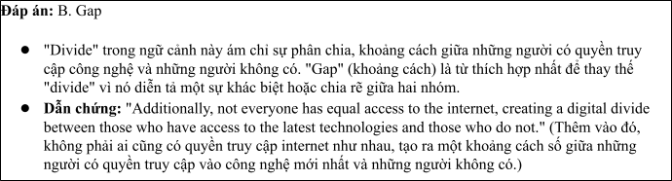
Câu 27. Which of the following best paraphrases the underlined sentence “Efforts are being made to address these issues” in paragraph 4?
1. People are struggling to solve these problems.
2. There is no way to solve these issues.
3. Solutions are being developed to tackle these problems.
4. Efforts to resolve these issues have failed.
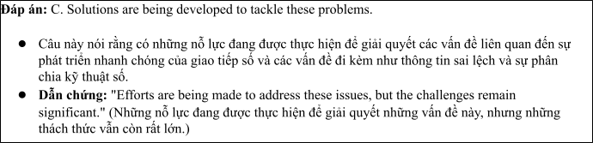
Câu 28. Which of the following is TRUE according to the passage?
1. Television was the first global communication tool.
2. The internet has made communication faster and more accessible.
3. People are no longer concerned with misinformation.
4. Communication in ancient times was limited to face-to-face interactions.
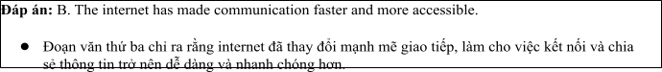
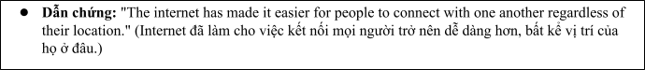
Câu 29. In which paragraph does the writer mention a past causal relationship?
A. Paragraph 1 B. Paragraph 2 C. Paragraph 3 D. Paragraph 4
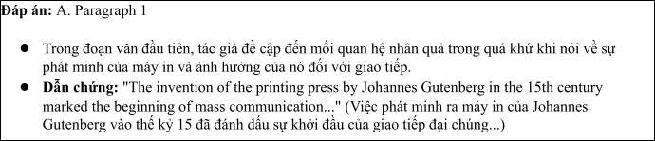
Câu 30. In which paragraph does the writer explore modern methods for maintaining communication?
A. Paragraph 1 B. Paragraph 2 C. Paragraph 3 D. Paragraph 4
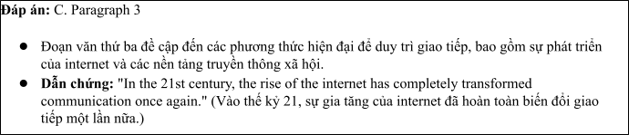
Read the following passage about the Development of Multinational Media and mark the letter A, B, C or D on your answer sheet to indicate the best answer to each of the following questions from 31 to 40.
In recent years, the rise of multinational media companies has had a significant impact on global communication. [I] With advances in technology and the growth of the internet, media organizations have expanded beyond national borders, reaching audiences worldwide. [II] By 2050, experts predict that a majority of media content will be produced by a few large global corporations, allowing them to shape cultural trends, public opinion, and political discourse. [III] There are several factors that have contributed to the rise of multinational media corporations, which also pose various challenges. [IV]
The main push factors behind the growth of multinational media include the increasing demand for diverse content, the growth of international markets, and advancements in technology. As populations become more interconnected, people demand media that reflects their varied cultures and interests, which can be met by global media companies. Moreover, these corporations can tap into emerging markets in developing countries, creating new revenue streams. The internet and digital platforms have further facilitated the expansion of multinational media by breaking down geographical barriers and allowing content to reach a global audience instantly.
However, this globalisation of media comes with both positive and negative consequences. On the one hand, multinational media companies provide access to information and entertainment from around the world, helping to promote cultural exchange. On the other hand, the concentration of media ownership raises concerns about media diversity and the potential for these companies to dominate public discourse. Additionally, the expansion of multinational media often leads to the overshadowing of local media outlets,
which may struggle to compete with the financial resources and global reach of their multinational counterparts.
To ensure that multinational media development is beneficial, it is essential to carefully regulate the industry and promote a balanced flow of information that respects both global and local interests.
Câu 31: Where in paragraph I does the following sentence best fit?

The rise of multinational media has expanded communication on a global scale.
A. [I] B. [II] C. [III] D. [IV]
\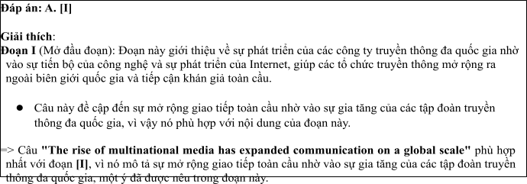
Câu 32: The phrase "poses various challenges" in paragraph 1 could be best replaced by .
A. brings about benefits B. creates difficulties
C. stimulates growth D. fosters competition
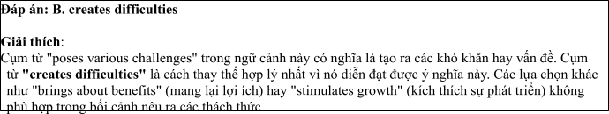
Câu 33: The word "which" in paragraph 2 refers to
A. education B. entertainment C. radio D. media
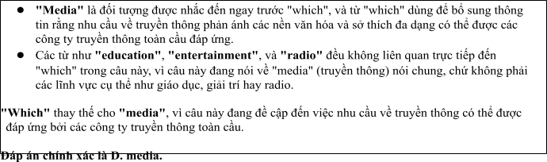
Câu 34: According to paragraph 3, which of the following is NOT a negative consequence of multinational media?
A. domination of public discourse B. overshadowing local media outlets
C. cultural exchange D. concentration of media ownership
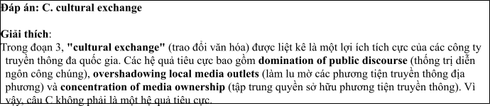
Câu 35: Which of the following best summarises paragraph 3?
A. Multinational media has positive effects on global communication but raises concerns about media diversity.
B. The expansion of multinational media companies promotes cultural exchange but reduces local media coverage.
C. While multinational media provides information, it also leads to greater competition and regulation.
D. Multinational media has financial resources that help it dominate the global market.
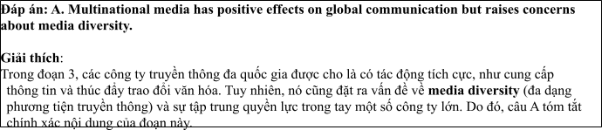
Câu 36: The word "overshadowing" in paragraph 3 is OPPOSITE in meaning to
A. dominating B. diminishing C. highlighting D. supporting
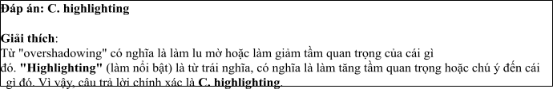
Câu 37: Which of the following is TRUE according to the passage?
A. Multinational media companies are increasing access to global information.
B. All countries have benefited equally from the growth of multinational media.
C. The growth of multinational media has led to a decrease in global communication.
D. Local media outlets have successfully competed with multinational companies.
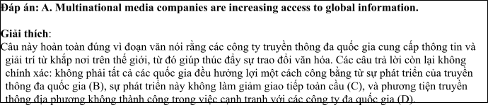
Câu 38: Which of the following best paraphrases the underlined sentence: “To ensure that multinational media development is beneficial, it is essential to carefully regulate the industry” in paragraph 4?
A. Regulating the multinational media industry will ensure that its development is harmful.
B. Multinational media should be left unregulated to allow for its natural development.
C. Carefully regulating multinational media is necessary for positive development.
D. It is unnecessary to regulate the multinational media industry as it will develop naturally.
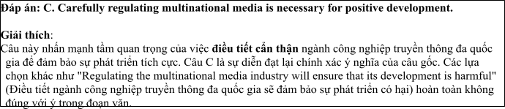
Câu 39: Which of the following can be inferred from the passage?
A. The dominance of multinational media companies benefits developing countries the most.
B. Local media outlets are often unable to compete with the global reach of multinational corporations.
C. Technology advancements have led to a decline in the need for global media companies.
D. Multinational media companies struggle to enter emerging markets.
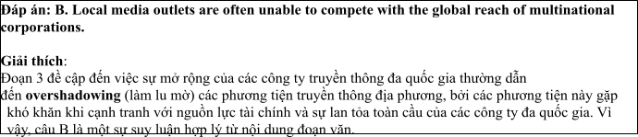
Câu 40: Which of the following best summarises the passage?
A. The rise of multinational media is reshaping global communication but requires careful regulation to avoid negative impacts on local media and diversity.
B. Multinational media has transformed global communication, making it easier to access diverse content while reducing local competition.
C. As multinational media companies grow, they create cultural exchange and new markets, though they also raise concerns about media concentration.
D. The rise of multinational media is beneficial for developing countries, but it comes at the cost of local media outlets.
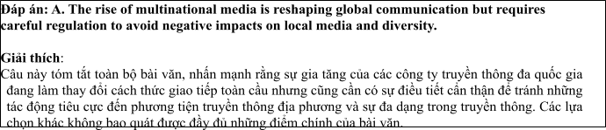

ĐỀ 6 | ĐỀ KIỂM TRA GIỮA HK2 NĂM HỌC 2024-2025  MÔN: TIẾNG ANH LỚP 12

Read the following advertisement and mark the letter A, B, C and D on your answer sheet to indicate the option that best fits each of the numbered blanks from 1 to 6
The Rise of Digital Media
The landscape of domestic media is rapidly evolving, with new trends emerging due to the growth of digital platforms.(1) ________, such as newspapers and TV, are increasingly being replaced by online channels where information can be accessed instantly. This shift in format allows for more (2) _______ and personalized content. People expect (3) _______ news that aligns with their interests and preferences. With digital media offering real-time updates, many users, (4) ________ accustomed to immediate access, no longer rely on conventional sources. As a result, online platforms are (5) _______ the news faster than ever before, providing instant reactions to global events. The demand for timely and relevant content continues to rise, shaping the future (6) _______ media in the digital age.
(Adapted from discovery news)
Câu 1: A. Traditional media outlets B. Media outlets traditional
C. Traditional outlets media D. Media traditional outlets
Câu 2: A. interactive B. interact C. interaction D. interactively
Câu 3: A. to receiving B. to receive C. receive D. to be receiving
Câu 4: A. which became B. became C. was become D. having become
Câu 5: A. getting B. breaking C. coming D. catching
Câu 6: A. to B. on C. of D. at
Read the following leaflet and mark the letter A, B, C or D on your answer sheet to indicate the option that best fits each of the numbered blanks from 7 to 12.
The Impact of Multimedia Communication in the Digital Age
• Multimedia communication has become a dominant force in the digital age. (7) _______ recent studies, multimedia platforms have revolutionized how people consume information, combining text, images, video, and audio to create more engaging (8) _______.
• The (9) _______ of data shared across these platforms is growing exponentially, with millions of users interacting with different types of media daily. Social media networks allow users to communicate with (10)________ in real-time, making global connections easier than ever before.
• This form of communication is closely related to the rise of mobile (11) _______, which enables access to multimedia content anytime, anywhere. As technology continues to advance, we can expect multimedia communication to (12) ________ shaping the way we interact and share information in the future.
Câu 7. A. Due to B. Thanks to C. On account of D. According to
Câu 8. A. content B. meaning C. method D. comment
Câu 9. A. majority B. item C. number D. amount
Câu 10. A. others B.each other C. the others D. another
Câu 11. A. flatform B. communication C. connection D. technology
Câu 12. A. go on B. interact with C. get over D. catch up
Mark the letter A, B, C or D on your answer sheet to indicate the best arrangement of utterances or sentences to make a meaningful exchange or text in each of the following questions from 13 to 17.
Câu 13
a. Minh: Yes, I have. I watch the news and follow social media every day to stay informed about the latest trends and developments.
b. Minh: Hi, Anh! It's been a while since we last met. You look great!
c. Anh: Hi, Minh! Thanks, you look fantastic as well. Have you been keeping up with the media in Vietnam lately?
A. a-c-b B. b-c-a C. c-b-a D. b-a-c
Câu 14
a. Lan: They provide up-to-date information and cover a wide range of topics, from politics to entertainment.
b. Nam: I think social media is too overwhelming. I don't think I'll rely on it much.
c. Nam: How are you going to stay updated on the media in Vietnam?
d. Lan: I'm going to follow Vietnamese news websites and social media channels.
e. Nam: Why do you choose those sources?
A. a-e-b-c-d B. c-e-d-b-a C. d-b-a-e-c D. c-d-e-a-b
Câu 15
Hi Hoa,
a. I’ve always found it interesting to watch how TV is evolving, but right now I’m busy with my internship, so I don’t have much time to explore these changes.
b. Thanks so much for the video you sent me last week on how Vietnamese TV stations are adapting to new technology.
c. Thanks also for sharing the link to the online platform with educational videos — they seem much more engaging than the ones I’ve been using.
d. We should watch more videos together soon. What’s your opinion?
e. Nevertheless, it was enjoyable to watch the video.
Write back soon,
Minh
A. d-b-a-c-e B. b-a-e-c-d C. a-d-b-c-e D. a-c-d-b-e
Câu 16
a. In conclusion, I’m excited about the opportunities that my role in Vietnamese media offers and the positive impact I can make in the industry.
b. For the last year, I have been working as a content strategist, producing articles and creating online campaigns that resonate with Vietnamese audiences.
c. Working remotely offers me the freedom to experiment with new ideas, and I find this environment enhances my creativity.
d. My fascination with both media and technology led me to a career in digital media, specifically within Vietnam’s rapidly growing industry.
e. While adhering to deadlines is crucial in this field, I don’t mind the occasional in-office meetings to brainstorm and collaborate with the team.
(Adapted from discovery)
A. d-b-c-e-a B. a-b-c-d-e C. b-c-d-a-e D. c-a-d-b-e
Câu 17
a. The increasing popularity of digital media has also led to a 40% rise in social media usage, which is becoming the primary source of news for many Vietnamese.
b. Vietnam’s print media industry has faced significant challenges over the past few years.
c. Newspapers and magazines, once popular, have been gradually replaced by digital platforms, signaling a shift towards online journalism.
d. This shift towards digital news has encouraged the rise of local news websites, independent journalism, and social media influencers, providing a wider variety of news and making the media scene in Vietnam more dynamic.
e. Nevertheless, in spite of this growth, fake news and misinformation remain a major problem in Vietnam’s online media, with no clear solutions in sight.
(Adapted from i-Learn Smart World)
A. c-a-e-b-d B. d-c-a-b-e C. b-c-d-a-e D. d-e-b-c-a
Read the following passage about The Development of Mass Media and Research and mark the letter A, B, C or D on your answer sheet to indicate the option that best fits each of the numbered blanks from 18 to 22.
Multimedia communication has become a vital part of our daily lives, reshaping the way we consume information. Over the years, (18) __________, transforming traditional media into more interactive and engaging forms. Platforms like YouTube, Facebook, and Instagram have revolutionized how we access news, entertainment, and even education. (19) _________ has increased exponentially, with millions of videos, images, and podcasts uploaded every day. Social media, (20) _________, has played a major role in this shift. Many people now (21) ________ , as they offer a faster and more personalized experience. In one instance, a friend of mine was able to watch a live-streamed event from the other side of the world, something that would have been impossible just a decade ago. Another situation involves a local business that (22) _______ , sharing new products in real-time. This shift towards multimedia content has significantly altered communication, enabling global connections like never before.
(Adapted from dailynews)
Câu 18:
A. it has been widely adopted in various industries
B. it is widely adopted in the variety of industries
C. it was widely adopted in the industries of variety
D. it was being widely adopted in various industries
Câu 19:
A. The amount of multimedia contents shared online
B. The number of multimedia contents shared online
C. The amount of multimedia contents sharing online
D. The number of multimedia contents shared online
Câu 20:
A. that allow instant interaction and sharing B. which allowed instant interaction and sharing
C. which allows instant interaction and sharing D. which is allowed instant interaction and sharing
Câu 21:
A. take up multimedia platforms to stay informed
B. catch up multimedia platforms to stay informed
C. suffer from multimedia platforms to stay informed
D. rely on multimedia platforms to stay informed
Câu 22:
A. uses Instagram stories to connect with customers
B. transfers Instagram stories to connect by customers
C. supports Instagram stories to combine with customers
D. transmits Instagram stories to deal with customers
Read the following passage about choosing communication studies of students and mark the letter A, B, C or D on your answer sheet to indicate the best answer to each of the following questions from 23 to 30.
Many students today are choosing communication studies as their major, believing it to be the key to a successful career. With the growth of social media, advertising, public relations, and digital platforms, communication skills are more in demand than ever. Graduates are among the most employable, often landing high-paying jobs in media, marketing, and content creation.
However, choosing communication as a field of study is not without challenges. The competitive job market and the need to stay updated with technological advances mean students must be proactive in acquiring practical skills. Courses in writing, video production, social media strategy, and data analysis are essential for students who want to stand out. The rise of artificial intelligence and automation in communication industries raises concerns about the future of the profession. Yet, many experts believe that human creativity and emotional intelligence will remain crucial in communication careers.
One advantage of a communication degree is its flexibility. Students can specialize in areas such as journalism, advertising, public relations, or digital media. The adaptability of the degree allows graduates to explore various industries, from entertainment to corporate sectors. Internships, networking, and hands-on experience are also vital in developing a professional portfolio.
As communication continues to shape the world, its impact on society is undeniable. For those passionate about making a difference through words, visuals, and technology, a degree in communication offers endless possibilities.
(Adapted from vietnamesenews)
Câu 23. Which of the following is NOT mentioned as a benefit of choosing communication studies as a major?
A. High employability rates B. Ability to specialize in various areas
C. Opportunities for internships and networking D. Guaranteed job placement after graduation
Câu 24. The word “artificial” in paragraph 2 is OPPOSITE in meaning to:
A. Natural B. Innovative C. Passive D. Aggressive
Câu 25. The word “who” in paragraph 2 refers to:
A. experts B. students C. corporate sectors D. Graduates
Câu 26. The word “adaptability” in paragraph 3 could be best replaced by:
A. Changeability B. Flexibility C. Dependability D. Accessibility
Câu 27. Which of the following best paraphrases the underlined sentence in paragraph 2? “The competitive nature of the job market and the constant need to stay updated with technological advances mean that students must be proactive in acquiring practical skills.”
A. Students need to acquire practical skills in order to compete in the job market.
B. The job market is not competitive, and students don’t need to update their skills.
C. Students must passively wait for skills to be acquired in the competitive job market.
D. Technological advances make it impossible for students to acquire practical skills.
Câu 28. Which of the following is TRUE according to the passage?
A. Communication graduates are guaranteed high-paying jobs in the future.
B. Technology is expected to replace human creativity in communication careers.
C. Students need to stay updated with new technologies in communication fields.
D. Communication degrees are very specialized, limiting career options.
Câu 29. In which paragraph does the writer mention a future concern about communication jobs?
A. Paragraph 1 B. Paragraph 2 C. Paragraph 3 D. Paragraph 4
Câu 30. In which paragraph does the writer discuss the versatility of a communication degree?
A. Paragraph 1 B. Paragraph 2 C. Paragraph 3 D. Paragraph 4
Read the following passage about Communication Studies and mark the letter A, B, C or D on your answer sheet to indicate the best answer to each of the following questions from 31 to 40.
[I] Over the past decade, there has been a significant increase in the number of students choosing to pursue degrees in communication. [II] By 2030, it is predicted that communication-related fields will be among the top areas of study for university students globally. [III] This shift is driven by various factors, each of which contributes to the growing popularity of communication programs. [IV]
The push factors include limited career opportunities in other fields. Many students find that their options in traditional professions are limited, and they often seek alternatives with better prospects. Communication, being a dynamic and evolving field, offers students the chance to develop a wide range of skills applicable to many industries. Moreover, the increasing digitalisation of society means that industries are constantly looking for professionals who can effectively navigate online platforms, manage content, and engage with diverse audiences. On the other hand, pull factors include the wide variety of career paths that a degree in communication opens up. Graduates can work in advertising, public relations, media, journalism, and corporate communications, which are sectors that often offer competitive salaries and ample opportunities for career growth.
However, the choice to study communication also has its challenges. One notable issue is the oversaturation of certain sectors, particularly journalism, where the demand for jobs does not always meet the supply of qualified candidates. Furthermore, the rapid pace of technological change in the media industry means that students must continuously update their skills to stay relevant.
The growing interest in communication studies reflects the demand for professionals who can effectively manage information in a world that is increasingly connected and information-driven. By understanding both the advantages and challenges of the field, students can make more informed decisions about their career paths.
(Adapted from education reports)
Câu 31. Where in paragraph I does the following sentence best fit?
"The number of students choosing communication-related fields is steadily increasing."
A. [I] B. [II] C. [III] D. [IV]
Câu 32. The phrase "growing popularity" in paragraph I could be best replaced by _____.
A. expanding influence B. increasing demand
C. rising awareness D. wider recognition
Câu 33. The word "oversaturation" in paragraph 3 refers to _____.
A. the abundance of career options in communication
B. the lack of demand in some communication sectors
C. the increasing number of qualified candidates
D. the limited availability of media-related jobs
Câu 34. According to paragraph 2, which of the following is NOT a pull factor?
A. Better career prospects
B. A wide range of industries to work in
C. Digitalisation of society
D. Limited career opportunities in other fields
Câu 35. Which of the following best summarises paragraph 3?
A. Communication is an oversaturated field, making it difficult for graduates to find jobs.
B. Graduates of communication face the challenge of staying up-to-date with technological changes.
C. Communication degrees offer various career opportunities but come with the challenge of competition.
D. The rapidly changing media landscape makes it hard for students to find stable jobs.
Câu 36. The word "dynamic" in paragraph 2 is OPPOSITE in meaning to _____.
A. inactive B. evolving C. flexible D. diverse
Câu 37. Which of the following is TRUE according to the passage?
A. Communication studies are expected to decline in popularity by 2030.
B. Technological advancements in media are a key reason for the rising demand for communication professionals.
C. Students pursuing communication degrees are often unable to find relevant career opportunities.
D. The media industry is experiencing a decline due to oversaturation.
Câu 38. Which of the following best paraphrases the underlined sentence "The growing interest in communication studies reflects the demand for professionals..." in paragraph 4?
A. The increasing popularity of communication degrees indicates a shrinking job market for professionals.
B. More students studying communication signals a rise in the demand for skilled professionals in the field.
C. Communication programs are becoming more competitive due to the growing number of interested students.
D. Communication studies are not yet in demand despite the growing number of students choosing it.
Câu 39. Which of the following can be inferred from the passage?
A. The communication field is growing, but its growth comes with challenges such as oversaturation and competition.
B. Students choose communication as a last resort when other fields offer fewer career prospects.
C. The rise in communication programs is due to the oversupply of jobs in other sectors.
D. The media industry is expected to become less competitive in the future due to fewer students studying communication.
Câu 40. Which of the following best summarises the passage?
A. Communication degrees are increasingly popular due to the diverse career opportunities they offer, but students face challenges such as competition and the need for continuous skill upgrades.
B. The growing interest in communication reflects an oversupply of qualified candidates, making it harder for graduates to secure jobs.
C. Students pursuing communication degrees are attracted to the field by its competitive salaries but may struggle with technological changes.
D. As the communication field expands, students are attracted to it due to the variety of career options, but they must be prepared for its evolving nature.

ĐÁP ÁN VÀ LỜI GIẢI

Read the following advertisement and mark the letter A, B, C and D on your answer sheet to indicate the option that best fits each of the numbered blanks from 1 to 6

The Rise of Digital Media
The landscape of domestic media is rapidly evolving, with new trends emerging due to the growth of digital platforms.(1) , such as newspapers and TV, are increasingly being replaced by online channels where information can be accessed instantly. This shift in format allows for more (2) and personalized content. People expect (3) news that aligns with their interests and preferences. With digital media offering real-time updates, many users, (4) accustomed to immediate access, no longer rely on conventional sources. As a result, online platforms are (5) the news faster than ever before, providing instant reactions to global events. The demand for timely and relevant content continues to rise, shaping the future (6) media in the digital age.
(Adapted from discovery news)
Câu 1: A. Traditional media outlets B. Media outlets traditional
C. Traditional outlets media D. Media traditional outlets
Câu 2: A. interactive B. interact C. interaction D. interactively
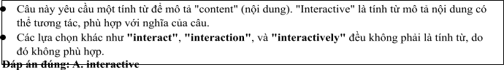
Câu 3: A. to receiving B. to receive C. receive D. to be receiving
Câu 4: A. which became B. became C. was become D. having become
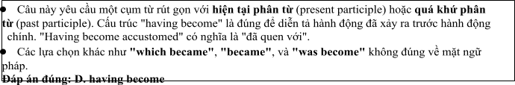
Câu 5: A. getting B. breaking C. coming D. catching
Câu 6: A. to B. on C. of D. at
Read the following leaflet and mark the letter A, B, C or D on your answer sheet to indicate the option that best fits each of the numbered blanks from 7 to 12.

The Impact of Multimedia Communication in the Digital Age
• Multimedia communication has become a dominant force in the digital age. (7) recent studies, multimedia platforms have revolutionized how people consume information, combining text, images, video, and audio to create more engaging (8) .
• The (9) of data shared across these platforms is growing exponentially, with millions of users interacting with different types of media daily. Social media networks allow users to communicate with (10) in real-time, making global connections easier than ever before.
• This form of communication is closely related to the rise of mobile (11) , which enables access to multimedia content anytime, anywhere. As technology continues to advance, we can expect multimedia communication to (12) shaping the way we interact and share information in the future.
Câu 7. A. Due to B. Thanks to C. On account of D. According to
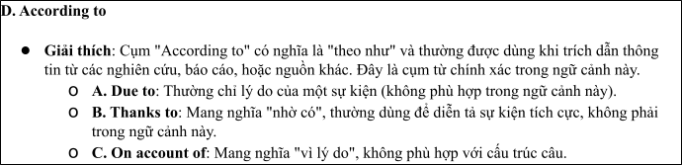
Câu 8. A. content B. meaning C. method D. comment
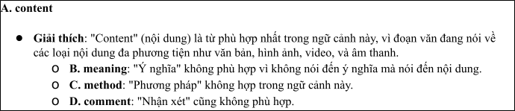
Câu 9. A. majority B. item C. number D. amount
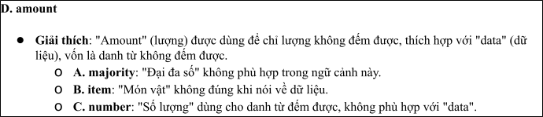
Câu 10. A. others B.each other C. the others D. another
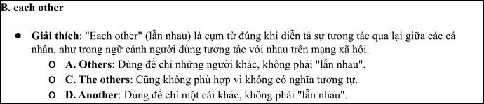
Câu 11. A. flatform B. communication C. connection D. technology
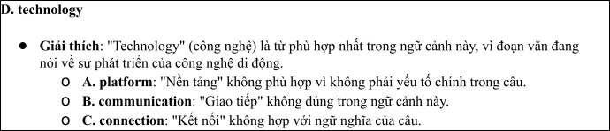
Câu 12. A. go on B. interact with C. get over D. catch up
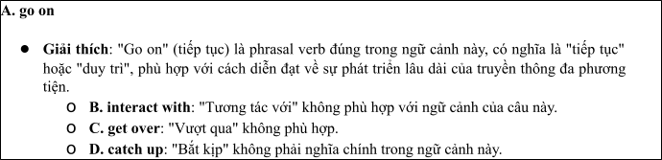
Mark the letter A, B, C or D on your answer sheet to indicate the best arrangement of utterances or sentences to make a meaningful exchange or text in each of thefollowing questions from 13 to 17.

Câu 13
1. Minh: Yes, I have. I watch the news and follow social media every day to stay informed about the latest trends and developments.
2. Minh: Hi, Anh! It's been a while since we last met. You look great!
3. Anh: Hi, Minh! Thanks, you look fantastic as well. Have you been keeping up with the media in Vietnam lately?
A. a-c-b B. b-c-a C. c-b-a D. b-a-c
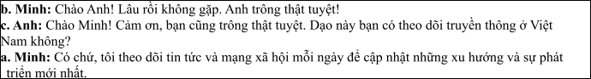

Câu 14
1. Lan: They provide up-to-date information and cover a wide range of topics, from politics to entertainment.
2. Nam: I think social media is too overwhelming. I don't think I'll rely on it much.
3. Nam: How are you going to stay updated on the media in Vietnam?
4. Lan: I'm going to follow Vietnamese news websites and social media channels.
5. Nam: Why do you choose those sources?
A. a-e-b-c-d B. c-e-d-b-a C. d-b-a-e-c D. c-d-e-a-b
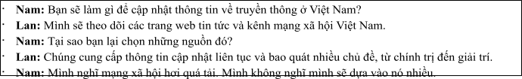

Câu 15
Hi Hoa,
1. I’ve always found it interesting to watch how TV is evolving, but right now I’m busy with my internship, so I don’t have much time to explore these changes.
2. Thanks so much for the video you sent me last week on how Vietnamese TV stations are adapting to new technology.
3. Thanks also for sharing the link to the online platform with educational videos — they seem much more
engaging than the ones I’ve been using.
4. We should watch more videos together soon. What’s your opinion?
5. Nevertheless, it was enjoyable to watch the video. Write back soon,
Minh
A. d-b-a-c-e B. b-a-e-c-d C. a-d-b-c-e D. a-c-d-b-e
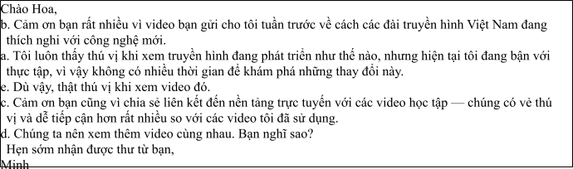

Câu 16
1. In conclusion, I’m excited about the opportunities that my role in Vietnamese media offers and the
positive impact I can make in the industry.
2. For the last year, I have been working as a content strategist, producing articles and creating online campaigns that resonate with Vietnamese audiences.
3. Working remotely offers me the freedom to experiment with new ideas, and I find this environment enhances my creativity.
4. My fascination with both media and technology led me to a career in digital media, specifically within
Vietnam’s rapidly growing industry.
5. While adhering to deadlines is crucial in this field, I don’t mind the occasional in-office meetings to brainstorm and collaborate with the team.
(Adapted from discovery)
A. d-b-c-e-a B. a-b-c-d-e C. b-c-d-a-e D. c-a-d-b-e
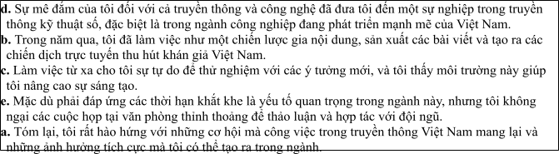

Câu 17
1. The increasing popularity of digital media has also led to a 40% rise in social media usage, which is becoming the primary source of news for many Vietnamese.
2. Vietnam’s print media industry has faced significant challenges over the past few years.
3. Newspapers and magazines, once popular, have been gradually replaced by digital platforms, signaling a shift towards online journalism.
4. This shift towards digital news has encouraged the rise of local news websites, independent journalism, and social media influencers, providing a wider variety of news and making the media scene in Vietnam more dynamic.
5. Nevertheless, in spite of this growth, fake news and misinformation remain a major problem in
Vietnam’s online media, with no clear solutions in sight.
(Adapted from i-Learn Smart World)
A. c-a-e-b-d B. d-c-a-b-e C. b-c-d-a-e D. d-e-b-c-a
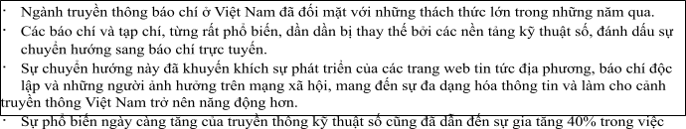
Read thefollowing passage about The Development of Mass Media and Research and mark the letter A, B, C or D on your answer sheet to indicate the option that bestfits each of the numbered blanksfrom 18 to 22.
Multimedia communication has become a vital part of our daily lives, reshaping the way we consume information. Over the years, (18) , transforming traditional media into more interactive and engaging forms. Platforms like YouTube, Facebook, and Instagram have revolutionized how we access news, entertainment, and even education. (19) has increased exponentially, with millions of videos, images, and podcasts uploaded every day. Social media, (20) , has played a major role in this shift. Many people now (21) , as they offer a faster and more personalized experience. In one instance, a friend of mine was able to watch a live-streamed event from the other side of the world, something that would have been impossible just a decade ago. Another situation involves a local business that (22)
, sharing new products in real-time. This shift towards multimedia content has significantly altered communication, enabling global connections like never before.
(Adapted from dailynews)
Câu 18:
1. it has been widely adopted in various industries
2. it is widely adopted in the variety of industries
3. it was widely adopted in the industries of variety
4. it was being widely adopted in various industries

Câu 19:
1. The amount of multimedia contents shared online
2. The number of multimedia contents shared online
3. The amount of multimedia contents sharing online
4. The number of multimedia contents shared online
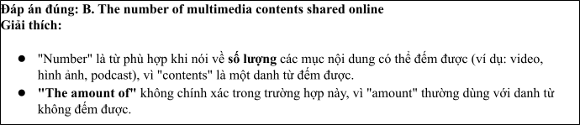

Câu 20:
A. that allow instant interaction and sharing B. which allowed instant interaction and sharing
C. which allows instant interaction and sharing D. which is allowed instant interaction and sharing

Câu 21:
1. take up multimedia platforms to stay informed
2. catch up multimedia platforms to stay informed
3. suffer from multimedia platforms to stay informed
4. rely on multimedia platforms to stay informed

Câu 22:
1. uses Instagram stories to connect with customers
2. transfers Instagram stories to connect by customers
3. supports Instagram stories to combine with customers
4. transmits Instagram stories to deal with customers
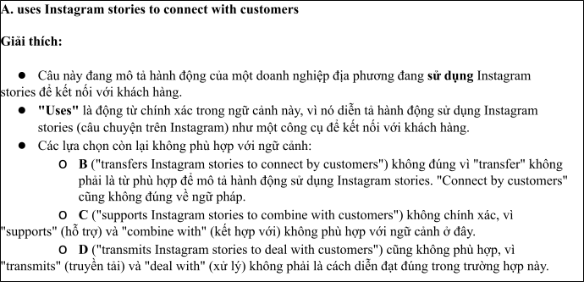
Read the following passage about choosing communication studies of students and mark the letter A, B, C or D on your answer sheet to indicate the best answer to each of the following questionsfrom 23 to 30.
Many students today are choosing communication studies as their major, believing it to be the key to a successful career. With the growth of social media, advertising, public relations, and digital platforms, communication skills are more in demand than ever. Graduates are among the most employable, often landing high-paying jobs in media, marketing, and content creation.
However, choosing communication as a field of study is not without challenges. The competitive job market and the need to stay updated with technological advances mean students must be proactive in acquiring practical skills. Courses in writing, video production, social media strategy, and data analysis are essential for students who want to stand out. The rise of artificial intelligence and automation in communication industries raises concerns about the future of the profession. Yet, many experts believe that human creativity and emotional intelligence will remain crucial in communication careers.
One advantage of a communication degree is its flexibility. Students can specialize in areas such as journalism, advertising, public relations, or digital media. The adaptability of the degree allows graduates to explore various industries, from entertainment to corporate sectors. Internships, networking, and hands- on experience are also vital in developing a professional portfolio.
As communication continues to shape the world, its impact on society is undeniable. For those passionate about making a difference through words, visuals, and technology, a degree in communication offers endless possibilities.
(Adapted from vietnamesenews)
Câu 23. Which of the following is NOT mentioned as a benefit of choosing communication studies as a major?
A. High employability rates B. Ability to specialize in various areas
C. Opportunities for internships and networking D. Guaranteed job placement after graduation
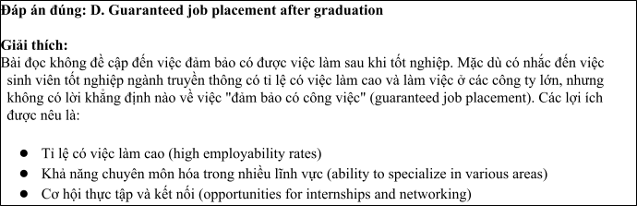
Câu 24. The word “artificial” in paragraph 2 is OPPOSITE in meaning to:
A. Natural B. Innovative C. Passive D. Aggressive
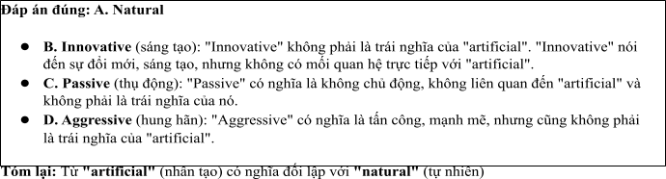
Câu 25. The word “who” in paragraph 2 refers to:
A. experts B. students C. corporate sectors D. Graduates
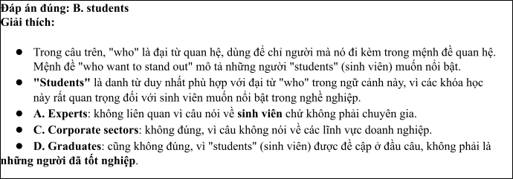
Câu 26. The word “adaptability” in paragraph 3 could be best replaced by:
A. Changeability B. Flexibility C. Dependability D. Accessibility
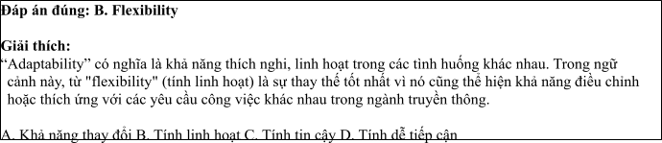
Câu 27. Which of the following best paraphrases the underlined sentence in paragraph 2? “The competitive nature of the job market and the constant need to stay updated with technological advances mean that students must be proactive in acquiring practical skills.”
1. Students need to acquire practical skills in order to compete in the job market.
2. The job market is not competitive, and students don’t need to update their skills.
3. Students must passively wait for skills to be acquired in the competitive job market.
4. Technological advances make it impossible for students to acquire practical skills.
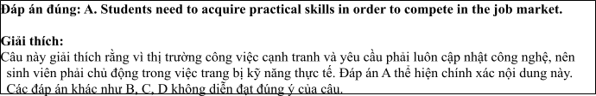
Câu 28. Which of the following is TRUE according to the passage?
1. Communication graduates are guaranteed high-paying jobs in the future.
2. Technology is expected to replace human creativity in communication careers.
3. Students need to stay updated with new technologies in communication fields.
4. Communication degrees are very specialized, limiting career options.
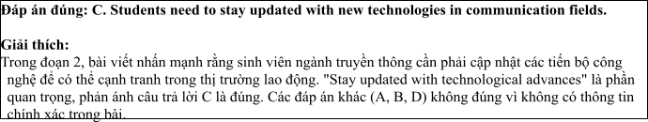
Câu 29. In which paragraph does the writer mention a future concern about communication jobs?
A. Paragraph 1 B. Paragraph 2 C. Paragraph 3 D. Paragraph 4
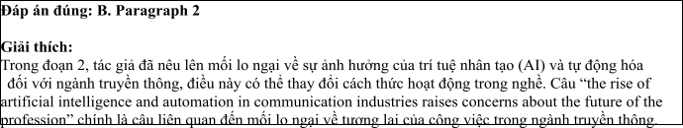
Câu 30. In which paragraph does the writer discuss the versatility of a communication degree?
A. Paragraph 1 B. Paragraph 2 C. Paragraph 3 D. Paragraph 4
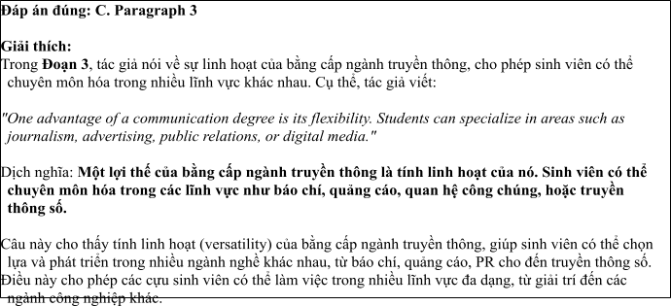
Read the following passage about Communication Studies and mark the letter A, B, C or D on your answer sheet to indicate the best answer to each of the following questions from 31 to 40.
[I] Over the past decade, there has been a significant increase in the number of students choosing to pursue degrees in communication. [II] By 2030, it is predicted that communication-related fields will be among the top areas of study for university students globally. [III] This shift is driven by various factors, each of which contributes to the growing popularity of communication programs. [IV]
The push factors include limited career opportunities in other fields. Many students find that their options in traditional professions are limited, and they often seek alternatives with better prospects. Communication, being a dynamic and evolving field, offers students the chance to develop a wide range of skills applicable to many industries. Moreover, the increasing digitalisation of society means that industries are constantly looking for professionals who can effectively navigate online platforms, manage content, and engage with diverse audiences. On the other hand, pull factors include the wide variety of career paths that a degree in communication opens up. Graduates can work in advertising, public relations, media, journalism, and corporate communications, which are sectors that often offer competitive salaries and ample opportunities for career growth.
However, the choice to study communication also has its challenges. One notable issue is the oversaturation of certain sectors, particularly journalism, where the demand for jobs does not always meet the supply of qualified candidates. Furthermore, the rapid pace of technological change in the media industry means that students must continuously update their skills to stay relevant.
The growing interest in communication studies reflects the demand for professionals who can effectively manage information in a world that is increasingly connected and information-driven. By understanding both the advantages and challenges of the field, students can make more informed decisions about their career paths.
(Adapted from education reports) Câu 31. Where in paragraph I does the following sentence best fit?

"The number of students choosing communication-related fields is steadily increasing."
A. [I] B. [II] C. [III] D. [IV]
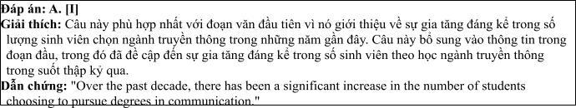
Câu 32. The phrase "growing popularity" in paragraph I could be best replaced by .
A. expanding influence B. increasing demand
C. rising awareness D. wider recognition
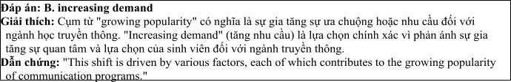
Câu 33. The word "oversaturation" in paragraph 3 refers to .
A. the abundance of career options in communication
B. the lack of demand in some communication sectors
C. the increasing number of qualified candidates
D. the limited availability of media-related jobs
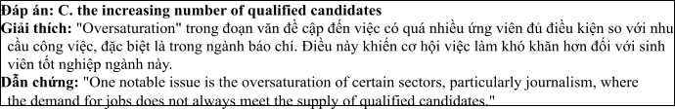
Câu 34. According to paragraph 2, which of the following is NOT a pull factor?
A. Better career prospects
B. A wide range of industries to work in
C. Digitalisation of society
D. Limited career opportunities in other fields
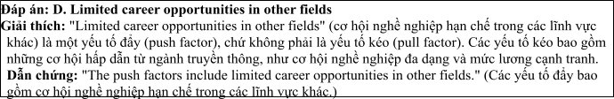
Câu 35. Which of the following best summarises paragraph 3?
A. Communication is an oversaturated field, making it difficult for graduates to find jobs.
B. Graduates of communication face the challenge of staying up-to-date with technological changes.
C. Communication degrees offer various career opportunities but come with the challenge of competition.
D. The rapidly changing media landscape makes it hard for students to find stable jobs.
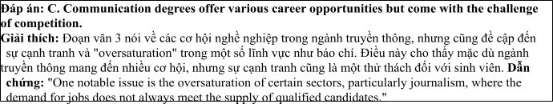
Câu 36. The word "dynamic" in paragraph 2 is OPPOSITE in meaning to .
A. inactive B. evolving C. flexible D. diverse
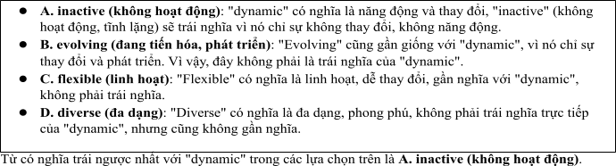
Câu 37. Which of the following is TRUE according to the passage?
1. Communication studies are expected to decline in popularity by 2030.
2. Technological advancements in media are a key reason for the rising demand for communication professionals.
3. Students pursuing communication degrees are often unable to find relevant career opportunities.
4. The media industry is experiencing a decline due to oversaturation.
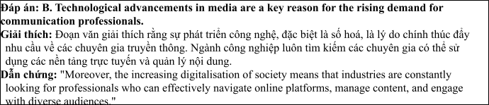
Câu 38. Which of the following best paraphrases the underlined sentence "The growing interest in communication studies reflects the demand for professionals..." in paragraph 4?
1. The increasing popularity of communication degrees indicates a shrinking job market for professionals.
2. More students studying communication signals a rise in the demand for skilled professionals in the field.
3. Communication programs are becoming more competitive due to the growing number of interested students.
4. Communication studies are not yet in demand despite the growing number of students choosing it.
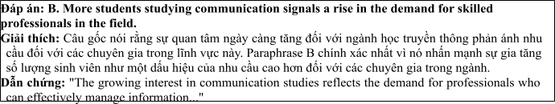
Câu 39. Which of the following can be inferred from the passage?
1. The communication field is growing, but its growth comes with challenges such as oversaturation and competition.
2. Students choose communication as a last resort when other fields offer fewer career prospects.
3. The rise in communication programs is due to the oversupply of jobs in other sectors.
4. The media industry is expected to become less competitive in the future due to fewer students studying communication.
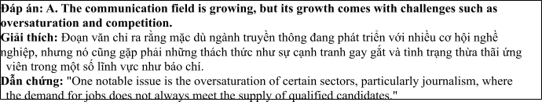
Câu 40. Which of the following best summarises the passage?
1. Communication degrees are increasingly popular due to the diverse career opportunities they offer, but students face challenges such as competition and the need for continuous skill upgrades.
2. The growing interest in communication reflects an oversupply of qualified candidates, making it harder for graduates to secure jobs.
3. Students pursuing communication degrees are attracted to the field by its competitive salaries but may struggle with technological changes.
4. As the communication field expands, students are attracted to it due to the variety of career options, but they must be prepared for its evolving nature.
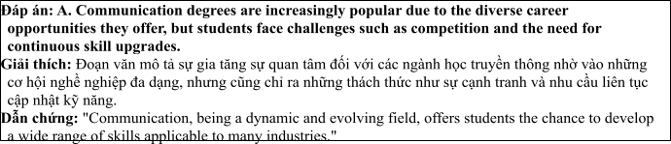

ĐỀ 7 | ĐỀ KIỂM TRA GIỮA HK2 NĂM HỌC 2024-2025  MÔN: TIẾNG ANH LỚP 12

Read the following advertisement and mark the letter A, B, C and D on your answer sheet to indicate the option that best fits each of the numbered blanks from 1 to 6
A Global Responsibility
Wildlife conservation plays a crucial role in preserving biodiversity and maintaining the health of ecosystems. With species around the world facing (1) ________ from habitat loss, poaching, and climate change, urgent efforts are required to protect them. Endangered animals, having lost (2) _______, are now more vulnerable than ever. Governments and organizations, (3) _______ together to create protected areas, strive to mitigate these risks. Conservation projects, supported by local communities, aim to restore habitats and reduce human-wildlife conflict. We must (4) ______ an effort to raise awareness (5) _______ the importance of protecting wildlife. Many people decide (6) ______ for wildlife protection programs, contributing their time and skills to this noble cause. By doing so, we ensure a future where nature thrives alongside human development.
(Adapted from daily news)
Câu 1: A. threats B. threat C. threaten D. threatening
Câu 2: A. natural their habitats B. their habitats natural
C. their natural habitats D. habitats their natural
Câu 3: A. which working B. worked C. was working D. working
Câu 4: A. stay B. make C. offer D. come
Câu 5: A. from B. on C. about D. to
Câu 6: A. to volunteering B. to volunteer C. volunteer D. to be volunteering
Read the following leaflet and mark the letter A, B, C or D on your answer sheet to indicate the option that best fits each of the numbered blanks from 7 to 12.
Conservation for Endangered Species
• Conservation for endangered species is crucial for maintaining biodiversity and ecological balance. (7) _______ global efforts, several species that were once on the brink of extinction are now seeing a slow recovery. The (8)________ of conservation programs (9)_______ habitat preservation and anti-poaching measures, aiming to create safe environments for wildlife.
• (10) _______ key aspect is the establishment of wildlife reserves, which offer protection and support breeding efforts. These efforts are driven by the combined forces of environmental (11) ________, local communities, and governments, working together for a common cause.
• With sustained funding and awareness, the protection of endangered species can make a significant difference in preserving our planet's rich (12) _______ for future generations.
Câu 7. A. Due to B. Thanks to C. On account of D. Irrespective of
Câu 8. A. majority B. item C. number D. amount
Câu 9. A. go off B. combine with C. take over D. focus on
Câu 10. A. Others B.Each other C. The others D. Another
Câu 11. A. contents B. issues C. organizations D. attitudes
Câu 12. A. sustainability B. eecosystem C. environment D. biodiversity
Mark the letter A, B, C or D on your answer sheet to indicate the best arrangement of utterances or sentences to make a meaningful exchange or text in each of the following questions from 13 to 17.
Câu 13
a. Mark: Thanks, Nam! It's something I feel really passionate about. Do you know much about how we can help?
b. Nam: Hey, Mark! I saw your post about helping endangered species. That's amazing!
c. Nam: Yes, there are lots of ways to help, like supporting wildlife reserves, reducing deforestation, and fighting illegal poaching.
A. a-c-b B. b-c-a C. c-b-a D. b-a-c
Câu 14
a. Sue: We should support stronger laws and raise awareness about the issue.
b. Alex: You're right. Public awareness is crucial to ending this illegal trade.
c. Alex: Why is raising awareness so important?
d. Sue: Because the more people understand the consequences of wildlife trafficking, the more they will act to stop it.
e. Alex: What can we do to stop illegal wildlife trade?
A. e-a-c-d-b B. c-e-d-b-a C. d-b-a-e-c D. c-d-e-a-b
Câu 15
Hi Sarah,
a. But I found the article quite enlightening and thought-provoking.
b. Thanks also for the recommendation of that environmental podcast — it’s much more insightful than the ones I’ve listened to before.
c. We should consider organizing an event to promote the protection of endangered animals. What do you think?
d. Thanks a lot for sharing that article about deforestation and its impact on endangered species.
e. It's important to learn more about these threats, but I am currently dedicating my time to studying animal protection laws.
Write back soon.
Anna
A. d-b-a-c-e B.d-e-a-b-c C. a-d-b-c-e D. a-c-d-b-e
Câu 16
a. My love for animals and conservation led me to pursue a career in wildlife protection.
b. While traveling to remote areas for field research can be challenging, it's a small sacrifice compared to the importance of the work we do.
c. In conclusion, I feel incredibly fulfilled in my role, as it allows me to combine my passion for animals with my professional skills in conservation.
d. For the past two years, I have been working with a nonprofit organization, where I help raise awareness and organize campaigns to protect endangered species.
e. The ability to work alongside passionate conservationists in the field inspires me and keeps me motivated.
(Adapted from discovery)
A. a-d-e-b-c B. a-b-c-d-e C. b-c-d-a-e D. c-a-d-b-e
Câu 17
a. Large, diverse habitats that once thrived with wildlife are being replaced by industrial development and agricultural expansion, signaling a shift towards human-driven land use.
b. The increase in wildlife protection efforts has led to a rise in funding and public awareness, with many communities now actively participating in conservation projects and wildlife monitoring.
c. Efforts to protect endangered species have gained significant momentum over the past decade.
d. However, despite these positive changes, the illegal poaching of certain species remains a major threat, as strict laws and enforcement efforts are still catching up with the growing demand for animal products.
e. This shift has brought in both challenges and opportunities, as new conservation organizations have emerged to protect vulnerable species, while some industries have started to integrate wildlife protection into their business models.
(Adapted from i-Learn Smart World)
A. c-a-e-b-d B. d-c-a-b-e C. c-a-e-b-d D. d-e-b-c-a
Read the following passage about Effective Strategies for Protecting Endangered Species and mark the letter A, B, C or D on your answer sheet to indicate the option that best fits each of the numbered blanks from 18 to 22.
The protection of endangered animals has become a global priority in recent years. Governments and organizations around the world (18) ________, and several laws have been enacted to protect vulnerable species. One of the most successful initiatives is the establishment of wildlife reserves, (19) _________to thrive. These efforts (20) __________. However, the illegal wildlife trade remains a serious threat, and
(21) _________. Poaching continues to be a problem, particularly in areas where resources are scarce, leading to a significant decrease in animal populations. For instance, rhino poaching in Africa has escalated, with poachers targeting these animals for their horns. Governments should (22) __________ before the situation becomes irreversible. If more resources were allocated to anti-poaching efforts, the survival of these species could be ensured for future generations.
(Adapted from discoverychannel)
Câu 18:
A. have recognized the urgent need to preserve biodiversity
B. are recognized the urgent need to preserving biodiversity
C. have been recognized the urgent need to preserve biodiversity
D. were recognized the urgent that needs to preserve biodiversity
Câu 19:
A. that provides for endangered animals a safe environment
B. which provide a safe environment for endangered animals
C. who provided the safeness of environment for animals endangered
D. which provide for endangered animals a safe environments
Câu 20:
A. had been supported by both local communities nor international organizations
B. are supported by both local communities or international organizations
C. have been supported by both local communities and international organizations
D. will have been supported by both local communities with international organizations
Câu 21:
A. stricter regulations can be enforced B. stricter regulations might be enforced
C. stricter regulations will be enforced D. stricter regulations must be enforced
Câu 22:
A. take immediate action to stop this illegal activity
B. create immediately action to have stopped this illegally activity
C. get immediate action not to stop this illegal activity
D. have immediate action to stop this activity illegally
Read the following passage about choosing communication studies of students and mark the letter A, B, C or D on your answer sheet to indicate the best answer to each of the following questions from 23 to 30.
There are currently over 8 million species of animals and plants in the world, but many of them are in danger of extinction due to human activities. Habitat destruction, poaching, and climate change are some of the main factors causing this crisis. Efforts to protect wildlife have increased in recent years, and many conservation organizations are working to ensure that these species are preserved for future generations. Some of the largest initiatives focus on creating wildlife reserves, strengthening anti-poaching laws, and raising public awareness.
One effective method of protecting wild animals is the establishment of protected areas, such as national parks and wildlife sanctuaries. These areas provide safe environments for animals to live and breed without the threat of human interference. For example, the Yellowstone National Park in the United States has successfully protected species like the gray wolf and bison. These protected areas also allow scientists to study wildlife in their natural habitats, which is crucial for understanding their behaviors and survival needs.
Another important approach is enforcing strict anti-poaching laws. Poaching for illegal trade in animal parts is one of the biggest threats to many endangered species, especially elephants, rhinos, and tigers. Countries like Kenya and India have adopted stricter wildlife protection laws, and they are actively working with international organizations to combat poaching. Increasing penalties for wildlife crimes and improving surveillance in high-risk areas are also essential in reducing poaching activities.
Technology plays a crucial role in modern wildlife conservation efforts. Drones and satellite tracking are being used to monitor animal movements and detect illegal activities such as poaching. Moreover, social media platforms and websites are used to raise awareness and encourage people to support wildlife protection campaigns. Programs like the “Wildlife Crime” app allow individuals to report suspicious activities, which helps authorities take swift action to protect endangered species.
(Adapted from dailynews)
Câu 23: Which of the following is NOT mentioned as a major threat to wildlife in the passage?
A. Habitat destruction B. Poaching C. Climate change D. Overhunting
Câu 24: The word “extinction” in paragraph 1 is OPPOSITE in meaning to
A. Survival B. Loss C. Reduction D. Abundance
Câu 25: The word “these” in paragraph 2 refers to
A. Species B. Habitats C. Parks and sanctuaries D. Animals
Câu 26: The word "interference" in paragraph 2 could be best replaced by
A. Protection B. Involvement C. Disruption D. Support
Câu 27: Which of the following best paraphrases the underlined sentence "Efforts to protect wildlife have increased in recent years" in paragraph 1?
A. There have been fewer efforts to protect wildlife in recent years.
B. The protection of wildlife has been ignored for many years.
C. Wildlife protection efforts have grown in importance in recent years.
D. Protection efforts for wildlife have been less effective recently.
Câu 28: Which of the following is TRUE according to the passage?
A. Protected areas are not helpful in conserving wildlife.
B. Poaching is not a serious threat to wild animals.
C. Technology has no impact on protecting endangered species.
D. Strict anti-poaching laws are essential in protecting endangered species.
Câu 29: In which paragraph does the writer mention a current method for wildlife protection?
A. Paragraph 1 B. Paragraph 2 C. Paragraph 3 D. Paragraph 4
Câu 30: In which paragraph does the writer discuss the use of technology in wildlife conservation?
A. Paragraph 1 B. Paragraph 2 C. Paragraph 3 D. Paragraph 4
Read the following passage about wildlife conservation and mark the letter A, B, C or D on your answer sheet to indicate the best answer to each of the following questions from 31 to 40.
[I] Wildlife conservation has become a critical global issue as many species face extinction due to human activities such as habitat destruction, poaching, and climate change. Protecting wildlife is crucial not only for preserving biodiversity but also for maintaining ecological balance. Experts warn that without urgent action, many species could vanish in the coming decades, which would have devastating consequences on ecosystems.
[II] One effective approach to wildlife conservation is habitat preservation. By creating protected areas, such as national parks and wildlife reserves, governments and conservation organisations ensure that animals have safe environments to live and breed. Additionally, reducing human encroachment on these areas through better land-use policies and stricter regulations helps protect these vital habitats in the long term.
[III] Another critical strategy involves combating poaching and illegal wildlife trade. Enhanced law enforcement, international collaboration, and the use of advanced technology such as drones and satellite surveillance are instrumental in detecting and preventing poaching activities. Public education campaigns are also essential, as they raise awareness about the impact of poaching and encourage ethical behavior towards wildlife.
[IV] Supporting sustainable practices, such as eco-tourism and responsible resource management, can also contribute to wildlife conservation. By promoting eco-friendly industries and sustainable farming techniques, human activities can coexist more harmoniously with nature. Additionally, captive breeding programs in zoos and wildlife sanctuaries help rebuild populations of endangered species, providing a safety net for animals on the brink of extinction.
(Adapted from vietnamesenews)
Câu 31. Where does the following sentence best fit?
“Many species face extinction due to human activities such as habitat destruction and poaching.”
A. [I] B. [II] C. [III] D. [IV]
Câu 32. The phrase “urgent action” in paragraph 1 could be best replaced by ____.
A. immediate response B. necessary intervention
C. organized plan D. long-term effort
Câu 33. The word “They” in paragraph 3 refers to ____.
A. Wildlife sanctuaries B. Public education campaigns C. Animals D. Protected areas
Câu 34. According to paragraph 2, which of the following is NOT a method of habitat preservation?
A. Creating national parks B. Reducing human encroachment
C. Encouraging illegal logging D. Enforcing stricter regulations
Câu 35. Which of the following best summarises paragraph 3?
A. Law enforcement alone can stop wildlife poaching.
B. Public awareness has minimal impact on poaching activities.
C. Technology and public education play essential roles in reducing poaching.
D. The government should focus on reducing poaching through legal punishment.
Câu 36. The word “encourage” in paragraph 3 is OPPOSITE in meaning to ____.
A. promote B. persuade C. prevent D. support
Câu 37. Which of the following is TRUE according to the passage?
A. Sustainable practices can harm wildlife conservation if not properly managed.
B. Eco-tourism has no significant benefits for wildlife protection.
C. Breeding programs in captivity can help rebuild endangered species populations.
D. Habitat preservation alone is sufficient for the survival of all species.
Câu 38. Which of the following best paraphrases the underlined sentence “By creating protected areas, such as national parks and wildlife reserves, governments and conservation organisations ensure that animals have safe environments to live and breed” in paragraph 2?
A. Protected areas guarantee a safe habitat for animals by preventing illegal poaching.
B. National parks and wildlife reserves offer a secure place for animals to live and reproduce.
C. Governments and organisations should create national parks to ensure animal survival.
D. Protecting wildlife means establishing stricter regulations in national parks.
Câu 39. Which of the following can be inferred from the passage?
A. Sustainable tourism can help raise awareness about wildlife conservation and generate funds.
B. Poaching is no longer a major threat to wildlife because of international cooperation.
C. Habitat destruction is the only major cause of wildlife extinction.
D. Conservation programs should focus solely on protecting habitats.
Câu 40. Which of the following best summarises the passage?
A. Effective wildlife conservation requires a comprehensive strategy, including habitat protection, combatting poaching, promoting sustainable practices, and supporting breeding programs.
B. Only protecting habitats will ensure the survival of endangered species.
C. Poaching is the main threat to wildlife and should be the sole focus of conservation efforts.
D. Wildlife conservation relies primarily on law enforcement and technology, with little emphasis on habitat protection.

ĐÁP ÁN VÀ LỜI GIẢI

Read the following advertisement and mark the letter A, B, C and D on your answer sheet to indicate the option that best fits each of the numbered blanks from 1 to 6

A Global Responsibility
Wildlife conservation plays a crucial role in preserving biodiversity and maintaining the health of ecosystems. With species around the world facing (1) from habitat loss, poaching, and climate change, urgent efforts are required to protect them. Endangered animals, having lost (2) , are now more vulnerable than ever. Governments and organizations, (3) together to create protected areas, strive to mitigate these risks. Conservation projects, supported by local communities, aim to restore habitats and reduce human-wildlife conflict. We must (4) an effort to raise awareness (5) the importance of protecting wildlife. Many people decide (6) for wildlife protection programs, contributing their time and skills to this noble cause. By doing so, we ensure a future where nature thrives alongside human development.
(Adapted from daily news)
Câu 1: A. threats B. threat C. threaten D. threatening
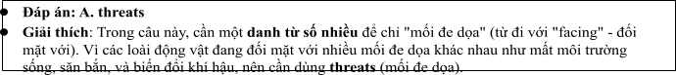
Câu 2: A. natural their habitats  C. their natural habitats |  | B. their habitats natural  D. habitats their natural
• Đáp án: C. their natural habitats  • Giải thích: Câu cần sử dụng "their natural habit  "habitats" (môi trường sống tự nhiên của chúng), và "môi trường sống tự nhiên của chúng". |  | ats" vì "natural" là tính từ chỉ đặc điểm của  "their" phải đứng trước "natural habitats" để chỉ
Câu 3: A. which working | B. worked | C. was working D. working
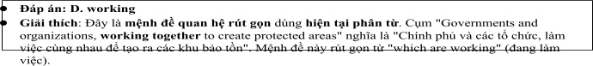
Câu 4: A. stay B. make C. offer D. come
Câu 5: A. from B. on C. about D. to
Câu 6: A. to volunteering B. to volunteer C. volunteer D. to be volunteering
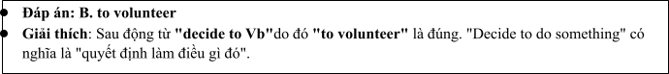
Read the following leaflet and mark the letter A, B, C or D on your answer sheet to indicate the option that best fits each of the numbered blanks from 7 to 12.

Conservation for Endangered Species
• Conservation for endangered species is crucial for maintaining biodiversity and ecological balance.
(7) global efforts, several species that were once on the brink of extinction are now seeing a slow recovery. The (8) of conservation programs (9) habitat preservation and anti-poaching measures, aiming to create safe environments for wildlife.
• (10) key aspect is the establishment of wildlife reserves, which offer protection and support breeding efforts. These efforts are driven by the combined forces of environmental (11) , local communities, and governments, working together for a common cause.
• With sustained funding and awareness, the protection of endangered species can make a significant difference in preserving our planet's rich (12) for future generations.
Câu 7. A. Due to B. Thanks to C. On account of D. Irrespective of
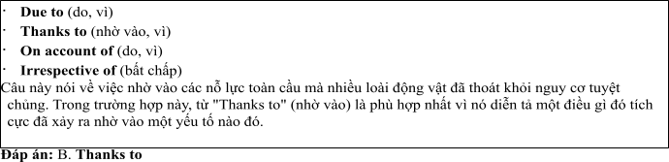
Câu 8. A. majority B. item C. number D. amount
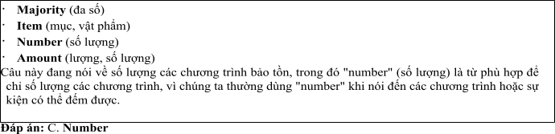
Câu 9. A. go off B. combine with C. take over D. focus on
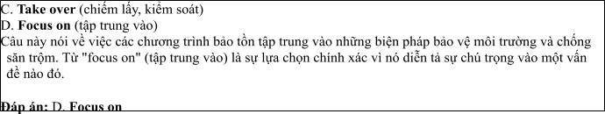
Câu 10. A. Others B.Each other C. The others D. Another
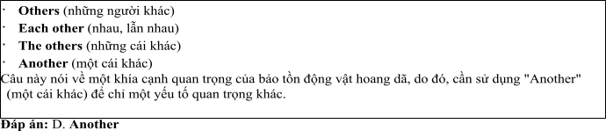
Câu 11. A. contents B. issues C. organizations D. attitues
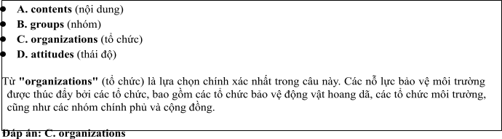
Câu 12. A. sustainability B. ecosystem C. environment D. biodiversity
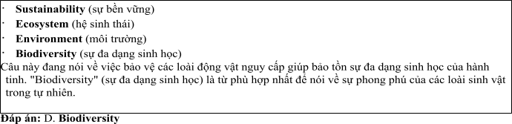
Mark the letter A, B, C or D on your answer sheet to indicate the best arrangement of utterances or sentences to make a meaningful exchange or text in each of thefollowing questions from 13 to 17.

Câu 13
1. Mark: Thanks, Nam! It's something I feel really passionate about. Do you know much about how we can help?
2. Nam: Hey, Mark! I saw your post about helping endangered species. That's amazing!
3. Nam: Yes, there are lots of ways to help, like supporting wildlife reserves, reducing deforestation, and fighting illegal poaching.
A. a-c-b B. b-c-a C. c-b-a D. b-a-c
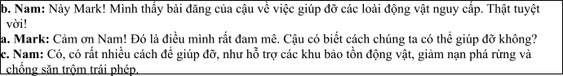

Câu 14
1. Sue: We should support stronger laws and raise awareness about the issue.
2. Alex: You're right. Public awareness is crucial to ending this illegal trade.
3. Alex: Why is raising awareness so important?
4. Sue: Because the more people understand the consequences of wildlife trafficking, the more they will act to stop it.
5. Alex: What can we do to stop illegal wildlife trade?
A. e-a-c-d-b B. c-e-d-b-a C. d-b-a-e-c D. c-d-e-a-b
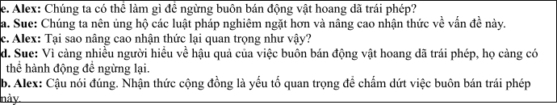

Câu 15 Hi Sarah,
1. But I found the article quite enlightening and thought-provoking.
2. Thanks also for the recommendation of that environmental podcast — it’s much more insightful than the ones I’ve listened to before.
3. We should consider organizing an event to promote the protection of endangered animals. What do you think?
4. Thanks a lot for sharing that article about deforestation and its impact on endangered species.
5. It's important to learn more about these threats, but I am currently dedicating my time to studying animal protection laws.
Write back soon.

Anna
A. d-b-a-c-e B.d-e-a-b-c C. a-d-b-c-e D. a-c-d-b-e
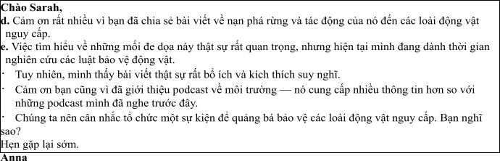

Câu 16
1. My love for animals and conservation led me to pursue a career in wildlife protection.
2. While traveling to remote areas for field research can be challenging, it's a small sacrifice compared to the importance of the work we do.
3. In conclusion, I feel incredibly fulfilled in my role, as it allows me to combine my passion for animals with my professional skills in conservation.
4. For the past two years, I have been working with a nonprofit organization, where I help raise awareness and organize campaigns to protect endangered species.
5. The ability to work alongside passionate conservationists in the field inspires me and keeps me motivated.
(Adapted from discovery)
A. a-d-e-b-c B. a-b-c-d-e C. b-c-d-a-e D. c-a-d-b-e
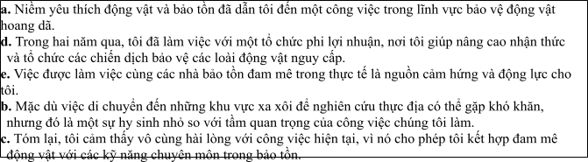

Câu 17
1. Large, diverse habitats that once thrived with wildlife are being replaced by industrial development and agricultural expansion, signaling a shift towards human-driven land use.
2. The increase in wildlife protection efforts has led to a rise in funding and public awareness, with many communities now actively participating in conservation projects and wildlife monitoring.
3. Efforts to protect endangered species have gained significant momentum over the past decade.
4. However, despite these positive changes, the illegal poaching of certain species remains a major threat, as strict laws and enforcement efforts are still catching up with the growing demand for animal products.
5. This shift has brought in both challenges and opportunities, as new conservation organizations have emerged to protect vulnerable species, while some industries have started to integrate wildlife protection into their business models.
(Adapted from i-Learn Smart World)
A. c-a-e-b-d B. d-c-a-b-e C. c-a-e-b-d D. d-e-b-c-a
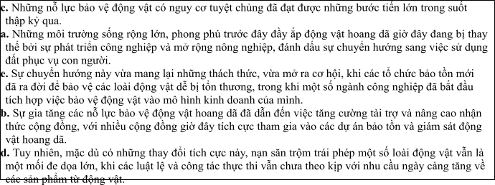
Read thefollowing passage about Effective Strategies for Protecting Endangered Species and mark the letter A, B, C or D on your answer sheet to indicate the option that bestfits each of the numbered blanksfrom 18 to 22.
The protection of endangered animals has become a global priority in recent years. Governments and organizations around the world (18) , and several laws have been enacted to protect vulnerable species. One of the most successful initiatives is the establishment of wildlife reserves, (19) to thrive. These efforts (20) . However, the illegal wildlife trade remains a serious threat, and
(21) . Poaching continues to be a problem, particularly in areas where resources are scarce, leading to a significant decrease in animal populations. For instance, rhino poaching in Africa has escalated, with poachers targeting these animals for their horns. Governments should (22) before the situation becomes irreversible. If more resources were allocated to anti-poaching efforts, the survival of these species could be ensured for future generations.
(Adapted from discoverychannel)
Câu 18:
1. have recognized the urgent need to preserve biodiversity
2. are recognized the urgent need to preserving biodiversity
3. have been recognized the urgent need to preserve biodiversity
4. were recognized the urgent that needs to preserve biodiversity
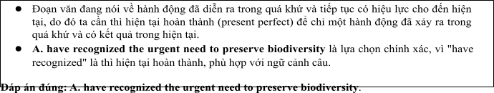

Câu 19:
1. that provides for endangered animals a safe environment
2. which provide a safe environment for endangered animals
3. who provided the safeness of environment for animals endangered
4. which provide for endangered animals a safe environments
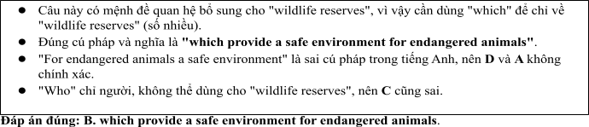

Câu 20:
1. had been supported by both local communities nor international organizations
2. are supported by both local communities or international organizations
3. have been supported by both local communities and international organizations
4. will have been supported by both local communities with international organizations
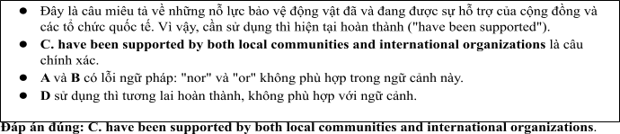

Câu 21:
A. stricter regulations can be enforced B. stricter regulations might be enforced
C. stricter regulations will be enforced D. stricter regulations must be enforced
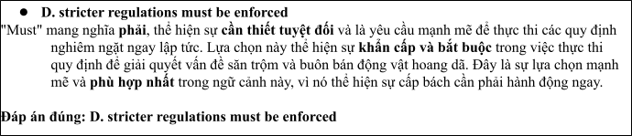

Câu 22:
1. take immediate action to stop this illegal activity
2. create immediately action to have stopped this illegally activity
3. get immediate action not to stop this illegal activity
4. have immediate action to stop this activity illegally
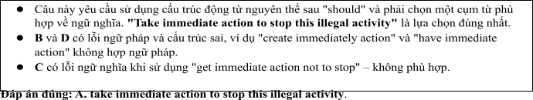
Read the following passage about choosing communication studies of students and mark the letter A, B, C or D on your answer sheet to indicate the best answer to each of the following questionsfrom 23 to 30.
There are currently over 8 million species of animals and plants in the world, but many of them are in danger of extinction due to human activities. Habitat destruction, poaching, and climate change are some of the main factors causing this crisis. Efforts to protect wildlife have increased in recent years, and many conservation organizations are working to ensure that these species are preserved for future generations. Some of the largest initiatives focus on creating wildlife reserves, strengthening anti-poaching laws, and raising public awareness.
One effective method of protecting wild animals is the establishment of protected areas, such as national parks and wildlife sanctuaries. These areas provide safe environments for animals to live and breed without
the threat of human interference. For example, the Yellowstone National Park in the United States has successfully protected species like the gray wolf and bison. These protected areas also allow scientists to study wildlife in their natural habitats, which is crucial for understanding their behaviors and survival needs.
Another important approach is enforcing strict anti-poaching laws. Poaching for illegal trade in animal parts is one of the biggest threats to many endangered species, especially elephants, rhinos, and tigers. Countries like Kenya and India have adopted stricter wildlife protection laws, and they are actively working with international organizations to combat poaching. Increasing penalties for wildlife crimes and improving surveillance in high-risk areas are also essential in reducing poaching activities.
Technology plays a crucial role in modern wildlife conservation efforts. Drones and satellite tracking are being used to monitor animal movements and detect illegal activities such as poaching. Moreover, social media platforms and websites are used to raise awareness and encourage people to support wildlife protection campaigns. Programs like the “Wildlife Crime” app allow individuals to report suspicious activities, which helps authorities take swift action to protect endangered species.
(Adapted from dailynews)
Câu 23: Which of the following is NOT mentioned as a major threat to wildlife in the passage?
A. Habitat destruction B. Poaching C. Climate change D. Overhunting
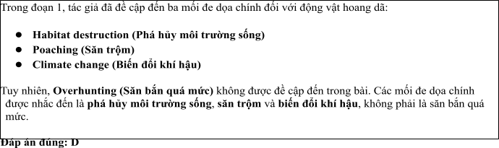
Câu 24: The word “extinction” in paragraph 1 is OPPOSITE in meaning to
A. Survival B. Loss C. Reduction D. Abundance
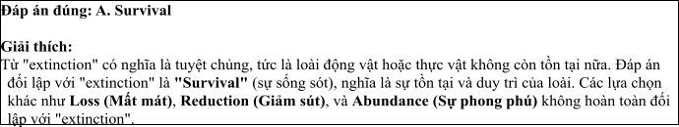
Câu 25: The word “these” in paragraph 2 refers to
A. Species B. Habitats C. Parks and sanctuaries D. Animals
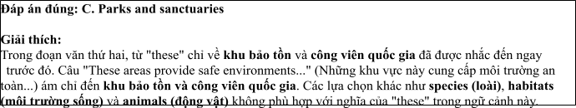
Câu 26: The word "interference" in paragraph 2 could be best replaced by
A. Protection B. Involvement C. Disruption D. Support
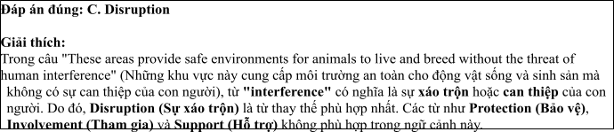
Câu 27: Which of the following best paraphrases the underlined sentence "Efforts to protect wildlife have increased in recent years" in paragraph 1?
1. There have been fewer efforts to protect wildlife in recent years.
2. The protection of wildlife has been ignored for many years.
3. Wildlife protection efforts have grown in importance in recent years.
4. Protection efforts for wildlife have been less effective recently.
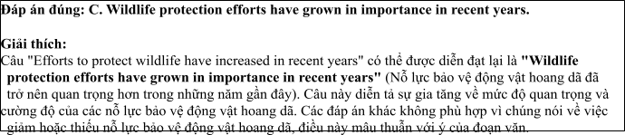
Câu 28: Which of the following is TRUE according to the passage?
1. Protected areas are not helpful in conserving wildlife.
2. Poaching is not a serious threat to wild animals.
3. Technology has no impact on protecting endangered species.
4. Strict anti-poaching laws are essential in protecting endangered species.
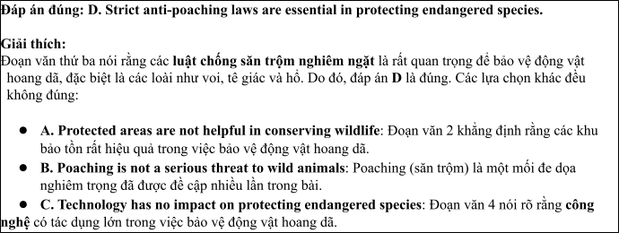
Câu 29: In which paragraph does the writer mention a current method for wildlife protection?
A. Paragraph 1 B. Paragraph 2 C. Paragraph 3 D. Paragraph 4
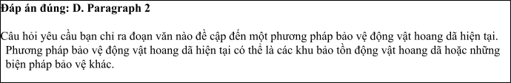
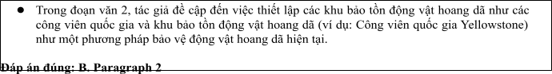
Câu 30: In which paragraph does the writer discuss the use of technology in wildlife conservation?
A. Paragraph 1 B. Paragraph 2 C. Paragraph 3 D. Paragraph 4
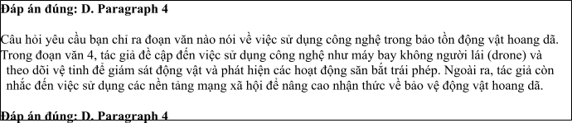
Read the following passage about wildlife conservation and mark the letter A, B, C or D on your answer sheet to indicate the best answer to each of the following questions from 31 to 40.
1. Wildlife conservation has become a critical global issue as many species face extinction due to human activities such as habitat destruction, poaching, and climate change. Protecting wildlife is crucial not only for preserving biodiversity but also for maintaining ecological balance. Experts warn that without urgent action, many species could vanish in the coming decades, which would have devastating consequences on ecosystems.
2. One effective approach to wildlife conservation is habitat preservation. By creating protected areas, such as national parks and wildlife reserves, governments and conservation organisations ensure that animals have safe environments to live and breed. Additionally, reducing human encroachment on these areas through better land-use policies and stricter regulations helps protect these vital habitats in the long term.
3. Another critical strategy involves combating poaching and illegal wildlife trade. Enhanced law enforcement, international collaboration, and the use of advanced technology such as drones and satellite surveillance are instrumental in detecting and preventing poaching activities. Public education campaigns are also essential, as they raise awareness about the impact of poaching and encourage ethical behavior towards wildlife.
4. Supporting sustainable practices, such as eco-tourism and responsible resource management, can also contribute to wildlife conservation. By promoting eco-friendly industries and sustainable farming techniques, human activities can coexist more harmoniously with nature. Additionally, captive breeding programs in zoos and wildlife sanctuaries help rebuild populations of endangered species, providing a safety net for animals on the brink of extinction.
(Adapted from vietnamesenews)
Câu 31. Where does the following sentence best fit?

“Many species face extinction due to human activities such as habitat destruction and poaching.”
A. [I] B. [II] C. [III] D. [IV]
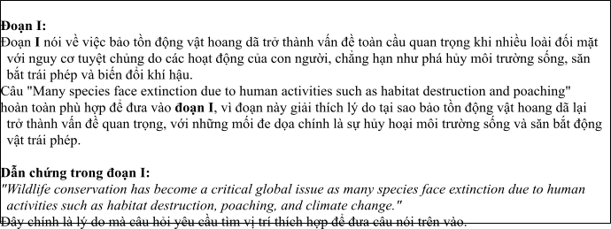
Câu 32. The phrase “urgent action” in paragraph 1 could be best replaced by .
1. immediate response B. necessary intervention
C. organized plan D. long-term effort
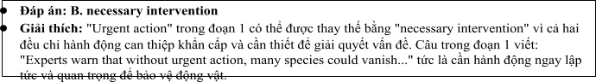
Câu 33. The word “They” in paragraph 3 refers to .
A. Wildlife sanctuaries B. Public education campaigns C. Animals D. Protected areas
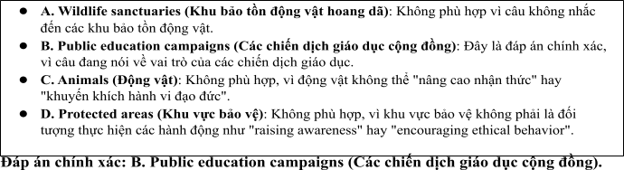
Câu 34. According to paragraph 2, which of the following is NOT a method of habitat preservation?
A. Creating national parks B. Reducing human encroachment
C. Encouraging illegal logging D. Enforcing stricter regulations
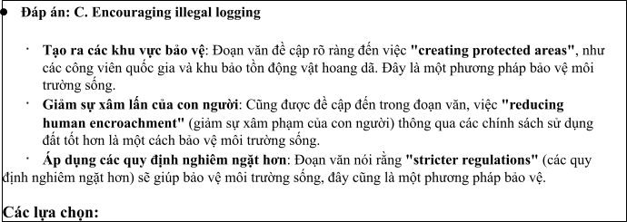
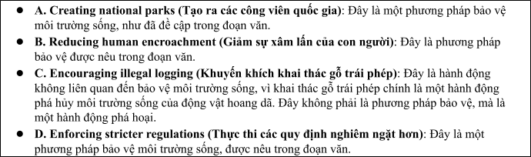
Câu 35. Which of the following best summarises paragraph 3?
1. Law enforcement alone can stop wildlife poaching.
2. Public awareness has minimal impact on poaching activities.
3. Technology and public education play essential roles in reducing poaching.
4. The government should focus on reducing poaching through legal punishment.
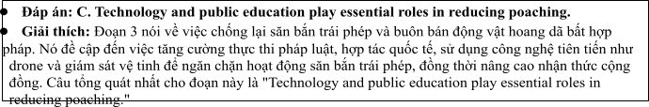
Câu 36. The word “encourage” in paragraph 3 is OPPOSITE in meaning to .
A. promote B. persuade C. prevent D. support
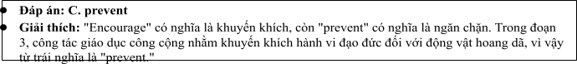
Câu 37. Which of the following is TRUE according to the passage?
1. Sustainable practices can harm wildlife conservation if not properly managed.
2. Eco-tourism has no significant benefits for wildlife protection.
3. Breeding programs in captivity can help rebuild endangered species populations.
4. Habitat preservation alone is sufficient for the survival of all species.
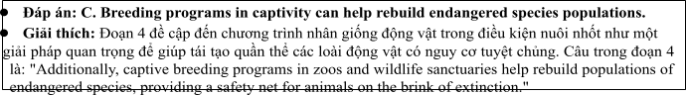
Câu 38. Which of the following best paraphrases the underlined sentence “By creating protected areas, such as national parks and wildlife reserves, governments and conservation organisations ensure that animals have safe environments to live and breed” in paragraph 2?
1. Protected areas guarantee a safe habitat for animals by preventing illegal poaching.
2. National parks and wildlife reserves offer a secure place for animals to live and reproduce.
3. Governments and organisations should create national parks to ensure animal survival.
4. Protecting wildlife means establishing stricter regulations in national parks.
Câu 39. Which of the following can be inferred from the passage?
1. Sustainable tourism can help raise awareness about wildlife conservation and generate funds.
2. Poaching is no longer a major threat to wildlife because of international cooperation.
3. Habitat destruction is the only major cause of wildlife extinction.
4. Conservation programs should focus solely on protecting habitats.
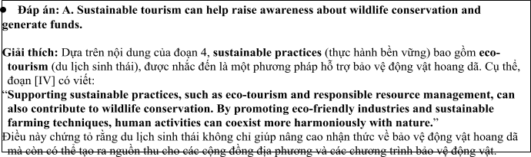
Câu 40. Which of the following best summarises the passage?
1. Effective wildlife conservation requires a comprehensive strategy, including habitat protection, combatting poaching, promoting sustainable practices, and supporting breeding programs.
2. Only protecting habitats will ensure the survival of endangered species.
3. Poaching is the main threat to wildlife and should be the sole focus of conservation efforts.
4. Wildlife conservation relies primarily on law enforcement and technology, with little emphasis on habitat protection.
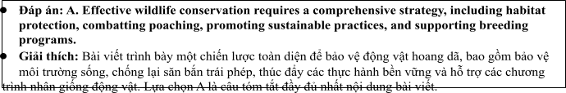

ĐỀ 8 | ĐỀ KIỂM TRA GIỮA HK2 NĂM HỌC 2024-2025  MÔN: TIẾNG ANH LỚP 12

Read the following advertisement and mark the letter A, B, C and D on your answer sheet to indicate the option that best fits each of the numbered blanks from 1 to 6
Protect Wildlife, Preserve Our Future
Protecting wildlife is vital for preserving our planet’s biodiversity. Many endangered species, vulnerable and helpless, are facing extinction due to habitat loss and poaching. Conservation efforts are (1) _______ working to protect these creatures from further harm. Through sustainable development and wildlife protection policies, we aim to create a safer environment for animals. Organizations and individuals (2) ______ a plan to fight illegal hunting and deforestation, (3) _______ a brighter future for wildlife. The government aims (4) ________ stricter laws against wildlife trafficking. By taking action now, we can reduce the negative impact of human activities (5) ______ ecosystems. Let’s unite to protect (6) ________ for generations to come—every effort counts!
(Adapted from daily news)
Câu 1: A. actively B. active C. action D. activity
Câu 2: A. get B. make C. come D. catch
Câu 3: A. which ensuring B. ensured C. was ensuring D. ensuring
Câu 4: A. to enforcing B. to enforce C. enforce D. to be enforcing
Câu 5: A. from B. on C. for D. in
Câu 6: A. these species incredible B. incredible these species
C. these incredible species D. species these incredible
Read the following leaflet and mark the letter A, B, C or D on your answer sheet to indicate the option that best fits each of the numbered blanks from 7 to 12.
Protecting Endangered Animals
• To protect endangered animals, we must take immediate action (7) ________habitat loss, poaching, and climate change. The (8) _______ of species facing extinction is increasing rapidly, affecting biodiversity around the world.
• Conservation efforts, such as creating protected (9) _______ and enforcing anti-poaching laws, are essential to safeguard these animals. (10) ________ critical actions include reducing deforestation and supporting sustainable practices.
• Governments, organizations, and individuals need to (11) _______ the root causes of these threats to preserve wildlife. Awareness campaigns and education on environmental (12) _______ are also crucial for ensuring the survival of these species. The role of conservationists is more important than ever to maintain ecological balance.
Câu 7. A. according to B. thanks to C. on account of D. due to
Câu 8. A. majority B. item C. number D. amount
Câu 9. A. areas B. groups C. organizations D. volunteers
Câu 10. A. Others B.Each other C. The others D. Other
Câu 11. A. go in B. deal with C. take up D. stand by
Câu 12. A. sustainability B. extinction C. avenue D. protection
Mark the letter A, B, C or D on your answer sheet to indicate the best arrangement of utterances or sentences to make a meaningful exchange or text in each of the following questions from 13 to 17.
Câu 13
a. Nam: Yes, I have. I’ve been raising awareness about endangered animals by sharing information on social media.
b. Nam: Hi, Mark! It's been a while. You look so energetic!
c. Mark: Hi, Nam! Thanks! You look fantastic too. Have you been doing anything to protect endangered species?
A. a-c-b B. b-c-a C. c-b-a D. b-a-c
Câu 14
a. Mark: I’m going to organize a campaign to inform people about endangered species.
b. Nam: Why a campaign?
c. Mark: Campaigns help spread knowledge quickly and encourage others to take action.
d. Nam: What will you do to raise awareness about wildlife protection?
e. Nam: I think spreading awareness online would be more effective. I’ll start a social media group.
A. d-a-b-c-e B. c-e-d-b-a C. d-b-a-e-c D. c-d-e-a-b
Câu 15
Hi Sarah,
a. Glad you saw it! We need to do more to protect the forests.
b. That’s awesome! Rescue centers play such a crucial role in saving animals from illegal trafficking.
c. Hey, Mark! I saw your post about protecting wildlife habitats.
d. Yes, I think we should raise awareness about deforestation, but for now, I’m focusing on supporting animal rescue centers.
e. We should work together to promote both causes. What’s your opinion on that?
Write back soon.
Anna
A. d-b-a-c-e B.c-a-d-b-e C. a-d-b-c-e D. a-c-d-b-e
Câu 16
a. Governments need to implement stricter measures against wildlife violations, including heavy penalties and anti-smuggling actions.
b. To protect wildlife, it is crucial to minimize illegal hunting and exploitation activities.
c. Wildlife protection organizations also play an important role in researching and monitoring species at risk of extinction.
d. In conclusion, everyone must work together to protect wildlife species as they contribute to maintaining ecological balance.
e. I always participate in campaigns calling for an end to wildlife trade, especially for endangered species.
(Adapted from discovery)
A. b-e-c-a-d B. a-b-c-d-e C. b-c-d-a-e D. c-a-d-b-e
Câu 17
a. On the other hand, harmful activities such as deforestation and pollution need to be reduced to allow wildlife to thrive.
b. Collecting data on wildlife populations and monitoring endangered species is crucial.
c. Scientific research helps identify areas that need protection and develop effective conservation strategies.
d. In conclusion, only through cooperation between nations and the international community can we effectively protect wildlife.
e. Wildlife protection is a long-term effort that requires continuous commitment from organizations and individuals.
(Adapted from i-Learn Smart World)
A. c-a-e-b-d B. d-c-a-b-e C. e-b-c-a-d D. d-e-b-c-a
Read the following passage about Effective Strategies for Protecting Endangered Species and mark the letter A, B, C or D on your answer sheet to indicate the option that best fits each of the numbered blanks from 18 to 22.
The government has recently increased efforts to protect wildlife due to the growing threats of poaching and habitat destruction. (18) _________, where animals are safeguarded from illegal hunting and environmental damage. Various protection programs have been launched by environmental agencies, (19) __________. These initiatives have been supported (20) __________, and have been praised for their effectiveness in conserving endangered species. However, despite these improvements, deforestation remains a major issue, as (21) ____________. In some regions, illegal logging is still happening at an alarming rate, posing a serious threat to wildlife habitats. As a result, more stringent policies need to be enforced (22) __________. Only with stronger actions and global cooperation can the survival of endangered species be ensured.
(Adapted fromNBCnews)
Câu 18:
A. Many new wildlife reserves have been established
B. Many new wildlife reserves are established
C. Many new wildlife reserves will have established .
D. Many new wildlife reserves were being established
Câu 19:
A. whom are working by the local communities to ensuring the sustainable practices
B. who are working with local communities to ensure sustainable practices
C. which are working by the local communities to ensure the sustainable practices
D. that are working with local communities to ensured a sustainable practices
Câu 20:
A. by both national or international organizations
B. by both national nor international organizations
C. by both national and international organizations
D. by neither national nor international organizations
Câu 21:
A. forests continued to be clearing for the agricultural expansion
B. forests continue to have been cleared by agricultural expansion
C. forests have continued to clear for agricultural expansion
D. forests continue to be cleared for agricultural expansion
Câu 22:
A. in order to address these ongoing challenges
B. in order that address these ongoing challenge
C. in order to the address for these ongoing challenges
D. in order to not address these ongoing challenges
Read the following passage about Wildlife Protection Efforts Around the World and mark the letter A, B, C or D on your answer sheet to indicate the best answer to each of the following questions from 23 to 30.
There are currently thousands of species of animals at risk of extinction worldwide. Many of these species are under threat due to human activities, such as deforestation, illegal hunting, and climate change. However, governments around the world have been taking action to protect endangered species and their habitats. One of the major steps involves strengthening wildlife protection laws, creating protected areas, and investing in wildlife conservation projects.
For instance, in Africa, the governments of countries like Kenya and South Africa have established vast national parks and wildlife reserves to safeguard species such as elephants, lions, and rhinos. These protected areas allow animals to roam freely without the threat of poaching or habitat destruction. Additionally, strict anti-poaching laws have been enacted, with severe penalties for those caught hunting endangered animals illegally.
Furthermore, technology plays a key role in protecting wildlife. Many countries now use drones and satellite technology to monitor wildlife populations and track animals' movements. Anti-poaching units rely on high-tech equipment like night-vision cameras and thermal imaging to catch illegal hunters. Social media and online campaigns have also helped raise awareness about wildlife conservation and mobilized global support for protecting endangered species.
In some regions, governments are working closely with local communities to ensure the sustainable use of natural resources. For example, in the Amazon rainforest, indigenous tribes have been supported in their efforts to combat deforestation and protect the wildlife living there. The hope is that by involving local people in conservation efforts, the protection of endangered species will be more effective and long-lasting.
(Adapted from animals news)
Câu 23. Which of the following is NOT mentioned as one of the ways governments are protecting wildlife?
A. Increasing the number of national parks B. Strengthening anti-poaching laws
C. Using technology to monitor wildlife D. Promoting animal farming
Câu 24. The word “extinction” in paragraph 1 is OPPOSITE in meaning to:
A. survival B. awareness C. protection D. evolution
Câu 25. The word “These” in paragraph 2 refers to:
A. endangered species B. wildlife reserves
C. wildlife protection laws D. poaching penalties
Câu 26. The word “monitor” in paragraph 3 could be best replaced by:
A. observe B. distract C. ignore D. prevent
Câu 27. Which of the following best paraphrases the underlined sentence: "Technology plays a key role in protecting wildlife" in paragraph 3?
A. Technology is the only way to protect endangered species.
B. Technology helps to track wildlife and reduce illegal hunting.
C. Technology should be used only for wildlife research.
D. Technology can never replace human efforts in wildlife protection.
Câu 28. Which of the following is TRUE according to the passage?
A. Technology has no role in wildlife protection.
B. Governments work with local communities to protect wildlife.
C. There are no wildlife reserves in Africa.
D. Indigenous people are prohibited from using natural resources.
Câu 29. In which paragraph does the writer mention the role of local communities in wildlife conservation?
A. Paragraph 1 B. Paragraph 2 C. Paragraph 3 D. Paragraph 4
Câu 30. In which paragraph does the writer explore modern methods for protecting wildlife?
A. Paragraph 1 B. Paragraph 2 C. Paragraph 3 D. Paragraph 4
Read the following passage about Wildlife conservation and mark the letter A, B, C or D on your answer sheet to indicate the best answer to each of the following questions from 31 to 40.
[I] In recent years, governments around the world have been increasingly focusing on wildlife conservation. As populations grow and human activities continue to encroach upon natural habitats, the need for stronger wildlife protection measures has become more urgent. [II] Today, many species face the risk of extinction, with some already classified as endangered. By 2030, experts predict that the number of critically endangered species could double if current trends continue. [III] Governments are implementing various strategies to counter this alarming trend, but the effectiveness of these measures depends on global cooperation and sustainable practices. [IV]
One major effort involves strengthening wildlife laws and regulations. For example, many countries have enacted stricter penalties for poaching and illegal trade in animal products. These laws are accompanied by better enforcement and monitoring systems to ensure that violators are caught and punished. Moreover, governments are allocating more resources to create and maintain protected areas, such as national parks and wildlife reserves, where animals can thrive without human interference.
However, wildlife protection is not only about laws and enforcement; it also requires addressing the root causes of habitat destruction. The expansion of urban areas, agricultural land, and infrastructure projects often leads to deforestation and the loss of ecosystems. Governments are now focusing on promoting sustainable land-use practices, such as reforestation and the preservation of key wildlife corridors that connect fragmented habitats. These strategies aim to minimize human impact on wildlife while ensuring that development can proceed in an environmentally responsible way.
Despite these efforts, wildlife protection remains a challenging issue. Deforestation, illegal hunting, and climate change continue to threaten animal populations worldwide. The future of many species depends not only on effective policy but also on public awareness and international collaboration. If governments, environmental organizations, and individuals work together, it is possible to protect endangered species and ensure that wildlife continues to play an integral role in the planet's ecosystems.
(Adapted from discovery channel)
Câu 31. Where in paragraph I does the following sentence best fit?
Governments are increasingly investing in protecting endangered species and their habitats.
A. [I] B. [II] C. [III] D. [IV]
Câu 32. The phrase “counter this alarming trend” in paragraph 3 could be best replaced by ____.
A. prevent this negative development B. reinforce this worrying trend
C. support this ongoing issue D. increase this problem
Câu 33. The word “where” in paragraph 4 refers to ____.
A. laws and regulations B. poaching activities C. protected areas D. urban areas
Câu 34. According to paragraph 4, which of the following is NOT a government effort to protect wildlife?
A. Stronger penalties for illegal wildlife trade
B. Creation of protected areas
C. Promotion of sustainable land-use practices
D. Promotion of unsustainable agricultural practices
Câu 35. Which of the following best summarises paragraph 3?
A. Governments are enhancing wildlife protection through laws, enforcement, and sustainable land-use practices.
B. Global cooperation is needed to address the threats of deforestation and climate change on wildlife.
C. The importance of creating protected areas and wildlife corridors to ensure species survival.
D. Strengthening laws and creating protected areas alone will not save endangered species.
Câu 36. The word “urgent “ in paragraph 1 is OPPOSITE in meaning to:
A. pressing B. important C. unnecessary D. critical
Câu 37. Which of the following is TRUE according to the passage?
A. Wildlife protection efforts focus solely on legal regulations.
B. Governments are addressing both the causes and consequences of wildlife loss.
C. Climate change has no significant impact on wildlife conservation.
D. Deforestation and habitat destruction are not primary threats to wildlife.
Câu 38. Which of the following best paraphrases the underlined sentence: “Despite these efforts, wildlife protection remains a challenging issue” in paragraph 4?
A. Wildlife protection continues to be a difficult challenge, despite the efforts made.
B. Wildlife protection has been completely solved, and there are no more challenges.
C. The efforts in wildlife protection have made the issue less important.
D. Wildlife protection has become easier and less challenging with current efforts.
Câu 39. Which of the following can be inferred from the passage?
A. Wildlife protection is no longer a priority for many governments.
B. The success of wildlife protection efforts relies on a combination of strong policies and community involvement.
C. Governments are failing to protect endangered species due to lack of resources.
D. Governments are not addressing the root causes of habitat destruction effectively.
Câu 40. Which of the following best summarises the passage?
A. Governments are taking action to protect wildlife through stronger laws, protected areas, and sustainable practices, but global cooperation is essential for success.
B. Wildlife conservation is a lost cause unless governments take immediate action.
C. The most effective way to protect endangered species is through stricter penalties for poaching and illegal wildlife trade.
D. Habitat destruction and illegal hunting are the primary causes of species extinction.

ĐÁP ÁN VÀ LỜI GIẢI

Read the following advertisement and mark the letter A, B, C and D on your answer sheet to indicate the option that best fits each of the numbered blanks from 1 to 6

Protect Wildlife, Preserve Our Future
Protecting wildlife is vital for preserving our planet’s biodiversity. Many endangered species, vulnerable and helpless, are facing extinction due to habitat loss and poaching. Conservation efforts are (1) working to protect these creatures from further harm. Through sustainable development and wildlife protection policies, we aim to create a safer environment for animals. Organizations and individuals (2) a plan to fight illegal hunting and deforestation, (3) a brighter future for wildlife. The government aims
(4) stricter laws against wildlife trafficking. By taking action now, we can reduce the negative impact of human activities (5) ecosystems. Let’s unite to protect (6) for generations to come—every effort counts!
(Adapted from daily news)
Câu 1: A. actively B. active C. action D. activity
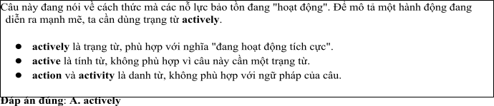
Câu 2: A. get B. make C. come D. catch
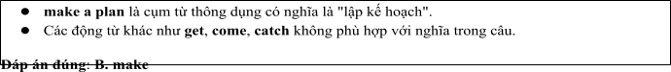
Câu 3: A. which ensuring B. ensured C. was ensuring D. ensuring
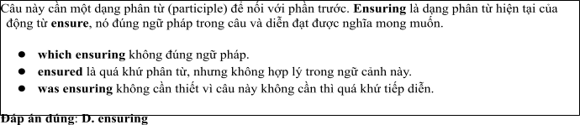
Câu 4: A. to enforcing B. to enforce C. enforce D. to be enforcing
Câu 5: A. from B. on C. for D. in
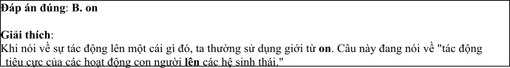
Câu 6: A. these species incredible B. incredible these species
C. these incredible species D. species these incredible
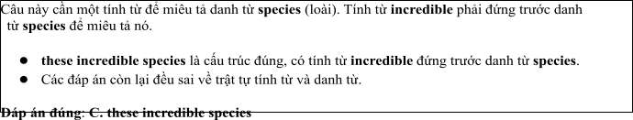
Read the following leaflet and mark the letter A, B, C or D on your answer sheet to indicate the option that best fits each of the numbered blanks from 7 to 12.

Protecting Endangered Animals
• To protect endangered animals, we must take immediate action (7) habitat loss, poaching, and climate change. The (8) of species facing extinction is increasing rapidly, affecting biodiversity around the world.
• Conservation efforts, such as creating protected (9) and enforcing anti-poaching laws, are essential to safeguard these animals. (10) critical actions include reducing deforestation and supporting sustainable practices.
• Governments, organizations, and individuals need to (11) the root causes of these threats to preserve wildlife. Awareness campaigns and education on environmental (12) are also crucial for ensuring the survival of these species. The role of conservationists is more important than ever to maintain ecological balance.
Câu 7. A. according to B. thanks to C. on account of D. due to
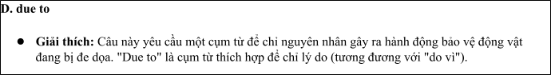
Câu 8. A. majority B. item C. number D. amount
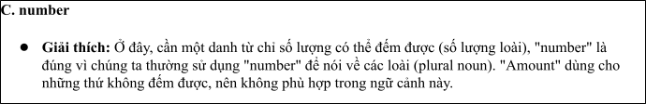
Câu 9. A. areas B. groups C. organizations D. volunteers
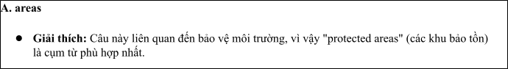
Câu 10. A. Others B.Each other C. The others D. Other
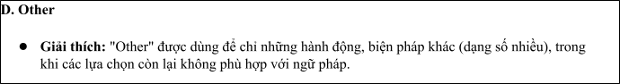
Câu 11. A. go in B. deal with C. take up D. stand by
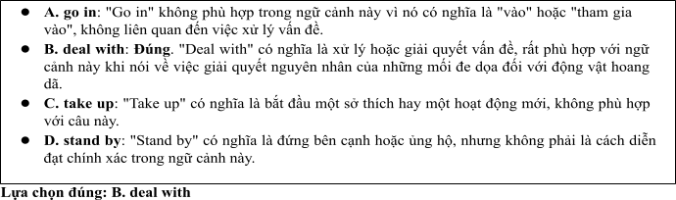
Câu 12. A. sustainability B. extinction C. avenue D. protection
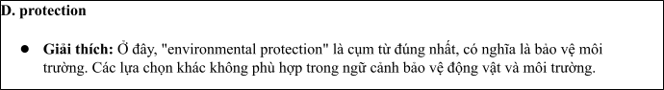
Mark the letter A, B, C or D on your answer sheet to indicate the best arrangement of utterances or sentences to make a meaningful exchange or text in each of thefollowing questions from 13 to 17.

Câu 13
1. Nam: Yes, I have. I’ve been raising awareness about endangered animals by sharing information on social media.
2. Nam: Hi, Mark! It's been a while. You look so energetic!
3. Mark: Hi, Nam! Thanks! You look fantastic too. Have you been doing anything to protect endangered species?
A. a-c-b B. b-c-a C. c-b-a D. b-a-c
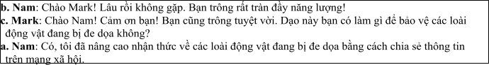

Câu 14
1. Mark: I’m going to organize a campaign to inform people about endangered species.
2. Nam: Why a campaign?
3. Mark: Campaigns help spread knowledge quickly and encourage others to take action.
4. Nam: What will you do to raise awareness about wildlife protection?
5. Nam: I think spreading awareness online would be more effective. I’ll start a social media group.
A. d-a-b-c-e B. c-e-d-b-a C. d-b-a-e-c D. c-d-e-a-b
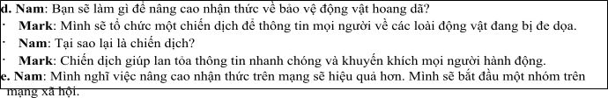

Câu 15 Hi Sarah,
1. Glad you saw it! We need to do more to protect the forests.
2. That’s awesome! Rescue centers play such a crucial role in saving animals from illegal trafficking.
3. Hey, Mark! I saw your post about protecting wildlife habitats.
4. Yes, I think we should raise awareness about deforestation, but for now, I’m focusing on supporting
animal rescue centers.
5. We should work together to promote both causes. What’s your opinion on that?
Write back soon.

Anna
A. d-b-a-c-e B.c-a-d-b-e C. a-d-b-c-e D. a-c-d-b-e
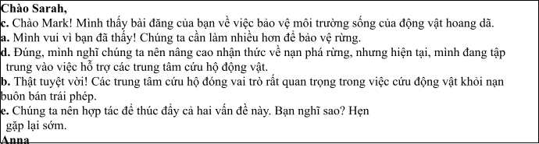

Câu 16
1. Governments need to implement stricter measures against wildlife violations, including heavy penalties and anti-smuggling actions.
2. To protect wildlife, it is crucial to minimize illegal hunting and exploitation activities.
3. Wildlife protection organizations also play an important role in researching and monitoring species at risk of extinction.
4. In conclusion, everyone must work together to protect wildlife species as they contribute to maintaining ecological balance.
5. I always participate in campaigns calling for an end to wildlife trade, especially for endangered species.
(Adapted from discovery)
A. b-e-c-a-d B. a-b-c-d-e C. b-c-d-a-e D. c-a-d-b-e
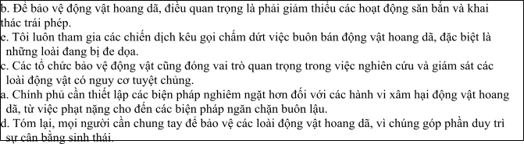

Câu 17
1. On the other hand, harmful activities such as deforestation and pollution need to be reduced to allow wildlife to thrive.
2. Collecting data on wildlife populations and monitoring endangered species is crucial.
3. Scientific research helps identify areas that need protection and develop effective conservation strategies.
4. In conclusion, only through cooperation between nations and the international community can we effectively protect wildlife.
5. Wildlife protection is a long-term effort that requires continuous commitment from organizations and individuals.
(Adapted from i-Learn Smart World)
A. c-a-e-b-d B. d-c-a-b-e C. e-b-c-a-d D. d-e-b-c-a
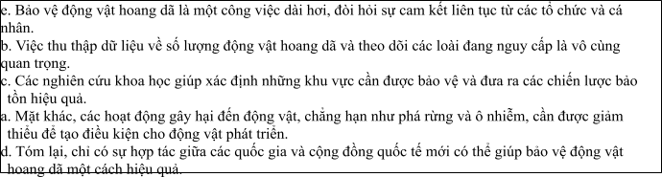

Read thefollowing passage about Effective Strategies for Protecting Endangered Species and mark the letter A, B, C or D on your answer sheet to indicate the option that bestfits each of the numbered blanksfrom 18 to 22.
The government has recently increased efforts to protect wildlife due to the growing threats of poaching and habitat destruction. (18) , where animals are safeguarded from illegal hunting and environmental damage. Various protection programs have been launched by environmental agencies, (19) . These initiatives have been supported (20) , and have been praised for their effectiveness in conserving endangered species. However, despite these improvements, deforestation remains a major issue, as (21) . In some regions, illegal logging is still happening at an alarming rate, posing a serious threat to wildlife habitats. As a result, more stringent policies need to be enforced (22) . Only with stronger actions and global cooperation can the survival of endangered species be ensured.
(Adapted fromNBCnews)
Câu 18:
1. Many new wildlife reserves have been established
2. Many new wildlife reserves are established
3. Many new wildlife reserves will have established.
4. Many new wildlife reserves were being established
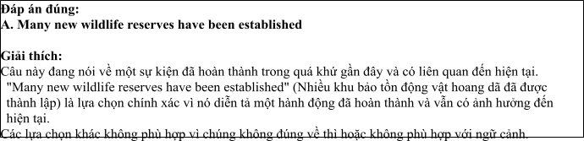

Câu 19:
1. whom are working by the local communities to ensuring the sustainable practices
2. who are working with local communities to ensure sustainable practices
3. which are working by the local communities to ensure the sustainable practices
4. that are working with local communities to ensured a sustainable practices
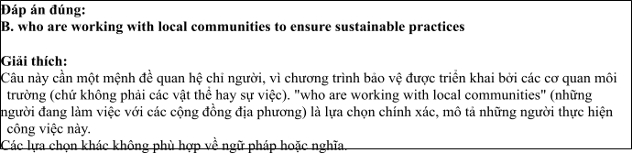

Câu 20:
1. by both national or international organizations
2. by both national nor international organizations
3. by both national and international organizations
4. by neither national nor international organizations

Câu 21:
1. forests continued to be clearing for the agricultural expansion
2. forests continue to have been cleared by agricultural expansion
3. forests have continued to clear for agricultural expansion
4. forests continue to be cleared for agricultural expansion

Câu 22:
1. in order to address these ongoing challenges
2. in order that address these ongoing challenge
3. in order to the address for these ongoing challenges
4. in order to not address these ongoing challenges

Read the following passage about Wildlife Protection Efforts Around the World and mark the letter A, B, C or D on your answer sheet to indicate the best answer to each of the following questionsfrom 23 to 30.
There are currently thousands of species of animals at risk of extinction worldwide. Many of these species are under threat due to human activities, such as deforestation, illegal hunting, and climate change. However, governments around the world have been taking action to protect endangered species and their habitats. One of the major steps involves strengthening wildlife protection laws, creating protected areas, and investing in wildlife conservation projects.
For instance, in Africa, the governments of countries like Kenya and South Africa have established vast national parks and wildlife reserves to safeguard species such as elephants, lions, and rhinos. These protected areas allow animals to roam freely without the threat of poaching or habitat destruction. Additionally, strict anti-poaching laws have been enacted, with severe penalties for those caught hunting endangered animals illegally.
Furthermore, technology plays a key role in protecting wildlife. Many countries now use drones and satellite technology to monitor wildlife populations and track animals' movements. Anti-poaching units rely on high-tech equipment like night-vision cameras and thermal imaging to catch illegal hunters. Social media and online campaigns have also helped raise awareness about wildlife conservation and mobilized global support for protecting endangered species.
In some regions, governments are working closely with local communities to ensure the sustainable use of natural resources. For example, in the Amazon rainforest, indigenous tribes have been supported in their efforts to combat deforestation and protect the wildlife living there. The hope is that by involving local people in conservation efforts, the protection of endangered species will be more effective and long-lasting.
(Adapted from animals news)
Câu 23. Which of the following is NOT mentioned as one of the ways governments are protecting wildlife?
A. Increasing the number of national parks B. Strengthening anti-poaching laws
C. Using technology to monitor wildlife D. Promoting animal farming
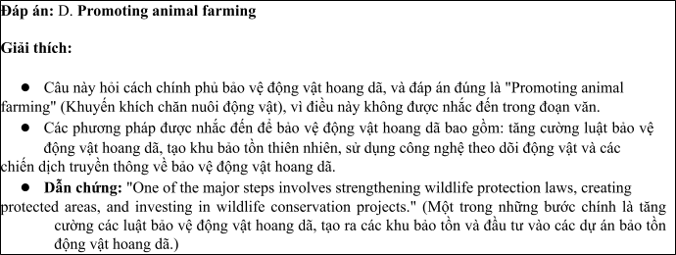
Câu 24. The word “extinction” in paragraph 1 is OPPOSITE in meaning to:
A. survival B. awareness C. protection D. evolution
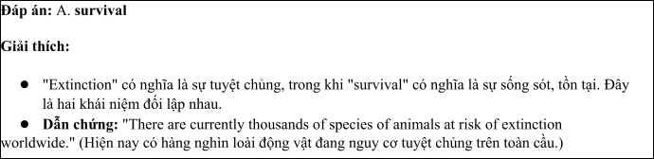
Câu 25. The word “These” in paragraph 2 refers to:
A. endangered species B. wildlife reserves
C. wildlife protection laws D. poaching penalties
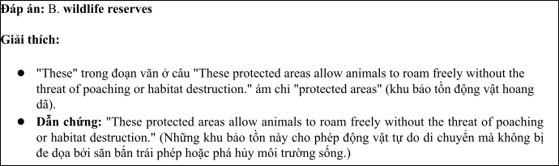
Câu 26. The word “monitor” in paragraph 3 could be best replaced by:
A. observe B. distract C. ignore D. prevent
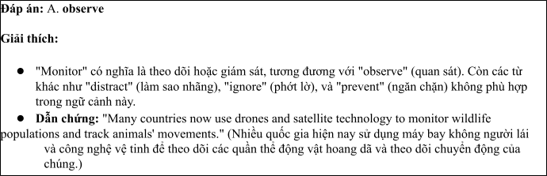
Câu 27. Which of the following best paraphrases the underlined sentence: "Technology plays a key role in protecting wildlife" in paragraph 3?
1. Technology is the only way to protect endangered species.
2. Technology helps to track wildlife and reduce illegal hunting.
3. Technology should be used only for wildlife research.
4. Technology can never replace human efforts in wildlife protection.
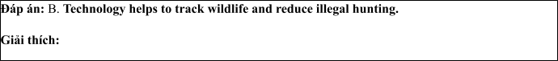
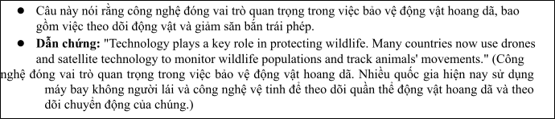
Câu 28. Which of the following is TRUE according to the passage?
1. Technology has no role in wildlife protection.
2. Governments work with local communities to protect wildlife.
3. There are no wildlife reserves in Africa.
4. Indigenous people are prohibited from using natural resources.
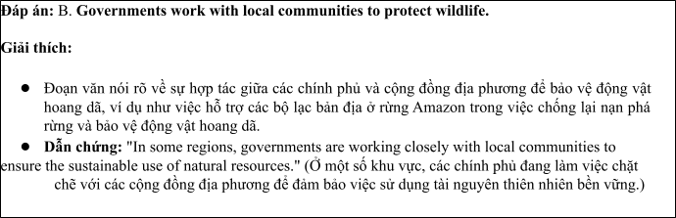
Câu 29. In which paragraph does the writer mention the role of local communities in wildlife conservation?
A. Paragraph 1 B. Paragraph 2 C. Paragraph 3 D. Paragraph 4
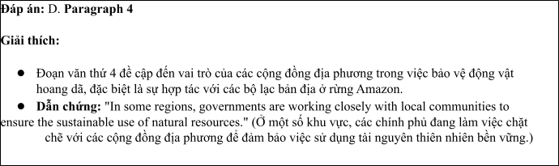
Câu 30. In which paragraph does the writer explore modern methods for protecting wildlife?
A. Paragraph 1 B. Paragraph 2 C. Paragraph 3 D. Paragraph 4
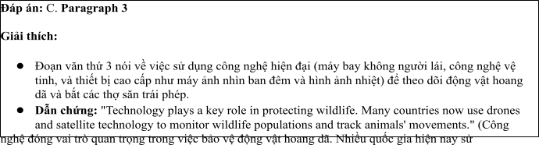

Read the following passage about Wildlife conservation and mark the letter A, B, C or D on your answer sheet to indicate the best answer to each of the following questions from 31 to 40.
[I] In recent years, governments around the world have been increasingly focusing on wildlife conservation. As populations grow and human activities continue to encroach upon natural habitats, the need for stronger wildlife protection measures has become more urgent. [II] Today, many species face the risk of extinction, with some already classified as endangered. By 2030, experts predict that the number of critically endangered species could double if current trends continue. [III] Governments are implementing various strategies to counter this alarming trend, but the effectiveness of these measures depends on global cooperation and sustainable practices. [IV]
One major effort involves strengthening wildlife laws and regulations. For example, many countries have enacted stricter penalties for poaching and illegal trade in animal products. These laws are accompanied by better enforcement and monitoring systems to ensure that violators are caught and punished. Moreover, governments are allocating more resources to create and maintain protected areas, such as national parks and wildlife reserves, where animals can thrive without human interference.
However, wildlife protection is not only about laws and enforcement; it also requires addressing the root causes of habitat destruction. The expansion of urban areas, agricultural land, and infrastructure projects often leads to deforestation and the loss of ecosystems. Governments are now focusing on promoting sustainable land-use practices, such as reforestation and the preservation of key wildlife corridors that connect fragmented habitats. These strategies aim to minimize human impact on wildlife while ensuring that development can proceed in an environmentally responsible way.
Despite these efforts, wildlife protection remains a challenging issue. Deforestation, illegal hunting, and climate change continue to threaten animal populations worldwide. The future of many species depends not only on effective policy but also on public awareness and international collaboration. If governments, environmental organizations, and individuals work together, it is possible to protect endangered species and ensure that wildlife continues to play an integral role in the planet's ecosystems.
(Adapted from discovery channel) Câu 31. Where in paragraph I does the following sentence best fit?

Governments are increasingly investing in protecting endangered species and their habitats.
A. [I] B. [II] C. [III] D. [IV]
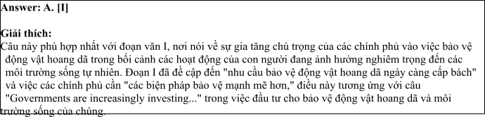
Câu 32. The phrase “counter this alarming trend” in paragraph 3 could be best replaced by .
A. prevent this negative development B. reinforce this worrying trend
C. support this ongoing issue D. increase this problem
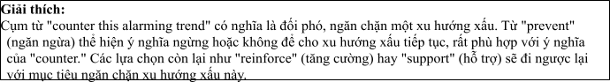
Câu 33. The word “where” in paragraph 4 refers to .
A. laws and regulations B. poaching activities C. protected areas D. urban areas
Câu 34. According to paragraph 4, which of the following is NOT a government effort to protect wildlife?
1. Stronger penalties for illegal wildlife trade
2. Creation of protected areas
3. Promotion of sustainable land-use practices
4. Promotion of unsustainable agricultural practices
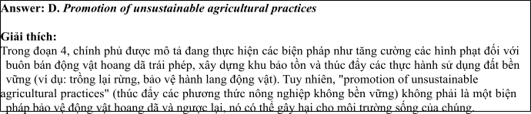
Câu 35. Which of the following best summarises paragraph 3?
1. Governments are enhancing wildlife protection through laws, enforcement, and sustainable land-use practices.
2. Global cooperation is needed to address the threats of deforestation and climate change on wildlife.
3. The importance of creating protected areas and wildlife corridors to ensure species survival.
4. Strengthening laws and creating protected areas alone will not save endangered species.
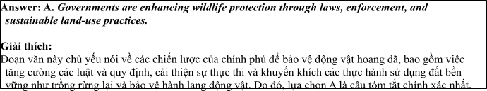
Câu 36. The word “urgent “ in paragraph 1 is OPPOSITE in meaning to:
A. pressing B. important C. unnecessary D. critical
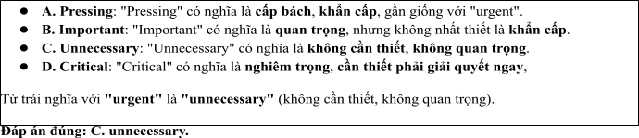
Câu 37. Which of the following is TRUE according to the passage?
1. Wildlife protection efforts focus solely on legal regulations.
2. Governments are addressing both the causes and consequences of wildlife loss.
3. Climate change has no significant impact on wildlife conservation.
4. Deforestation and habitat destruction are not primary threats to wildlife.
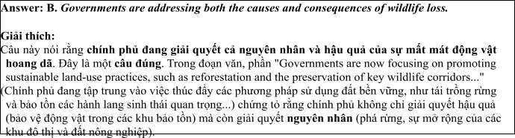
Câu 38. Which of the following best paraphrases the underlined sentence: “Despite these efforts, wildlife protection remains a challenging issue” in paragraph 4?
1. Wildlife protection continues to be a difficult challenge, despite the efforts made.
2. Wildlife protection has been completely solved, and there are no more challenges.
3. The efforts in wildlife protection have made the issue less important.
4. Wildlife protection has become easier and less challenging with current efforts.

1. Wildlife protection continues to be a difficult challenge, despite the efforts made.
• Giải thích: Đây là cách diễn đạt lại gần giống nhất với câu gốc. Nó giữ nguyên ý rằng bảo vệ động vật hoang dã vẫn là một thách thức khó khăn mặc dù đã có những nỗ lực.

• Đáp án đúng.
2. Wildlife protection has been completely solved, and there are no more challenges.
• Giải thích: Câu này trái ngược hoàn toàn với ý của câu gốc. Câu gốc nói rằng bảo vệ động vật hoang dã vẫn là một vấn đề thách thức, trong khi câu này lại khẳng định vấn đề đã được giải
quyết hoàn toàn.
• Sai.

3. The efforts in wildlife protection have made the issue less important.
• Giải thích: Câu này thay đổi ý của câu gốc. Nó nói rằng vấn đề bảo vệ động vật hoang dã đã trở nên kém quan trọng hơn, trong khi câu gốc nói rõ rằng vấn đề vẫn rất quan trọng và khó khăn.
• Sai.

4. Wildlife protection has become easier and less challenging with current efforts.
• Giải thích: Câu này cho rằng bảo vệ động vật hoang dã đã trở nên dễ dàng hơn và ít thách thức hơn nhờ các nỗ lực hiện tại, điều này trái ngược với ý trong câu gốc, vì câu gốc nhấn mạnh rằng vấn đề vẫn còn thách thức.
• Sai.

Đáp án đúng là: A. Wildlife protection continues to be a difficult challenge, despite the efforts
made.
Câu 39. Which of the following can be inferred from the passage?
1. Wildlife protection is no longer a priority for many governments.
2. The success of wildlife protection efforts relies on a combination of strong policies and community involvement.
3. Governments are failing to protect endangered species due to lack of resources.
4. Governments are not addressing the root causes of habitat destruction effectively.
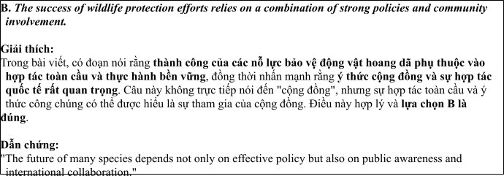
Câu 40. Which of the following best summarises the passage?
1. Governments are taking action to protect wildlife through stronger laws, protected areas, and sustainable practices, but global cooperation is essential for success.
2. Wildlife conservation is a lost cause unless governments take immediate action.
3. The most effective way to protect endangered species is through stricter penalties for poaching and illegal wildlife trade.
4. Habitat destruction and illegal hunting are the primary causes of species extinction.
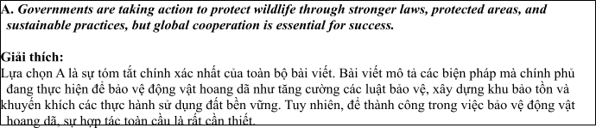

ĐỀ 9 | ĐỀ KIỂM TRA GIỮA HK2 NĂM HỌC 2024-2025  MÔN: TIẾNG ANH LỚP 12

Read the following advertisement and mark the letter A, B, C and D on your answer sheet to indicate the option that best fits each of the numbered blanks from 1 to 6
Unlock the Future of Multimedia Communication with AI
Experience the future of multimedia communication with Artificial Intelligence. AI is revolutionizing how we create, share, and interact with content, (1) _______ communication more personalized and efficient. With its ability to analyze data and (2) _______ media delivery, AI enhances user experiences (3) ______ real-time. On our platform, AI integrates seamlessly across various devices and applications. It’s exciting (4) _______ AI’s potential for transforming multimedia services. While companies (5) ______ challenges when adopting AI, those who embrace it will reap long-term benefits. Stay ahead in (6) ________ by leveraging AI to enhance your media communication strategy.
(Adapted from vietnamese news)
Câu 1: A. which making B. made C. was making D. making
Câu 2: A. optimize B. optimization C. optimal D. optimally
Câu 3: A. on B. at C. for D. in
Câu 4: A. to unlocking B. to unlock C. unlock D. to be unlocked
Câu 5: A. come B. face C. stay D. get
Câu 6: A. the digital fast-evolving world B. the world fast-evolving digital
C. the fast-evolving digital world D. the fast-evolving world digital
Read the following leaflet and mark the letter A, B, C or D on your answer sheet to indicate the option that best fits each of the numbered blanks from 7 to 12.
Preserving Wildlife with ChatGPT in National Parks
• Using ChatGPT in national parks is revolutionizing wildlife conservation efforts. (7) _______ experts, AI-powered solutions are essential for monitoring endangered species and their habitats. ChatGPT assists park rangers in gathering real-time data, analyzing animal (8) _______, and improving response strategies. (9) ________ tools, like drones and camera traps, work alongside AI to enhance park management.
• These innovations help to (10)_______ critical issues such as poaching and habitat loss. The integration of AI technology offers a new way to protect biodiversity and ensure sustainable environments.
• Conservation efforts have been significantly improved with AI’s ability to process large amounts of data quickly and accurately. The (11)_______ of wildlife experts agree that AI is a vital tool for the future of global (12) ________.
Câu 7. A. According to B. Thanks to C. Because of D. Due to
Câu 8. A. area B. custom C. relation D. behavior
Câu 9. A. Others B. Each other C. The others D. Other
Câu 10. A. go off B. deal with C. take in D. sit up
Câu 11. A. majority B. item C. number D. amount
Câu 12. A. connection B. issue C. conservation D. protection
Mark the letter A, B, C or D on your answer sheet to indicate the best arrangement of utterances or sentences to make a meaningful exchange or text in each of the following questions from 13 to 17.
Câu 13
a. Linh: Yes, I use ChatGPT every day to create content for posts and ads. It really helps save time and improve work quality.
b. Linh: Hi, Minh! It's been so long. You look great!
c. Minh: Hi, Linh! Thanks. You look really energetic too. Have you been using ChatGPT for your work?
A. a-c-b B. b-c-a C. c-b-a D. b-a-c
Câu 14
a. Linh: ChatGPT helps me generate creative ideas quickly and write engaging content, saving me a lot of time.
b. Mai: How do you plan to improve your content creation skills for social media?
c. Linh: I’m going to use ChatGPT to help brainstorm ideas and create posts more efficiently.
d. Mai: Why ChatGPT?
e. Mai: I see. But I’ve heard that it might not always be accurate. I’m not sure I want to rely on it.
A. b-c-d-a-e B. c-e-d-b-a C. d-b-a-e-c D. c-d-e-a-b
Câu 15
Hey Chris,
a. I think it’d be really fun if we teamed up for a project and used ChatGPT to create content. What do you think?
b. It’s amazing how ChatGPT can help with generating ideas, but I’m currently focused on learning more about data analytics.
c. Nevertheless, I found the tutorials quite useful.
d. Thanks a lot for the ChatGPT tutorials you shared with me.
e. Thanks for the recommendation about the AI writing tools — they seem much more efficient than what I’ve been using.
Write back soon.
David
A. d-b-a-c-e B.d-b-c-e-a C. a-d-b-c-e D. a-c-d-b-e
Câu 16
a. The option to work from home has been a huge bonus, giving me the flexibility to work when I feel most inspired.
b. My love for technology and connecting with people naturally led me to a career in social media.
c. In the end, I’m thrilled with my current position because it blends my passion for technology with my skills in content creation.
d. I’ve spent the past year excelling at creating engaging online content, managing social media channels, and developing effective marketing campaigns for a small business.
e. While tight deadlines and the need for flexibility are important, I’m okay with the occasional face-to-face meeting to stay on track.
(Adapted from discovery)
A. b-d-a-e-c B. a-b-c-d-e C. b-c-d-a-e D. c-a-d-b-e
Câu 17
a. This shift has opened the door for new kinds of businesses, including AI-powered content creation agencies and virtual assistants, which have contributed to a booming digital economy.
b. What was once a manual and time-consuming process of content creation is now increasingly being replaced by AI-driven platforms like ChatGPT, showing the media industry’s shift towards automation.
c. Nevertheless, despite the growth, many media outlets still struggle with using AI in a way that maintains a human touch, as some AI-generated content can come across as robotic or overly simplistic.
d. As a result of these advancements, we’ve seen an influx of AI professionals, with many now entering the industry to capitalize on the rise of automation in content creation.
e. The integration of AI tools in media production has made a significant impact in recent years.
(Adapted from i-Learn Smart World)
A. c-a-e-b-d B. d-c-a-b-e C. e-b-a-d-c D. d-e-b-c-a
Read the following passage about Effective Strategies for Protecting Endangered Species and mark the letter A, B, C or D on your answer sheet to indicate the option that best fits each of the numbered blanks from 18 to 22.
In recent years, the use of ChatGPT in media communications has revolutionized the way content is created and distributed. (18) __________, assist with content creation, and even answer customer queries in real-time, improving the efficiency of many media outlets. For instance, many online news platforms now (19) ___________, allowing journalists to focus more on in-depth analysis. One of the main advantages is its ability to handle repetitive tasks, (20) __________. ChatGPT can also be employed to develop personalized marketing messages that resonate with specific audiences, something that was much harder to achieve in the past. Because of its adaptability, it is being embraced by companies worldwide which are looking to innovate their media strategies. A good example is a local TV station that now uses ChatGPT (21) ________. However, some people still question whether AI-generated content (22) __________. What do you think about this? How do you feel about the increasing role of AI in content creation?
. (Adapted from economynews)
Câu 18:
A. This AI-powered tool is used to generate text
B. This tool of AI-powered is used to generating text
C. This AI-powered tool was being used to generate text
D. This tool AI-powered is used to be generated text
Câu 19:
A. deal with ChatGPT to draft quick articles
B. rely on ChatGPT to draft articles quickly
C. take on ChatGPT to draft articles quickly
D. make up ChatGPT to draft articles quickly
Câu 20:
A. who frees up a valuable time for the creators of human
B. that free up valuable time for the creators of human
C. which frees up valuable time for human creators
D. that frees up the valuable time for human creators
Câu 21:
A. not to produce the engaging social media posts
B. to have produced engaging posts social media
C. not to produce social media posts engaging
D. to produce engaging social media posts
Câu 22:
A. can truly match the creativity and emotional depth of human writing
B. must truly match the depth of human writing of creativity and emotional
C. should truly match the creative and emotional depth of human writing
D. might truly match the creativity and emotion depth of writing human
Read the following passage about Wildlife Protection Efforts Around the World and mark the letter A, B, C or D on your answer sheet to indicate the best answer to each of the following questions from 23 to 30.
The government of Vietnam has been taking important steps to protect endangered species in recent years. With over 10,000 species at risk in the country, it is crucial to address the growing threats that these animals face. Some of the most endangered species include the Indochinese tiger, the black-shanked douc, and the Saola, a rare wild ox that was first discovered in the Annamite Mountains. The government has implemented several measures to protect wildlife, such as creating national parks and wildlife sanctuaries, along with stronger wildlife laws.
One of the most significant actions has been the establishment of the "Forest Protection and Development Program," which aims to conserve and restore natural habitats for endangered species. Additionally, Vietnam has signed international agreements to combat illegal wildlife trade. Authorities now work more closely with non-governmental organizations (NGOs) and conservationists to monitor endangered species and enforce environmental regulations.
To raise awareness among the public, the Vietnamese government has launched educational campaigns on the importance of preserving wildlife. These programs emphasize the role of biodiversity in maintaining ecological balance and highlight the need to protect animals that are vital to the environment.
Technology is also being used to protect endangered animals. Cameras and drones are employed to monitor wildlife in national parks, and a "Wildlife Protection Unit" has been set up to track illegal poaching activities. Through these combined efforts, Vietnam hopes to reduce the risk of extinction for its endangered species and ensure the protection of its biodiversity.
(Adapted from discovery channel)
Câu 23. Which of the following is NOT mentioned as one of the endangered species in Vietnam?
A. Indochinese tiger B. Black-shanked douc C. Saola D. Giant panda
Câu 24. The word "sanctuaries" in paragraph 1 is OPPOSITE in meaning to
A. zoos B. farms C. wilderness D. cities
Câu 25. The word “which” in paragraph 2 refers to
A. the “Forest Protection and Development Program” B. a "Wildlife Protection Unit"
C. NGOs and conservationist D. educational campaign
Câu 26. The word "monitor" in paragraph 4 could be best replaced by
A. ignore B. observe C. disturb D. feed
Câu 27. Which of the following best paraphrases the underlined sentence: Technology is also being used to protect endangered animals in paragraph 4?
A. Technology has no impact on animal protection.
B. Technology is a key tool in helping protect endangered animals.
C. Technology should not be used in wildlife conservation.
D. The government is focusing on animal protection only through technology.
Câu 28. Which of the following is TRUE according to the passage?
A. Vietnam has created a program solely for the protection of tigers.
B. The Vietnamese government has signed international agreements to fight illegal wildlife trade.
C. Poaching is no longer a major threat to endangered animals in Vietnam.
D. Only national parks are used to protect endangered species in Vietnam.
Câu 29. In which paragraph does the writer mention government efforts to protect endangered species?
A. Paragraph 1 B. Paragraph 2 C. Paragraph 3 D. Paragraph 4
Câu 30. In which paragraph does the writer discuss modern methods for protecting endangered species?
A. Paragraph 1 B. Paragraph 2 C. Paragraph 3 D. Paragraph 4
Read the following passage about Wildlife conservation and mark the letter A, B, C or D on your answer sheet to indicate the best answer to each of the following questions from 31 to 40.
[I] In recent years, wildlife conservation efforts have gained significant attention from governments and environmental organizations around the world. National parks and wildlife reserves are considered key areas for the protection of endangered species. [II] These protected areas serve as sanctuaries for animals, ensuring they are free from the dangers of poaching and habitat destruction. By 2030, experts predict that the number of protected wildlife areas could double if current trends in conservation continue. [III] Governments and organizations are adopting various strategies to improve the effectiveness of these areas, but their success depends on global cooperation and a commitment to sustainable practices. [IV]
One major initiative involves strengthening anti-poaching laws and regulations. For example, many countries have introduced stricter penalties for poaching and illegal trade in animal products. These laws are backed by increased patrols and surveillance, ensuring that violators are caught and prosecuted. Additionally, governments are investing in the creation of wildlife corridors to allow animals to migrate freely between protected areas, reducing the risk of inbreeding and ensuring healthy populations.
However, protecting wildlife is not only about enforcement; it also involves addressing the underlying causes of habitat loss. The expansion of agriculture, logging, and infrastructure projects continues to threaten ecosystems within and around protected areas. Governments are now focusing on promoting sustainable land-use practices, such as reforestation and the preservation of key habitats that are critical for wildlife survival. These strategies aim to minimize human impact on wildlife while promoting development in a responsible way.
Despite these efforts, wildlife conservation remains a complex and ongoing challenge. Habitat destruction, illegal hunting, and climate change continue to threaten species worldwide. The future of many animals depends not only on effective policy but also on public awareness and international collaboration. If governments, environmental organizations, and local communities work together, it is possible to safeguard endangered species and ensure they play an essential role in maintaining ecological balance.
(Adapted from dailynews)
Câu 31. Where in paragraph I does the following sentence best fit?
“More and more efforts are being made to protect wildlife through the establishment of national parks and reserves.”
A. [I] B. [II] C. [III] D. [IV]
Câu 32. The phrase “various strategies” in paragraph 1 could be best replaced by ____.
A. single approaches B. same methods C. two ways D. different approaches
Câu 33. The word “they” in paragraph 1 refers to ____
A. wildlife corridors B. laws and regulations C. protected areas D. governments
Câu 34. According to paragraph 2, which of the following is NOT a method to protect wildlife?
A. Increase in wildlife patrols
B. Creation of wildlife corridors
C. Punishing poachers with harsher laws
D. Expansion of logging and agricultural land
Câu 35. Which of the following best summarizes paragraph 3?
A. The protection of wildlife depends mainly on legal enforcement and reducing habitat loss.
B. Efforts to protect wildlife should focus on habitat conservation, reducing human impact, and encouraging sustainable development.
C. The main goal of wildlife protection is to enforce laws against poaching and illegal trade.
D. Protecting wildlife involves both legal efforts and improving education and awareness in communities.
Câu 36. The word “complex” in paragraph 4 is OPPOSITE in meaning to
A. simple B. profound C. critical D. severe
Câu 37. Which of the following is TRUE according to the passage?
A. Only poaching laws can effectively protect wildlife.
B. Governments and international organizations are working together to expand protected areas and wildlife corridors.
C. Habitat destruction is not a significant threat to wildlife in protected areas.
D. Public awareness and international collaboration are not important for wildlife protection.
Câu 38. Which of the following best paraphrases the underlined sentence “Protecting wildlife is not only about enforcement; it also involves addressing the underlying causes of habitat loss.” in paragraph 3?
A. Wildlife protection is more about addressing habitat loss than enforcing the law.
B. To protect wildlife effectively, governments must focus solely on enforcement and laws.
C. Protecting wildlife is complex, and it requires both enforcement and addressing the causes of habitat loss.
D. It is crucial to address the effects of habitat destruction rather than focus on legal regulations.
Câu 39. Which of the following can be inferred from the passage?
A. Wildlife protection is a simple process that can be solved through stricter laws alone.
B. Governments are failing to protect endangered species due to lack of resources.
C. Effective wildlife protection requires both legal measures and sustainable land-use practices.
D. The creation of wildlife corridors has no impact on reducing human-wildlife conflicts.
Câu 40. Which of the following best summarizes the passage?
A. Effective wildlife protection requires strict enforcement, sustainable land-use practices, and international cooperation to ensure that wildlife remains a key part of the ecosystem.
B. Protecting wildlife requires simply enforcing stricter laws and creating more reserves.
C. The key to protecting wildlife is to reduce poaching and illegal trade.
D. Wildlife protection efforts are mainly focused on raising awareness and creating more national parks.

ĐÁP ÁN VÀ LỜI GIẢI

Read the following advertisement and mark the letter A, B, C and D on your answer sheet to indicate the option that best fits each of the numbered blanks from 1 to 6

Unlock the Future of Multimedia Communication with AI
Experience the future of multimedia communication with Artificial Intelligence. AI is revolutionizing how we create, share, and interact with content, (1) communication more personalized and efficient. With its ability to analyze data and (2) media delivery, AI enhances user experiences (3) real-time. On our platform, AI integrates seamlessly across various devices and applications. It’s exciting (4)
AI’s potential for transforming multimedia services. While companies (5) challenges when adopting AI, those who embrace it will reap long-term benefits. Stay ahead in (6) by leveraging AI to enhance your media communication strategy.
(Adapted from vietnamese news)
Câu 1: A. which making B. made C. was making D. making
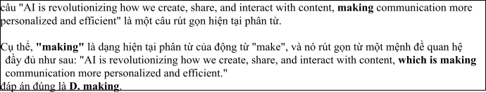
Câu 2: A. optimize B. optimization C. optimal D. optimally
Câu 3: A. on B. at C. for D. in
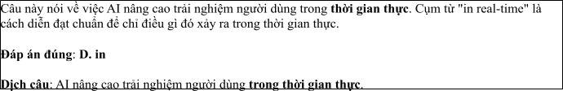
Câu 4: A. to unlocking B. to unlock C. unlock D. to be unlocked
Câu 5: A. come B. face C. stay D. get
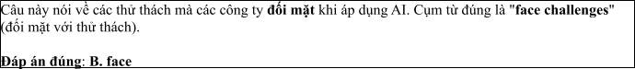
Câu 6: A. the digital fast-evolving world B. the world fast-evolving digital
C. the fast-evolving digital world D. the fast-evolving world digital
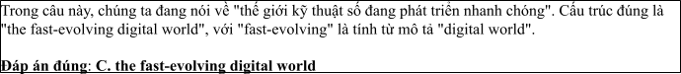
Read the following leaflet and mark the letter A, B, C or D on your answer sheet to indicate the option that best fits each of the numbered blanks from 7 to 12.

Preserving Wildlife with ChatGPT in National Parks
• Using ChatGPT in national parks is revolutionizing wildlife conservation efforts. (7) experts, AI-powered solutions are essential for monitoring endangered species and their habitats. ChatGPT assists park rangers in gathering real-time data, analyzing animal (8) , and improving response strategies. (9) tools, like drones and camera traps, work alongside AI to enhance park management.
• These innovations help to (10) critical issues such as poaching and habitat loss. The integration of AI technology offers a new way to protect biodiversity and ensure sustainable environments.
• Conservation efforts have been significantly improved with AI’s ability to process large amounts of data quickly and accurately. The (11) of wildlife experts agree that AI is a vital tool for the future of global (12) .
Câu 7. A. According to B. Thanks to C. Because of D. Due to
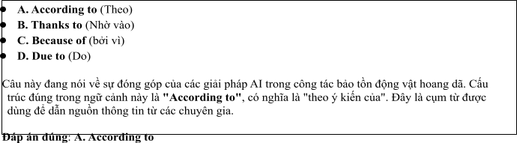
Câu 8. A. area B. custom C. relation D. behavior
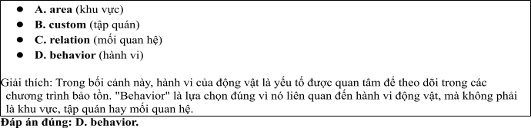
Câu 9. A. Others B. Each other C. The others D. Other
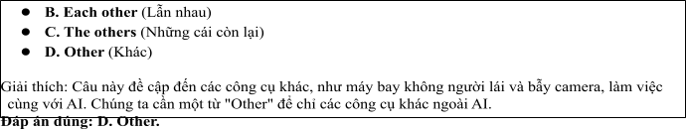
Câu 10. A. go off B. deal with C. take in D. sit up
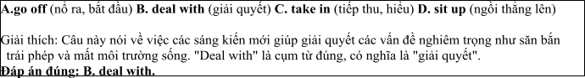
Câu 11. A. majority B. item C. number D. amount
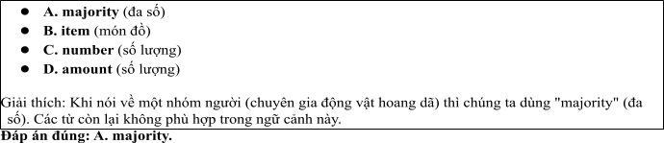
Câu 12. A. connection B. issue C. conservation D. protection
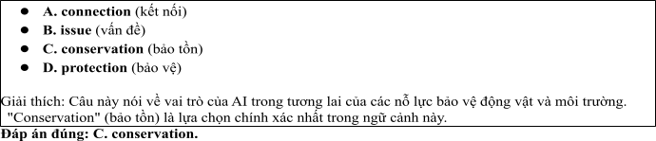
Mark the letter A, B, C or D on your answer sheet to indicate the best arrangement of utterances or sentences to make a meaningful exchange or text in each of thefollowing questions from 13 to 17.

Câu 13
1. Linh: Yes, I use ChatGPT every day to create content for posts and ads. It really helps save time and improve work quality.
2. Linh: Hi, Minh! It's been so long. You look great!
3. Minh: Hi, Linh! Thanks. You look really energetic too. Have you been using ChatGPT for your work?
A. a-c-b B. b-c-a C. c-b-a D. b-a-c
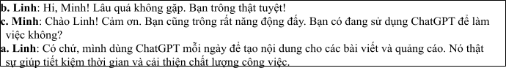

Câu 14
1. Linh: ChatGPT helps me generate creative ideas quickly and write engaging content, saving me a lot of time.
2. Mai: How do you plan to improve your content creation skills for social media?
3. Linh: I’m going to use ChatGPT to help brainstorm ideas and create posts more efficiently.
4. Mai: Why ChatGPT?
5. Mai: I see. But I’ve heard that it might not always be accurate. I’m not sure I want to rely on it.
A. b-c-d-a-e B. c-e-d-b-a C. d-b-a-e-c D. c-d-e-a-b
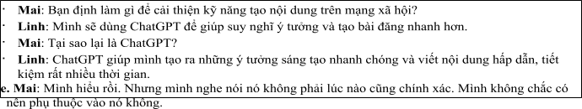

Câu 15
Hey Chris,
1. I think it’d be really fun if we teamed up for a project and used ChatGPT to create content. What do you
think?
2. It’s amazing how ChatGPT can help with generating ideas, but I’m currently focused on learning more
about data analytics.
3. Nevertheless, I found the tutorials quite useful.
4. Thanks a lot for the ChatGPT tutorials you shared with me.
5. Thanks for the recommendation about the AI writing tools — they seem much more efficient than what
I’ve been using. Write back soon. David
A. d-b-a-c-e B.d-b-c-e-a C. a-d-b-c-e D. a-c-d-b-e
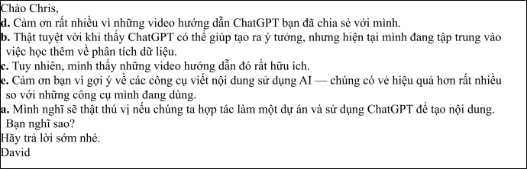

Câu 16
1. The option to work from home has been a huge bonus, giving me the flexibility to work when I feel most inspired.
2. My love for technology and connecting with people naturally led me to a career in social media.
3. In the end, I’m thrilled with my current position because it blends my passion for technology with my
skills in content creation.
4. I’ve spent the past year excelling at creating engaging online content, managing social media channels,
and developing effective marketing campaigns for a small business.
5. While tight deadlines and the need for flexibility are important, I’m okay with the occasional face-to- face meeting to stay on track.
(Adapted from discovery)
A. b-d-a-e-c B. a-b-c-d-e C. b-c-d-a-e D. c-a-d-b-e
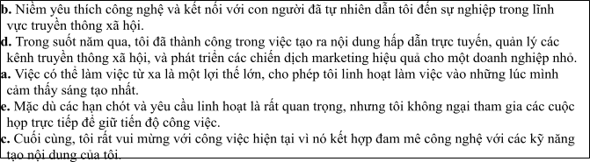

Câu 17
1. This shift has opened the door for new kinds of businesses, including AI-powered content creation agencies and virtual assistants, which have contributed to a booming digital economy.
2. What was once a manual and time-consuming process of content creation is now increasingly being replaced by AI-driven platforms like ChatGPT, showing the media industry’s shift towards automation.
3. Nevertheless, despite the growth, many media outlets still struggle with using AI in a way that maintains a human touch, as some AI-generated content can come across as robotic or overly simplistic.
4. As a result of these advancements, we’ve seen an influx of AI professionals, with many now entering the
industry to capitalize on the rise of automation in content creation.
5. The integration of AI tools in media production has made a significant impact in recent years.
(Adapted from i-Learn Smart World)
A. c-a-e-b-d B. d-c-a-b-e C. e-b-a-d-c D. d-e-b-c-a
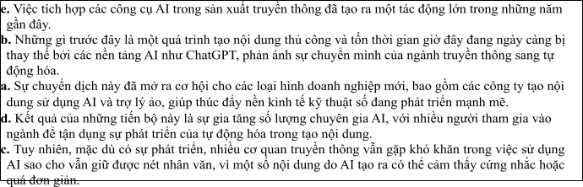
Read thefollowing passage about Effective Strategies for Protecting Endangered Species and mark the letter A, B, C or D on your answer sheet to indicate the option that bestfits each of the numbered blanksfrom 18 to 22.
In recent years, the use of ChatGPT in media communications has revolutionized the way content is created and distributed. (18) , assist with content creation, and even answer customer queries in real- time, improving the efficiency of many media outlets. For instance, many online news platforms now (19)
, allowing journalists to focus more on in-depth analysis. One of the main advantages is its ability to handle repetitive tasks, (20) . ChatGPT can also be employed to develop personalized
marketing messages that resonate with specific audiences, something that was much harder to achieve in the past. Because of its adaptability, it is being embraced by companies worldwide which are looking to innovate their media strategies. A good example is a local TV station that now uses ChatGPT (21) . However, some people still question whether AI-generated content (22) . What do you think about this? How do you feel about the increasing role of AI in content creation?
. (Adapted from economynews)
Câu 18:
1. This AI-powered tool is used to generate text
2. This tool of AI-powered is used to generating text
3. This AI-powered tool was being used to generate text
4. This tool AI-powered is used to be generated text
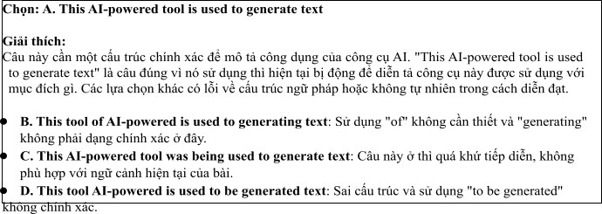

Câu 19:
1. deal with ChatGPT to draft quick articles
2. rely on ChatGPT to draft articles quickly
3. take on ChatGPT to draft articles quickly
4. make up ChatGPT to draft articles quickly
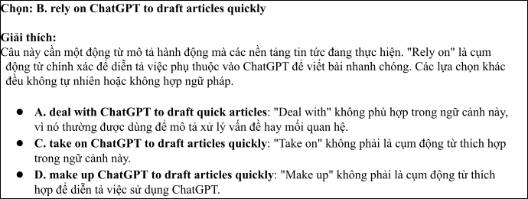

Câu 20:
1. who frees up a valuable time for the creators of human
2. that free up valuable time for the creators of human
3. which frees up valuable time for human creators
4. that frees up the valuable time for human creators
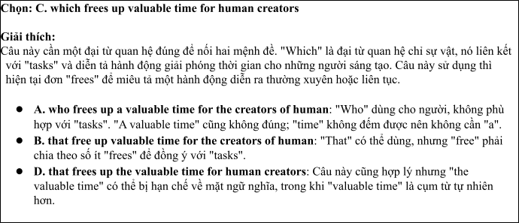

Câu 21:
1. not to produce the engaging social media posts
2. to have produced engaging posts social media
3. not to produce social media posts engaging
4. to produce engaging social media posts
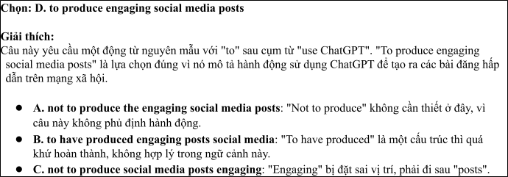

Câu 22:
1. can truly match the creativity and emotional depth of human writing
2. must truly match the depth of human writing of creativity and emotional
3. should truly match the creativive and emotional depth of human writing
4. might truly match the creativity and emotion depth of writing human
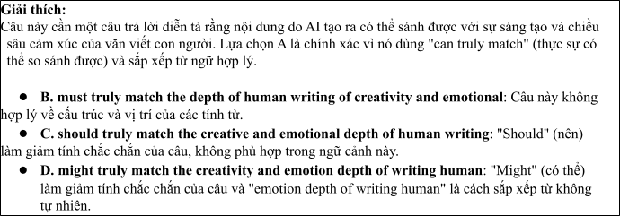
Read the following passage about Wildlife Protection Efforts Around the World and mark the letter A, B, C or D on your answer sheet to indicate the best answer to each of the following questionsfrom 23 to 30.
The government of Vietnam has been taking important steps to protect endangered species in recent years. With over 10,000 species at risk in the country, it is crucial to address the growing threats that these animals face. Some of the most endangered species include the Indochinese tiger, the black-shanked douc, and the Saola, a rare wild ox that was first discovered in the Annamite Mountains. The government has implemented several measures to protect wildlife, such as creating national parks and wildlife sanctuaries, along with stronger wildlife laws.
One of the most significant actions has been the establishment of the "Forest Protection and Development Program," which aims to conserve and restore natural habitats for endangered species. Additionally, Vietnam has signed international agreements to combat illegal wildlife trade. Authorities now work more closely with non-governmental organizations (NGOs) and conservationists to monitor endangered species and enforce environmental regulations.
To raise awareness among the public, the Vietnamese government has launched educational campaigns on the importance of preserving wildlife. These programs emphasize the role of biodiversity in maintaining ecological balance and highlight the need to protect animals that are vital to the environment.
Technology is also being used to protect endangered animals. Cameras and drones are employed to monitor wildlife in national parks, and a "Wildlife Protection Unit" has been set up to track illegal poaching activities. Through these combined efforts, Vietnam hopes to reduce the risk of extinction for its endangered species and ensure the protection of its biodiversity.
(Adapted from discovery channel) Câu 23. Which of the following is NOT mentioned as one of the endangered species in Vietnam?
A. Indochinese tiger B. Black-shanked douc C. Saola D. Giant panda
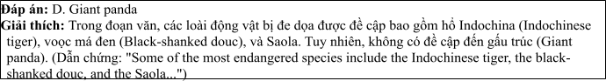
Câu 24. The word "sanctuaries" in paragraph 1 is OPPOSITE in meaning to
A. zoos B. farms C. wilderness D. cities
Câu 25. The word “which” in paragraph 2 refers to
A. the “Forest Protection and Development Program” B. a "Wildlife Protection Unit"
C. NGOs and conservationist D. educational campaign
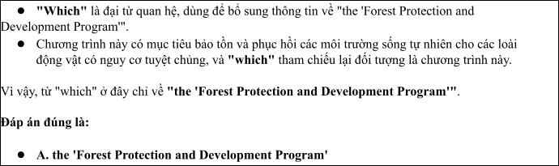
Câu 26. The word "monitor" in paragraph 4 could be best replaced by
A. ignore B. observe C. disturb D. feed
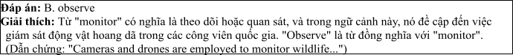
Câu 27. Which of the following best paraphrases the underlined sentence: Technology is also being used to protect endangered animals in paragraph 4?
1. Technology has no impact on animal protection.
2. Technology is a key tool in helping protect endangered animals.
3. Technology should not be used in wildlife conservation.
4. The government is focusing on animal protection only through technology.
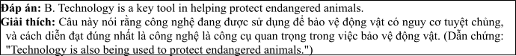
Câu 28. Which of the following is TRUE according to the passage?
1. Vietnam has created a program solely for the protection of tigers.
2. The Vietnamese government has signed international agreements to fight illegal wildlife trade.
3. Poaching is no longer a major threat to endangered animals in Vietnam.
4. Only national parks are used to protect endangered species in Vietnam.
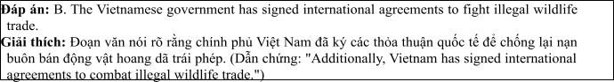
Câu 29. In which paragraph does the writer mention government efforts to protect endangered species?
A. Paragraph 1 B. Paragraph 2 C. Paragraph 3 D. Paragraph 4
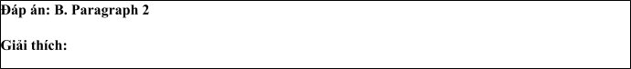
Trong đoạn văn, chính phủ Việt Nam thực hiện nhiều biện pháp để bảo vệ động vật hoang dã, đặc biệt là những loài có nguy cơ tuyệt chủng. Đoạn 2 chính là nơi mà tác giả đề cập chi tiết về các nỗ lực của chính phủ Việt Nam trong việc bảo vệ động vật hoang dã. Cụ thể:

• Dẫn chứng từ đoạn 2:
"One of the most significant actions has been the establishment of the 'Forest Protection and Development Program,' which aims to conserve and restore natural habitats for endangered species. Additionally, Vietnam has signed international agreements to combat illegal wildlife trade. Authorities now work more closely with non-governmental organizations (NGOs) and conservationists to monitor endangered species and enforce environmental regulations."

Giải thích
• Tác giả mô tả một trong những hành động quan trọng của chính phủ là thành lập Chương trình Bảo vệ và Phát triển Rừng để bảo tồn và phục hồi các môi trường sống tự nhiên cho các loài động vật có nguy cơ tuyệt chủng.
• Chính phủ Việt Nam cũng đã ký kết các hiệp định quốc tế để chống lại nạn buôn bán động vật
hoang dã trái phép.
• Chính quyền hợp tác chặt chẽ với các tổ chức phi chính phủ (NGOs) và các nhà bảo tồn để giám
sát các loài động vật có nguy cơ tuyệt chủng và thực thi các quy định về bảo vệ môi trường.
Câu 30. In which paragraph does the writer discuss modern methods for protecting endangered species?
A. Paragraph 1 B. Paragraph 2 C. Paragraph 3 D. Paragraph 4
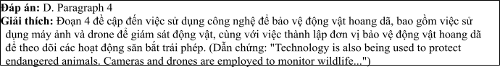
Read the following passage about Wildlife conservation and mark the letter A, B, C or D on your answer sheet to indicate the best answer to each of the following questions from 31 to 40.
1. In recent years, wildlife conservation efforts have gained significant attention from governments and environmental organizations around the world. National parks and wildlife reserves are considered key areas for the protection of endangered species. [II] These protected areas serve as sanctuaries for animals, ensuring they are free from the dangers of poaching and habitat destruction. By 2030, experts predict that the number of protected wildlife areas could double if current trends in conservation continue. [III] Governments and organizations are adopting various strategies to improve the effectiveness of these areas, but their success depends on global cooperation and a commitment to sustainable practices. [IV]
One major initiative involves strengthening anti-poaching laws and regulations. For example, many countries have introduced stricter penalties for poaching and illegal trade in animal products. These laws are backed by increased patrols and surveillance, ensuring that violators are caught and prosecuted. Additionally, governments are investing in the creation of wildlife corridors to allow animals to migrate freely between protected areas, reducing the risk of inbreeding and ensuring healthy populations.
However, protecting wildlife is not only about enforcement; it also involves addressing the underlying causes of habitat loss. The expansion of agriculture, logging, and infrastructure projects continues to threaten ecosystems within and around protected areas. Governments are now focusing on promoting sustainable land-use practices, such as reforestation and the preservation of key habitats that are critical for wildlife survival. These strategies aim to minimize human impact on wildlife while promoting development in a responsible way.
Despite these efforts, wildlife conservation remains a complex and ongoing challenge. Habitat destruction, illegal hunting, and climate change continue to threaten species worldwide. The future of many animals depends not only on effective policy but also on public awareness and international collaboration. If governments, environmental organizations, and local communities work together, it is possible to safeguard endangered species and ensure they play an essential role in maintaining ecological balance.
(Adapted from dailynews) Câu 31. Where in paragraph I does the following sentence best fit?

“More and more efforts are being made to protect wildlife through the establishment of national parks and reserves.”
A. [I] B. [II] C. [III] D. [IV]
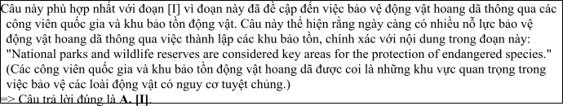
Câu 32. The phrase “various strategies” in paragraph 1 could be best replaced by .
A. single approaches B. same methods C. two ways D. different approaches
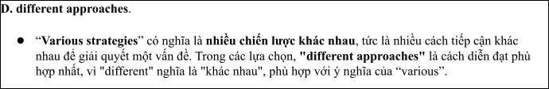
Câu 33. The word “they” in paragraph 1 refers to
A. wildlife corridors B. laws and regulations C. protected areas D. governments
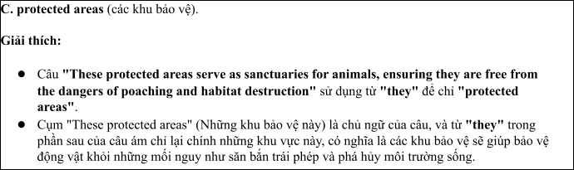
Câu 34. According to paragraph 2, which of the following is NOT a method to protect wildlife?
1. Increase in wildlife patrols
2. Creation of wildlife corridors
3. Punishing poachers with harsher laws
4. Expansion of logging and agricultural land
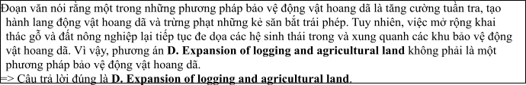
Câu 35. Which of the following best summarizes paragraph 3?
1. The protection of wildlife depends mainly on legal enforcement and reducing habitat loss.
2. Efforts to protect wildlife should focus on habitat conservation, reducing human impact, and encouraging sustainable development.
3. The main goal of wildlife protection is to enforce laws against poaching and illegal trade.
4. Protecting wildlife involves both legal efforts and improving education and awareness in communities.
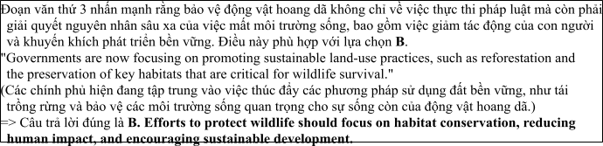
Câu 36. The word “complex” in paragraph 4 is OPPOSITE in meaning to
A. simple B. profound C. critical D. severe
Câu 37. Which of the following is TRUE according to the passage?
1. Only poaching laws can effectively protect wildlife.
2. Governments and international organizations are working together to expand protected areas and wildlife corridors.
3. Habitat destruction is not a significant threat to wildlife in protected areas.
4. Public awareness and international collaboration are not important for wildlife protection.
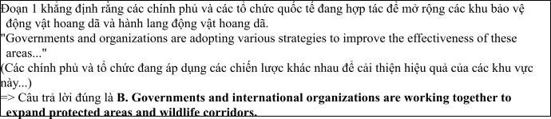
Câu 38. Which of the following best paraphrases the underlined sentence “Protecting wildlife is not only about enforcement; it also involves addressing the underlying causes of habitat loss.” in paragraph 3?
1. Wildlife protection is more about addressing habitat loss than enforcing the law.
2. To protect wildlife effectively, governments must focus solely on enforcement and laws.
3. Protecting wildlife is complex, and it requires both enforcement and addressing the causes of habitat loss.
4. It is crucial to address the effects of habitat destruction rather than focus on legal regulations.
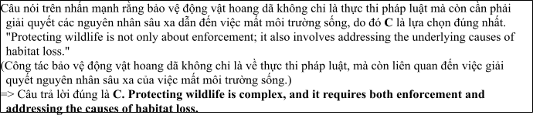
Câu 39. Which of the following can be inferred from the passage?
1. Wildlife protection is a simple process that can be solved through stricter laws alone.
2. Governments are failing to protect endangered species due to lack of resources.
3. Effective wildlife protection requires both legal measures and sustainable land-use practices.
4. The creation of wildlife corridors has no impact on reducing human-wildlife conflicts.
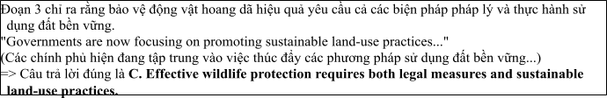
Câu 40. Which of the following best summarizes the passage?
1. Effective wildlife protection requires strict enforcement, sustainable land-use practices, and international cooperation to ensure that wildlife remains a key part of the ecosystem.
2. Protecting wildlife requires simply enforcing stricter laws and creating more reserves.
3. The key to protecting wildlife is to reduce poaching and illegal trade.
4. Wildlife protection efforts are mainly focused on raising awareness and creating more national parks.
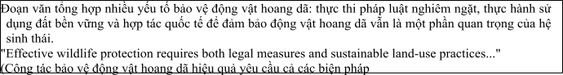

ĐỀ 10 | ĐỀ KIỂM TRA GIỮA HK2 NĂM HỌC 2024-2025  MÔN: TIẾNG ANH LỚP 12

Read the following advertisement and mark the letter A, B, C and D on your answer sheet to indicate the option that best fits each of the numbered blanks from 1 to 6
The Role of AI in Revolutionizing Healthcare
AI is revolutionizing healthcare by improving diagnostics, patient care, and treatment outcomes. By using (1) _______ deep learning techniques, AI can analyze medical images, identify diseases, and predict patient conditions in real time. (2) ______ with AI, doctors can make more accurate diagnoses and personalized treatment plans. Working (3) ______ AI technologies, medical researchers are now able to process large datasets, accelerating the development of new drugs and therapies. It is crucial to remind ourselves (4) _______ technology to ensure it is used ethically and responsibly. AI also helps to get rid of medical errors, (5) ________ healthcare systems safer and more reliable. With AI’s potential, we can improve (6) _______ for future generations.
Câu 1: A. advanced B. advancement C. advancing D. advances
Câu 2: A. Which equipped B. Equipping C. Being equipped D. Equipped
Câu 3: A. on B. with C. at D. from
Câu 4: A. to act B. to acting C. act D. to be acted
Câu 5: A. taking B. staying C. catching D. making
Câu 6: A. the quality of healthcare B. the healthcare of quality
C. quality of the healthcare D. the healthcare quality of
Read the following leaflet and mark the letter A, B, C or D on your answer sheet to indicate the option that best fits each of the numbered blanks from 7 to 12.
The Role of AI in Revolutionizing Wildlife Conservation Efforts
• In recent years, Artificial Intelligence (AI) has become a powerful tool in enhancing wildlife conservation efforts. (7) _______ AI, researchers can now monitor endangered species in real-time, predict poaching (8) ______, and prevent illegal hunting in remote areas.
• (9) _______ breakthrough is the use of AI-powered drones, which patrol vast landscapes and collect data on animal movements. This innovation has greatly improved wildlife protection strategies. Starting with AI-based cameras, experts can identify species and track their populations more effectively.
• The use of these technologies has (10) _______ a significant reduction in poaching incidents. In fact, the (11) _______ of elephants saved annually has increased by over 30%, thanks to these advancements. AI is truly transforming how we protect our planet’s precious (12) _______.
Câu 7. A. In light of B. Because of C. With the help of D. Owing to
Câu 8. A. actions B. incidents C. attempts D. crimes
Câu 9. A. A further B. Another C. Each D. A
Câu 10. A. resulted in B. resulted from C. contributed to D. led away
Câu 11. A. rate B. size C. amount D. number
Câu 12. A. fauna B. nature C. wildlife D. ecosystem
Mark the letter A, B, C or D on your answer sheet to indicate the best arrangement of utterances or sentences to make a meaningful exchange or text in each of the following questions from 13 to 17.
Câu 13
a. Linda: Hi, Nam! I've been good, thanks. You look so passionate about wildlife protection!
b. Nam: Yes, I’ve been volunteering at animal shelters recently. We need to do more to protect endangered species.
c. Nam: Hi, Linda! It's great to see you again. How have you been?
A. a-c-b B. b-c-a C. c-b-a D. c-a-b
Câu 14
a. John: What do you think about the influence of mass media on young people?
b. John: I agree, but I think they need to be more critical of the media they consume.
c. Rachel: I think it has a huge impact, especially with social media platforms.
d. John: In what way?
e. Rachel: Young people often get influenced by what they see online, like fashion trends or lifestyle choices.
A. a-c-d-e-b B. c-e-d-b-a C. d-b-a-e-c D. c-d-e-a-b
Câu 15
Hi Sarah,
a. No problem! But you should definitely check out the video documentary on this topic; it’s really eye-opening.
b. thanks for the news article you sent me last week about the rise of fake news.
c. It’s definitely a big issue, but I’ve been focusing on other things lately, so I haven’t had much time to look deeper into it.
d. That sounds interesting! I’ll make sure to watch it when I have more free time.
e. You’re welcome, Ben! I thought it was important to share that article because it's such a relevant topic right now.
Write back soon,
Alex
A. d-b-a-c-e B. b-e-c-a-d C. a-d-b-c-e D. a-c-d-b-e
Câu 16
a. Sounds like impactful work! Do you think working remotely has allowed you to be more productive in your efforts?
b. Absolutely! It allows me to focus on research and strategizing while staying connected with global experts on conservation.
c. My love for nature and wildlife protection led me to a career in conservation.
d. That’s amazing, Linda! What exactly do you do in the field of conservation?
e. For the past year, I’ve been working with a local NGO, focusing on protecting endangered species like tigers and rhinos.
(Adapted from discovery)
A. c-d-e-a-b B. a-b-c-d-e C. b-c-d-a-e D. c-a-d-b-e
Câu 17
a. Tom: AI has made a huge difference in wildlife conservation recently.
b. Sarah: Exactly. With real-time data, conservationists can respond much faster to threats, like illegal hunting or habitat destruction.
c. Tom: It’s amazing how AI is helping save these species. We need to invest more in this technology to protect wildlife better.
d. Sarah: Yes, it’s incredible! AI-powered drones are being used to monitor endangered species in remote areas.
e. Tom: These drones have really improved our ability to track animal populations and protect them from poachers.
(Adapted from i-Learn Smart World)
A. c-a-e-b-d B. d-c-a-b-e C. a-d-e-b-c D. d-e-b-c-a
Read the following passage about AI and mark the letter A, B, C or D on your answer sheet to indicate the option that best fits each of the numbered blanks from 18 to 22.
Artificial Intelligence (AI) is becoming a crucial tool in wildlife conservation, especially in protecting endangered species in remote areas. AI-powered technologies, such as drones, cameras, and sensors, (18) __________. A recent study found that poaching incidents have decreased by 40% in areas equipped with AI systems. These systems can alert park rangers in real-time, (19) _________. One of the most effective AI applications is the use of machine learning algorithms to identify patterns in animal behavior, (20) _______. Because of these advancements, conservationists are now able to protect larger areas more efficiently. However, (21) __________ due to limited resources. For example, in a remote reserve in Africa, the lack of a stable internet connection has delayed the installation of AI-powered surveillance systems. In another case, an AI system failed to detect a sudden increase in poaching, highlighting the need for continuous improvements in the technology. Despite these challenges, (22) __________in their natural habitats. .
(Adapted from economynews)
Câu 18:
A. are being used to monitor animal movements and detect potential threats.
B. were being used to monitor the movements of animal and detecting potential threats.
C. have been used to monitoring animal movements and detecting the threats of potential.
D. will be used to monitor animal movements and being detected potential threats.
Câu 19:
A. enable them to responding quickly to illegal activities
B. enabling them to respond quickly to illegal activities
C. which enabling them to respond quickly to illegal activities
D. that enabled them to respond quickly to illegal activities
Câu 20:
A. whom can help to predict poaching attempts before they occurred
B. who can help predict poaching attempts before they are occurring
C. which can help predict poaching attempts before they occur
D. that can help predict to poaching attempts before they occur
Câu 21:
A. some wildlife reserves change challenges in implementing with these technologies
B. some wildlife reserves destroy challenges in implementing for these technologies
C. some wildlife reserves balance challenges in implementing in these technologies
D. some wildlife reserves face challenges in implementing these technologies
Câu 22:
A. AI remains a promising solution for ensuring the safety of wildlife
B. AI remain a promising solution for ensuring the safety of wildlife
C. AI remains a promising solution to ensure safety wildlife
D. AI remains a promise solution for ensuring the safety wildlife
Read the following passage about The Development of Multimedia Communication and mark the letter A, B, C or D on your answer sheet to indicate the best answer to each of the following questions from 23 to 30.
The field of multimedia communication has seen incredible growth in recent years, changing the way people interact with information. With the advancement of technology, media now includes more than just text, radio, and television. Multimedia communication involves the use of a combination of different content forms, such as text, audio, video, and interactive elements, to convey messages to audiences in engaging and effective ways. Today, people access multimedia content on various devices, including smartphones, tablets, and computers, making it easier than ever to stay connected.
One of the most significant drivers of this change is the rise of the internet and digital platforms. Social media, streaming services, and websites are at the forefront of delivering multimedia content, allowing individuals to consume and create information in a variety of formats. Video-sharing platforms like YouTube and social media sites such as Instagram and TikTok have made it possible for everyone to share content with a global audience. As a result, businesses, educators, and governments are increasingly using multimedia to connect with their audiences, whether through marketing campaigns, online courses, or public service announcements.
Moreover, multimedia communication is not just about entertainment or education; it also plays an essential role in social and political movements. Through videos, podcasts, and blogs, individuals can raise awareness, mobilize others, and drive change in society. In fact, the power of multimedia communication has helped shape public opinions on critical issues like climate change, human rights, and social justice.
As the demand for multimedia content continues to rise, the field of communication is also evolving. New technologies such as virtual reality (VR) and augmented reality (AR) are pushing the boundaries of how media can be experienced. These innovations offer new opportunities for creating immersive and interactive experiences, further blurring the lines between the physical and digital worlds.
(Adapted from theguardian.com/uk/media)
Câu 23. Which of the following is NOT mentioned as an example of multimedia content?
A. Audio B. Video C. Text D. Print
Câu 24. The word "drivers" in paragraph 2 is closest in meaning to
A. causes B. obstacles C. benefits D. risks
Câu 25. The word "platforms" in paragraph 2 refers to
A. tools or websites used to deliver multimedia content B. physical locations for broadcasting
C. ways of interacting with customers D. methods of sharing audio content
Câu 26. The word "mobilize" in paragraph 3 could be best replaced by
A. motivate B. organize C. entertain D. control
Câu 27. Which of the following best paraphrases the underlined sentence in paragraph 2: "Video-sharing platforms like YouTube and social media sites such as Instagram and TikTok have made it possible for everyone to share content with a global audience"?
A. YouTube and social media sites allow people to share content locally.
B. Platforms like YouTube and Instagram have enabled global sharing of content.
C. Everyone can create content thanks to the limitations of platforms like YouTube.
D. Social media has made it more difficult for people to share content with others.
Câu 28. Which of the following is TRUE according to the passage?
A. Only educational organizations use multimedia content to connect with their audiences.
B. The growth of multimedia communication is mostly due to the development of virtual reality.
C. Social media has contributed to the increased accessibility of multimedia communication.
D. Multimedia communication is limited to text, video, and audio formats.
Câu 29. In which paragraph does the writer discuss the impact of new technology on communication?
A. Paragraph 1 B. Paragraph 2 C. Paragraph 3 D. Paragraph 4
Câu 30. In which paragraph does the writer explain the role of multimedia communication in social and political movements?
A. Paragraph 1 B. Paragraph 2 C. Paragraph 3 D. Paragraph 4
Read the following passage about Protecting Endangered Species and mark the letter A, B, C or D on your answer sheet to indicate the best answer to each of the following questions from 31 to 40.
[I] Over the past decades, the number of endangered species worldwide has been steadily increasing. This phenomenon is primarily driven by human activities, such as habitat destruction, poaching, and climate change. Conservation efforts have been made to address these issues, but much more needs to be done to protect vulnerable wildlife.
[II] One of the main threats to endangered species is habitat loss. Deforestation, urbanisation, and agricultural expansion have destroyed vast areas of natural habitats, forcing many animals to relocate or face extinction. Additionally, illegal hunting and the trade of endangered species for their fur, bones, and other body parts remain significant threats, despite global regulations.
[III] In response to these challenges, a variety of conservation strategies have been implemented. Protected areas such as national parks and wildlife reserves are established to conserve habitats and offer sanctuary to endangered species. Furthermore, stricter anti-poaching laws have been enforced in many regions to curb illegal hunting. International collaboration has also played a crucial role in the fight against wildlife trafficking.
[IV] While progress has been made, there is still much work to be done. Enhanced public awareness and education on the importance of biodiversity are essential to garner more support for wildlife conservation. Additionally, innovative technologies such as drones and satellite monitoring are helping to track animal populations and combat illegal activities. Governments, NGOs, and local communities must continue to work together to protect the most vulnerable species from extinction.
(Adapted from CNN news)
Câu 31. Where does the following sentence best fit?
"The protection of endangered species requires significant efforts from both local and global communities."
A. [I] B. [II] C. [III] D. [IV]
Câu 32. The phrase "human activities" in paragraph 1 could be best replaced by ____.
A. Natural phenomena B. Human interventions
C. Environmental changes D. Animal behaviors
Câu 33. The word "sanctuary" in paragraph 3 refers to ____
A. a hospital for injured animals B. a place of safety for endangered species
C. a type of breeding program for animals D. an educational center for wildlife
Câu 34. According to paragraph 2, which of the following is NOT a threat to endangered species?
A. Habitat destruction B. Climate change C. Overfishing D. Poaching
Câu 35. Which of the following best summarises paragraph 4?
A. More people need to be educated about wildlife protection.
B. Technology and international collaboration are key in wildlife conservation.
C. Governments and local communities have failed to prevent species extinction.
D. Wildlife protection efforts need to be focused solely on animals' habitats.
Câu 36. The word "relocate" in paragraph 2 is OPPOSITE in meaning to
A. migrate B. remain C. expand D. disappear
Câu 37. Which of the following is TRUE according to the passage?
A. Illegal hunting is the primary cause of species extinction.
B. Public education on conservation is not necessary for effective protection.
C. Governments and NGOs have joined forces to address wildlife trafficking.
D. International efforts to stop poaching have failed to make an impact.
Câu 38. Which of the following best paraphrases the underlined sentence: "Conservation efforts have been made to address these issues, but much more needs to be done" in paragraph 1?
A. Conservation efforts have been insufficient in resolving the problem.
B. Much more action is required to effectively address the issues surrounding endangered species.
C. The conservation measures taken so far have been highly effective.
D. The solutions to protecting endangered species have already been implemented.
Câu 39. Which of the following can be inferred from the passage?
A. Habitat destruction is the sole reason for the decline in endangered species.
B. Innovative technologies are crucial for tracking and protecting endangered species.
C. Poaching is no longer a significant threat to endangered animals.
D. There is no need for stricter laws against poaching.
Câu 40. Which of the following best summarises the passage?
A. The extinction of endangered species is inevitable without radical changes to human behavior.
B. Local communities should bear the primary responsibility for wildlife conservation.
C. The focus of conservation efforts should be solely on protecting animal habitats rather than on reducing poaching.
D. Although habitat destruction and poaching pose a serious threat to wildlife, global efforts, including technology, stricter laws, and public awareness, can help protect endangered species.

ĐÁP ÁN VÀ LỜI GIẢI

Read the following advertisement and mark the letter A, B, C and D on your answer sheet to indicate the option that best fits each of the numbered blanks from 1 to 6

The Role of AI in Revolutionizing Healthcare
AI is revolutionizing healthcare by improving diagnostics, patient care, and treatment outcomes. By using
(1) deep learning techniques, AI can analyze medical images, identify diseases, and predict patient conditions in real time. (2) with AI, doctors can make more accurate diagnoses and personalized treatment plans. Working (3) AI technologies, medical researchers are now able to process large datasets, accelerating the development of new drugs and therapies. It is crucial to remind ourselves (4)
technology to ensure it is used ethically and responsibly. AI also helps to get rid of medical errors,
(5) healthcare systems safer and more reliable. With AI’s potential, we can improve (6) for future generations.
Câu 1: A. advanced B. advancement C. advancing D. advances
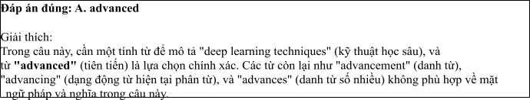
Câu 2: A. Which equipped B. Equipping C. Being equipped D. Equipped
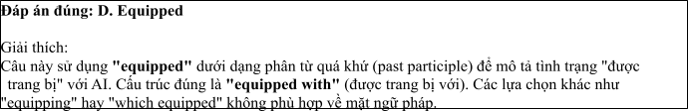
Câu 3: A. on B. with C. at D. from
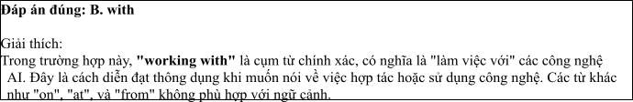
Câu 4: A. to act B. to acting C. act D. to be acted
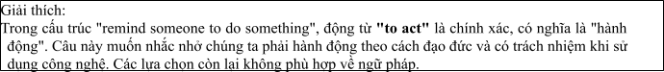
Câu 5: A. taking B. staying C. catching D. making
Câu 6: A. the quality of healthcare B. the healthcare of quality
C. quality of the healthcare D. the healthcare quality of
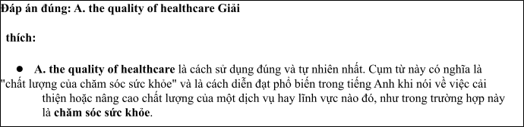
Read the following leaflet and mark the letter A, B, C or D on your answer sheet to indicate the option that best fits each of the numbered blanks from 7 to 12.

The Role of AI in Revolutionizing Wildlife Conservation Efforts
• In recent years, Artificial Intelligence (AI) has become a powerful tool in enhancing wildlife conservation efforts. (7) AI, researchers can now monitor endangered species in real-time, predict poaching (8) , and prevent illegal hunting in remote areas.
• (9) breakthrough is the use of AI-powered drones, which patrol vast landscapes and collect data on animal movements. This innovation has greatly improved wildlife protection strategies. Starting with AI-based cameras, experts can identify species and track their populations more effectively.
• The use of these technologies has (10) a significant reduction in poaching incidents. In fact, the (11) of elephants saved annually has increased by over 30%, thanks to these advancements. AI is truly transforming how we protect our planet’s precious (12) .
Câu 7. A. In light of B. Because of C. With the help of D. Owing to
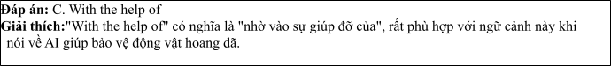
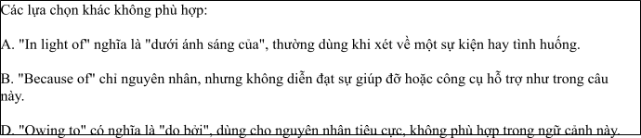
Câu 8. A. actions B. incidents C. attempts D. crimes
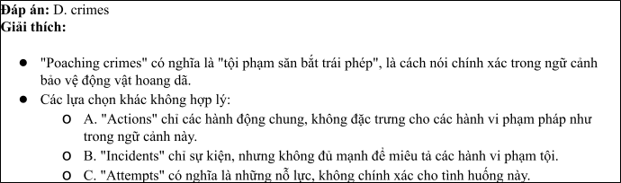
Câu 9. A. A further B. Another C. Each D. A
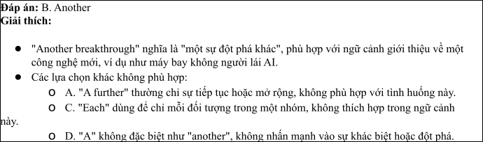
Câu 10. A. resulted in B. resulted from C. contributed to D. led away
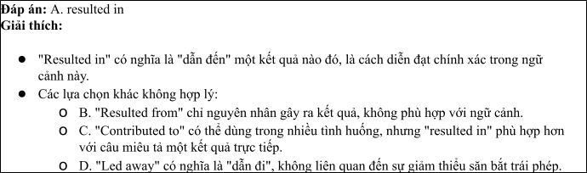
Câu 11. A. rate B. size C. amount D. number
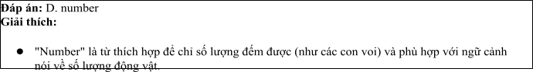
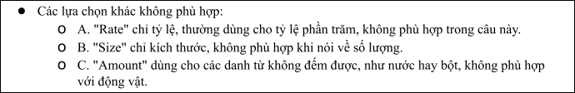
Câu 12. A. fauna B. nature C. wildlife D. ecosystem
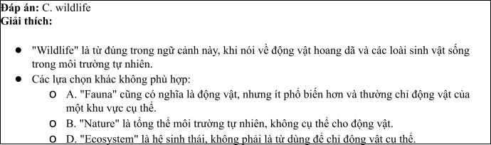
Mark the letter A, B, C or D on your answer sheet to indicate the best arrangement of utterances or sentences to make a meaningful exchange or text in each of the following questions from 13 to 17.

Câu 13
1. Linda: Hi, Nam! I've been good, thanks. You look so passionate about wildlife protection!
2. Nam: Yes, I’ve been volunteering at animal shelters recently. We need to do more to protect endangered
species.
3. Nam: Hi, Linda! It's great to see you again. How have you been?
A. a-c-b B. b-c-a C. c-b-a D. c-a-b
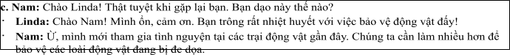

Câu 14
1. John: What do you think about the influence of mass media on young people?
2. John: I agree, but I think they need to be more critical of the media they consume.
3. Rachel: I think it has a huge impact, especially with social media platforms.
4. John: In what way?
5. Rachel: Young people often get influenced by what they see online, like fashion trends or lifestyle choices.
A. a-c-d-e-b B. c-e-d-b-a C. d-b-a-e-c D. c-d-e-a-b
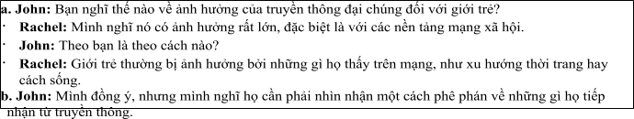

Câu 15
Hi Sarah,
1. No problem! But you should definitely check out the video documentary on this topic; it’s really eye- opening.
2. thanks for the news article you sent me last week about the rise of fake news.
3. It’s definitely a big issue, but I’ve been focusing on other things lately, so I haven’t had much time to
look deeper into it.
4. That sounds interesting! I’ll make sure to watch it when I have more free time.
5. You’re welcome, Ben! I thought it was important to share that article because it's such a relevant topic
right now.
Write back soon, Alex
A. d-b-a-c-e B. b-e-c-a-d C. a-d-b-c-e D. a-c-d-b-e
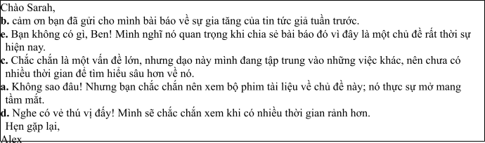

Câu 16
1. Sounds like impactful work! Do you think working remotely has allowed you to be more productive in your efforts?
2. Absolutely! It allows me to focus on research and strategizing while staying connected with global experts on conservation.
3. My love for nature and wildlife protection led me to a career in conservation.
4. That’s amazing, Linda! What exactly do you do in the field of conservation?
5. For the past year, I’ve been working with a local NGO, focusing on protecting endangered species like
tigers and rhinos.
(Adapted from discovery)
A. c-d-e-a-b B. a-b-c-d-e C. b-c-d-a-e D. c-a-d-b-e
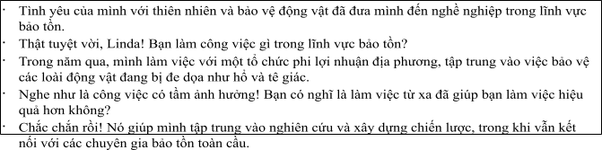

Câu 17
1. Tom: AI has made a huge difference in wildlife conservation recently.
2. Sarah: Exactly. With real-time data, conservationists can respond much faster to threats, like illegal hunting or habitat destruction.
3. Tom: It’s amazing how AI is helping save these species. We need to invest more in this technology to
protect wildlife better.
4. Sarah: Yes, it’s incredible! AI-powered drones are being used to monitor endangered species in remote areas.
5. Tom: These drones have really improved our ability to track animal populations and protect them from poachers.
(Adapted from i-Learn Smart World)
A. c-a-e-b-d B. d-c-a-b-e C. a-d-e-b-c D. d-e-b-c-a
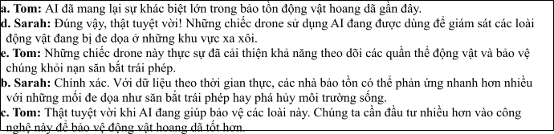
Read the following passage about AI and mark the letter A, B, C or D on your answer sheet to indicate the option that bestfits each of the numbered blanks from 18 to 22.
Artificial Intelligence (AI) is becoming a crucial tool in wildlife conservation, especially in protecting endangered species in remote areas. AI-powered technologies, such as drones, cameras, and sensors, (18)
. A recent study found that poaching incidents have decreased by 40% in areas equipped with AI systems. These systems can alert park rangers in real-time, (19) . One of the most effective AI applications is the use of machine learning algorithms to identify patterns in animal behavior, (20) . Because of these advancements, conservationists are now able to protect larger areas more efficiently. However, (21) due to limited resources. For example, in a remote reserve in Africa, the lack of a stable internet connection has delayed the installation of AI-powered surveillance systems. In another case, an AI system failed to detect a sudden increase in poaching, highlighting the need for continuous improvements in the technology. Despite these challenges, (22) in their natural habitats. .
(Adapted from economynews)
Câu 18:
1. are being used to monitor animal movements and detect potential threats.
2. were being used to monitor the movements of animal and detecting potential threats.
3. have been used to monitoring animal movements and detecting the threats of potential.
4. will be used to monitor animal movements and being detected potential threats.
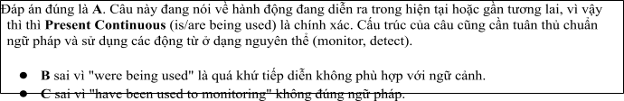

Câu 19:
1. enable them to responding quickly to illegal activities
2. enabling them to respond quickly to illegal activities
3. which enabling them to respond quickly to illegal activities
4. that enabled them to respond quickly to illegal activities
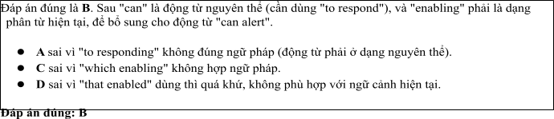

Câu 20:
1. whom can help to predict poaching attempts before they occurred
2. who can help predict poaching attempts before they are occurring
3. which can help predict poaching attempts before they occur
4. that can help predict to poaching attempts before they occur
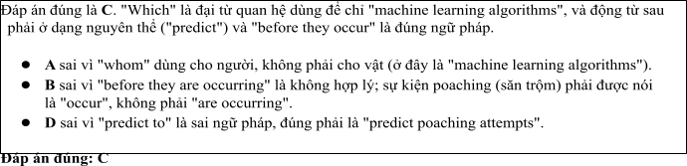

Câu 21:
1. some wildlife reserves change challenges in implementing with these technologies
2. some wildlife reserves destroy challenges in implementing for these technologies
3. some wildlife reserves balance challenges in implementing in these technologies
4. some wildlife reserves face challenges in implementing these technologies
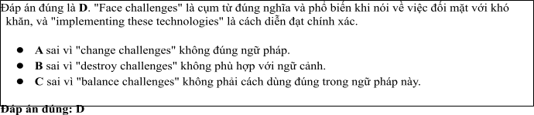

Câu 22:
1. AI remains a promising solution for ensuring the safety of wildlife
2. AI remain a promising solution for ensuring the safety of wildlife
3. AI remains a promising solution to ensure safety wildlife
4. AI remains a promise solution for ensuring the safety wildlife
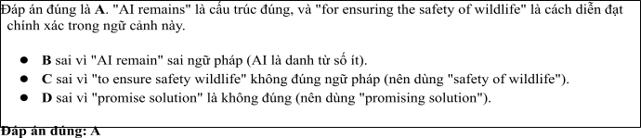
Read the following passage about The Development of Multimedia Communication and mark the letter A, B, C or D on your answer sheet to indicate the best answer to each of the following questions from 23 to 30.
The field of multimedia communication has seen incredible growth in recent years, changing the way people interact with information. With the advancement of technology, media now includes more than just text, radio, and television. Multimedia communication involves the use of a combination of different content forms, such as text, audio, video, and interactive elements, to convey messages to audiences in engaging and effective ways. Today, people access multimedia content on various devices, including smartphones, tablets, and computers, making it easier than ever to stay connected.
One of the most significant drivers of this change is the rise of the internet and digital platforms. Social media, streaming services, and websites are at the forefront of delivering multimedia content, allowing individuals to consume and create information in a variety of formats. Video-sharing platforms like YouTube and social media sites such as Instagram and TikTok have made it possible for everyone to share content with a global audience. As a result, businesses, educators, and governments are increasingly using multimedia to connect with their audiences, whether through marketing campaigns, online courses, or public service announcements.
Moreover, multimedia communication is not just about entertainment or education; it also plays an essential role in social and political movements. Through videos, podcasts, and blogs, individuals can raise awareness, mobilize others, and drive change in society. In fact, the power of multimedia communication has helped shape public opinions on critical issues like climate change, human rights, and social justice.
As the demand for multimedia content continues to rise, the field of communication is also evolving. New technologies such as virtual reality (VR) and augmented reality (AR) are pushing the boundaries of how media can be experienced. These innovations offer new opportunities for creating immersive and interactive experiences, further blurring the lines between the physical and digital worlds.
(Adapted from theguardian.com/uk/media) Câu 23. Which of the following is NOT mentioned as an example of multimedia content?
A. Audio B. Video C. Text D. Print
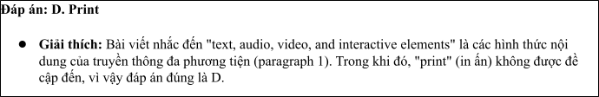
Câu 24. The word "drivers" in paragraph 2 is closest in meaning to
A. causes B. obstacles C. benefits D. risks
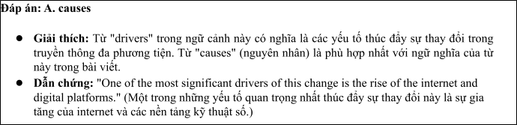
Câu 25. The word "platforms" in paragraph 2 refers to
A. tools or websites used to deliver multimedia content B. physical locations for broadcasting
C. ways of interacting with customers D. methods of sharing audio content
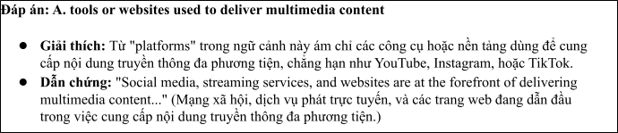
Câu 26. The word "mobilize" in paragraph 3 could be best replaced by
A. motivate B. organize C. entertain D. control
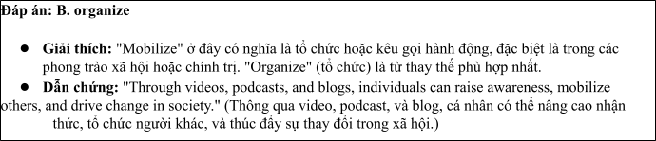
Câu 27. Which of the following best paraphrases the underlined sentence in paragraph 2: "Video-sharing platforms like YouTube and social media sites such as Instagram and TikTok have made it possible for everyone to share content with a global audience"?
1. YouTube and social media sites allow people to share content locally.
2. Platforms like YouTube and Instagram have enabled global sharing of content.
3. Everyone can create content thanks to the limitations of platforms like YouTube.
4. Social media has made it more difficult for people to share content with others.
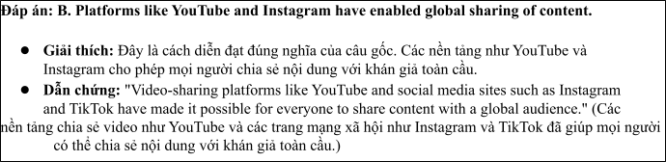
Câu 28. Which of the following is TRUE according to the passage?
1. Only educational organizations use multimedia content to connect with their audiences.
2. The growth of multimedia communication is mostly due to the development of virtual reality.
3. Social media has contributed to the increased accessibility of multimedia communication.
4. Multimedia communication is limited to text, video, and audio formats.
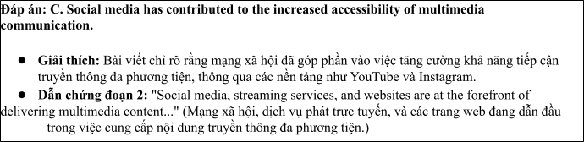
Câu 29. In which paragraph does the writer discuss the impact of new technology on communication?
A. Paragraph 1 B. Paragraph 2 C. Paragraph 3 D. Paragraph 4
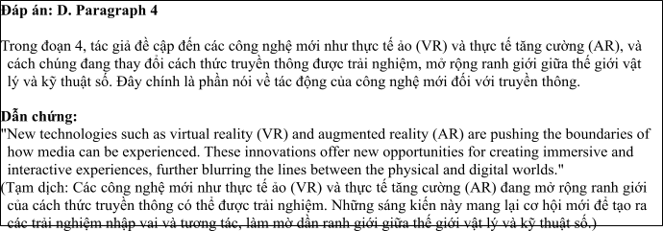
Câu 30. In which paragraph does the writer explain the role of multimedia communication in social and political movements?
A. Paragraph 1 B. Paragraph 2 C. Paragraph 3 D. Paragraph 4
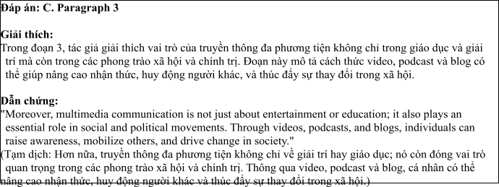
Read the following passage about Protecting Endangered Species and mark the letter A, B, C or D on your answer sheet to indicate the best answer to each of the following questions from 31 to 40.
1. Over the past decades, the number of endangered species worldwide has been steadily increasing. This phenomenon is primarily driven by human activities, such as habitat destruction, poaching, and climate

change. Conservation efforts have been made to address these issues, but much more needs to be done
to protect vulnerable wildlife.
2. One of the main threats to endangered species is habitat loss. Deforestation, urbanisation, and agricultural expansion have destroyed vast areas of natural habitats, forcing many animals to relocate or face extinction. Additionally, illegal hunting and the trade of endangered species for their fur, bones, and other body parts remain significant threats, despite global regulations.
3. In response to these challenges, a variety of conservation strategies have been implemented. Protected areas such as national parks and wildlife reserves are established to conserve habitats and offer sanctuary to endangered species. Furthermore, stricter anti-poaching laws have been enforced in many regions to curb illegal hunting. International collaboration has also played a crucial role in the fight against wildlife trafficking.
4. While progress has been made, there is still much work to be done. Enhanced public awareness and education on the importance of biodiversity are essential to garner more support for wildlife conservation. Additionally, innovative technologies such as drones and satellite monitoring are helping to track animal populations and combat illegal activities. Governments, NGOs, and local communities must continue to work together to protect the most vulnerable species from extinction.
(Adapted from CNN news)
Câu 31. Where does the following sentence best fit?

"The protection of endangered species requires significant efforts from both local and global communities."
A. [I] B. [II] C. [III] D. [IV]
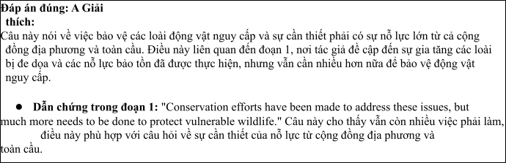
Câu 32. The phrase "human activities" in paragraph 1 could be best replaced by .
1. Natural phenomena B. Human interventions
C. Environmental changes D. Animal behaviors
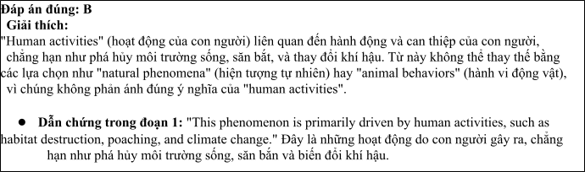
Câu 33. The word "sanctuary" in paragraph 3 refers to
A. a hospital for injured animals B. a place of safety for endangered species
C. a type of breeding program for animals D. an educational center for wildlife
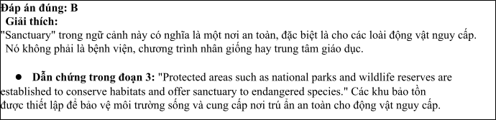
Câu 34. According to paragraph 2, which of the following is NOT a threat to endangered species?
A. Habitat destruction B. Climate change C. Overfishing D. Poaching
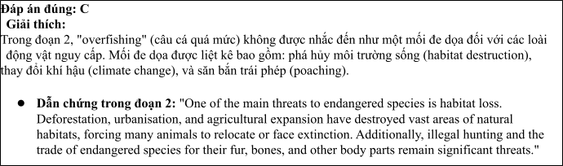
Câu 35. Which of the following best summarises paragraph 4?
1. More people need to be educated about wildlife protection.
2. Technology and international collaboration are key in wildlife conservation.
3. Governments and local communities have failed to prevent species extinction.
4. Wildlife protection efforts need to be focused solely on animals' habitats.
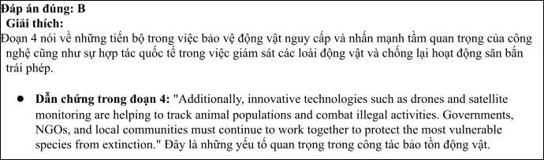
Câu 36. The word "relocate" in paragraph 2 is OPPOSITE in meaning to
A. migrate B. remain C. expand D. disappear
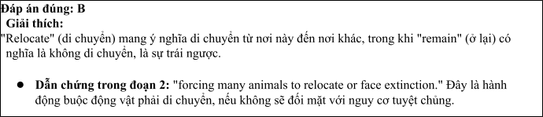
Câu 37. Which of the following is TRUE according to the passage?
1. Illegal hunting is the primary cause of species extinction.
2. Public education on conservation is not necessary for effective protection.
3. Governments and NGOs have joined forces to address wildlife trafficking.
4. International efforts to stop poaching have failed to make an impact.
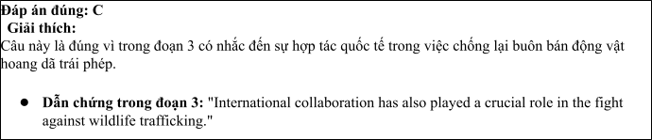
Câu 38. Which of the following best paraphrases the underlined sentence: "Conservation efforts have been made to address these issues, but much more needs to be done" in paragraph 1?
1. Conservation efforts have been insufficient in resolving the problem.
2. Much more action is required to effectively address the issues surrounding endangered species.
3. The conservation measures taken so far have been highly effective.
4. The solutions to protecting endangered species have already been implemented.
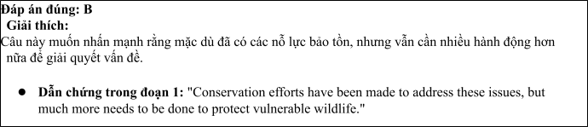
Câu 39. Which of the following can be inferred from the passage?
1. Habitat destruction is the sole reason for the decline in endangered species.
2. Innovative technologies are crucial for tracking and protecting endangered species.
3. Poaching is no longer a significant threat to endangered animals.
4. There is no need for stricter laws against poaching.
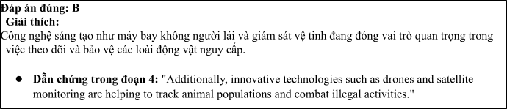
Câu 40. Which of the following best summarises the passage?
1. The extinction of endangered species is inevitable without radical changes to human behavior.
2. Local communities should bear the primary responsibility for wildlife conservation.
3. The focus of conservation efforts should be solely on protecting animal habitats rather than on reducing poaching.
4. Although habitat destruction and poaching pose a serious threat to wildlife, global efforts, including technology, stricter laws, and public awareness, can help protect endangered species.

Đáp án đúng: D Lý do:
Đáp án D là câu tóm tắt tốt nhất vì nó phản ánh đầy đủ các ý chính trong bài, bao gồm các mối đe dọa
chính đối với động vật nguy cấp (phá hủy môi trường sống và săn bắn trái phép), cũng như các biện pháp toàn cầu cần thiết để bảo vệ động vật (công nghệ, các luật chống săn bắn trái phép, và nâng cao nhận
thức cộng đồng).

Dẫn chứng từ bài viết:
1. Habitat destruction and poaching pose a serious threat to wildlife:
• Đoạn 1 nói về sự gia tăng của các loài bị đe dọa do hoạt động của con người như phá hủy môi trường sống và săn bắn trái phép.
• Đoạn 2 mô tả cụ thể về mối đe dọa từ việc phá hủy môi trường sống (deforestation, urbanisation, agricultural expansion) và săn bắn trái phép (illegal hunting).

2. Global efforts, including technology, stricter laws, and public awareness, can help protect endangered species:
• Đoạn 3 đề cập đến các nỗ lực bảo tồn toàn cầu như thiết lập các khu bảo vệ (national parks, wildlife reserves) và áp dụng các luật chống săn bắn trái phép nghiêm ngặt.
• Đoạn 4 nói về vai trò của công nghệ sáng tạo như máy bay không người lái và giám sát
vệ tinh trong việc bảo vệ động vật nguy cấp và việc nâng cao nhận thức cộng đồng về tầm quan trọng của sự đa dạng sinh học.

