UNIT 11. ELECTRONIC DEVICES
I. VOCABULARY
Stt | Word | Type | Pronunciation | Meaning
1 | 3D printer | (n) | /θriː di: ˈprɪntər/ | máy in 3D
 | E.g. He has just bought a 3D printer. Anh Ấy vừa mua một máy in 3D.
2 | application | (n) | /ˌæplɪˈkeɪʃn/ | việc áp dụng, ứng dụng
 | E.g. What are the practical applications of this work? Ứng dụng thực tế của công việc này là gì?
3 | aluminium | (n) | /ˌæljəˈmɪniəm/ | nhôm
 | E.g. Aluminium is a light, silver-grey metal. Nhôm là kim loại nhẹ, màu xám bạc.
4 | camcorder | (n) | /ˈkæmkɔːrdər/ | máy quay phim xách tay
 | E.g. A camcorder is a small video camera that can be held easily in one hand. Máy quay phim là một máy quay nhỏ có thể cầm dễ dàng bằng một tay.
5 | cardboard | (n) | /ˈkɑːrdbɔːrd/ | bìa cứng, các tông
 | E.g. The children wanted a piece of cardboard to cut shapes from. Bọn trẻ muốn có một mảnh bìa cứng để cắt thành các hình dạng.
6 | copper | (n) | /ˈkɒpər/ | đồng
 | E.g. They mine a lot of copper around these parts. Họ đào được rất nhiều đồng ở khu vực này.
7 | e-reader | (n) | /'i: ri:dər/ | máy đọc sách điện tử
 | E.g. This book is also available in e-reader format. Cuốn sách này cũng có định dạng sách điện tử.
8 | leaflet | (n) | /’li:flət/ | tờ rơi (tờ quàng cáo)
 | E.g. We picked up a few leaflets on local places of interest. Chúng tôi nhặt được vài tờ rơi về các điểm du lịch hâp dân ở địa phương.
9 | plastic | (n) | /ˈplæstɪk/ | chất dẻo, nhựa
 | E.g. These chairs made from plastic. Những chiếc ghế này được làm từ nhựa.
10 | portable | (adj) | /ˈpɔːrtəbl/ | có thể mang theo, xách tay
 | E.g. The equipment is lightweight, portable and easy to store. Thiết bị này nhẹ, có thể xách tay và dễ bảo quản.
11 | portable  music player | (n.phr) | / ˈpɔːrtəbl  ˈmjuːzɪk ˈpleɪər / | máy nghe nhạc cầm tay
 | E.g. My mother gave me a portable music player last month. Tháng trước mẹ tặng tôi một chiếc máy nghe nhạc bỏ túi.
12 | robotic  vacuum cleaner | (n.phr) | / rəʊˈbɒtɪk  ˈvækjuːm kliːnər/ | robot hút bụi tự động
 | E.g. A robotic vacuum cleaner is very helpful for my family. Một con robot hút bụi tự động rất có ích cho gia đình tôi.
13 | rubber | (n) | /ˈrʌbər/ | cao su
 | E.g. I don't like the smell of burning rubber. Tôi không thích mùi cao su cháy.
14 | responsive | (adj) | /rɪˈspɒnsɪv/ | đáp ứng, phản ứng lại
 | E.g. Firms have to be responsive to consumer demand. Doanh nghiệp phải đáp ứng nhu cầu của người tiều dùng.
15 | self-portrait | (n) | /ˌself ˈpɔːrtrət/ | ảnh chân dung tự chụp
 | E.g. How beautiful his self-portrait is! Bức chân dung tự họa của anh ấy đẹp quá!
16 | smartwatch | (n) | /ˈsmɑːrtwɑːtʃ/ | đồng hồ thông minh
 | E.g. The company has just launched a new smartwatch. Công ty vừa ra mắt một chiếc đồng hồ thông minh mới.
17 | steel | (n) | /sti:l/ | thép
 | E.g. The frame is made of steel. Khung này được làm bằng thép.
18 | stylish | (adj) | /ˈstaɪlɪʃ/ | họp thời trang, phong cách
 | E.g. You look very stylish. Bạn trông rất phong cách.
19 | suck | (v) | /sʌk/ | hút
 | E.g. She was sucking up milk through a straw. Cô ấy đang hút sữa bằng ống hút.
20 | touchscreen | (n) | /'tʌtʃskri:n/ | màn hình cảm ứng
 | E.g. Customers use a touchscreen to buy tickets. Khách hàng sử dụng màn hình cảm ứng để mua vé.
21 | virtual | (adj) | /ˈvɜːrtʃuəl/ | ảo
 | E.g. You can also take a virtual tour of the museum. Bạn cũng có thể thực hiện một chuyến tham quần áo đến bảo tàng.
22 | vision | (n) | /ˈvɪʒn/ | tầm nhìn, thị lực
 | E.g. Cats have good night vision. Mèo có tầm nhìn rất tốt vào ban đêm.
23 | window shade | (n) | /ˈwɪndəʊ ʃeɪd/ | mành cừa sổ
 | E.g. My father's company made drapes and window shades. Công ty của bố tôi sản xuất rèm cửa và rèm cửa sổ.
24 | wireless | (adj) | /‘waɪələs/ | không dây, vô tuyến
 | E.g. We will use wireless TV in 2030. Chúng ta sẽ sử dụng tivi không dây vào năm 2030

II. WORD FORMATION
Words | Related words | Transcription | Meaning
application (n)  /ˌæplɪˈkeɪʃn/ việc áp dụng, ứng dụng | applicable (adj) | /əˈplɪkəbl/ | có thể dùng được, có thể áp dụng, có thể ứng dụng được
application (n)  /ˌæplɪˈkeɪʃn/ việc áp dụng, ứng dụng | applicant (n) | /ˈəplɪkənt/ | người xin việc; người thỉnh
application (n)  /ˌæplɪˈkeɪʃn/ việc áp dụng, ứng dụng | applicability (n) | /əˌplɪkəˈbɪləti/ | tính ứng dụng, tính khả dụng
application (n)  /ˌæplɪˈkeɪʃn/ việc áp dụng, ứng dụng | apply (v) | /əˈplaɪ/ | ứng dụng, áp dụng, gắn vào, ghép vào
application (n)  /ˌæplɪˈkeɪʃn/ việc áp dụng, ứng dụng | applicator (n) | /ˈæplɪkeɪtər/ | vật dụng để bôi cái gì
portable (adj) /ˈpɔːrtəbl/  có thể mang theo, xách tay | portable (n) | /ˈpɔːrtəbl/ | cái dễ mang theo
portable (adj) /ˈpɔːrtəbl/  có thể mang theo, xách tay | portability (n) | /ˌpɔːrtəˈbɪləti/ | tính di chuyển được
printer (n)  /ˈprɪntər/  máy in | print (v) | /ˈprɪnt/ | in
printer (n)  /ˈprɪntər/  máy in | printable (adj) | /ˈprɪntəbl/ | có thể in
responsive (adj)  /rɪˈspɒnsɪv/ phản ứng nhanh nhạy, nhạy bén | responsively (adv) | /rɪˈspɒnsɪvli/ | phản ứng nhanh, thuận lợi; dễ bị điều khiển, dễ sai khiến
responsive (adj)  /rɪˈspɒnsɪv/ phản ứng nhanh nhạy, nhạy bén | responsiveness (n) | /rɪˈspɒnsɪvnəs/ | sự đáp ứng nhiệt tình; sự thông cảm sự phản ứng nhanh; tình trạng dề bị điều khiển, dễ sai khiến
responsive (adj)  /rɪˈspɒnsɪv/ phản ứng nhanh nhạy, nhạy bén | responsible (adj) | /rɪˈspɒnsəbl/ | chịu trách nhiệm (về mặt pháp lý)
responsive (adj)  /rɪˈspɒnsɪv/ phản ứng nhanh nhạy, nhạy bén | responsibility (n) | /rɪˌspɒnsəˈbɪləti/ | trách nhiệm; sự chịu trách nhiệm; bổn phận; nghĩa vụ
responsive (adj)  /rɪˈspɒnsɪv/ phản ứng nhanh nhạy, nhạy bén | response (n) | /rɪˈspɒns/ | sự trả lời; câu trả lời, sự đáp lại
responsive (adj)  /rɪˈspɒnsɪv/ phản ứng nhanh nhạy, nhạy bén | respond (v) | /rɪˈspɒnd/ | hưởng ứng, phản ứng lại, đáp lại
responsive (adj)  /rɪˈspɒnsɪv/ phản ứng nhanh nhạy, nhạy bén | respondent (n) | /rɪˈspɒndənt/ | trả lời, đáp lại
virtual  /ˈvɜːrtʃuəl/  ảo | virtually | /ˈvɜːrtʃuəli/ | thực sự, hầu như, gần như
vision  tầm nhìn, thị lực | visual (adj) | /ˈvɪʒuəl/ | thuộc thị giác, liên quan đến thị giác
vision  tầm nhìn, thị lực | visible (adj) | /ˈvɪzəbl/ | hữu hình, có thể nhìn thấy được
vision  tầm nhìn, thị lực | visibility (n) | /ˌvɪzəˈbɪləti/ | tính chất có thể nhìn thấy được
vision  tầm nhìn, thị lực | invisible (adj) | /ɪnˈvɪzəbl/ | không thể trông thấy được, vô hình
vision  tầm nhìn, thị lực | invisibility (n) | /ɪnˌvɪzəˈbɪləti/ | tính không thể trông thấy được, tính vô hình
wireless (adj)  /'waɪələs/ không dây,  vô tuyến | wire (n) | /'waɪə/ | dây, dây điện
III. GRAMMAR
✱ Suggest/ advise/ recommend + V-ing/ a clause with SHOULD
Chúng ta có thể sử dụng suggest/ advise/ recommend để đưa ra lời gợi ý, lời khuyên về một vấn đề nào đó. Theo sau các động từ này có thể là V-ing hoặc một mệnh đề với should + V.
S + suggest/ advise/ recommend + V-ing
S + suggest/ advise/ recommend + (that) + S + (should) +V(bare infinitive)
E.g. I suggested going to the supermarket.
(Tôi nghĩ là nên đi siêu thị.)
I suggested that you should go to the supermarket.
(Tôi gợi ý rang cậu nền đi siêu thị.)
E.g. I advise walking more for good health.
(Tôi khuyên bạn nên đi bộ nhiều hơn để có sức khỏe tốt.)
I advise that you should walk more for good health.
(Tôi khuyên bạn nên đi bộ nhiều để có sức khoẻ tốt.)
E.g. I recommend eating more fruits and vegetables.
(Tôi gợi ý nên ăn nhiều trái cây và rau xanh.)
I recommend that we should eat more fruits and vegetables.
(Tôi gợi ý rằng chúng ta nên ăn nhiều trái cây và rau xanh.)
IV. PRONUNCIATION
✱ STRESS ON ALL WORDS IN SENTENCES – TRỌNG ÂM NHẤN VÀO TẤT CẢ CÁC TỪ TRONG CÂU
Trong tiếng Anh, khi trọng âm nhấn vào tất cả các từ trong câu, đó thường là trường hợp đặc biệt như là câu mệnh lệnh hay một số thể loại văn học đặc biệt như thơ điệu.
Việc nhấn mạnh vào tất cả các từ trong câu có thể được sử dụng để tạo ra một hiệu ứng cụ thể, nhưng thường chỉ xảy ra trong ngữ cảnh hài hước hoặc biểu đạt sự ngạc nhiên, cảnh báo hay mệnh lệnh.
E.g. Go out! Be quiet! Watch out!
Don’t worry! I love you! Speak louder!
IV. PRATICE
Exercise 1: Write each sentence in the suitable box, then read them aloud.
Don’t run! | Go away! |  | Read aloud! |  | Don’t forget!
Come closer! | Stop talking! |  | Stand up! |  | Think twice!
Go ahead! | Watch out! |  | Speak slowly! |  | Keep silent!
OO |  | OOo |  | OoO
Exercise 2: Write the correct stress pattern for each sentence. Number 0 is an example for you.
No. | Sentence | Stress pattern
0. | Be quiet! | OOo
1. | Say sorry!
2. | Run faster!
3. | Straight ahead!
4. | Come here!
5. | Don’t touch!
6. | Be careful!
7. | Follow me!
8. | Try it on!
9. | Speak louder!
10. | Look out!
Exercise 3: Look and match the photos with the correct words.
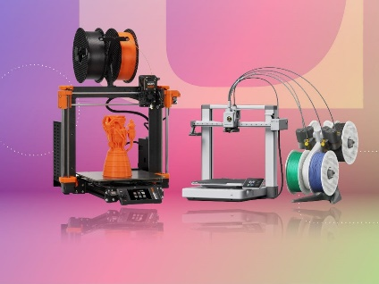 | 1 _____ | A | tablet
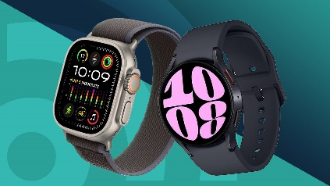 | 2 _____ | B | 3D printer
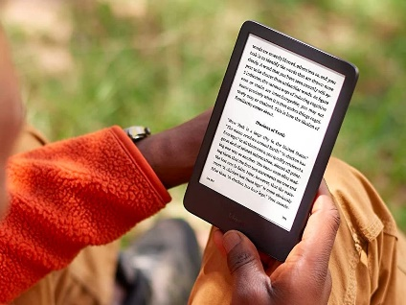 | 3 _____ | C | camcorder
 | 4 _____ | D | smartwatch
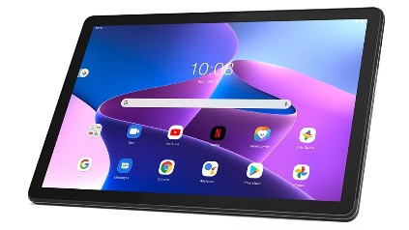 | 5 _____ | E | e-reader
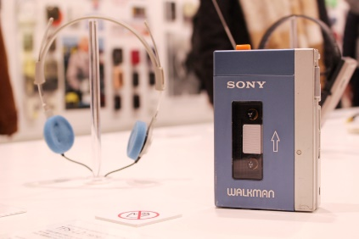 | 6 _____ | F | robotic vacuum cleaner
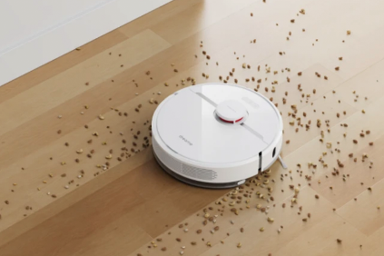 | 7 _____ | G | portable music player
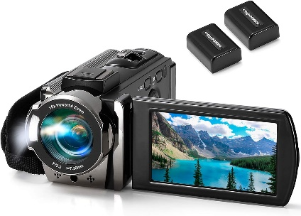 | 8 _____ | H | laptop
Exercise 4: Match each device in Column A with its function in Column B.
1. robotic vacuum cleaner _____ | A. plays digital music files on the go
2. smartwatch _____ | B. cleans floors autonomously and navigates around obstacles
3. 3D printer _____ | C. reads e-books and stores thousands of books
4. portable music player _____ | D. creates three-dimensional objects from digital designs
5. camcorder _____ | E. records videos with high-quality audio and visuals
6. e-reader _____ | F. tracks fitness, receives notifications, and makes calls
Exercise 5: Circle the odd one out.
1. A. rubber | B. plastic | C. iron | D. printer
2. A. touchscreen | B. virtual | C. keyboard | D. headphone
3. A. wireless | B. desktop | C. laptop | D.tablet
4. A. smartwatch | B. camcorder | C. customer | D. television
5. A. interact | B. effective | C. modem | D. convenient
6. A. suggest | B. assistant | C. advise | D. recommend
7. A. aluminium | B.copper | C. silver | D. electricity
8. A. device | B. equipment | C. navigate | D. appliance

Exercise 6: Choose the best options to complete the sentences.

1. They suggested ____________ a movie tonight to relax and have some fun together.

A. watching B. watch C. to watch D. watched

2. My parents advised me that I should ____________ more money for the future.

A. saving B. to save C. save D. to saving

3. The music teacher recommended Tom ____________ in the school concert to showcase his talent.

A. sings B. sing C. sang D. sung

4. Mr Smith advises ____________ regularly to improve skills and perform better in matches.

A. to practising B. practised C. practise D. practising

5. My classmates decided ____________ a 3D printer to create models for their project.

A. to try B. trying C. to trying D. try

6. She wants ____________ a smartwatch to monitor her heart rate while exercising.

A. to got B. gets C. getting D. to get

7. Kim advised ____________ too much time on video games and social media.

A. not spending B. don’t spend C. not spend D. isn’t spending

8. His teacher suggests that he ____________ questions if he doesn’t understand something.

A. asks B. should ask C. will ask D. to ask

9. My friend John told me ____________ him after school to make plans for the weekend.

A. to call B. call C. calling D. to called

10. The travel agent recommended ____________ the beach during the summer for a relaxing vacation.

A. visited B. visits C. visiting D. to visiting

Exercise 7: Write the correct form of each verb in brackets.
1. My dentist advised that I (brush) __________________ my teeth twice a day for good oral hygiene.
2. Ms Hong suggested that Tam should (rest) _______________ at home to recover from her illness.
3. The nutritionist recommended (eat) __________________ more fruits and vegetables to have a balanced diet.
4. My brother avoids (stay) _______________ up late because it makes him feel tired in the morning.
5. We agree (go) __________________ to the cinema on Friday night because there’s a new movie out that we both want to see.
6. The lifeguard advised (not swim) __________________ alone in deep water to avoid accidents.
7. They promise (not use) __________________ their phones during family dinners to have quality time together.
8. Phuong recommended that Kien (wear) __________________ sunscreen to protect his skin from the sun’s harmful rays.
Exercise 8: Complete the conversation with the words or phrases in the box.
watching | highlight | more convenient | using
recommendations | portable | e-reader | smartwatches
Ben: Man, I’ve got so many books to read for this course! It’s gonna take ages.
Carla: Really? Have you thought about getting an (1) __________________?
Ben: No, I haven’t. Why do you recommend (2) __________________ one?
Carla: Well, because it’s much (3) __________________ than carrying around all those heavy books. Plus, you can easily adjust the font size and (4) __________________ important sections.
Ben: That does sound useful. What about tablets? Do you have one of those?
Carla: Yeah, I use my tablet for browsing the internet and (5) __________________ movies. But for reading, I prefer an e-reader.
Ben: Hmm...I might look into that. What about (6) __________________? Are they worth it?
Carla: Definitely. They’re (7) __________________ and keep you connected without having to constantly check your phone. Perfect for when you’re on the go.
Ben: You’re right. Thanks for the (8), Carla.
Exercise 9: Choose the underlined part A, B, C or D that needs correcting.
1. The mechanic (A) advised that (B) Hoa should gets (C) her car serviced regularly (D).
2. They suggested to check (A) the (B) weather before (C) going (D) hiking.
3. I recommend that Lan learning (A) a (B) new language to boost (C) her (D) skills.
4. Our (A) TV, who (B) has a 4K screen, provides (C) amazing (D) picture quality.
5. My brother often uses (A) his player music (B) with headphones when (C) he goes for (D) a walk.
6. A computer is often use (A) for typing (B) documents and browsing (C) the (D) internet.
7. Lily said that (A) her smartphone is (B) running out of (C) battery and needed (D) to be charged.
8. The tech expert suggested that me (A) should install antivirus software on (B) my computer to protect (C) it from (D) malware and viruses.
Exercise 10: Circle the correct words or phrases to complete the sentences.
1. My teacher recommended practise / to practise / practising vocabulary every day to improve my English skills.
2. My younger brother enjoys to read / reads / reading mystery novels before going to bed.
3. Kevin suggested that we should book / booking / booked our flights early to get a better deal.
4. My friend is excited to learn surf / to surfing / to surf during our beach vacation.
5. Anna avoids to drink / drinking / drinks caffeinated beverages before bedtime to sleep better.
6. Ben suggested taking / takes / took a short break every hour to rest your eyes when working on the computer.
7. We don’t mind to watch / watching / watch the movie again if you want see / seeing / to see it.
8. Oliver advised to wear / wear / wearing comfortable shoes and bringing / bring / brought a water bottle for the hike.
Exercise 11: Make your own suggestion for each situation, using the structure “suggest / advise / recommend + that + S + should + bare infinitive”. Number 0 is an example for you.
0. Binh has got a fever and a headache.
I suggest that Binh should go to the doctor.
1. Sarah has a sore throat and finds it hard to speak.
_________________________________________________________________________________________________
2. Mark feels nervous before giving a presentation in class.
_________________________________________________________________________________________________
3. Phong wants to improve his English pronunciation.
_________________________________________________________________________________________________
4. Alice is struggling with her weight and wants to improve her health.
_________________________________________________________________________________________________
5. Emily has trouble falling asleep at night.
_________________________________________________________________________________________________
6. Samantha wants to improve her relationships with her family members.
_________________________________________________________________________________________________
7. Maria has an important job interview tomorrow.
_________________________________________________________________________________________________
8. Kevin is interested in starting his own business but doesn’t know where to begin.
_________________________________________________________________________________________________
Exercise 12: Read the text and choose the correct options.
Thu: My favourite electronic device is my smartphone. I have a sleek and stylish iPhone that I carry with me everywhere. I love my smartphone because it allows me to stay connected with my friends and family through calls, messages, and social media apps like Facebook and Instagram. I also enjoy using it to capture special moments with its high-quality camera, whether I’m at a party or out exploring the city.
Ngan: I love reading so the device that I like best is my e-reader. 1 own a Kindle Paperwhite. It can carry hundreds of books in one lightweight device, which allows me to read anytime and anywhere. Whether I’m commuting to work or relaxing at home, I can easily dive into my favourite novels and discover new stories with just a few taps on my e-reader’s screen. Such a wonderful invention!
Hoa: I have many electronic devices but my favourite one is the camcorder. It’s a special device that lets me capture important moments in my life. With my camcorder, I can record birthdays, holidays, and family gatherings. I also use it to film my adventures when I go on trips. I love watching these videos later and reminiscing about all the fun times I’ve had. My camcorder is like a treasure chest full of memories that I can keep forever. It’s small and easy to carry around, so I can take it with me wherever I go.
1. Which electronic device is NOT mentioned in this passage?
A. A smartphone B. A camcorder C. A tablet D. An e-reader
2. What type of smartphone does Thu have?
A. iPhone B. Samsung C. Oppo D. Huawei
3. How does Thu stay connected with friends and family using her smartphone?
A. Through calls and messages B. Through social media apps
C. Through letters D. Both A&B are correct.
4. Which sentence is TRUE about Thu’s smartphone?
A. Its design is ugly and outdated.
B. It has a low-quality camera.
C. It allows Thu to capture special moments.
D. It is primarily used for playing games and listening to music.
5. Which electronic device does Ngan prefer?
A. Smartphone B. E-reader C. Camcorder D. Laptop
6. Where can Ngan read on her e-reader?
A. Only at home B. Only on the bus
C. Anywhere D. Only in the library
7. What is the main function of the camcorder?
A. Capturing important moments B. Playing games
C. Listening to music D. Sending emails
8. What feature of the camcorder does Hoa mention?
A. It has a big screen. B. It is waterproof.
C. It is small and light. D. It costs a lot of money.
Exercise 13: Read the text and decide whether the following statements are True or False.
Using electronic devices to team English has many advantages. First of all, they are portable and can be taken anywhere. This means that you can study English on the bus, in a café, or even in bed.
Secondly, there is a wide range of apps and websites available which offer interactive exercises and activities. These can make studying more interesting and enjoyable. For example, you can practise your listening skills by watching videos or listening to podcasts. You can also play games to improve your vocabulary and grammar.
Another benefit is that electronic devices allow you to access online dictionaries and translation tools. This can be very useful if you come across a word or phrase you don’t understand.
Finally, electronic devices make it easy to connect with other learners and native speakers of English. You can join online communities, take part in discussions, and find language exchange partners. This provides opportunities for practising your speaking and writing skills.
In conclusion, electronic devices can be a valuable tool for learning English. However, it’s important to use them in moderation and not rely on them too much.
Statements | T or F
1. The advantages of using electronic devices for learning English are numerous.
2. You can study English everywhere by using electronic devices.
3. There are only a few apps and websites available for English learning.
4. Watching videos can help improve writing skills.
5. Playing games is a fun way to enhance vocabulary and grammar in English.
6. Online dictionaries cannot help you understand unfamiliar words in English.
7. Connecting with other English learners is easy with electronic devices.
8. We should completely rely on electronic devices.
Exercise 14: Write correct sentences using the given words.
1. Kien / recommend / read / reviews / before / book / hotel / online.
____________________________________________________________________________________________________
2. Anna / advise / use / public transportation / reduce / carbon emissions.
____________________________________________________________________________________________________
3. My sister / enjoy / take photographs / free time.
____________________________________________________________________________________________________
4. He / not mind / walk / school / if / weather / be / nice.
____________________________________________________________________________________________________
5. I / suggest / read / book / instead / watch / TV / before bed.
____________________________________________________________________________________________________
6. Sarah / advise / drink / plenty / water / throughout / day.
____________________________________________________________________________________________________
7. Lam / want / buy / new phone / with / better camera.
____________________________________________________________________________________________________
8. She / suggest / listen / classical music / while / study / for /calm atmosphere.
____________________________________________________________________________________________________
Exercise 15: Underline the mistake and rewrite the correct one.
1. My doctor advised that I should getting more exercise to improve my health.
____________________________________________________________________________________________________
2. The teacher suggested study for at least an hour every day to prepare for the test.
____________________________________________________________________________________________________
3. Yesterday, I buyed a robotic vacuum cleaner to help keep my floors clean.
____________________________________________________________________________________________________
4. My new tablet, that I received as a gift, has a large screen for watching movies.
____________________________________________________________________________________________________
5. The nutritionist recommended that Huy includes more vegetables in his diet.
____________________________________________________________________________________________________
6. My boss told me to finishing the report before the meeting.
____________________________________________________________________________________________________
7. They advise used a screen protector on your e-reader to prevent scratches.
____________________________________________________________________________________________________
8. Don’t downloading apps from unknown sources to prevent malware on your device.
____________________________________________________________________________________________________
Exercise 16: Write correct sentences that have the same meaning as the given ones.
1. "Why don’t you focus more on your grammar, Michael?"
I suggest that Michael _________________________________________________________________________
____________________________________________________________________________________________________
2. "Let’s go to the shopping centre this weekend."
I suggest _______________________________________________________________________________________
____________________________________________________________________________________________________
3. "You might want to try the new café downtown."
I recommend __________________________________________________________________________________
____________________________________________________________________________________________________
4. "You should listen carefully to the instructions before starting the task."
I advise that you _______________________________________________________________________________
____________________________________________________________________________________________________
5. "How about learning a new language online during your free time?"
I suggest _______________________________________________________________________________________
____________________________________________________________________________________________________
6. Have you considered joining a book club to meet new people?"
I suggest that you ______________________________________________________________________________
____________________________________________________________________________________________________
7. "It is a good idea for you to start exercising regularly for better health, Jack."
I advise ________________________________________________________________________________________
____________________________________________________________________________________________________
8. "Maybe you should explore online courses to enhance your skills and knowledge in a specific area, Mary."
I recommend that Mary _______________________________________________________________________
____________________________________________________________________________________________________
ĐÁP ÁN
