UNIT 8: THE WORLD AROUND US

A. VOCABULARY (TỪ VỰNG)
Lesson 1
No | Words |  | Transcription | Meaning
1 | campsite | (n) | /ˈkæmpsaɪt/ | Khu cắm trại
2 | canyon | (n) | /ˈkænjən/ | Hẻm núi
3 | cave | (n) | /keɪv/ | Hang động
4 | hiking | (n) | /ˈhaɪkɪŋ/ | Chuyến đi bộ đường dài
5 | kayaking | (n) | /ˈkaɪækɪŋ/ | Trò chèo thuyền kayak
6 | rafting | (n) | /ˈræftɪŋ/ | Việc đi bè

Lesson 2
No | Words |  | Transcription | Meaning
7 | battery | (n) | /ˈbætəri/ | Pin
8 | bottled water | (n) | /ˈbɑːtld ˈwɔːtər | Nước đóng chai
9 | flashlight | (n) | /ˈflæʃlaɪt/ | Đèn pin
10 | pillow | (n) | /ˈpɪləʊ/ | Gối
11 | sleeping bag | (n) | /ˈsliːpɪŋ bæɡ/ | Túi ngủ
12 | tent | (n) | /tent/ | Lều
13 | towel | (n) | /ˈtaʊəl/ | Khăn

Lesson 3
No | Words |  | Transcription | Meaning
14 | bay | (n) | /beɪ/ | Vịnh
15 | beach | (n) | /biːtʃ/ | Bãi biển
16 | forest | (n) | /ˈfɔːrɪst/ | Khu rừng
17 | highland | (n) | /ˈhaɪlənd/ | Cao nguyên
17 | island | (n) | /ˈaɪlənd/ | Hòn đảo
18 | mountain | (n) | /ˈmaʊntn/ | Núi
19 | waterfall | (n) | /ˈwɔːtərfɔːl/ | Thác nước

Further words
No | Words |  | Transcription | Meaning
20 | sneakers | (n) | /ˈsniːkərz/ | Giày chơi quần vợt
21 | sunglasses | (n) | /ˈsʌnɡlæsɪz/ | Kính râm
22 | confirm | (v) | /kənˈfɜːrm/ | Xác nhận
23 | decide | (v) | /dɪˈsaɪd/ | Quyết định
24 | heritage | (n) | /ˈherɪtɪdʒ/ | Di sản
25 | information | (n) | /ˌɪnfərˈmeɪʃn/ | Thông tin
26 | snorkeling | (n) | /ˈsnɔːrklɪŋ/ | Lặn có ống thở
27 | sandcastle | (n) | /ˈsændkæsl/ | Lâu đài cát
28 | international | (adj) | /ˌɪntərˈnæʃnəl/ | Thuộc về quốc tế
29 | dangerous | (adj) | /ˈdeɪndʒərəs/ | Nguy hiểm
30 | description | (n) | /dɪˈskrɪpʃn/ | Sự miêu tả

B. GRAMMAR (NGỮ PHÁP)
I. Modals: “should, shouldn’t; can, can’t”
1. Should & shouldn’t:

“should” (nên) và “shouldn’t” (không nên) dùng để đưa ra lời khuyên

Should là động từ khuyết thiếu, do đó nó không cần chia theo các ngôi và luôn cần một động từ nguyên thể không “to” đi đằng sau.
Thể | Thể khẳng định / Thể phủ định | Thể nghi vấn
Chức năng | Dùng để diễn tả lời khuyên, hay ý nghĩ điều gì là đúng, nên làm hoặc không nên làm. | Dùng để hỏi ý kiến hay yêu cầu một lời khuyên.
Cấu trúc | S + should/ shouldn’t + V + (các thành phần khác). | Should + S + V + (các thành phần khác)?  Yes, S + should.  No, S + shouldn’t.
Ví dụ | We should brush our teeth twice a day.  (Chúng ta nên đánh răng hai lần một ngày.)  We shouldn’t waste water.  (Chúng ta không nên lãng phí nước.) | Should we buy a new car?  (Chúng ta có nên mua một chiếc ô tô mới không?)  Yes, we should.  (Có, chúng ta nên mua.)

2. Can & can’t:
“can” (Có thể) và “can’t” (Không thể) là động từ khuyết thiếu, do đó nó không cần chia theo các ngôi và luôn cần một động từ nguyên thể không “to” đi đằng sau.
Thể | Thể khẳng định/ Phủ định | Thể nghi vấn
Cấu trúc | S + can/ can’t + V + (các thành phần khác). | Can + S + V + (các thành phần khác)?  Yes, S + can.  No, S + can’t.
Chức năng | Diễn tả khả năng của một người có thể/ không thể làm được gì hoặc một sự việc có thể/ không thể xảy ra ở hiện tại. | Dùng trong câu hỏi đề nghị, xin phép, yêu cầu.
Ví dụ: | - She can speak Spanish.  (Cô ấy có thể nói tiếng Tây Ban Nha.)  - It can rain. (Trời có thể mưa.) | - Can I ask you a question?  (Tôi có thể hỏi bạn 1 câu không?)  - Can you swim? (Bạn có thể bơi không?)

II. Conjunction: “so”
Liên từ/ Từ nối là từ dùng để kết hợp các từ, cụm từ, mệnh đề hay câu với nhau. Trong đó:
 | Liên từ đẳng lập | Liên từ phụ thuộc
Chức năng | Dùng để nối các từ, cụm từ cùng một loại, hoặc các mệnh đề ngang hàng nhau (tính từ với tính từ, danh từ với danh từ...) | Dùng để nối các nhóm từ, cụm từ hoặc mệnh đề có chức năng khác nhau - mệnh đề phụ với mệnh đề chính trong câu.
Vị trí | - Luôn luôn đứng giữa 2 từ hoặc 2 mệnh đề mà nó liên kết.  - Nếu nối các mệnh đề độc lập thì luôn có dấu phẩy đứng trước liên từ. | - Thường đứng đầu mệnh đề phụ thuộc.  - Mệnh đề phụ thuộc có thể đứng trước hoặc đứng sau mệnh đề chính nhưng phải luôn được bắt đầu bằng liên từ phụ thuộc.
Các liên từ | Chỉ sự thêm vào: and (và)... | Diễn tả nguyên nhân, lý do: because (bởi vì)...
Các liên từ | Chỉ sự tương phản, đối lập: but (nhưng)... | Chỉ hai hành động trái ngược nhau về mặt logic: although (mặc dù)
Các liên từ | Chỉ kết quả: so (vì vậy, cho nên)...
Các liên từ | Chỉ sự lựa chọn: or (hoặc)...
Ví dụ | - I’ll come and see you soon.  (Tôi sẽ đến và gặp bạn sớm.)  - His mother won’t be there, but his father might.  (Mẹ anh ấy sẽ không ở đó nhưng bố anh ấy thì có thể.)  - It is raining, so I can’t go camping.  (Trời đang mưa nên tôi không thể đi cắm trại được.)  - I had a cold so I didn’t go to school.  - We are going kayaking so you need to bring a towel.  - We need to bring a tent so we can sleep.  - We need to bring bottled water so we don’t get thirsty.  - We should bring a flashlight so we can see at night. | - Last night we came late because it rained heavily.  (Tối qua chúng tôi đến trễ vì trời mưa to.)  Although the car is old, it is still reliable. (Mặc dù chiếc ô tô đã cũ, nhưng nó vẫn đáng tin cậy.)

C. EXERCISE (BÀI TẬP)
❶ PHONETICS
I. Choose the words whose underlined part is pronounced differently from that of the others in each group.
1. A. sleeping B. island C. campsite D. staying
2. A. nearby B. battery C. pretty D. thirty
3. A. close B. canyon C. climbing D. cell phone
4. A. tent B. jacket C. best D. get
5. A. rafting B. camping C. plane D. kayaking
6. A. beach B. seafood C. beautiful D. weather
7. A. wonders B. comic books C. forests D. trips
8. A. pillows B. towels C. flashlights D. toys
9. A. sunglasses B. candies C. sandcastles D. caves
10. A. confirmed B. traveled C. stayed D. hiked

II. Choose the word whose main stressed syllable is placed differently from that of the other in each group.
1. A. pillow B. towel C. forest D. confirm
2. A. weekend B. campsite C. flashlight D. highland
3. A. waterfall B. vacation C. kayaking D. canyon
4. A. dangerous B. natural C. beautiful D. delicious
5. A. Caribbean B. international C. geography D. Indonesian

❷ VOCABULARY
I. Use the words in the box and write them for each picture. (Activities)
campsite cave hiking kayaking canyon rafting

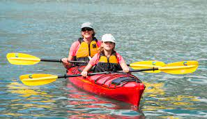 | 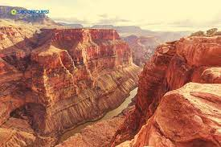 | 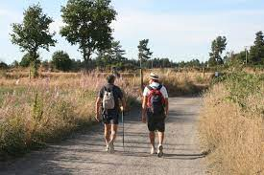
1. _______________ | 2. _______________ | 3. _______________
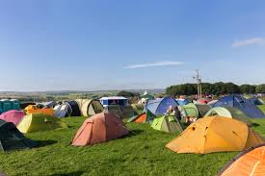 | 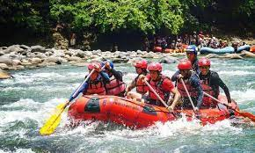 | 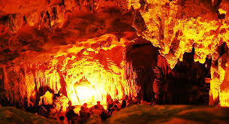
4. _______________ | 5. _______________ | 6. _______________

II. Write the suitable word for each picture. (Things)

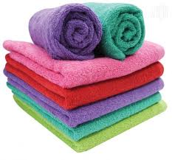 | 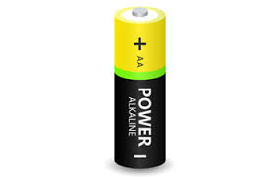 | 
1. _______________ | 2. _______________ | 3. _______________
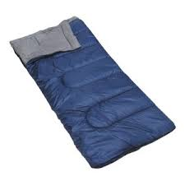 | 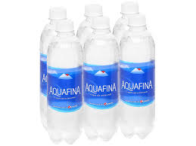 | 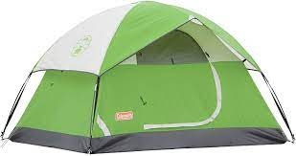
4. _______________ | 5. _______________ | 6. _______________
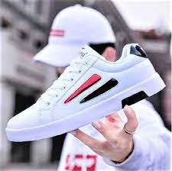 |  | 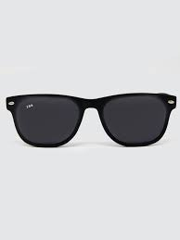
7. _______________ | 8. _______________ | 9. _______________
III. Write the suitable word for each picture. (Places)

 | 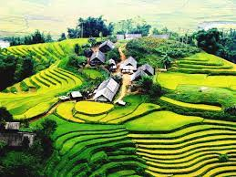 | 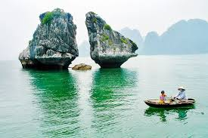
1. _______________ | 2. _______________ | 3. _______________
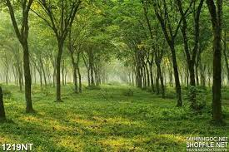 | 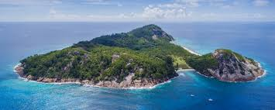 | 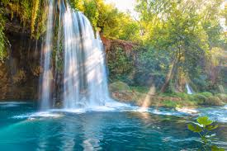
4. _______________ | 5. _______________ | 6. _______________
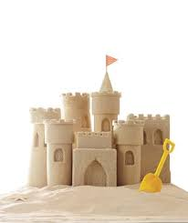 | 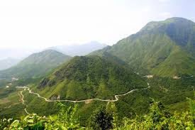 | 
7. _______________ | 8. _______________ | 9. _______________

❸ GRAMMAR
I. Use “should/shouldn’t” to fill in the blanks to complete the sentences.
1. Tom _______________ eat so many lollipops. It’s bad for his teeth.
2. He’s fifteen. He _______________ drive a car.
3. Pregnant women _______________ smoke as it can damage the baby.
4. We _______________ go somewhere exciting for our holiday.
5. People _______________ drive fast in the town centre.
6. You _______________ ask the teacher for help you if you don’t understand the lesson.
7. _______________ I buy the dress or the skirt?
8. She _______________ tell lies.
9. That’s a fantastic book. You _______________ read it.
10. The doctor said: “You _______________ eat healthy food. You _______________ eat fast food. You _______________ watch so much TV. You _______________ walk 1 hour a day. You _______________ drink fruit juice and water. You _______________ drink wine or beer.
11. You _______________ be so selfish.
12. I don’t think you _______________smoke so much.
13. You _______________ exercise more.
14. I think you _______________ try to speak to her.
15. You are overweight. You _______________ go on a diet.
16. Where _______________ we park our car?
17. You _______________ never speak to your mother like this.
18. The kids _______________ spend so much time in front of the TV.
19. _______________ I tell her the truth or should I say nothing?
20. I think we _______________ reserve our holiday in advance.
II. Use “can/can’t” to fill in the blanks to complete the sentences.
1. I (can/ can’t) speak French. I picked it up while I was in France.
2. I (can/ can’t) come to the party. I am really busy.
3. We (can/ can’t) hear you. The music is so loud.
4. Where are my keys? I (can/ can’t) find them.
5. I (can/ can’t) believe it. We won two million dollars.
6. We (can/ can’t) meet tomorrow if you want.
7. (Can/ Can’t) you make me a cup of tea, please?
8. He (can/ can’t) jump. His leg hurts so much.
9. Illiterate people (can/ can’t) read and write.
10. Fish (can/ can’t) swim.
11. (Can/can’t) you swim? - Yes, I (can/can’t)
12. I’m sorry I (can/can’t) help you today, I’m really busy.
13. Please (can/can’t) you buy some milk on your way home? - I (can/can’t) leave the house because I’m looking after the baby.
14. I (can/can’t) ride a bike but I (can/can’t) drive a car.
15. I just (can/can’t) manage to wake up on time, I’m always late.
16. Hello, (can/can’t) I help you? - Actually, no you (can/can’t). This restaurant is awful and we’ve been waiting here for half an hour. We’re leaving.
17. I have a special talent, I (can/can’t) touch my nose with my tongue (can/can’t) you?
18. (Can/Can’t) I go to the bathroom please?- Yes, of course you (can/can’t).
19. Look! It’s right there! (Can/Can’t) you see it? It’s so obvious!
20. I’ve never been able to eat breakfast in the mornings. I (can/can’t) talk to anyone either!

III. Choose A, B, C or D to complete the sentences.
1. I like English _______________ I like French very much.
A. and B. but C. or D. so
2. My brother likes Maths _______________ he doesn’t like history.
A. and B. but C. or D. so
3. The children forgot their homework,_______________ the teacher was angry with them.
A. and B. but C. or D. so
4. Can you read _______________ write English words?
A. and B. but C. or D. so
5. Are the questions right _______________ wrong?
A. and B. but C. or D. so
6. It’s great _______________ it’s fun.
A. and B. but C. or D. so
7. Would you like tea _______________ hot chocolate for your breakfast?
A. and B. but C. or D. so
8. Our car is old, _______________ it drives beautifully.
A. and B. but C. or D. so
9. It was very warm, _______________ we all went swimming.
A. and B. but C. or D. so
10. Do we have French _______________ Music after the break?
A. and B. but C. or D. so
11. I like sugar in my tea, _______________ I don’t like milk in it.
A. and B. but C. or D. so
12. We were very tired _______________ happy after our flight to Sydney.
A. and B. but C. or D. so
13. Jane was cold, _______________ he put on a coat.
A. and B. but C. or D. so
14. Julie has a guitar, _______________ she plays it really well.
A. and B. but C. or D. so
15. Maria tried to read a novel in French, _______________it was too difficult.
A. and B. but C. or D. so
16. He lives in London, _______________ he studies at a college.
A. and B. but C. or D. so
17. You can go to the tourist office _______________ ask them for any information you need.
A. and B. but C. or D. so
18. Does Miss Smith like the red boots _______________ the black and white sandals?
A. and B. but C. or D. so
19. Lynda likes Tom _______________ he is in love with Annette.
A. and B. but C. or D. so
20. Geraldine Chaplin is a great actress ________ she is less well-known than her father Charlie Chaplin.
A. and B. but C. or D. so

❹ READING
I. Read the email and write True (T) or False (F) for the statements.
New message
To: julianstone@frendzmail.com
Subject: Visiting Vietnam
Dear Julian,
I'm so glad you are coming to Vietnam for your vacation. It's beautiful! When you're here, we should travel to see some of Vietnam's natural wonders. Mộc Châu Highland and Cúc Phương National Park are two beautiful places in the north of Vietnam. There are some really pretty villages, huge forests, and amazing waterfalls. We can go to both places by train or bus. We should also go to Phú Quốc Island and Lăng Cô Bay. They have beautiful white sand beaches. We could go scuba diving and snorkeling there. Those places are famous for their delicious seafood, too. We can go to Phú Quốc by plane or boat.
See you soon,
Phúc

Sentences | True/ False
1. Julian is coming to Vietnam for her vacation.
2. Mộc Châu Highland and Cúc Phương National Park are in the south of Vietnam.
3. You can’t go to Mộc Châu Highland by bus or train.
4. If you love the beach, you should go to Phú Quốc Island on Lăng Cô Bay.
5. You can eat seafood in Phu Quoc Island.

II. Read and choose the correct answer (A, B, C or D)
Christine Robinson, August 12
Bali is a wonderful place for o vocation.
A lot of visitors go to Bali for their vacations every year. You can enjoy the white sand beaches, take photos, and moot friendly local people. You can also go on cycling tours, scuba diving, and even snorkeling. Bali is one of the most beautiful islands in Indonesia. You can go there by boat or plane. You should not go there between October and March because it is very rainy. Between April and October are the best times to visit Bali, during the dry season. You can also go to the International Film Festival in Bali every September. If you get the chance, you should spend your vacation in this beautiful place.
1. People can enjoy beautiful beaches with _______________.
A. golden sand B. white sand C. rain D. forest
2. People can enjoy cycling and _______________.
A. rock climbing B. kayaking C. scuba diving D. snorkeling
3. People can take a _______________ to Bali.
A. bus B. train C. boat D. plane
4. People shouldn’t go there between _______________ and _______________ because of the rain.
А. November - December B. October - December
C. October – March D. September – December
5. The Indonesian International Film Festival happens every _______________ in Bali.
A. three years B. year C. two years D. four years

III. Read the article and answer the questions.
I am Kate, I live in Cairo, which is the capital of Egypt. There are more than ten million people here. A lot of them come from the countryside because there are more jobs here.
I live in an apartment near the city center. It is a busy, exciting place. It has cinemas and shops, but unfortunately there is a lot of traffic too. Many tourists come from all over the world to see the Pyramids, which are near the city.
I like Cairo because it is big and exciting. I have a lot of friends and it is easy to meet new people. I am glad that I live here, but my mother doesn’t like it. She used to live in the countryside, and she would like to go back one day.
1. Is Cairo the capital of Egypt?
_____________________________________________________________________________________________________________
2. How many people are there in Cairo?
_____________________________________________________________________________________________________________
3. Why do people go to Cairo?
_____________________________________________________________________________________________________________
4. Where do many tourists come from to see the Pyramids?
_____________________________________________________________________________________________________________
5. Where did Kate’s mother used to live?
_____________________________________________________________________________________________________________

❺ WRITING
I. Look at the travel brochures and choose a place you'd like to go with your friends on vacation. Write a paragraph about your choice using the given information.
Write 50 to 60 words.
THE RED CANYON  Beautiful place  What to do: go rock climbing, go rafting  How to get there: 3 hours by car  Where to stay: a hotel by the canyon  Note: swimming: too dangerous! | THE GREEN CAVE  Interesting place  What to do: go hiking, go kayaking inside the caves  How to get there: 5 hours by bus  Where to stay: a campsite near the cave  Note: rock climbing: too dangerous!

_____________________________________________________________________________________________________________
_____________________________________________________________________________________________________________
_____________________________________________________________________________________________________________
_____________________________________________________________________________________________________________

II. Read the information below and write a postcard telling your friend about Boy of Islands.
Write 50 to 60 words.
NEW ZEALAND
BAY OF ISLANDS
- Amazing beaches
- go fishing
- go surfing
- nice, sunny weather
- delicious seafood
Hello Liam,
_____________________________________________________________________________________________________________
_____________________________________________________________________________________________________________
_____________________________________________________________________________________________________________
_____________________________________________________________________________________________________________
Can't wait to see you.
Paul
D. FURTHER PRACTICE (LUYỆN TẬP)
1. The water is too dangerous. We can/can't go kayaking here.
2. The canyon is beautiful. We should/shouldn't go hiking there.
3. The bus comes in five minutes. We can/can't go back to the campsite.
4. We should/shouldn't take the bus. It's too slow. Let's go by train.
5. We can/can't stay at this campsite. It's closed.
6. We should/shouldn't go hiking today. It is raining very hard.
7. You should/shouldn't go to the beach. It really is very beautiful.
8. What can/need we do in Đà Nẵng?
9. We need/should to bring a pillow because the campsite doesn't have any
10. It's very cold at night so/don't bring a jacket.
11. You should/can't swim in that water. It's very dangerous.
12. The campsite has food so/should we don't need to bring any.
II. Complete the sentences by using “although/ because/ but/ so”.
1. _______________ Norway is a beautiful country, it is very cold in winter.
2. It is warm and sunny today _______________ we are going to the beach.
3. The car is very old _______________ it is reliable.
4. Today is my daughter’s birthday, _______________ I need to buy her a present.
5. You should take an umbrella _______________ it is going to rain.
6. The camera is expensive _______________ it is very good.
7. I love chips _______________ it is not healthy.
8. His mother is not feeling well, _______________ he needs to take care of her.
9. Your marks in English are low _______________ you don’t study hard enough.
10. _______________ he is a good ski instructor, I don’t like him very much.
11. I’d like to go with you _______________ I’m too busy right now.
12. There are no buses this hour, _______________ we need to catch a taxi.
13. _______________ it rains a lot in winter, I like walking the dog in the park.
14. He fails his driving test, _______________ he needs to do it again.
15. We invite them to the party _______________ they don’t want to come.
16. I don’t like the concert _______________ the band doesn’t play well.
17. We don’t go on holiday _______________ we don’t have a lot of money.
18. I want to buy a car _______________ I need it for my job.
19. I’m learning French _______________ I want to live in Paris.
20. _______________ he’s got a car, he never drives to work.

III. Rearrange the words to make the full sentences.
1. accident / an / she’s / in / because / hospital / she / had.
_____________________________________________________________________________________________________________
2. but / they / many / work / don’t / hours / they / have / money / much.
_____________________________________________________________________________________________________________
3. asked / Paul / me / question, / a / replied / I / so.
_____________________________________________________________________________________________________________
4. buy / I / peppers / potatoes. / and / tomatoes,
_____________________________________________________________________________________________________________
5. them / apple / can / have / an / or/ a / . / She / have / both /. / She / mango / can’t / of
_____________________________________________________________________________________________________________
6. can / piano /./ Karthik / play / but / he / play / the/ can’t / the/ violin
_____________________________________________________________________________________________________________
7. hard-working / is / but / her / is / lazy / . / She / very / brother
_____________________________________________________________________________________________________________
8. clever / is / and / beautiful / . / she
_____________________________________________________________________________________________________________
9. shirt / can / the / blue / or / take / green / shirt/ . / You / the
_____________________________________________________________________________________________________________
10. / am / sister / tall / I / short / . / My / is / but
_____________________________________________________________________________________________________________

ĐÁP ÁN
UNIT 8: THE WORLD AROUND US

A. VOCABULARY (TỪ VỰNG)
Lesson 1
No | Words |  | Transcription | Meaning
1 | campsite | (n) | /ˈkæmpsaɪt/ | Khu cắm trại
2 | canyon | (n) | /ˈkænjən/ | Hẻm núi
3 | cave | (n) | /keɪv/ | Hang động
4 | hiking | (n) | /ˈhaɪkɪŋ/ | Chuyến đi bộ đường dài
5 | kayaking | (n) | /ˈkaɪækɪŋ/ | Trò chèo thuyền kayak
6 | rafting | (n) | /ˈræftɪŋ/ | Việc đi bè

Lesson 2
No | Words |  | Transcription | Meaning
7 | battery | (n) | /ˈbætəri/ | Pin
8 | bottled water | (n) | /ˈbɑːtld ˈwɔːtər | Nước đóng chai
9 | flashlight | (n) | /ˈflæʃlaɪt/ | Đèn pin
10 | pillow | (n) | /ˈpɪləʊ/ | Gối
11 | sleeping bag | (n) | /ˈsliːpɪŋ bæɡ/ | Túi ngủ
12 | tent | (n) | /tent/ | Lều
13 | towel | (n) | /ˈtaʊəl/ | Khăn

Lesson 3
No | Words |  | Transcription | Meaning
14 | bay | (n) | /beɪ/ | Vịnh
15 | beach | (n) | /biːtʃ/ | Bãi biển
16 | forest | (n) | /ˈfɔːrɪst/ | Khu rừng
17 | highland | (n) | /ˈhaɪlənd/ | Cao nguyên
17 | island | (n) | /ˈaɪlənd/ | Hòn đảo
18 | mountain | (n) | /ˈmaʊntn/ | Núi
19 | waterfall | (n) | /ˈwɔːtərfɔːl/ | Thác nước

Further words
No | Words |  | Transcription | Meaning
20 | sneakers | (n) | /ˈsniːkərz/ | Giày chơi quần vợt
21 | sunglasses | (n) | /ˈsʌnɡlæsɪz/ | Kính râm
22 | confirm | (v) | /kənˈfɜːrm/ | Xác nhận
23 | decide | (v) | /dɪˈsaɪd/ | Quyết định
24 | heritage | (n) | /ˈherɪtɪdʒ/ | Di sản
25 | information | (n) | /ˌɪnfərˈmeɪʃn/ | Thông tin
26 | snorkeling | (n) | /ˈsnɔːrklɪŋ/ | Lặn có ống thở
27 | sandcastle | (n) | /ˈsændkæsl/ | Lâu đài cát
28 | international | (adj) | /ˌɪntərˈnæʃnəl/ | Thuộc về quốc tế
29 | dangerous | (adj) | /ˈdeɪndʒərəs/ | Nguy hiểm
30 | description | (n) | /dɪˈskrɪpʃn/ | Sự miêu tả

B. GRAMMAR (NGỮ PHÁP)
I. Modals: “should, shouldn’t; can, can’t”
1. Should & shouldn’t:
“should” (nên) và “shouldn’t” (không nên) dùng để đưa ra lời khuyên
Should là động từ khuyết thiếu, do đó nó không cần chia theo các ngôi và luôn cần một động từ nguyên thể không “to” đi đằng sau.
Thể | Thể khẳng định / Thể phủ định | Thể nghi vấn
Chức năng | Dùng để diễn tả lời khuyên, hay ý nghĩ điều gì là đúng, nên làm hoặc không  nên làm. | Dùng để hỏi ý kiến hay yêu cầu một lời khuyên.
Cấu trúc | S + should/ shouldn’t + V + (các thành phần khác). | Should + S + V + (các thành phần khác)?  Yes, S + should. No, S + shouldn’t.
Ví dụ | We should brush our teeth twice a day. (Chúng ta nên đánh răng hai lần một ngày.)  We shouldn’t waste water.  (Chúng ta không nên lãng phí nước.) | Should we buy a new car?  (Chúng ta có nên mua một chiếc ô tô mới không?)  Yes, we should.  (Có, chúng ta nên mua.)

2. Can & can’t:
“can” (Có thể) và “can’t” (Không thể) là động từ khuyết thiếu, do đó nó không cần chia theo các ngôi và luôn cần một động từ nguyên thể không “to” đi đằng sau.
Thể | Thể khẳng định/ Phủ định | Thể nghi vấn
Cấu trúc | S + can/ can’t + V + (các thành phần khác). | Can + S + V + (các thành phần khác)? Yes, S + can.  No, S + can’t.
Chức năng | Diễn tả khả năng của một người có thể/ không thể làm được gì hoặc một sự việc có thể/ không thể xảy ra ở hiện tại. | Dùng trong câu hỏi đề nghị, xin phép, yêu cầu.
Ví dụ: | - She can speak Spanish.  (Cô ấy có thể nói tiếng Tây Ban Nha.)  - It can rain. (Trời có thể mưa.) | - Can I ask you a question?  (Tôi có thể hỏi bạn 1 câu không?)  - Can you swim? (Bạn có thể bơi không?)

II. Conjunction: “so”
Liên từ/ Từ nối là từ dùng để kết hợp các từ, cụm từ, mệnh đề hay câu với nhau. Trong đó:
 | Liên từ đẳng lập | Liên từ phụ thuộc
Chức năng | Dùng để nối các từ, cụm từ cùng một loại, hoặc các mệnh đề ngang hàng nhau (tính từ với tính từ, danh từ với  danh từ...) | Dùng để nối các nhóm từ, cụm từ hoặc mệnh đề có chức năng khác nhau - mệnh đề phụ với mệnh đề chính trong câu.
Vị trí | - Luôn luôn đứng giữa 2 từ hoặc 2 mệnh đề mà nó liên kết.  - Nếu nối các mệnh đề độc lập thì luôn có dấu phẩy đứng trước liên từ. | - Thường đứng đầu mệnh đề phụ thuộc.  - Mệnh đề phụ thuộc có thể đứng trước hoặc đứng sau mệnh đề chính nhưng  phải luôn được bắt đầu bằng liên từ phụ thuộc.
Các liên từ | Chỉ sự thêm vào: and (và)... | Diễn tả nguyên nhân, lý do: because (bởi vì)...
Các liên từ | Chỉ sự tương phản, đối lập: but  (nhưng)... | Chỉ hai hành động trái ngược nhau về mặt logic: although (mặc dù)
Các liên từ | Chỉ kết quả: so (vì vậy, cho nên)...
Các liên từ | Chỉ sự lựa chọn: or (hoặc)...

Ví dụ | - I’ll come and see you soon. (Tôi sẽ đến và gặp bạn sớm.)  - His mother won’t be there, but his father might.  (Mẹ anh ấy sẽ không ở đó nhưng bố anh ấy thì có thể.)  - It is raining, so I can’t go camping. (Trời đang mưa nên tôi không thể đi cắm trại được.)  - I had a cold so I didn’t go to school.  - We are going kayaking so you need to bring a towel.  - We need to bring a tent so we can sleep.  - We need to bring bottled water so we don’t get thirsty.  - We should bring a flashlight so we can see at night. | - Last night we came late because it rained heavily.  (Tối qua chúng tôi đến trễ vì trời mưa to.)  Although the car is old, it is still reliable. (Mặc dù chiếc ô tô đã cũ, nhưng nó vẫn đáng tin cậy.)

C. EXERCISE (BÀI TẬP)
❶ PHONETICS
I. Choose the words whose underlined part is pronounced differently from that of the others in each group.
1. A. sleeping | B. island | C. campsite | D. staying
2. A. nearby | B. battery | C. pretty | D. thirty
3. A. close | B. canyon | C. climbing | D. cell phone
4. A. tent | B. jacket | C. best | D. get
5. A. rafting | B. camping | C. plane | D. kayaking
6. A. beach | B. seafood | C. beautiful | D. weather
7. A. wonders | B. comic books | C. forests | D. trips
8. A. pillows | B. towels | C. flashlights | D. toys
9. A. sunglasses | B. candies | C. sandcastles | D. caves
10. A. confirmed | B. traveled | C. stayed | D. hiked

II. Choose the word whose main stressed syllable is placed differently from that of the other in each group.
1. A. pillow | B. towel | C. forest | D. confirm
2. A. weekend | B. campsite | C. flashlight | D. highland
3. A. waterfall | B. vacation | C. kayaking | D. canyon
4. A. dangerous | B. natural | C. beautiful | D. delicious
5. A. Caribbean | B. international | C. geography | D. Indonesian

❷ VOCABULARY
I. Use the words in the box and write them for each picture. (Activities)
campsite cave hiking kayaking canyon rafting

 | 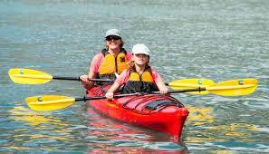 |  |  | 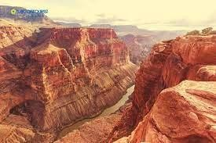 |  | 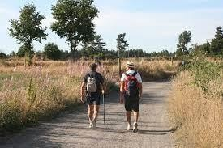
1. kayaking |  |  | 2. canyon |  | 3. hiking
 | 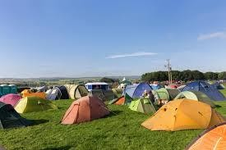 |  |  | 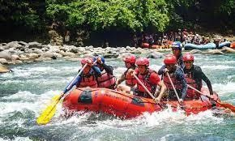 |  | 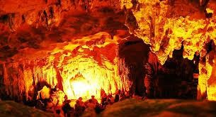
4. campsite |  |  | 5. rafting |  | 6. cave
II. Write the suitable word for each picture. (Things)
 | 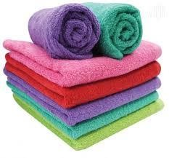 |  |  | 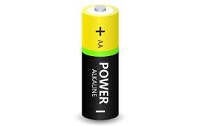 |  |  | 
1. towel |  |  | 2. battery |  |  | 3. flashlight
 | 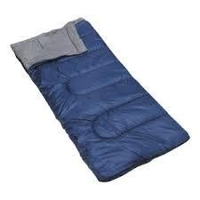 |  |  | 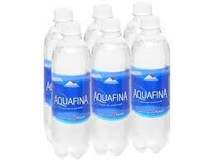 |  |  | 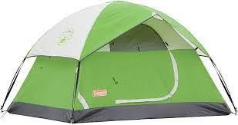
4. sleeping bag |  |  | 5. bottled water |  |  | 6. tent
 |  |  |  | 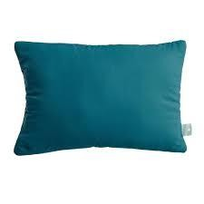 |  |  | 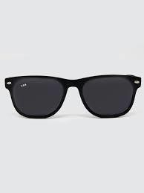
7. sneakers |  |  | 8. pillow |  |  | 9. sunglasses
III. Write the suitable word for each picture. (Places)
 | 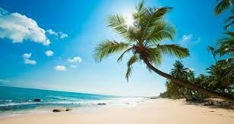 |  |  | 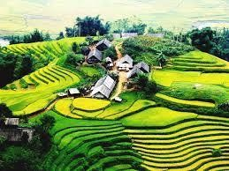 |  |  | 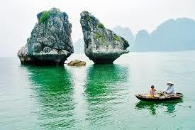
1. beach |  |  | 2. highland |  |  | 3. bay
 | 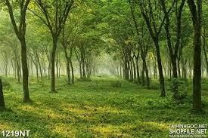 |  |  | 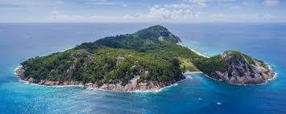 |  |  | 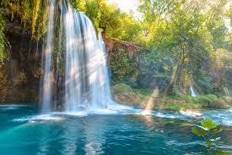
4. forest |  |  | 5. island |  |  | 6. water fall
 | 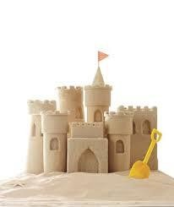 |  |  | 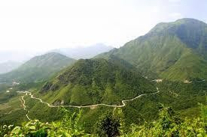 |  |  | 
7. sandcastle |  |  | 8. mountain |  |  | 9. national park

❸ GRAMMAR
I. Use “should/shouldn’t” to fill in the blanks to complete the sentences.
1. Tom shouldn’t eat so many lollipops. It’s bad for his teeth.
2. He’s fifteen. He shouldn’t drive a car.
3. Pregnant women shouldn’t smoke as it can damage the baby.
4. We should go somewhere exciting for our holiday.
5. People shouldn’t drive fast in the town centre.
6. You should ask the teacher for help you if you don’t understand the lesson.
7. Should I buy the dress or the skirt?
8. She shouldn’t tell lies.
9. That’s a fantastic book. You should read it.
10. The doctor said: “You should eat healthy food. You shouldn’t eat fast food. You shouldn’t watch so much TV. You should walk 1 hour a day. You should drink fruit juice and water. You shouldn’t drink wine or beer.
11. You shouldn’t be so selfish.
12. I don’t think you should smoke so much.
13. You should exercise more.
14. I think you should try to speak to her.
15. You are overweight. You should go on a diet.
16. Where should we park our car?
17. You should never speak to your mother like this.
18. The kids shouldn’t spend so much time in front of the TV.
19. Should I tell her the truth or should I say nothing?
20. I think we should reserve our holiday in advance.
II. Use “can/can’t” to fill in the blanks to complete the sentences.
1. I (can/ can’t) speak French. I picked it up while I was in France.
2. I (can/ can’t) come to the party. I am really busy.
3. We (can/ can’t) hear you. The music is so loud.
4. Where are my keys? I (can/ can’t) find them.
5. I (can/ can’t) believe it. We won two million dollars.
6. We (can/ can’t) meet tomorrow if you want.
7. (Can/ Can’t) you make me a cup of tea, please?
8. He (can/ can’t) jump. His leg hurts so much.
9. Illiterate people (can/ can’t) read and write.
10. Fish (can/ can’t) swim.
11. (Can/can’t) you swim? - Yes, I (can/can’t)
12. I’m sorry I (can/can’t) help you today, I’m really busy.
13. Please (can/can’t) you buy some milk on your way home? - I (can/can’t) leave the house because I’m looking after the baby.
14. I (can/can’t) ride a bike but I (can/can’t) drive a car.
15. I just (can/can’t) manage to wake up on time, I’m always late.
16. Hello, (can/can’t) I help you? - Actually, no you (can/can’t). This restaurant is awful and we’ve been waiting here for half an hour. We’re leaving.
17. I have a special talent, I (can/can’t) touch my nose with my tongue (can/can’t) you?
18. (Can/Can’t) I go to the bathroom please?- Yes, of course you (can/can’t).
19. Look! It’s right there! (Can/Can’t) you see it? It’s so obvious!
20. I’ve never been able to eat breakfast in the mornings. I (can/can’t) talk to anyone either!
III. Choose A, B, C or D to complete the sentences.
1. I like English I like French very much.
A. and B. but C. or D. so
2. My brother likes Maths he doesn’t like history.
A. and B. but C. or D. so
3. The children forgot their homework, the teacher was angry with them.
A. and B. but C. or D. so
4. Can you read write English words?
A. and B. but C. or D. so
5. Are the questions right wrong?
A. and B. but C. or D. so
6. It’s great it’s fun.
A. and B. but C. or D. so
7. Would you like tea hot chocolate for your breakfast?
A. and B. but C. or D. so
8. Our car is old, it drives beautifully.
A. and B. but C. or D. so
9. It was very warm, we all went swimming.
A. and B. but C. or D. so
10. Do we have French Music after the break?
A. and B. but C. or D. so
11. I like sugar in my tea, I don’t like milk in it.
A. and B. but C. or D. so
12. We were very tired happy after our flight to Sydney.
A. and B. but C. or D. so
13. Jane was cold, he put on a coat.
A. and B. but C. or D. so
14. Julie has a guitar, she plays it really well.
A. and B. but C. or D. so
15. Maria tried to read a novel in French, it was too difficult.
A. and B. but C. or D. so
16. He lives in London, he studies at a college.
A. and B. but C. or D. so
17. You can go to the tourist office ask them for any information you need.
A. and B. but C. or D. so
18. Does Miss Smith like the red boots the black and white sandals?
A. and B. but C. or D. so
19. Lynda likes Tom he is in love with Annette.
A. and B. but C. or D. so
20. Geraldine Chaplin is a great actress she is less well-known than her father Charlie Chaplin.
A. and B. but C. or D. so

❹ READING
I. Read the email and write True (T) or False (F) for the statements.
 New message
To: julianstone@frendzmail.com Subject: Visiting Vietnam
Dear Julian,
I'm so glad you are coming to Vietnam for your vacation. It's beautiful! When you're here, we should travel to see some of Vietnam's natural wonders. Mộc Châu Highland and Cúc Phương National Park are two beautiful places in the north of Vietnam. There are some really pretty villages, huge forests, and amazing waterfalls. We can go to both places by train or bus. We should also go to Phú Quốc Island and Lăng Cô Bay. They have beautiful white sand beaches. We could go scuba diving and snorkeling there. Those places are famous for their delicious seafood, too. We can go to Phú Quốc by plane or boat.
See you soon, Phúc

Sentences | True/ False
1. Julian is coming to Vietnam for her vacation. | T
2. Mộc Châu Highland and Cúc Phương National Park are in the south of Vietnam. | F
3. You can’t go to Mộc Châu Highland by bus or train. | F
4. If you love the beach, you should go to Phú Quốc Island on Lăng Cô Bay. | T
5. You can eat seafood in Phu Quoc Island. | T

II. Read and choose the correct answer (A, B, C or D)
Christine Robinson, August 12
Bali is a wonderful place for o vocation.
A lot of visitors go to Bali for their vacations every year. You can enjoy the white sand beaches, take photos, and moot friendly local people. You can also go on cycling tours, scuba diving, and even snorkeling. Bali is one of the most beautiful islands in Indonesia. You can go there by boat or plane. You should not go there between October and March because it is very rainy. Between April and October are the best times to visit Bali, during the dry season. You can also go to the International Film Festival in Bali every September. If you get the chance, you should spend your vacation in this beautiful place.
1. People can enjoy beautiful beaches with .
A. golden sand B. white sand C. rain D. forest
2. People can enjoy cycling and .
A. rock climbing B. kayaking C. scuba diving D. snorkeling
3. People can take a to Bali.
A. bus B. train C. boat D. plane
4. People shouldn’t go there between and because of the rain.
А. November - December B. October - December
C. October – March D. September – December
5. The Indonesian International Film Festival happens every in Bali.
A. three years B. year C. two years D. four years

III. Read the article and answer the questions.
I am Kate, I live in Cairo, which is the capital of Egypt. There are more than ten million people here. A lot of them come from the countryside because there are more jobs here.
I live in an apartment near the city center. It is a busy, exciting place. It has cinemas and shops, but unfortunately there is a lot of traffic too. Many tourists come from all over the world to see the Pyramids, which are near the city.
I like Cairo because it is big and exciting. I have a lot of friends and it is easy to meet new people. I am glad that I live here, but my mother doesn’t like it. She used to live in the countryside, and she would like to go back one day.
1. Is Cairo the capital of Egypt?
Yes, it is.
2. How many people are there in Cairo?
There are more than ten million people.
3. Why do people go to Cairo?
Because there are more jobs in Cairo than in the countryside.
4. Where do many tourists come from to see the Pyramids?
Many tourists come from all over the world to see the Pyramids
5. Where did Kate’s mother used to live?
She used to live in the countryside.

❺ WRITING
I. Look at the travel brochures and choose a place you'd like to go with your friends on vacation. Write a paragraph about your choice using the given information.
Write 50 to 60 words.
THE RED CANYON  Beautiful place  What to do: go rock climbing, go rafting How to get there: 3 hours by car  Where to stay: a hotel by the canyon Note: swimming: too dangerous! | THE GREEN CAVE  Interesting place  What to do: go hiking, go kayaking inside the caves How to get there: 5 hours by bus  Where to stay: a campsite near the cave Note: rock climbing: too dangerous!

I think we should go to The Red Canyon. It's a beautiful place. We can go rock climbing and rafting there. It takes about three hours by car to get there. We can stay at a hotel by the canyon. We can't go swimming. It's too dangerous.
II. Read the information below and write a postcard telling your friend about Boy of Islands. Write 50 to 60 words.
NEW ZEALAND BAY OF ISLANDS
- Amazing beaches
- go fishing
- go surfing
- nice, sunny weather
- delicious seafood
Hello Liam,
I'm having a great time in New Zealand. It's beautiful. When you're here, we should travel to see some of New Zealand's natural wonders Bay of Islands has amazing beaches. We can go fishing and surfing. The weather is very nice and sunny. The seafood is really delicious. You should try it when you come here.
Can't wait to see you. Paul

D. FURTHER PRACTICE (LUYỆN TẬP)
1. The water is too dangerous. We can/can't go kayaking here.
2. The canyon is beautiful. We should/shouldn't go hiking there.
3. The bus comes in five minutes. We can/can't go back to the campsite.
4. We should/shouldn't take the bus. It's too slow. Let's go by train.
5. We can/can't stay at this campsite. It's closed.
6. We should/shouldn't go hiking today. It is raining very hard.
7. You should/shouldn't go to the beach. It really is very beautiful.
8. What can/need we do in Đà Nẵng?
9. We need/should to bring a pillow because the campsite doesn't have any
10. It's very cold at night so/don't bring a jacket.
11. You should/can't swim in that water. It's very dangerous.
12. The campsite has food so/should we don't need to bring any.

II. Complete the sentences by using “although/ because/ but/ so”.
1. Although Norway is a beautiful country, it is very cold in winter.
2. It is warm and sunny today so we are going to the beach.
3. The car is very old but it is reliable.
4. Today is my daughter’s birthday, so I need to buy her a present.
5. You should take an umbrella because it is going to rain.
6. The camera is expensive but it is very good.
7. I love chips although it is not healthy.
8. His mother is not feeling well, so he needs to take care of her.
9. Your marks in English are low because you don’t study hard enough.
10. Although he is a good ski instructor, I don’t like him very much.
11. I’d like to go with you but I’m too busy right now.
12. There are no buses this hour, so we need to catch a taxi.
13. Although it rains a lot in winter, I like walking the dog in the park.
14. He fails his driving test, so he needs to do it again.
15. We invite them to the party but they don’t want to come.
16. I don’t like the concert because the band doesn’t play well.
17. We don’t go on holiday because we don’t have a lot of money.
18. I want to buy a car because I need it for my job.
19. I’m learning French because I want to live in Paris.
20. Although he’s got a car, he never drives to work.
III. Rearrange the words to make the full sentences.
1. accident / an / she’s / in / because / hospital / she / had.

She’s in hospital because she had an accident.
2. but / they / many / work / don’t / hours / they / have / money / much.

They work many hours but they don’t have much money.
3. asked / Paul / me / question, / a / replied / I / so.

Paul asked me a question, so I replied.
4. buy / I / peppers / potatoes. / and / tomatoes,

I buy peppers, potatoes and tomatoes.
5. them / apple / can / have / an / or/ a / . / She / have / both /. / She / mango / can’t / of

She can have an apple or a mango. She can’t have both of them.
6. can / piano /./ Karthik / play / but / he / play / the/ can’t / the/ violin

Karthik can play the piano but he can’t play the violin.
7. hard-working / is / but / her / is / lazy / . / She / very / brother

She is hard-working but her brother is very lazy.
8. clever / is / and / beautiful / . / she

She is clever and beautiful.
9. shirt / can / the / blue / or / take / green / shirt/ . / You / the
You can take the blue shirt or the green shirt. 10. / am / sister / tall / I / short / . / My / is / but I am short but my sister is tall.

