UNIT 4. MY NEIGHBORHOOD
PART 1. THEORY
I. VOCABULARY
No. | English | Pronunciation | Vietnamese
1 | antique shop | /æn’ti:k ʃɒp/ | cửa hàng đồ cổ
2 | art gallery | /ɑːt ‘gælərɪ/ | phòng tranh triển lãm nghệ thuật
3 | backyard | /,bæk’jɑːd/ | sân sau
4 | bakery | /’beɪkərɪ/ | cửa hàng bán bánh
5 | barber’s | /’bɑːbə(r)z/ | hiệu cắt tóc
6 | beauty salon | /’bju:tɪ ‘sælɒn/ | cửa hàng làm đẹp
7 | boring | /’bɔ:rɪη/ | buồn chán
8 | bus stop | /'bʌs stɒp/ | điểm dừng xe buýt
9 | cathedral | /’kəθi:drəl/ | thánh đường, giáo đường
10 | cemetery | /'semətrɪ/ | nghĩa trang
11 | charity shop | /’tʃærətɪ ʃɒp/ | cửa hàng từ thiện
12 | chemist’s/ pharmacy | /’kemɪsts/ /fɑːməsɪ/ | hiệu thuốc
13 | children’s playground | /’tʃɪldrənz ‘pleɪgraʊnd/ | sân chơi trẻ em
14 | cinema | /’sɪnəmə/ | rạp chiếu phim
15 | department store | /dɪ’pɑːtmənt stɔ:(r)/ | cửa hàng bách hóa
16 | dress shop | /dres ʃɒp/ | cửa hàng quần áo
17 | fire station | /’faɪə(r)' steɪʃn/ | trạm cứu hỏa
18 | general store | /’dʒenrəl stɔ:(r)/ | cửa hàng tạp hóa
19 | gift shop | /gɪft ʃɒp/ | cửa hàng lưu niệm
20 | greengrocer's | /’gri:ngrəʊsə(r)z/ | cửa hàng rau quả
21 | grocery | /’grəʊsərɪ/ | cửa hàng tạp hóa
22 | hairdresser’s | /'heədresə(r)z/ | hiệu uốn tóc
23 | health centre | /helθ ‘sentə(r)/ | trung tâm y tế
24 | hospital | /hɒspɪtl/ | bệnh viện
25 | hotel | /həʊ’tel/ | khách sạn
26 | lamp post | /læmp pəʊst/ | cột đèn đường
27 | market | /’mɑːkɪt/ | chợ
28 | memorial | /mə’mɔ:rɪəl/ | đài tưởng niệm
29 | modern | /’mɒdn/ | hiện đại
30 | palace | /’pæləs/ | cung điện
31 | park | /pɑːk/ | công viên
32 | pedestrian subway | /pə’destrɪən ‘sʌbweɪ/ | đường hầm đi bộ
33 | petrol station | /’petrəl ‘steɪʃn/ | trạm xăng
34 | police station | /pə’li:s ‘steɪʃn/ | đôn cảnh sát
35 | railway station | /reɪlweɪ ‘steɪʃn/ | trạm xe lửa
36 | restaurant | /’restrɒnt/ | nhà hàng
37 | shoe shop | /ʃu: ʃɒp/ | cửa hàng giầy
38 | sports shop | /spɔ:t ʃɒp/ | cửa hàng đồ thể thao
39 | statue | /’stætʃu:/ | tượng
40 | suburb | /’sʌbɜ:b/ | vùng ngoại ô
41 | temple | /’templ/ | đền, miếu
42 | town square | /taʊn skweə(r)/ | quảng trường thành phố

Một vài tính từ hay gặp
No. | English | Pronunciation | Vietnamese
1 | cheap | /'tʃi:p/ | rẻ
2 | comfortable | /'kʌmftəbl/ | thoải mái
3 | convenient | /kən’vi:niənt/ | tiện nghi
4 | crowded | /kraʊdɪd/ | đông đúc
5 | expensive | /ɪk’spensɪv/ | đắt
6 | fantastic | /fæ’tæstɪk/ | tuyệt vời, tuyệt diệu
7 | fast | /fɑːst/ | nhanh
8 | friendly | /’frendlɪ/ | thân thiện
9 | heavy | /’hevɪ/ | nặng, (giao thông) đông đúc
10 | historic | /hɪ’stɒrɪk/ | có tính chất lịch sử
11 | narrow | /’nærəʊ/ | hẹp, nhỏ
12 | noisy | /’nɔɪzɪ/ | Ồn ào
13 | peaceful | /'pi’sfl/ | yên bình
14 | polluted | /pə’lu:tɪd/ | ô nhiễm

II. GRAMMAR
1. Comparative adjectives
a. Form (Câu trúc)
- Với tính từ ngắn
S + be + adj-er + than ...
Ex: Lan is taller than Hoa.
Phong is stronger than Linh.
This car is cheaper than that car.
Summer is hotter than winter.
- Với tính từ dài
S + be + more adj + than ...
Ex: He is more intelligent than me.
This dress is more expensive than that dress.
My cellphone is more modern than her cellphone.
Life in the city is more convenient than life in the countryside.

b. Usage (Cách sử dụng)
Dạng so sánh hơn được sử dụng để so sánh tính chất của 2 người hoặc 2 vật với nhau. Trong tiếng Anh có 2 dạng tính từ so sánh đó là tính từ ngắn và tính từ dài.
Short adjectives (tính từ ngắn) | Long adjectives (tính từ dài)
Tính từ ngắn là những tính từ gồm 1 hoặc 2 âm tiết có tận cùng là “y”.  - nice  - long  - happy  Để chuyển sang dạng so sánh, ta thêm r/er vào cuối tính từ ấy.  - nice nicer  - long longer  Nếu tận cùng của tính từ là phụ âm “y”, ta đổi “y ier”  - dry drier  - happy happier  Với các tính từ kết thúc bằng một nguyên âm đơn + phụ âm đơn, ta gấp đôi phụ âm  - hot hotter  - big bigger | Tính từ dài là những tính từ có từ  2 âm tiết trở lên và không kết thúc bằng “y”.  - intelligent  - beautiful  - expensive  Để chuyển sang dạng so sánh, ta thêm "more" lên trước tính từ ấy.  - intelligent more intelligent  - expensive more expensive  Với các tính từ kết thúc bằng -ed, -ing, -fill, -less: khi chuyển sang dạng so sánh hơn, ta đều coi nó là tính từ dài  bored more bored  interesting more interesting  careful more careful  helpless more helpless

c. Chú ý các trường hợp bất quy tắc
Trường hợp | So sánh hơn
good/ well | better
bad/ badly | worse
many/ much | more
little | less
far | farther (xa hơn về khoảng cách nghĩa đen)
far | further (xa hơn về nghĩa bóng)
near | nearer
late | later
happy | happier
simple | simpler
narrow | narrower
clever | cleverer
iii. PHONETICS

Cách phát âm âm /ɪ/ và /i:/.

a. Âm /ɪ/
Cách phát âm

- Để phát âm âm /ɪ/ ta đưa lưỡi hướng lên trên và ra phía trước, khoảng cách môi trên và dưới hẹp, mở rộng miệng sang 2 bên nhưng hẹp hơn một chút so với âm /i:/.

- Các em hãy tập thực hành phát âm các từ sau:
bin /bɪn/ | begin /bɪ’gɪn/
fish /fɪʃ/ | minute /'mɪnɪt/
him /hɪm/ | dinner /'dɪnər/
gym /gɪm/ | chicken /'tʃɪkn/
six /sɪks/ | fifty /'fɪftɪ/

Cách nhận biết

- Chữ "a” được phát âm là /ɪ/ khi danh từ có hai âm tiết và có tận cùng bằng "age”.
Examples | Transcription | Meaning
village | /'vɪlɪdʒ/ | làng
cottage | /'kɔ:tɪdʒ/ | nhà tranh, lều tranh
shortage | /‘ʃɔ:tɪdʒ/ | tình trạng thiếu hụt
baggage | /'bægɪdʒ/ | hành lý trang bị cầm tay
courage | /’kʌrɪdʒ/ | lòng can đảm

- Chữ "e" được phát âm là /ɪ/ trong tiếp đầu ngữ "be”, "de" và "re”
Examples | Transcription | Meaning
begin | /bɪ'gɪn/ | bắt đầu
become | /bɪ'kʌm/ | trở nên
behave | /bɪ'heɪv/ | cư xử
defrost | /dɪ'frɔ:st/ | làm rã đông, làm tan giá
decide | /dɪ’saɪd/ | quyết định

- Chữ "i" được phát âm là /ɪ/ trong các từ có một âm tiết và tận cùng bằng chữ "i” + phụ âm
Examples | Transcription | Meaning
win | /wɪn/ | chiến thắng
miss | /mɪs/ | nhớ
ship | /ʃɪp/ | thuyền, tàu
bit | /bɪt/ | miếng nhỏ, một mẩu
sit | /sɪt/ | ngồi

- Chữ "ui” được phát âm là /ɪ/
Examples | Transcription | Meaning
build | /bɪld/ | xây dựng
guilt | /gɪlt/ | tội lỗi
guitar | /gɪtɑːr/ | đàn ghi ta
mosquito | /məs’kɪtəʊ/ | con muỗi

b. Âm /i:/
Cách phát âm
Để phát âm âm /i:/, ta đưa lưỡi hướng lên trên và ra phía trước, khoảng cách môi trên và dưới hẹp, mở rộng miệng sang 2 bên. Khi phát âm âm này, miệng hơi bè một chút, giống như đang mỉm cười vậy.
Các em hãy tập thực hành phát âm các từ sau:
sheep /ʃi:p/  see /si:/  bean /bi:n/  eat /i:t/  key/ki:/ | agree /ə'gri:/  complete /kəm'pli:t/  receive /rɪ'si:v/  believe /bɪ'li:v/  Vietnamese /vjetnə'mi:z/

Cách nhận biết
- Chữ "e” thường được phát âm là /i:/ khi từ có tận cùng là phụ âm + e và trong các từ như be, he, she, me,...
Examples | Transcription | Meaning
scene | /si:n/ | phong cảnh
complete | /kəm'pli:t/ | hoàn toàn
Vietnamese | /vjetnə’mi:z/ | người Việt Nam
- Chữ "ea” thường được phát âm là /i:/ khi từ có tận cùng là “ea” hoặc “ea” + một phụ âm
Examples | Transcription | Meaning
tea | /ti:/ | trà
meal | /mi:l/ | bữa ăn
easy | /’i:zɪ/ | dễ dàng

cheap | /tʃi:p/ | rẻ
meat | /mi:t/ | thịt
- Chữ "ee” thường được phát âm là /i:/
Examples | Transcription | Meaning
three | /θri:/ | SỐ 3
see | /si:/ | nhìn, trông, thấy
free | /fri:/ | tự do
heel | /hi:l/ | gót chân
screen | /skri:n/ | màn ảnh
- Chữ "ei" được phát âm là /i:/ khi đi sau âm /s/ hoặc chữ c, s
Examples | Transcription | Meaning
receive | /rɪ'si:v/ | nhận được
ceiling | /’si:lɪη/ | trần nhà
receipt | /rɪ’si:t/ | giấy biên lai
seize | /si:z/ | nắm lẩy, túm lấy
- Chữ "ie” được phát âm là /i:/ khi nó là những nguyên âm ở giữa một chữ
Examples | Transcription | Meaning
grief | /gri:f/ | nỗi lo buồn
chief | /tʃi:f/ | người đứng đầu
believe | /bɪ'li:v/ | tin tưởng
belief | /bɪ'li:f/ | niềm tin, lòng tin

PART 2. LANGUAGE
I. VOCABULARY
Exercise 1. Look at the pictures and complete the blanks with the words from the box.
petrol station |  | pedestrian subway |  | palace | railway station
memorial |  | shoe shop |  | fire station | hairdresser’s
cemetery |  | police station |  | statue | dress shop
gift shop |  | bakery |  | cathedral | beauty salon
lamp post |  | greengrocer's |  | sports shop | children’s playground
 | 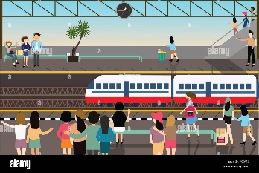 |  |  |  |  | 
 | 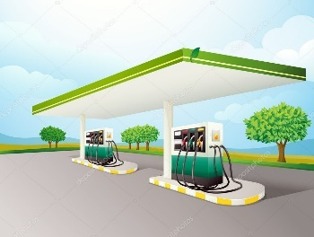 |  | 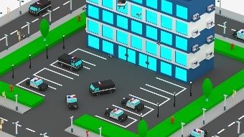 |  |  | 
 | 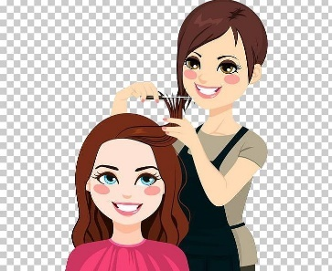 |  | 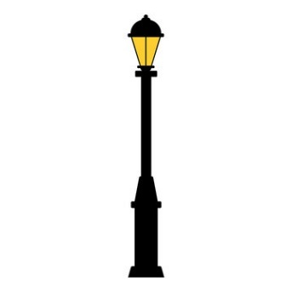 |  |  | 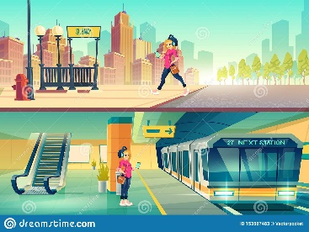
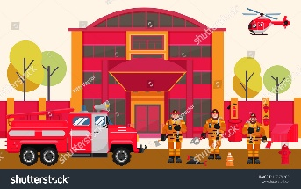 |  |  | 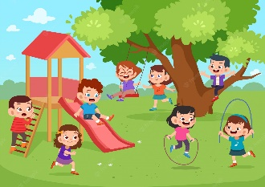 |  |  | 
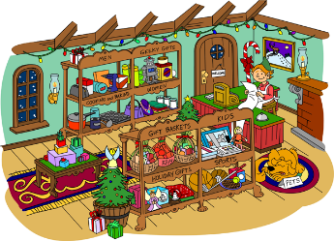 |  |  | 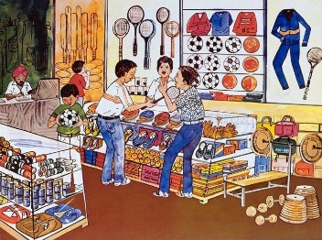 |  |  | 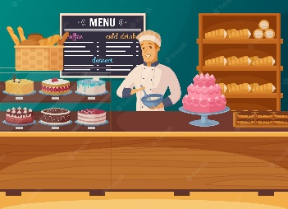
Giaoandethitienganh.info
Exercise 2. Choose the correct adjectives to complete the sentences.
1. The road is not (wide/ narrow) enough for two cars to pass comfortably.
2. Inside the cathedral, it's (noisy/ peaceful) and quiet.
3. Those shoes are really (cheap/ expensive) – they only cost £25.
4. My house is rather far from my school, so it’s a bit (convenient/ inconvenient).
5. Kids always find Christmas (exciting/ boring). They are always looking forward to Christmas.
6. The air in the countryside is fresh and (polluted/unpolluted).
7. Hoi An is a(n) (old/ modern) town near Da Nang.
8. There are a lot of shops nearby, so the streets are always busy and (noisy/ quiet) during the day.
Exercise 3. Read and do the crossword below.
1. You see works of art, statues, ... at this place.
2. You ride a bike, walk a dog, play games, ... at this place
3. You wait for the bus at this place.
4. You have a frieal at this place.
5. You enjoy a cup of coffee at this place.
6. You see a movie at this place.
7. You go to this place when you are hurt.
8. You buy bread at this place.
9. You buy fruit, meat, vegetables, ... at cheap prices at this place.
10. You buy medicines at this place.
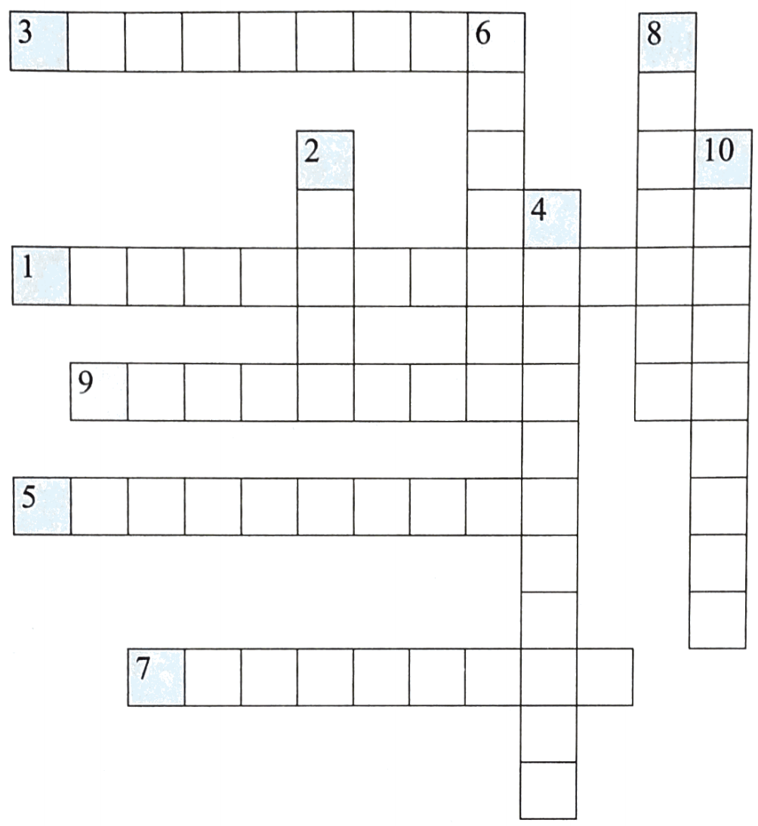
Exercise 4. Complete the sentences with suitable words from the box.
fast | modern | narrow | expensive | suburb
peaceful | polluted | boring | fantastic | noisy
1. Air in city is more ____________ than air in countryside.
2. This shirt is 40.000. That shirt is 30.000. This shirt is more ____________ than that shirt.
3. Life in countryside is quite ____________.
4. Would you like to live in a apartment or a traditional house?
5. We are going to spend tonight in the mountain. It is going to be very ____________ because there is nothing to play with.
6. My neighbor is having his house rebuilt. It is so ____________ that I cannot focus on anything.
7. This street is so ____________ that heavy traffic usually occurs.
8. Turtles are slow. Rabbits are ____________.
9. My family lives in the ____________ of a big city.
10. Having a villa with a beach view is ____________.
II. GRAMMAR
Exercise 1. Make the comparative form of the following adjectives.
No. | Adjective | Comparative adjective
1 | narrow
2 | historic
3 | polluted
4 | short
5 | good
6 | boring
7 | peaceful
8 | crowded
9 | bad
10 | modern
11 | fast
12 | cheap
13 | convenient
14 | noisy
15 | heavy
Exercise 2. Complete the sentences with comparative adjectives.
1. My house is (big) ____________ than yours.
2. This flower is (beautiful) ____________ than that one.
3. Buildings are (high) ____________ than houses.
4. Non-smokers usually live (long) ____________ than smokers.
5. A holiday by the sea is (good) ____________ than a holiday in the mountains.
6. It is strange but often a coke is (expensive) ____________ than a beer in my country.
7. Dogs are (intelligent) than rabbits.
8. Lucy is (old) ____________ than Ellie.
9. Russia is far (large) ____________ than UK
10. My Latin class is (boring) ____________ than my English class.
11. In the UK, the streets are generally (narrow) ____________ than in the USA.
12. London is (busy) ____________ than Glasgow.
13. Julie is (quiet) ____________ than her sister.
14. Amanda is (ambitious) ____________ than her classmates.
15. My garden is a lot (colourful) ____________ than this park.
Exercise 3. Rewrite the sentence using comparative form, the first one has been done for you as an example.
0. Hue/small/Hanoi
Hue is smaller than Hanoi.
1. My school/ big/ your school.

2. My father/ old/ my mother.

3. This ruler/long/that ruler.

4. This room/large/my room.

5. The boys/ strong/ the girls.

6. Everest/ high/ other mountains in the world.

7. Summer/ hot/ winter.

8. Phuong/good at English/Mai Ly

9. A dictionary/ thick/ a textbook.

10. The Great Wall/ long/ Hadrian's Wall.

Exercise 4. Complete the sentences with the correct forms of the adjectives in brackets. Number 1 is an example for you.
1. Maths is more boring than English, (boring)
2. The French restaurant in our town is _____________ the Italian restaurant. (expensive)
3. Love is _____________ money. (important)
4. Your flat is _____________ mine. (large)
5. Our theater is _____________ our cinema. (big)
6. Iron is _____________ wood. (heavy)
7. My Physics course is _____________ my Math course. (difficult)
8. My mum is _____________ my dad. (busy)
9. My new school is _____________ my old school. (modern)
10. This chair is _____________ that chair. (comfortable)
11. Museums are _____________ art galleries. (interesting)
12. The market is _____________ the shopping centre. (cheap)
13. The amusement park is _____________ the swimming pool. (noisy)
14. The Nile River is _____________ the Mississippi. (long)
15. A dog is _____________ a cow. (intelligent)
Exercise 5. Complete the second sentence so that it means the same as the first sentence, using the adjective in capitals.
1. The first question was easier than the second one. (DIFFICULT)
The second question
2. The black coat is smaller than the brown one. (BIG)
The brown coat
3. The chair isn’t as comfortable as the sofa. (COMFORTABLE)
The sofa
4. Jim’s suitcase was lighter than Jack’s suitcase. (HEAVY)
Jack’s suitcase
5. His homework was better than mine. (BAD)
My homework
6. The big television is more expensive than the small one. (CHEAP)
The small television
7. The Royal Hotel is more old-fashioned than the Holton Hotel. (MODERN)
The Holton Hotel
8. The weather yesterday was worse than it is today. (GOOD)
The weather today
9. People in the city aren’t as friendly as those in the country. (FRIENDLY)
People in the country
10. Life in the city is more interesting than life in the country. (BORING)
Life in the country
III. PHONETICS
Exercise 1. Divide the words into two columns: /ɪ/ or /i:/
building | cheap | cinema | seafood | city
keep | historic | exciting | slim | village
beach | peaceful | convenient | busy | street
sheep | evening | different | delicious | think
Exercise 2. Circle the word that has the underlined part pronounced differently.
1. A. live B. wide C. bicycle D. exciting
2. A. feet B. seat C. near D. team
3. A. busy B. city C. think D. terrible
4. A. great B. heat C. cheek D. peaceful
5. A. historic B. expensive C. office D. finally
6. A. film B. city C. nice D. miss
7. A. big B. wide C. quite D. exciting
8. A. cheap B. sleepy C. near D. peaceful
9. A. heavy B. sea C. team D. street
10. A. noisy B. expensive C. house D. post

PART 3. COMMUNICATION SKILLS
I. LISTENING
Listen and do the tasks followed.
Exercise 1. Listen and decide if each statement is True (T) or False (F). Track 07
1. If you are _________, there are many places for you to go.
2. Besides people, there are many _________in the city.
3. _________is where you can see art works.
4. If you are hungry, let's have _________at a restaurant.
5. If you don't want to travel around the city, let's take a bus, a taxi or even a _________.
Exercise 2. Listen again and answer the question. Track 08
1. Where can you see a movie?
_____________________________________________________________________
2. What can you see at a museum?
_____________________________________________________________________
3. Where do people buy groceries?
_____________________________________________________________________
4. What can you buy at a bakery?
_____________________________________________________________________
5. How many ways to travel around the city are mentioned?
_____________________________________________________________________
II. SPEAKING
Exercise 1. Complete the following conversations with missing words.

Conversation A
Tourist: Excuse me. Can you (1) ___________ me the (2) ___________ to Ben Thanh Market?
Hoa: Ben Thanh Market? Go straight (3) ___________. (4) ___________ the second turning (5) ___________ the right. Ben Thanh Market is on your left.
Tourist: Is there a post office near (6) ___________?
Hoa: Oh, yes. It’s opposite (7) ___________ supermarket.
Tourist: Thank you very much.
Hoa: You’re (8) ___________.
Conversation B
Tourist: Excuse me. Is (1) ___________ a restaurant near here?
Lan: Oh, yes. But it's not very near here. Turn right into Tran Phu Street. (2) ___________ the first turning (3) ___________ the left. You will be on Nguyen Trai Street. The restaurant is (4) ___________ the end of the street.
Tourist: That's so far.
Lan: (5) ___________ do you go there?
Tourist: I walk.
Lan: You should go (6) ___________ taxi.
Tourist: Thank you. Bye.
Lan: Not at all. Bye.
Exercise 2. Put the conversation in the correct order.
a. How long does it take to get there?
b. Thank you so much.
c. Excuse me! Could you tell me the way to the nearest supermarket, please?
d. Yes. There is a bank opposite the post office.
e. Not at all.
f. Go straight on and turn left at the bookstore. The supermarket will be across the street, next to the post office.
g. It’s just a fifteen-minute walk.
h. Thanks a lot. Is there a bank near the supermarket?

Your answer
1. _____ | 2. _____ | 3. _____ | 4. _____ | 5. _____ | 6. _____ | 7. _____ | 8. _____
III. READING
Exercise 1. Read the passage and answer the question.
I live in a house near the sea. It is an old house, about 20 years old, and it is not very large. There are two bedrooms upstairs but no bathroom. The bathroom is downstairs next to the kitchen and there is a living room where there is a lovely old fireplace. There is a garden goes down to the beach and in spring and summer there are flowers everywhere. I live alone with my dog, Boxer but we have many visitors. Many of my friends work in the city, so they often stay with me because they want to relax. I love my house for many reasons: the garden, the flowers in summer, the fire in winter.
1. Where is the house?
_________________________________________________________________________
2. How old is the house?
_________________________________________________________________________
3. How many bedrooms are there upstairs?
_________________________________________________________________________
4. Why does the owner of the house have so many visitors?
_________________________________________________________________________
5. Why does the owner love his house?
_________________________________________________________________________
Exercise 2. Read the passage and decide which statements are true (T) or false (F).
I have a good friend. Her name is Nga. She’s in class 6A. This is her routine. Every morning, Nga gets up at half past six. She washes her face, brushes her teeth and eats a big breakfast. Then she goes to school at seven o’clock. She has lessons from half past seven to half past eleven. At twelve o'clock, she has lunch. In the afternoon, she does the housework. Then she plays volleyball with her friends. In the evening, she does homework. She goes to bed at ten o’clock.
Statements | T | F
1. Every morning, Nga gets up at six thirty.
2. She has a quick and small breakfast.
3. She goes to school at half past seven.
4. She has lessons from half past seven to twelve o’clock.
5. In the evening, she does her homework and goes to bed at ten.
Exercise 3. Read the text and answer the questions.
Mai Anh goes to Nha Trang with her family on holiday. She stays at a hotel on the side of the beach. In the early morning, she goes to the sea and swims for an hour. Then she has breakfast in a canteen on the beach to enjoy fresh air in the morning. In the afternoon, she takes some photos of the sights. She is staying in Nha Trang for four days and takes of a lot of nice photos. She is buying some postcards and souvenirs for her friends. It is an enjoyable holiday because she has a lot of fun.
1. Where does Mai Anh go on holiday?
_________________________________________________________________________
2. What does she do in the early morning?
_________________________________________________________________________
3. What does she do in the afternoon?
_________________________________________________________________________
4. How long is she staying in Nha Trang?
_________________________________________________________________________
5. Why is her holiday enjoyable?
_________________________________________________________________________
IV. WRITING
Exercise 1. Reorder the words or phrases to make meaningful sentences.
1. we/ first/ where/ go/ this morning/ shall?
_________________________________________________________________________
2. the cafeteria/ and/ a cold drink/ let’s/ get/ to/ go.
_________________________________________________________________________
3. like/ you/ the countryside/ do/ living/ in?
_________________________________________________________________________
4. neighbourhood/ post office/ in/ there/ your/ a/ is?
_________________________________________________________________________
5. me/ you/ the way/ could/ the Japanese Bridge/ to/ tell/ please?
_________________________________________________________________________
6. houses/ are/ there/ historic/ Hoi An/ many/ ancient town/ in.
_________________________________________________________________________
7. polluted/ smoke/ the air/ is/ with/ factories/ from.
_________________________________________________________________________
8. much/ than/ living in a big city/ expensive/ is/ living in the countryside/ more
_________________________________________________________________________
Exercise 2. Complete the second sentence so that it means the same meaning.
1. Shall we go to the Japanese Covered Bridge first?
Let's
2. Helen’s brother is shorter than her.
Helen
3. Travelling abroad for a holiday is much more expensive than travelling in your country.
Travelling in your country
4. Country life isn’t as interesting as city life.
City life is
5. Would you mind telling me the way to the National Museum?
Can
6. The bus stop is in front of the hotel.
The hotel
7. Turn left at the first traffic lights.
Take
8. The weather yesterday was worse than it is today.
The weather today is
9. There are three supermarkets in my town.
My town
10. The shopping mall is near the Italian restaurant.
The Italian restaurant isn’t
Exercise 3. Use the words in brackets to rewrite the sentences without changing the meaning of the original sentences.
1. How about playing volleyball for a change? (SHALL)
___________________________________________________________________________
2. Do you want to go for lunch now? (WOULD)
___________________________________________________________________________
3. Can you tell me the way to the nearest post office? (HOW)
___________________________________________________________________________
4. The first question in the test was easier than the second one. (DIFFICULT)
___________________________________________________________________________
5. I expected my exam results to be better. (THAN)
___________________________________________________________________________
6. The bookstore is at the side of the grocery store. (NEXT)
___________________________________________________________________________
7. Dave doesn’t earn as much money as his wife. (MORE)
___________________________________________________________________________
8. Could you close that window, please? (MIND)
___________________________________________________________________________

