UNIT 9.
CITIES OF THE WORLD
PART 1. THEORY
I. VOCABULARY
No. | English | Type | Pronunciation | Vietnamese
1 | Africa | n | /'æfrɪkə/ | châu Phi
2 | architect | n | /'ɑ:kɪtekt/ | kiến trúc
3 | Asia | n | /’e ɪʒə/ | châu Á
4 | award | n | /ə'wɔ:d/ | phấn thưởng
5 | capital | n | /'kæpɪtəl/ | thủ đô
6 | city | n | /'sɪtɪ/ | thành phố
7 | common | n | /'kɒmən/ | thông thường
8 | continent | n | /'kɒntɪnənt/ | lục địa
9 | country | n | /'kʌntrɪ/ | quốc gia
10 | creature | n | /'kri:tʃər/ | sinh vật
11 | design | v | /dɪ'zaɪn/ | thiết kế
12 | Europe | n | /'jʊərəp/ | châu Âu
13 | heritage | n | /'herɪtɪdʒ/ | di sản
14 | journey | n | /'dʒɜ:nɪ/ | chuyến đi, hành trình
15 | merlion | n | /'mɜ'laɪən/ | sư tử cá
16 | palace | n | /'pæləs/ | lâu đài
17 | postcard | n | /'pəʊstkɑ:d/ | bưu thiếp
18 | square | n | /skweər/ | quảng trường
19 | symbol | n | /'sɪmbəl/ | biểu tượng
20 | tower | n | /'taʊər/ | tòa tháp
21 | university | n | /ju:nɪ'vɜ:sɪtɪ/ | trường đại học
22 | writer | n | /'raɪtər/ | nhà văn

Một số tính từ thường gặp
No. | English | Type | Pronunciation | Vietnamese
1 | awful | adj | /'ɔ:fəl/ | kinh khủng
2 | crowded | adj | /'kraʊdɪd/ | đông đúc
3 | dangerous | adj | /’de ɪndʒərəs/ | nguy hiểm
4 | exciting | adj | /ɪk’saɪtɪη/ | náo nhiệt
5 | expensive | adj | /ɪk'spensɪv/ | đắt đỏ
6 | famous (for) | adj | /'feɪməs fɔ:r/ | nổi tiếng
7 | historic | adj | /hɪ'stɒrɪk/ | có tính lịch sử
8 | noisy | adj | /'nɔɪzɪ/ | ầm ĩ
9 | peaceful | adj | /'pi:sfəl/ | thanh bình
10 | polluted | adj | /pə'lu:tid/ | bị ô nhiễm
11 | popular | adj | /'pɒpjələr/ | phổ biến
12 | quiet | adj | /kwaɪət/ | yên tĩnh
13 | royal | adj | /'rɔɪəl/ | thuộc hoàng gia
14 | safe | adj | /seɪf/ | an toàn

II. GRAMMAR
1. POSSISSIVE ADJECTIVE (TÍNH TỪ SỞ HỮU)
a. Định nghĩa
Tính từ sở hữu là những từ đứng trước danh từ để cho biết danh từ đó của ai, của cái gì. Chúng ta gọi nó là tính từ sở hữu vì nó thể hiện tính chất sở hữu của người hoặc vật với danh từ đi sau nó.
b. Bảng đại từ nhân xưng và tính từ sở hữu tương ứng
Đại từ nhân xưng (Personal pronoun) | Tính từ sở hữu (Possessive adjectives)
I (Tôi) | My (Của tôi)
You (Bạn, các bạn) | Your (Của bạn, của các bạn)
They (Họ) | Their (Của họ)
We (chúng tôi) | Our (Của chúng tôi)
She (Cô ấy) | Her (Của cô ấy)
He (Anh ấy) | His (Của anh ấy)
It (Nó) | Its (Của nó)
Ex:
my pencil (bút chì của tôi)
your sister (chị gái của bạn)
our country (đất nước của chúng tôi)
their idea (ý tưởng của họ)
his food (đồ ăn của anh ấy)
her hand (bàn tay của cô ấy)
its toy (đồ chơi của nó)
c. Vị trí trong câu
Nó luôn đứng trước danh từ mà nó sở hữu và các danh từ này không có mạo từ đi kèm.
Ex 1: They are my friends. (Họ là bạn của tôi.)
Ex 2: Her books are on the table. (Những quyển sách của cô ấy ở trên bàn.)
Ex 3: The dog wags its tail. (Con chó vẫy đuôi của nó.)
2. POSSISSIVE PRONOUNS (ĐẠI TỪ SỞ HỮU)
a. Định nghĩa
Đại từ sở hữu là những đại từ dùng để chỉ sự sở hữu.
b. Bảng đại từ nhân xưng và tính từ sở hữu tương ứng
Đại từ nhân xưng (Personal pronoun) | Tính từ sở hữu (Possessive adjectives)
I (Tôi) | mine (...của tôi)
You (bạn, các bạn) | yours (...của bạn, của các bạn)
They (Họ) | theirs (...của họ)
We (Chúng tôi) | ours (...của chúng tôi)
She (Cô ấy) | hers (...của cô ấy)
He (Anh ấy) | his (...của anh ấy)
It (Nó) | its (...của nó)
c. Cách dùng đại từ sở hữu
Đại từ sở hữu dùng để thay thê cho một tính từ sở hữu + một danh từ
Ex 1: Her shirt is blue, and mine is red. (mine = my shirt)
(Áo của cô ấy màu xanh và của tôi màu đỏ.)
Ex 2: This is your pencil and that is his. (his = his pencil)
(Đây là bút chì của bạn và kia là bút chì của anh ấy.)
Đại từ sở hữu dùng trong cầu sở hữu kép.
Ex: She is a good friend of mine. (Cô ấy là một người bạn tốt của tôi.)
Lưu ý về tính từ sở hữu và đại từ sở hữu
Tính từ sở hữu: luôn đi cùng với danh từ.
Đại từ sở hữu: Bản thân nó đã mang nghĩa của một cụm danh từ. Do đó đại từ sở hữu không đi kèm với bất kỳ danh từ nào khác.
Ví dụ chi tiết phân biệt cách dùng đại từ sở hữu và tính từ sở hữu.
This is my book. | This book is mine.
This is your book. | This book is yours.
This is his book. | This book is his.
This is her book. | This book is hers.
This is our book. | This book is ours.
This is their book. | This book is theirs.

iii. PHONETICS
Cách phát âm âm /əʊ/ và /aʊ/.

1. Âm /əʊ/
a. Cách phát âm âm /əʊ/
- Âm /əʊ/ là 1 nguyên âm đôi. Để phát âm âm này, đầu tiên đặt lưỡi ở vị trí phát âm của âm /ə/, sau đó miệng tròn dần để phát âm âm /ʊ/. (Chú ý: phát âm /ə/ dài, /ʊ/ ngắn và nhanh.)

Các em tập thực hành phát âm các từ sau:
go /gəʊ/ | boat /bəʊt/ | shoulder /'ʃəʊldər/
road /rəʊd/ | phone /fəʊn/ | October /ɒk'təʊbər/
old /əʊld/ | joking /dʒəʊkɪη/ | potato /pə'teitəʊ /
b. Dấu hiệu nhận biết
- “o” thường được phát âm là /əʊ/ khi nó ở cuối một từ
Examples | Transcription | Meaning
go | /gəʊ/ | đi
no | /nəʊ/ | không
ago | /ə'gəʊ/ | trước đây
mosquito | /mə'ski:təʊ/ | con muỗi
potato | /pə'teɪtəʊ/ | khoai tây
tomato | /tə'mɑ:təʊ/ | cà chua
- "oa” được phát âm là /əʊ/ trong một từ có một âm tiết tận cùng bằng một hay hai phụ âm
Examples | Transcription | Meaning
coat | /kəʊt/ | áo choàng
road | /rəʊd/ | con đường
coal | /kəʊl/ | than đá
loan | /ləʊn/ | sự cho vay nợ
goat | /gəʊt/ | con dê
- “ou” có thể được phát âm là /əʊ/
Examples | Transcription | Meaning
soul | /səʊl/ | tâm hồn
dough | /dəʊ/ | bột nhão
shoulder | /ʃəʊldər/ | vai
poultry | /'pəʊltrɪ/ | gia cầm
- “ow” được phát âm là /əʊ/
Examples | Transcription | Meaning
know | /nəʊ/ | biết
slow | /sləʊ/ | chậm
widow | /‘wɪdəʊ/ | bà góa phụ
window | /'wɪndəʊ/ | cửa sổ
bowl | /həʊl/ | cái bát
2. Âm /aʊ/
a. Cách phát âm âm /aʊ/
- Âm /aʊ/ là 1 nguyên âm đôi. Để phát âm âm này, đầu tiên ta mở khẩu hình miệng như khi phát âm âm /a/. Tiếp đó ta mở miệng tròn dần để phát âm /ʊ/. (Chú ý: phát âm /a/ dài, /ʊ/ ngắn và nhanh.)
Các em hãy tập thực hành phát âm các từ sau:
how /haʊ /  now /naʊ /  loud /laʊd/ | mouse /maʊs/  sound /saʊnd/  about /ə'baʊt/ | accounting /ə'kaʊtɪη/ mountain /'maʊtn/  council /'kaʊnsl/
b. Dấu hiệu nhận biết
- “ou” được phát âm là /aʊ/ trong những từ có nhóm “ou” với một hay hai phụ âm
Examples | Transcription | Meaning
found | /faʊnd/ | tìm thấy (quá khứ của find)
cloud | /klaʊd/ | đám mây
mouth | /maʊθ/ | mồm, miệng
doubt | /daʊt/ | sự nghi ngờ, ngờ vực
- “ow” được phát âm là /aʊ/
Examples | Transcription | Meaning
tower | /taʊər/ | tháp
power | /paʊər/ | sức mạnh, quyền lực
powder | /'paʊdər/ | bột
crown | /kraʊn/ | vương miện
drown | /draʊn/ | chết đuối, chết chìm

PART 2. LANGUAGE
I. VOCABULARY
Exercise 1. Look at the photo and write the correct word. The first letter is a hint.
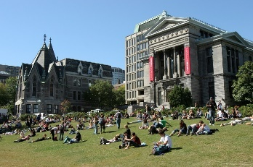 | 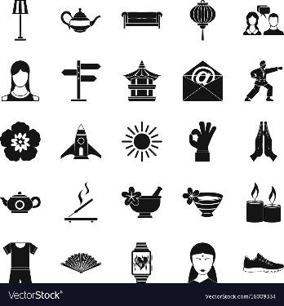 | 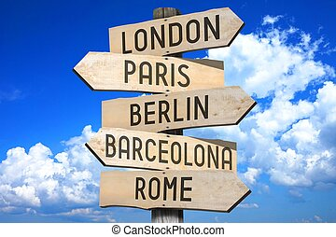 | 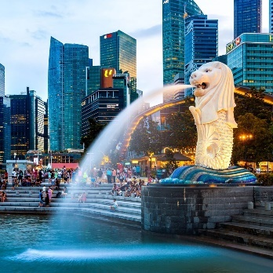
1. u _ _ _ _ _ _ _ _ _ | 2. A _ _ _ | 3. c _ _ _ _ _ _ | 4. m _ _ _ _ _ _
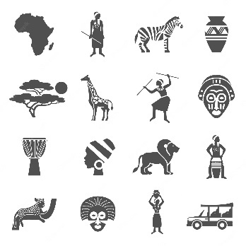 | 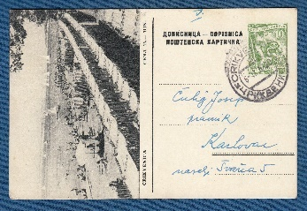 | 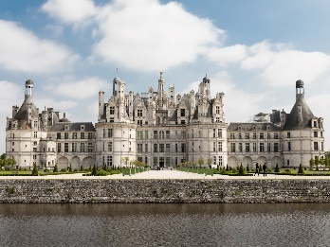 | 
5. A _ _ _ _ _ | 6. p _ _ _ _ _ _ _ | 7. p _ _ _ _ _ | 8. E _ _ _ _ _
Exercise 2. Match the adjective with their opposite one.
No. | A | Opt. | B | Your anwer
1. | large | A. | poor
2. | expensive | B. | quiet
3. | rich | C. | terrible
4. | polluted | D. | clean
5. | high | E. | small
6. | noisy | E | low
7. | dangerous | G. | cheap
Exercise 3. Look at the photos and put the word under the correct photo.
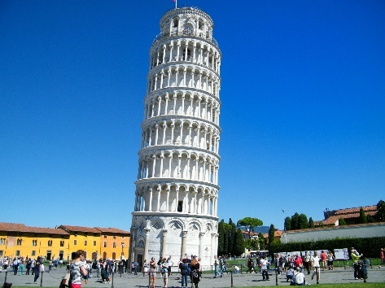 |  | 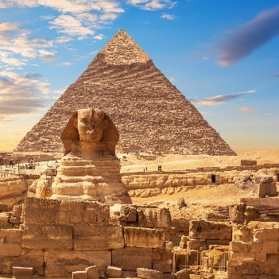
1. | 2. | 3.
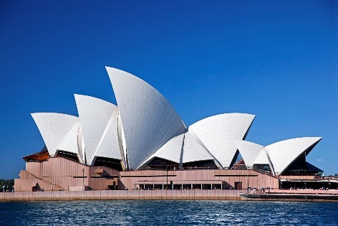 | 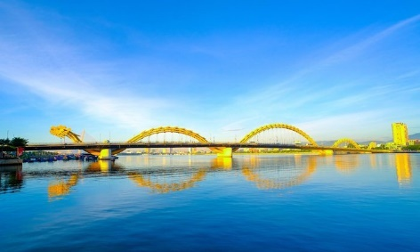 | 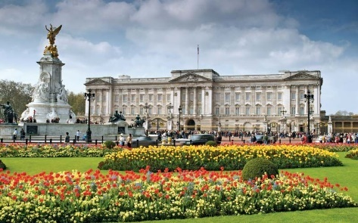
4. | 5. | 6.
 | 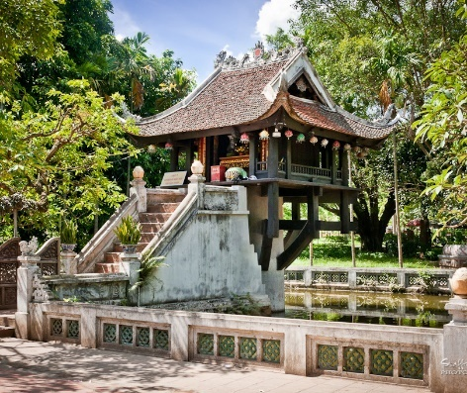 | 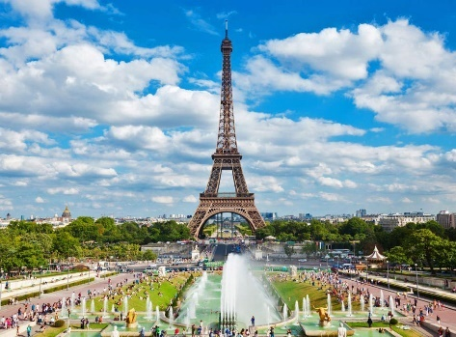
7. | 8. | 9.
Exercise 4. Choose the word that is opposite in meaning to the underlined word.
1. The streets were very noisy throughout the night.
A. crowded B. busy C. quiet D. empty
2. That modern building is so ugly!
A. big B. impressive C. unattractive D. beautiful
3. We didn’t go camping last weekend. The weather was awful.
A. unpleasant B. nice C. bad D. terrible
4. Rio de Janeiro is an exciting city
A. interesting B. dangerous C. boring D. expensive
5. The beaches in Sydney are clean and beautiful.
A. clear B. dirty C. famous D. fresh
6. It’s dangerous to walk around the city at night.
A. safe B. exciting C. cold D. popular
7. The dish is delicious with cheese.
A. tasty B. pleasant C. fatty D. awful
8. York is a historic city in North Yorkshire.
A. exciting B. modern C. famous D. quiet
Exercise 5. Write the adjectives in the correct column. Some can go more than one column.
new | sunny | big | beautiful | quiet
awful | ugly | huge | polluted | cloudy
dangerous | modern | historic | tall | cold
exciting | windy | safe | small | noisy

Weather | Building | City

II. GRAMMAR
Exercise 1a. Write the possessive adjectives of the subject pronoun in brackets.
1. (I) __________ sister is ten years old. | 5. (You) __________ bicycles are old.
2. (He) __________ eyes are blue. | 6. (She) __________ house is big.
3. (They) __________ car is red. | 7. (He) __________ father is doctor.
4. (We) __________ dog is white. | 8. (The boy) __________ sister is Mary.
Exercise 1b. Complete the sentences with a correct possessive adjective.
1. I have finished __________ homework tonight.
2. Linda is talking with __________ mother.
3. Tom doing homework with __________ sister.
4. In the morning, Lyly water __________ plants and feed __________ dog.
5. She is wearing shoes. __________ shoes are very lovely.
6. The cat wagged __________ tail.
7. On next weekend, she is going to visit __________ parents and __________ grandmother.
8. Every morning, Tom often takes __________ dog for a walk.
9. Lyly is sick. I will bring her __________ homework.
10. Jack just gave me a tree in __________ garden.
Exercise 2. Choose the best option to complete the sentence.
1. These toys are __________.
A. you B. your C. yours
2. I love __________ grandparents.
A. mine B. me C. my
3. __________ children are young.
A. They’re B. They C. Their
4. That CD is __________.
A. mine B. my C. me
5. These clothes aren’t __________.
A. our B. ours C. We
6. Your bike is a lot faster than __________.
A. my B. its C. mine
7. The book is __________ but you’re welcome to read it.
A. mine B. yours C. my
8. __________ dog is always so friendly.
A. There B. They C. Their
9. My sister gets along well with __________.
A. yours B. my C. your
10. I looked everywhere for my keys but I could only find __________.
A. your B. yours C. them
Exercise 3. Read the email. Choose the correct option to fill in the blank.

Dear Christian,
My name is Emily and I want to be (1) __________ e-pal. I am seven years old and I am from England. My parents are doctors. I (2) __________ two brothers. They are students at the University of London. Have (3) __________ got any brothers or sisters? In my free time, I go to the cinema with my brothers or hang out with my friends. My best friend (4) __________ Selma. (5) __________ mother is from India and her father is from Germany. Please write soon and tell (6) __________ all about your family and friends.
Best wishes,
Emily
1. A. yours | B. your | C. you
2. A. be | B. can | C. have got
3. A. you | B. your | C. yours
4. A. am | B. is | C. are
5. A. She | B. Hers | C. Her
6. A. I | B. me | C. my
Exercise 4. Choose the best option to complete the sentence.
1. This isn’t her skirt. __________ is blue.
A. Hers B. Her C. She D. He
2. __________ daughter is a teacher.
A. Our B. Ours C. Us D. We
3. Look at __________!
A. I B. mine C. me D. my
4. Linda is __________ cousin.
A. him B. he C. he’s D. his
5. This craft isn’t mine. It’s __________.
A. him B. she C. hers D. them
Exercise 5. Complete the sentences. Use the correct possessive adjective or possessive pronoun. Number 1 is an example for you.
1. The coat belongs to me. It is mine.
2. Peter has got a kite. The kite is __________.
3. My friends and I have got sweets. The sweets are __________.
4. I have a new book. It is __________.
5. My brothers have got bikes. The bikes are __________.
6. Karen has got a dog. That’s __________ dog.
7. I’ve got a watch. This is __________ watch.
8. Mary has new pillows. They are __________.
9. The chair belongs to Mary. It is __________.
10. Mum has got a new bag. That’s __________ bag.
11. She has a new cat. It is __________.
12. You have a new toy. It is __________.
13. We have new shoes. They are __________.
14. Peter has some books. They are __________.
Exercise 6. Complete the sentences. Use the correct possessive adjective or possessive pronoun.
1. Is it __________ book? (you)
2. It’s __________ question, not __________. (they, we)
3. Is this camera __________? (you)
4. Are these __________ shoes? (you)
5. That’s not __________ key. __________ is yellow. (I)
6. They know __________ address but they don’t know __________. (we, they)
7. __________ room is bigger than __________ but __________ is nicer. (I, she, she)
8. I can see __________ children at the school gate but where are __________? (you, I)
9. I want to change __________ bike. I want to buy one like __________. (I, you)
10. __________ car is cheap but __________ is expensive. (I/ he)
11. “Whose camera is it?” - “It’s __________. (you)
12. Excuse me, those are __________ seat. (we)
13. Is it __________ suitcase or __________? (you/he)
14. Has the dog had __________ food? (it)
15. They’re not __________ keys. They’re __________. (I/she)
16. I don’t think it’s __________ room. I think it’s __________. (you/ they)
17. The police asked me for __________ address. (I)
18. I think this is __________ book. Oh no, it’s __________. (I/ you)
19. __________ brother hasn’t got a phone, so he uses __________. (I/ we)
20. __________ garden is bigger than __________. (they/we)

III. PHONETICS
Exercise 1. Put the words in the correct column according to the pronunciation.
cow | stole | now | coat | allow
house | bowl | roll | boat | out
load | home | bow | foul | cold
brow | about | most | go | how
old | flower | pole | though | comb
grouse | slow | plough |  | ouch

/aʊ/ |  | /əʊ/
Exercise 2. Underline the word containing sound /aʊ/ and double underline the word containing sound /əʊ/ then read aloud these sentences.
1. We found our gowns downtown.
2. Shower the flower for an hour.
3. She phoned me in October.
4. They showed us their home.
5. Is the window open?
6. How’s the loud vowel sound?

PART 3. COMMUNICATION SKILLS
I. LISTENING
Listen and do the tasks followed.
Exercise 1. Listen and decide if each statement is True (T) or False (F). Track 05
1. The speaker went on holiday in Paris in May. __________
2. They visited nowhere except for the Eiffel Tower and Notre Dame. __________
3. Her friend took lots of photos, but she did not. __________
4. The market was full of little stalls. __________
5. They bought few souvenirs. __________
Exercise 2. Listen and answer the question. Track 06
1. Who did she go on holiday with?
__________________________________________________________________________________
2. What did they do first?
__________________________________________________________________________________
3. What are some beautiful places in Paris?
__________________________________________________________________________________
4. Where did they get lost?
__________________________________________________________________________________
5. What were sold at the market?
__________________________________________________________________________________
II. SPEAKING
Exercise 1. Complete the conversation then practise speaking it.
tourists | world | beautiful | height | city | history
- Where are you from, Nick?
- I’m from Toronto.
- I heard it is a very big (1) __________, isn’t it?
- Yes, you’re right. It is a very (2) __________ city. I like it very much.
- What’s interesting in your country?
- There are a lot of places which (3) __________ like to visit. But I like CN Tower. It is one of the tallest building in the (4) __________.
- Really? Do you know its (5) __________?
- Yes, of course. It was completed in 1976 and it is used for TV and radio broadcasting.
- What’s the (6) __________?
- It is 553 meters high.
- Great!
Exercise 2. Complete the dialogue with the sentences from the box then practise speaking it.
What did you see?
Did you have fun?
Are you having a good time?
Did you visit any famous places?
What did you do yesterday?
Beth: Hi Dad!
Dad: Hi Beth. (1) ___________________________________________________________________
Beth: Yes, thanks. This holiday isn’t long enough!
Dad: (2) __________________________________________________________________________
Beth: We were in London. I saw the River Thames and I went to a souvenir shop.
Dad: (3) __________________________________________________________________________
Beth: Yes, we visited the Natural History Museum. It’s the best museum in London!
Dad: (4) __________________________________________________________________________
Beth: A diplodocus. It was the tallest dinosaur in the world - it was bigger than three buses!
Dad: (5) __________________________________________________________________________
Beth: Yes, I did and Ben did too!
III. READING
Exercise 1. Read the text and choose the best answer (A, B, or C) to each statement.
Da Nang is one of the most peaceful cities in Viet Nam with a lot of beautiful beaches. This is a wonderful place for those who love the sea and enjoy fresh air.
Life here is not so busy as that in Ho Chi Minh City. It is not only a beautiful city but also a safe place to live in. Every evening, after work, you can easily catch the sight of families riding to the beach, leaving their motorbikes. They believe that their vehicles will still be there when they come back. There is no beggar here and the air is fresh. Another good thing is the food. If you love seafood, Da Nang will be the right choice. The food here is very fresh and the price is not expensive.
1. Da Nang is a good place for sea lovers.
A. Right B. Wrong C. Doesn’t say
2. The life in Da Nang is busier than that in Ho Chi Minh City.
A. Right B. Wrong C. Doesn’t say
3. There are beautiful mountains in Da Nang.
A. Right B. Wrong C. Doesn’t say
4. It is not expensive to buy seafood in Da Nang City.
A. Right B. Wrong C. Doesn’t say
5. Da Nang is not only peaceful but also beautiful.
A. Right B. Wrong C. Doesn’t say
Exercise 2. Read the following text and decide which answer best fits each numbered blank.
Hoi An is one of the (1) __________ towns in Vietnam. It (2) __________ on the lower section of the Thu Bon River. It is a very beautiful town with a lot of colour (3) __________ which are hung (4) __________ the town. Hoi An is famous (5) __________ one week tailoring. Customers order clothes (6) __________ the morning and get them (7) __________ the evening. The price is not very (8) __________. If you want to find the place of the (9) __________ time, Hoi An is a (10) __________ choice.
1. A. newer | B. newest | C. oldest
2. A. are | B. is | C. are being
3. A. lanterns | B. stars | C. balloons
4. A. on | B. around | C. up
5. A. of | B. for | C. with
6. A. at | B. in | C. on
7. A. with | B. on | C. in
8. A. expensive | B. cheap | C. more expensive
9. A. modern | B. old | C. new
10. A. best | B. worst | C. good
Exercise 3. Read the following text and use the words given in the box to fill the blanks. There are 2 extra words you don't need to use.
foreigners | country | among | more | modern | of | islands
The unique beauty of Ha Long Bay with its karst makes it a natural to be added to UNESCO’s World heritage listing. But, it seems the opinions are divided (1) __________ travelers.
There are (2) __________ than 1600 islets in the bay, their limestone worn down by 500 million years of tropical downpours, and topped by thick jungle growth. Some of the islands are hollow, creating majestic caves. Some of the larger (3) __________ have their own lakes.
At the centre (4) __________ the bay there are 775 of the formations in an area of just 330 square kilometres - an invitation for (5) __________ to board a traditional Vietnamese junk-boat and explore the bay, its island, caves, and floating villages.
IV. WRITING
Exercise 1a. Use the given words to write the complete sentences.
1. Nha Trang/ attract/ lots/ tourists/ because/ it/ most beautiful/ beaches/ Viet Nam.
__________________________________________________________________________________
2. Ha Noi/ crowded/ than/ any other cities/ Viet Nam.
__________________________________________________________________________________
3. The Eiffel Tower/ is/ visited/ landmark/ world.
__________________________________________________________________________________
4. I/ be/ Sa Pa/ many times/ with/ family.
__________________________________________________________________________________
5. Most people/ Tokyo/ travel/ work/ train.
__________________________________________________________________________________
Exercise 1b. Rearrange the words to make meaningful sentences.
1. Sydney/ the/ cleanest/ the/ is/ and/ the/ most/ in/ city/ world/ beautiful/./
__________________________________________________________________________________
2. I/ cannot/ because/ my/ sleep/ neighborhood/ very/ noisy/ is/./
__________________________________________________________________________________
3. After/ John/ clean/ has/ his/ washed/ car/,/ looks/ it/ very/./
__________________________________________________________________________________
4. Tea/ is/ in/ most/ drink/ the/ London/ popular/./
__________________________________________________________________________________
5. most/ populous/ city/ Ha Noi/ of the/ in Viet Nam/./ is/ one/
__________________________________________________________________________________
Exercise 2. There is ONE mistake in each sentence. Let's underline the mistake and rewrite the correct sentence.
1. The Royal Palace is one of the largest palace in Europe.
__________________________________________________________________________________
2. “Have you ever eat Ha Noi Pho, Steven?”
__________________________________________________________________________________
3. Up to now, I have visited Da Lat third times.
__________________________________________________________________________________
4. Do you think the most popular Vietnamese writer of children is To Hoai?
__________________________________________________________________________________
5. Sydney Opera House is an UNESCO World Heritage building.
__________________________________________________________________________________
6. The Merlion is a creature with the head of a lion so the body of a fish.
__________________________________________________________________________________
7. New York is an excited city with many skyscrapers.
__________________________________________________________________________________
8. You can play boating on the West Lake and it is very nice.
__________________________________________________________________________________
9. I have been to the beaches in Nha Trang many times to my family.
__________________________________________________________________________________
10. Is Chicago or Los Angeles the two biggest city in the United States?
__________________________________________________________________________________
Exercise 3a. Put the words in the correct order to have correct sentences.
1. from/ vacation/ come/ Phu Quoc Island/1/ just/ have/ a/ back/ in.
__________________________________________________________________________________
2. university/ Viet Nam/ the/ was/ Quoc Tu Giam/ first/ in.
__________________________________________________________________________________
3. world/ six/ in/ are/ continents/ there/ the.
__________________________________________________________________________________
4. Viet Nam I tower/ it/ famous/ in/ the/ is/ most.
__________________________________________________________________________________
5. years/ new/ building/ is/ but/ looks/100/ more than/ old/ the/ it.
__________________________________________________________________________________
Exercise 3b. Write in complete sentences using the words or phrases given.
1. Da Nang/ attract/ lots/ tourists/ because/ it/ most beautiful/ beaches/ Viet Nam./
__________________________________________________________________________________
2. Hoi An/ famous/ old houses/ building/ traditional crafts.
__________________________________________________________________________________
3. We/ visit/ New York/ one day/ the future.
__________________________________________________________________________________
4. Temple of Literature/ one/ Ha Noi’s/ most/ picturesque / tourist attractions./
__________________________________________________________________________________
5. Merlion/ lion’s head/ fish’s body/ symbol/ Singapore./
__________________________________________________________________________________

