UNIT 8. FILMS
I. VOCABULARY
Word | Type |  | Pronunciation | Meaning
acting | n |  | /ˈæktɪŋ/ | sự diễn xuất

Ex: She started her acting career while still at school. (Cô ấy bắt đấu sự nghiệp diễn xuất của mình khi vẫn còn đi học.)
comedy | n |  | /ˈkɒmədi/ | phim hài

Ex: Do you prefer comedy or cartoon? [Bạn thích phim hài hay phim hoạt hình hơn?)
confusing | adj |  | /kənˈfjuːzɪŋ/ | khó hiểu, bối rối

Ex: The instruction is really confusing. (Chỉ dẫn này thực sự khó hiểu.)
director | n |  | /daɪˈrektə(r)/ | đạo diễn

Ex: The director of the film is Victor Vu. (Đạo diễn của phim này là Victor Vũ.)
documentary | n |  | /ˌdɒkjuˈmentri/ | phim tài liệu

Ex: I watched a documentary on the Civil War. (Tôi đã xem một bộ phim tài liệu về Nội chiến.)
dull | adj |  | /dʌl/ | buồn tẻ, chán ngắt

Ex: The first half of the film was pretty dull. (Nửa đầu của bộ phim khá buồn tẻ.)
enjoyable | adj |  | /ɪnˈdʒɔɪəbl | thú vị, thích thú

Ex: His latest film is an enjoyable romp. (Bộ phim mới nhất của anh ấy là một cuộc phiêu lưu thú vị.)
fantasy | n |  | /ˈfæntəsi/ | phim giả tưởng

Ex: The young prince lives in a world of fantasy. (Chàng hoàng tử trẻ tuổi sống trong một bộ phim giả tưởng.)
frightening | adj |  | /ˈfraɪtnɪŋ/ | gây sợ hãi, rung rợn

Ex: The noise was frightening. (Tiếng ồn gây sợ hãi.)
gripping | adj |  | /ˈɡrɪpɪŋ/ | hấp dẫn, thú vị

Ex: The film was absolutely gripping. (Bộ phim thật sự rất hấp dẫn.)
horror film | n |  | /ˈhɒrə(r) fɪlm/ | phim kinh dị

Ex: I am a big fan of horror films. (Tôi là người hâm mộ dòng phim kinh dị.)
moving | n |  | /ˈmuːvɪŋ/ | cảm động

Ex: The end of the film is really moving. (Kết thúc của bộ phim thật sự cảm động.)
must-see | adj |  | /məst- siː/ | đáng xem, cần phải xem, không thể bỏ qua

Ex: This exhibit is a must-see one for anyone interested in Japanese art. (Triển lãm này là nơi không thể bỏ qua đối với bất kỳ ai quan tâm đến nghệ thuật Nhật Bản.)
poster | n |  | /ˈpəʊstə(r)/ | áp phích quảng cảo

Ex: We saw a poster advertising a new film of Victor Vu. (Chúng tôi thấy một tấm áp phích quảng cáo một bộ phim mới của Victor Vu.)
review | n |  | /rɪˈvjuː/ | bài phê bình (về một bộ phim)

Ex: She gave the film a glowing review. (Cô ấy đã cho bộ phim một bài đánh giá sáng chói.)
scary | adj |  | /ˈskeəri/ | sợ hãi, rùng rợn, đáng sợ

Ex: It was a really scary moment. (Đó là một khoảnh khắc thực sự đáng sợ.)
science fiction film | n |  | /ˌsaɪəns ˈfɪkʃn fɪlm/ | phim khoa học viễn tưởng

Ex: This science fiction film had some marvellous special effects. (Bộ phim khoa học viễn tưởng này có một số hiệu ứng đặc biệt kỳ diệu.
shocking | adj |  | /ˈʃɑːkɪŋ/ | gây sửng sốt

Ex. The truth about his childhood was shocking. (Sự thật về thời thơ ấu của anh ây đã gây sửng sốt.)
star | v |  | /stɑːr/ | đóng vai chính

Ex: John starred in that movie. (John đóng vai chính trong bộ phim đó.)
survey | n |  | /ˈsɜːrveɪ/ | cuộc khảo sát

Ex: We are conducting a survey about our new film. (Chúng tôi đang tiến hành một cuộc khảo sát về bộ phim mới của chúng tôi.)
twin | n |  | /twɪn/ | sinh đôi

Ex: My sister has twin sons. (Chị gái tôi có hai đứa con trai sinh đôi.)
violent | adj |  | /ˈvaɪələnt/ | có tính bạo lực

Ex: The film contains some violent scenes. (Phim có chứa một số cảnh có tính bạo lực.)
wizard | n |  | /ˈwɪzəd/ | phù thủy

Ex: Ex: He was a wizard. (Anh ta là một phù thuỷ.)

* SOME TYPES OF FILMS (Một số thể loại phim)
Words | Type | Pronunciation |  |  | Meaning
action film | n | /ˈækʃn fɪlm/ |  |  | phim hành động  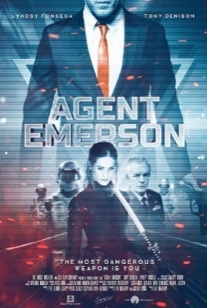
adventure film | n | /ədˈventʃər fɪlm/ |  |  | phim phiêu lưu  
animated film | n | /ˈænɪmeɪtɪd fɪlm/ |  |  | phim hoạt hình (thiết kế bằng đồ họa vi tính)  
cartoon | n | /kɑːˈtuːn/ |  |  | phim hoạt hình (thiết kế bằng tay)  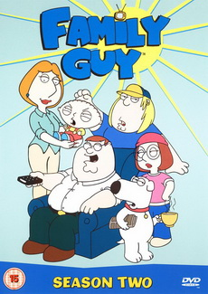
comedy | n | /ˈkɑːmədi/ |  |  | hài kịch  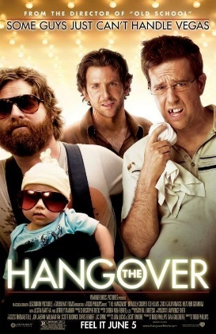
documentary film | n | /ˌdɑːkjuˈmentrɪ fɪlm/ |  |  | phim tài liệu  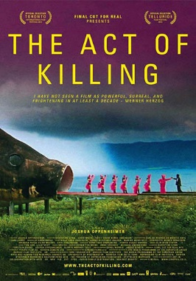
drama | n | /ˈdrɑːmə/ |  |  | kịch, nghệ thuật kịch  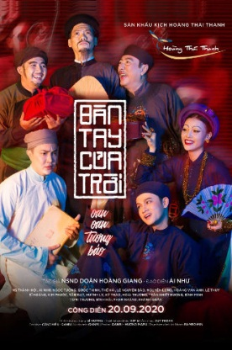
romance film | n | /ˈrəʊmæns fɪlm/ |  |  | phim tình cảm  
musical film | n | /ˈmjuːzɪkl fɪlm/ |  |  | phim ca nhạc  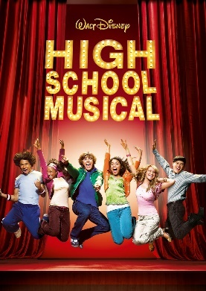
romantic comedy | n | /rəʊˈmæntɪk ˈkɑːmədi/ |  |  | phim hài kịch tình cảm  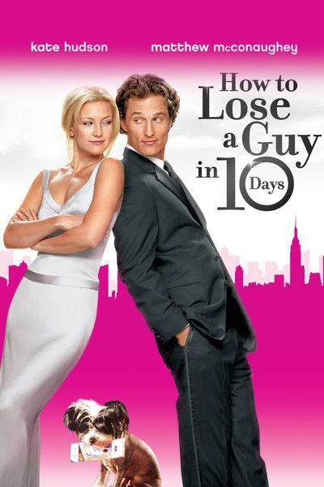
war film | n | /wɔːr fɪlm/ |  |  | phim đề tài chiến tranh  
trailer | n | /ˈtreɪlər/ |  |  | đoạn giới thiệu phim  

* SOME ADJECTIVE TO DESCRIBE FILMS (Một số tính từ thường dùng để mô tả phim
interesting | adj | /ˈɪntrəstɪŋ/ |  |  | thú vị
exciting | adj | /ɪkˈsaɪtɪŋ/ |  |  | hào hứng
disappointing | adj | /ˌdɪsəˈpɔɪntɪŋ/ |  |  | đáng thất vọng
surprising | adj | /sərˈpraɪzɪŋ/ |  |  | gây kinh ngạc
excellent | adj | /ˈeksələnt/ |  |  | tuyệt vời
perfect | adj | /ˈpɜːrfɪkt/ |  |  | hoàn hảo
hilarious | adj | /hɪˈleriəs/ |  |  | vui nhộn, hài hước
boring | adj | /ˈbɔːrɪŋ/ |  |  | buồn chán
moving | adj | /ˈmuːvɪŋ/ |  |  | cảm động
gripping | adj | /ˈɡrɪpɪŋ/ |  |  | hấp dẫn, thú vị
shocking | adj | /ˈʃɑːkɪŋ/ |  |  | làm sửng sốt
scary | adj | /ˈskeəri/ |  |  | sợ hãi, rùng rợn

II. WORD FORMATION
Word | Meaning | Related words
acting (n) | diễn xuất | acting (adj) | act (v)
acting (n) | diễn xuất | actor (n) | actress (n)
acting (n) | diễn xuất | action (n) | activity (n)
acting (n) | diễn xuất | active (adj)
comedy (n) | phim hài | comic (adj) | comedian (n)
confusing (adj) | khó hiểu, gây bối rối | confuse (v) | confusingly (adv)
confusing (adj) | khó hiểu, gây bối rối | confusion (n)
director (n) | người đạo diễn (phim, kịch...) | direct (v) | directory (n)
documentary (n) | phim tài liệu | document (n) | document (v)
documentary (n) | phim tài liệu | documentation (n)
enjoyable (adj) | thú vị, thích thú | enjoy (v) | enjoyment (n)
enjoyable (adj) | thú vị, thích thú | enjoyably (adv)
fantasy (n) | phim giả tưởng, tưởng tượng | fantastic (adj) | fantatically (adv)
fantasy (n) | phim giả tưởng, tưởng tượng | fantasize (v)
frightening (adj) | làm sợ hãi, rùng rợn | frighteningly | frightened (adj)
frightening (adj) | làm sợ hãi, rùng rợn | frightener (n) | frighten (v)
moving (adj) | cảm động | movingly (adv)
review (n) | bài phê bình (về một bộ phim) | review (v) | reviewer (n)
scary (adj) | sự hãi, rùng rợn | scare (v) | scare (n)
scary (adj) | sự hãi, rùng rợn | scarily (adv)
shocking (adj) | làm sửng sốt | shockingly (adv) | shock (v)
shocking (adj) | làm sửng sốt | shock(n)
star (v) | đóng vai chính | star (n)
survey (n) | cuộc khảo sát | survey (v) | surveyor (n)
violent (adj) | hung bạo | violence (n) | violently (adv)

III. GRAMMAR

Connectors: although/ though and even though (Các từ nối: although/ though và even though)
Chúng ta sử dụng although/though/even though (mặc dù) để nối hai mệnh đề mang ý nghĩa tương phản, trái ngược.
Sau although/ though/ even though là một mệnh đề.
Although/Though/Even though + S + V
Ex. Although the weather was bad, we had a wonderful holiday.
(Mặc dù thời tiết xấu, chúng tôi vân có kỳ nghỉ tuyệt vời.)
Even though I don't like her, I try my best to help her.
(Mặc dù tôi không thích cô ấy, tôi cố gắng hết sức để giúp cô ấy.)
Ngoài ra, ta có thể sử dụng However và Nevertheless (tuy nhiên) để nối giữa hai câu thể hiện ý tương phản. Chúng ta thường sử dụng dấu phẩy sau các từ đó.
However, + S + V
Nevertheless, + S + V
Ex. Anna is very young. However, she is very talented.
(Anna rất trẻ tuổi. Tuy nhiên, cô ấy rất tài năng.)
It rains very hard. Nevertheless, my children go to school on time.

(Trời mưa rất to. Tuy vậy, các con tôi vẫn tới trường đúng giờ.)

IV. PRONUNCIATION
SOUND /ɪə/ AND /eə/
1. Cách phát âm nguyên âm đôi /ɪə/ và /eə/
Cách phát âm nguyên âm đôi /ɪə/
Nguyên âm đôi /ɪə/ được tạo thành bởi sự kết hợp giữa 2 nguyên âm là /ɪ/ và /ə/. Khi phát âm âm này, ta để khóe miệng hơi kéo sang hai bên, nâng lưỡi cao để phát âm âm /ɪ/, sau đó thu hai khóe miệng lại, hạ lưỡi về vị trí thư giãn. Đồng thời phát âm âm /ə/. Như vậy ta đã phát âm được âm /ɪə/. | 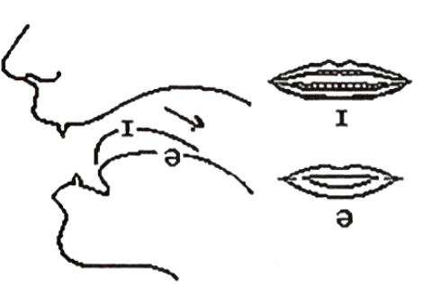

Cách phát âm nguyên âm đôi /eə/
Nguyên âm đôi /eə/ là sự kết hợp giữa /e/ và /ə/. Để phát âm âm này, ta để hai khóe miệng hơi kéo sang hai bên, lưỡi đặt ở độ cao trung bình để phát âm âm /e/, sau đó thu hai khóe miệng lại, lưỡi hơi kéo về phía sau để phát âm âm /ə/. Như vậy, chúng ta đã phát âm được âm /eə/. | 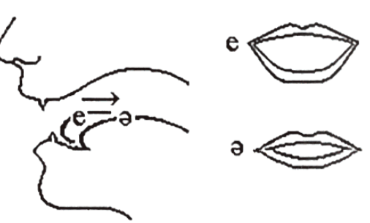

2. Dấu hiệu nhận biết
Nguyên âm đôi /ɪə/
"ea" thường được phát âm là /ɪə/ trong những từ có nhóm ear
Words | Type | Pronunciation | Meaning
fear | v | /fɪə(r)/ | sợ hãi
smear | v | /smɪə(r)/ | trát, bôi lem nhem
weary | adj | /'wɪəri/ | uể oải, mệt mỏi
"ee" phát âm là /ɪə/ khi đứng trước tận cùng là "r" của mỗi từ
Words | Type | Pronunciation | Meaning
deer | n | /dɪə(r)/ | con nai, hoẵng
leer | v | /lɪə(r)/ | liếc trộm
steer | v | /stɪə(r)/ | lái xe, tàu
Nguyên âm đôi /eə/
"a" phát âm là /eə/ trong những từ có một âm tiết mà tận cùng bằng "are" hoặc trong một âm tiết của một từ khi "a" đứng trước "r"
Words | Type | Pronunciation | Meaning
care | v | /keə(r)/ | chăm sóc
dare | v | /deə(r)/ | dám
fare | n | /feə(r)/ | tiền vé
"ai" phát âm là /eə/ khi đứng trước "r"
Words | Type | Pronunciation | Meaning
hair | n | /heə(r)/ | tóc  Giaoandethitienganh.info sưu tầm
pair | n | /peə(r)/ | cặp, đôi
chair | n | /tʃeə(r)/ | cái ghế
"ea" phát âm là /eə/
Words | Type | Pronunciation | Meaning
swear | v | /sweə(r)/ | thề
bearish | adj | /'beəriʃ/ | hay cáu gắt
wear | v | /weə(r)/ | mặc, đội, đeo
"ei" có thể được phát âm là /eə/
Words | Type | Pronunciation | Meaning
their | det | /ðeə(r)/ | của họ
heir | n | /eə(r)/ | người thừa kế

V. PRACTICE
Exercise 1. Put the words in the correct column depending on the pronunciation.
deer | chair | fearful | fairy | where | engineer
fear | care | dare | smear | fare | hair
pair | weary | chair | bearish | leer | wear
steer | swear | hear | heir | tear | weary
/ɪə/ |  |  | /eə/

Exercise 2. Underline the words with the sound /iə/. Double underline words with the sound /eə/. Then say the sentences aloud.
1. We're here.
2. Where are the spare pairs Stan and Dan wear?
3. I have these ears a hundred years.
4. The fair hair man ran in the sand.
5. They are cramming for their exam over there.
6. Have a beer, cheer!
7. Up there, in the air, of course.
8. Is there a bank near here?
9. Their meaning isn't really clear.
10. Look at that airplane.
Exercise 3. Match the words to their definitions.
1. gripping | a. funny and interesting
2. scary | b. extremely good
3. violent | c. causing strong feelings of sadness or sympathy
4. boring | d. very surprising, and difficult to believe
5. moving | e. not surprising
6. entertaining | f. frightening
7. predictable | g. using or involving force to hurt or attack
8. hilarious | h. very exciting
9. shocking | i. not interesting
10. incredible | j. extremely funny
Your answer: 1. ______ 2. ______ 3. ______ 4. ______ 5. ______
6. ______ 7. ______ 8. ______ 9. ______ 10. ______

Exercise 4. Complete the sentences with the correct adjectives in Exercise 3.
1. The film was so ___________ that Mrs. Brown cried at the end.
2. Romance move plots have become so ___________ that you can tell exactly what's coming.
3. My mother can't stand war film because they're too ___________.
4. It was an action film, but it was so ___________ that I fell asleep in the middle.
5. We laughed all the way through the film. It was so ___________.
6. That thriller was so ___________. I couldn't take my eyes off the screen for a second.
7. Sam always has nightmares after watching ___________ movies.
8. The ending of The Sixth Sense was really ___________. It surprised me a lot.
9. The Meyerowitz Stories is getting some ___________ reviews and should be one to add your watch list.
10. Most historical movies are both educational and ___________.
Exercise 5. Complete the sentences with the types of film in the box.
animation | romance | comedies | science - fiction | horror
adventure | documentary | thriller | romantic comedies | action
1. A ___________ is an exciting film, especially about murder or serious crimes.
2. ___________ film features lots of monsters such as Frankenstein, or Dracula that make you scream and be afraid, very afraid!
3. ___________ are sweet films that include romance, but also lots of funny moments as well.
4. In general, ___________ make you laugh - a lot!
5. ___________ films are about imaginary events in the future or in outer space.
6. A ___________ is a film that investigate some real - life story.
7. In ___________ film the heroes have lots of battles, do incredible stunts and drive fast.
8. ___________ films use computer graphics to make elaborate stories.
9. ___________ films have a main character who's usually either on a conquest or exploration.
10. ___________ films are stories of people finding each other and falling in love.

Exercise 6. Give the correct form of the given word to complete the sentences.
1. It's bad for young kids to see ___________ on TV. (violent)
2. This is a ___________ story, you shouldn't read it alone. (frighten)
3. Titanic is a ___________ movie. It has a sad ending and everyone cries watching it. (move)
4. Paul Walker has won Oscar for the best ___________. (act)
5. This girl sings ___________ although she is a ___________. (bad/sing)
6. This film made a strong ___________ on me. (impress)
7. Have you ever seen this comedy? It's really ___________. (fun)
8. The film was ___________ though they spent millions of dollars making it. (succeed)
9. I love action films. They're very ___________. (excite)
10. Big Ben Down is about a group of ___________ who take control of Big Ben. (terror)
11. We were ___________ with the service at the cinema. Everything was terrible. (satisfy)
12. The film is a big ___________. It is boring from beginning to end. (disappoint)

Exercise 7. Complete these sentences with although or in spite of.
1. ___________ all my careful plans, a lot of things went wrong.
2. ___________ I had planned everything carefully, a lot of things went wrong.
3. I love music ___________ I can't play a musical instrument.
4. ___________ being very tired, we carried on walking.
5. The heating was on, but ___________ this the house was still cold.
6. Keith decided to give up his job ___________ I advised him not to.
7. I couldn't sleep ___________ I was tired.
8. ___________ it rained a lot, they enjoyed themselves.
9. I didn't get the job ___________ my qualifications.
10. ___________ what I said last night, I still love you.
Exercise 8. Complete these sentences using Although + a sentence from the table.
I didn't speak the language  he had promised to be on time  I had never seen him before  she smokes 40 cigarettes a day  It was quite cold | it rained a lot  he has a very responsible job  I had all the necessary qualifications we  don't like her very much  the traffic was bad
1. ______________________, he isn't particularly well-paid.
2. ______________________, I recognised him from a photograph.
3. I didn't wear a coat ______________________
4. We thought we'd better invite her to the party ______________________
5. ______________________, I managed to make myself understood.
6. He was late ______________________
7. ______________________, she is quite fit.
8. ______________________, we enjoyed our holiday.
9. I didn't get the job ______________________
10. ______________________, I arrived on time.

Exercise 9. Choose the best option to complete the sentence.
1. ___________ the bad weather, we went on a school picnic.
A. Although B. Despite C. In spite
2. ___________ his illness, Tom went to school because he had an important exam.
A. In spite of B. Although C. But
3. ___________ she was very busy, my mother cooked a great meal for us.
A. Despite B. In spite of C. Although
4. I still got a low grade ___________ I studied for my Math test.
A. although B. despite C. in spite of
5. I have so many cavities ___________ I brush my teeth regularly.
A. in spite of B. even though C. despite
6. ___________ the heavy fog, we managed to get to the meeting on time.
A. But B. Although C. In spite of
7. ___________ we played well, we couldn't win the game.
A. Although B. Even though C. A&B
8. She still loves her husband ___________ they broke up.
A. even though B. in spite of C. despite
9. The elevator was out of order so I had to use the stairs ___________ being exhausted.
A. in spite B. despite C. A&B
10. I'm not going to eat fast food ___________ I'm starving.
A. although B. because C. even

Exercise 10. Complete the sentences, using although, despite, in spite of, however, or nevertheless. Sometimes, two answers are possible.
1. ___________ it was raining heavily, he went out without a raincoat.
2. My father is very busy ___________ he is always willing to give a hand with the housework.
3. Some English words have the same pronunciation ___________ they are spelled differently, for example, dear and deer.
4. I was cold and wet. ___________, Bob put on his swimming suit and went to the beach.
5. I think I did OK in my speech last night ___________ I'd had almost no sleep for 24 hours.
6. Carol arrived at the meeting ___________ I asked her not to be there.
7. The sky was grey and cloudy. ___________ , we went to the beach.
8. It looks like they're going to succeed ___________ their present difficulties.
9. ___________ there was no electricity, I was able to read because I had a candle.
10. ___________ I heard the telephone ring, I didn't answer it.
Exercise 11. Complete the sentences, using the following words. Sometimes, two answers are possible: although, despite/in spite of, however/ nevertheless.
1. ___________ it was raining heavily; he went out without a raincoat.
2. ___________ I heard the telephone ring, I didn't answer it.
3. I like the outdoors. ___________ I don't like bugs and dirt.
4. ___________ her fear, she wrapped her arms around him.
5. The sky was grey and cloudy. ___________, we went to the beach.
6. Nevertheless, ________ many and serious shortcomings, the long series of Depretis administrations was marked by the adoption of some useful measures.
7. We have not yet won; ___________, we shall keep trying.
8. And yet, ___________ her feelings, any relationship with him was potentially dangerous.
9. ___________ the issue was not discussed, it was far from out of her mind.
10. ___________ applying for hundreds of jobs, he is still out of work.
Exercise 12. Choose the best answer to complete each of the following 4 sentences.
1. I am very interested ___________ learning English.
A. to B. in C. at D. for
2. In the party last night, she looked ___________ in a red dress.
A. love B. lovely C. loving D. lovelily
3. Is Minh ___________ with the final semester's result?
A. satisfy B. satisfied C. satisfying D. be satisfying
4. The ending of the film is ___________. All audiences are very sad.
A. disappointed B. satisfying C. disappointing D. satisfied
5. This is a ___________ film and it makes me cry a lot.
A. funny B. moving C. comedy D. excited
6. ___________ he is a CEO and earns a lot of money, he is very mean.
A. Because B. Although C. Despite D. Because of
7. This is a(n) ___________ on real life during wars in Vietnam in 1945.
A. horror film B. sci-fi C. comedy D. documentary
8. She ___________ the Oscar Prize as the best actress this year.
A. wins B. acts C. performs D. directs
9. She is hard-working ___________ she isn't lucky in examinations.
A. Therefore B. But C. However D. So
10. She decided to quit this job ___________ the low salary.
A. because of B. despite C. because D. although
11. My son feels very happy when he sees that ___________ with a lot of cute animals.
A. horror film B. biopic C. thriller film D. animation
12. Most ___________ say that this film is worth watching.
A. plots B. settings C. critics D. acting
13. He acts very well. I'm sure that yesterday he stayed up all night reading the ___________.
A. acting B. character C. survey D. script
14. Before you go to the cinema, you can watch the trailer and read ___________ of the film.
A. reviews B. disaster C. critic D. character
15. That was a ___________ and boring horror film so I slept from the beginning to the end.
A. shocking B. entertaining C. gripping D. predictable
Exercise 13. Choose the underlined word or phrase (marked A, B, C or D) in each sentence that needs correcting.
1. There are (A) many action scenes (B) in this film, so he finds it so gripped (C) and attracting (D).
2. They produced (A) the film very (B) well, and it was based in (C) a real story (D) in many years.
3. She likes (A) the open (B) of the film because it (C) is very impressive.
4. Although the main characters (A) in that film (B) aren't famous, but (C) their performance (D) is very good.
5. Despite (A) of the heavy traffic (B), she still (C) went to the film company in time (D) yesterday.
6. In spite of a warded (A) a lot prizes in his acting (B) career, he tries (C) to challenge himself to achieve (D) more success.
7. The director thought the film would make (A) success when it was shown (B). Therefore (C), it didn't attract (D) audiences a lot.
8. When you see signs (A) along the road (B) the sign "Left turning only" (C) you must obey them (D).
9. They were annoying (A) at the young (B) actor's bad attitude (C) behind the scene (D).
10. My parents have (A) an intention (B) of travelling (C) in Japan on (D) the middle of November.

Exercise 14. Read and decide T (true)/ F (false) for each statement.
Watching television is an interesting and funny activity. The word television is < often shortened to TV. On TV you can watch many different programs about a wide range of things. Some examples of TV programs are news, cartoons, reality shows, 1 sports, documentaries and soap operas.
There are several channels which show different TV programs. In Vietnam, the main channels are called "VTV1", "VTV2", and "VTV3". TV guides tell US what programs are showing on which channel, and at what time on a particular day.
Most programs on TV are episodes that are part of a series. These episodes usually last for about 30 minutes or full hour. At the weekend, there are lots of interesting movies on TV. Now you don't need to go to the cinema. You can watch films at home. It's so comfortable.
You can learn a lot from watching TV but you should not watch too much or you will hurt your eyes.
No | Statements | T/F
1. | Watching television is an interesting and fun activity.
2. | You can watch only some programs about a wide range of things.
3. | "VTV1", "VTV2", and "VTV3"are the main channels in Vietnam.
4. | We know the time and the name of programs thanks to TV guides.
5. | There are lots of interesting movies on TV on weekdays.
6. | TV doesn't bring us any benefits. It damages our eyes.
Exercise 15. Choose the word from the box that best fits the blank space in the following passage.
consisted | been | which | would | many
way | explain | recent | fewer | their
The world's first film was shown in 1895 by two French brothers, Louis and Auguste Lumiere. Although it only (1) ____________ of short, simple scenes, people loved it and films have (2) ____________ popular ever since. The first films were silent, with titles on the screen to (3) ____________ the story.
Soon the public had (4) favorite actors and actresses and, in this, (5) ____________ the first film stars appeared. In the 1927, the first "talkie", a film with sound, was shown and from then on, the public (6) ____________ only accept this kind of film.
Further improvements continued, particularly in America, (7) ____________ produced 95% of all films. With the arrival of television in 1950s, (8) ____________ people went to see films, but in (9) ____________ years audiences have grown again. More countries have started to produce films that influences film-making and there are currently (10) ____________ national film industries.
Exercise 16. Rewrite each sentence so that it has the same meaning with the original sentence. Starting with the given words.
1. Although Tom was a poor student, he studied very well.
In spite of
2. Mary could not go to school because she was sick.
Because of
3. Although the weather was bad, she went to school on time.
Despite
4. My mother told me to go to school although I was sick.
In spite of
5. Because there was a big storm, I stayed at home.
Because of
6. Tom was admitted to the university although his grades were bad.
Despite
7. Although she has a physical handicap, she has become a successful woman.
Despite
8. In spite of his good salary, Tom gave up his job.
Although
9. Though he had not finished the paper, he went to sleep.
In spite of
10. In spite of the high prices, my daughter insists on going to the movies.
Even though
Exercise 17. Rewrite each sentence so that it has the same meaning with the original sentence.
1. Although his wife was sick, he still went to work yesterday.
______________________________________________________________________________.
2. Despite her unkind behavior, we still love her.
______________________________________________________________________________.
3. Despite the fact that Tony learnt very hard, he failed this test.
______________________________________________________________________________.
4. Her brother really enjoyed this job although the salary was very low.
______________________________________________________________________________.
5. In spite of the dirty room, Salim didn't clean it.
______________________________________________________________________________.
6. Although there was the traffic jam, they went to the post office.
______________________________________________________________________________.
7. Although my uncle was tired, he still drove a hundred kilometers to the next city.
______________________________________________________________________________.
8. The film poster is wonderful. I don't like to see it.
______________________________________________________________________________.
9. Although Nam is not an intelligent student, he learns well.
______________________________________________________________________________.
10. In spite of the heavy rain, we went to school.
______________________________________________________________________________.

ĐÁP ÁN
UNIT 8: FILMS
Exercise 1.
/el/ | /ea/
deer, fearful, engineer, fear, smear,  weary, leer, steer, hear, tear, weary | chair, fairy, where, care, dare, fare, hair,  pair, chair, bearish, wear, swear, heir, tear

Exercise 2.
1.We're here.
2.Where are the spare pairs Stan and Dan wear?
3. I have these ears a hundred years.
4. The fair hair man ran in the sand.
5. They are cramming for their exam over there.
6. Have a beer, cheer!
7. Up there, in the air, of course.
8. Is there a bank near here?
9. Their meaning isn't really clear.
10. Look at that airplane.
Exercise 3.
1.h 2. f 3.g 4.i 5.c 6. a 7.e 8. j 9. d 10. b
Exercise 4.
1. moving 2. predictable 3. violent 4. boring 5. hilarious
6. gripping 7. scary 8. shocking 9. incredible 10. Entertaining
Exercise 5.
1.thriller 2. Horror 3. Romantic comedies 4. comedies 5. Science fiction 6. Documentary 7. action 8. Animation 9. Adventure 10. Romance
Exercise 6.
1.violence 2. frightening 3. Moving 4. Actor 5. badly/ singer 6. Impression 7. Funny 8. unsuccessful 9. Exciting 10. Terrorists 11. Unsatisfied 12. Disappointment
Exercise 7.
1. In spite of 2. Although 3. although 4. In spite of 5. in spite of 6. although 7. although 8. Although 9. in spite of 10. In spite of
Exercise 8.
1. Although he has a very responsible job
2. Although I had never seen him before
3. although it was quite cold
4. although we don't like her very much
5. Although I didn't speak the language
6 allthough he had promsed to be on time
7. Although she smolkes, 40 cigarettes a day
8. Although it rained a lot
9. although 1 had all the necessary quallifications
10. Although the traffc was bad
Exercise 9.
1.B 2A 3.C 4.A 5.B 6.C 7.C 8.A 9.8 10.A
Exercise 10.
1. Although
2. However/Nevertheless
3. although
4 However/Nevertheless
5. although 6. although
7. However/Nevertheless
8. despite/ in spilte of 9. Although
10. Although
Exercise 11,
1. Although 2. Although 3. However/Nevertheless 4. Despite/In spite of
5. However/Nevertheless 6. despite/ in spite of
7. however/nevertheless 8. despite/ in spite of
9. Although 10. Despite/In spite of
Exercise 12.
1.8 2.8 3.8 4.C 5.B 6.B 7.D 8.A 9.C 10.A
11.D 12.C 13.D 14.A 15.D
Exercise 13.
1.C 2.C 3.B 4.C 5.A 6.A 7.C 8.C 9.A 10. D
Exercise 14.
1.T 2.F 3.T 4.T 5.F 6.F Exercise 15.
1. consisted 2. been 3. explain 4. Their 5. way
6. would 7. which 8. fewer 9. Recent 10. Many
Exercise 16.
1. In spite of being a poor student, Tom studied very well.
2. Because of being sick, Mary couldn't go to school.
3. Despite the bad weather, she went to school on time.
4. In spite of my sickness, my mother told me to go to school.
5. Because of a big storm, I stayed at home.
6. Despite Tom's bad grades, he was admitted to the university.
7. Despite her physical handicap, she has become a successful woman.
8. Although Tom got a good salary, he gave up his job.
9. In spite of having not finished the paper, he went to sleep.
10. Even though the prices are high, my daughter insists on going to the movies.
Exercise 17.
1. Despite the fact that his wife was sick, he still went to work yesterday.
2. Although she behaves unkind, we still love her.
3. Although Tony learnt very hard, he failed this test.
4. Her brother really enjoyed this job despite the low salary.
5. Although the room was dirty, Salim didn't clean it.
6. Despite the traffic jam, they went to the post office.
7. In spite of the fact that my uncle was tired, he still drove a hundred kilometers to
the next city.
8. Although the film poster is wonderful, I don't like to see it.
9. Despite/ In spite of not being an intelligent student, he learns well.
10. Although it rained heavily, we went to school.

