GRADE 7
UNIT 1. HOBBIES TIẾNG ANH 7 GETTING STARTED
amazing /əˈmeɪzɪŋ/ (adj): tuyệt vời
make it yourself /meɪk ɪt jɔːˈself/ (v.phr): tự làm lấy
building dollhouses /ˈbɪl.dɪŋ ˈdɒlˌhaʊsiz/ (n.phr): xây nhà búp bê
cardboard /ˈkɑːdbɔːd/ (n): bìa cứng, các-tông creativity /ˌkriːeɪˈtɪvəti/ (n): sự sáng tạo horse-riding /ˈhɔːs raɪdɪŋ/ (n): cưỡi ngựa common /ˈkɒmən/ (adj): phổ biến, thịnh hành
collecting teddy bears /kəˈlektɪŋ ˈted.i /berz/ (n.phr): sưu tầm gấu bông
make model /meɪk ˈmɒdl / (v.phr): làm mô hình collecting coins /kəˈlektɪŋ kɔɪnz/ (n.phr): sưu tầm đồng xu gardening /ˈɡɑːdnɪŋ/ (n): việc làm vườn
learn how to do something /lɜrn haʊ tu du ˈsʌmθɪŋ/ (v.phr): học cách làm việc gì
go to the club /goʊ tu ðə klʌb/ (v.phr): đi câu lạc bộ

A CLOSER LOOK 1
go jogging /goʊ ˈʤɑ:gɪŋ/ (v.phr): chạy bộ
do yoga /duːˈjoʊgə / (v.phr): tập yoga
do judo /du ˈʤuˌdoʊ/ (v.phr): tập võ judo go camping /goʊ ˈkæmpɪŋ/ (v.phr): cắm trại keep fit /kip fɪt/ (v.phr): giữ dáng
surf /sɜːf/ (v): lướt sóng
play the violin /pleɪ ðə vaɪəˈlɪn / (v.phr): chơi đàn vĩ cầm

A CLOSER LOOK 2
rise /raɪz/ (v): mọc, nhô lên (mặt trời)
leave /liːv/ (v): rời khỏi
flow through /floʊ θru/ (phr.v): chảy qua timetable /ˈtaɪmteɪbl/ (n): thời khóa biểu drawing class /ˈdrɔɪŋ klæs/ (n): lớp học vẽ set /set/ (v): lặn (mặt trời)
play basketball /pleɪ ˈbæskətˌbɔl/ (v.phr): chơi bóng rổ
arrive /əˈraɪv/ (v): đến
start /stɑːt/ = begin /bɪˈɡɪn/ (v): bắt đầu

COMMUNICATION
be interested in something /bi ˈɪntrəstəd ɪn/ (phr): hứng thú về việc gì
read books /ri:d bʊks/ (v.phr): đọc sách
listen to music /ˈlɪsn/ /tuː/ /ˈmjuːzɪk/ (v.phr): nghe nhạc
exercise /ˈeksəsaɪz/ (v): tập thể dục

SKILLS 1
belong to /bɪˈlɔŋ tu / (phr.v): thuộc về
insect and bug /ˈɪnˌsɛkt ænd bʌg/ (n): côn trùng và bọ
outdoor activity /ˈaʊtdɔːr/ /ækˈtɪvɪti/ (n.phr): hoạt động ngoài trời
develop creativity /dɪˈvɛləp ˌkrieɪˈtɪvəti/ (v.phr): phát triển khả năng sáng tạo
reduce stress /rɪˈdjuːs strɛs/ (v.phr): giảm căng thẳng
patient /ˈpeɪʃnt/ (adj): kiên nhẫn
take on responsibility /teɪk ɒn rɪsˌpɒnsəˈbɪlɪti/ (v.phr): chịu trách nhiệm
join in /ʤɔɪn ɪn/ (phr.v): tham gia

maturity /məˈtʃʊərəti/ (n): sự trưởng thành
make someone happy /meɪk ˈsʌmwʌn ˈhæpi/ (v.phr): làm ai đó vui vẻ
spend time together /spɛnd taɪm təˈgɛðə/ (v.phr): dành thời gian cho nhau
valuable lesson /ˈvæljʊəbl ˈlɛsn/ (n.phr): bài học giá trị
water plants /ˈwɔːtə plɑːnts/ (v.phr): tưới cây

SKILLS 2
benefit /ˈbenɪfɪt/ (n): lợi ích
duty /ˈdjuːti/ (n): nghĩa vụ, bổn phận share /ʃeə(r)/ (v,n): chia sẻ LOOKING BACK
footballer /ˈfʊtbɔːlə(r)/ (n): cầu thủ đá bóng play sport /pleɪ spɔːt / (v.phr): chơi thể thao run through /rʌn θruː/ (phr.v): chảy qua divide into /dɪˈvaɪd ˈɪn.tuː/ (v.phr): chia thành PROJECT
brainstorm /ˈbreɪnstɔːm/ (v): động não
take it up /teɪk ɪt ʌp/ (phr.v): bắt đầu một thói quen, sở thích
discuss /dɪˈskʌs/ (v): thảo luận

Part 1: Bài 1.Viết lại các câu sau ở thể khẳng định (+), thể phủ định (-), thể nghi vấn (?) của thì hiện tại đơn.
(+) He goes to the cinema.
(-)
(?)

(-) James doesn’t like strawberry
(?) (+)

(?) Do they work in this software company? (-) (+)
(+) His new trousers are black
(-)
(?)

(?) Does she want to quit the job?
(-) (+)

Bài 2: Khoanh tròn vào câu trả lời đúng
1. My sister (go/goes) ice skating every winter
2. They seldom (have/has) dinner with each other.
3. I (come/ comes) from Ha Noi, Viet Nam.
4. Jim and I (don’t/ doesn’t ) go to school by bus.
5. His hobby (is/are) collecting stamps
6. Jane and I (am/ are) best friends.
7. My cat doesn’t (eat/eats) vegetables.
8. (Does/ Do) your mother finish her work at 4 o’clock?
9. We (watch/watches) Tv everyday.
10. Peter never (forgets/ forget) to do his homework.
11. Tom always (win/ wins) when he plays chess
12. (Do/ Are) you a student?
13. Mice (is/are) afraid of cats.
14. How does your father (travel/ travels) to work everyday?
15. They sometimes (go/goes) sightseeing in rural areas.

Bài 3: Cho dạng đúng của động từ trong ngoặc ở thì hiện tại đơn.
1. Nurses and doctors (work) in hospitals.
2. This schoolbag (belong) to Jim.
3. the performance (begin) at 7pm?
4. Sometimes, I (get) up before the sun (rise)
5. Whenever she (be) in trouble, she (call) me for help.
6. Dogs (have) eyyesight than human.
7. She (speak) four different languages.
8. The Garage Sale (open) on 2nd of August and (finish) on 4th of October.
9. She (be) a great teacher.
10. Who this umbrella (belong) to?
11. Who (go) to the theater once a month?
12. James often (skip) breakfast.
13. I rarely (do) morning exercises.
14. My cousin (have) a driving lesson once a week.
15. My father and I often (play) football with each other.

Bài 4: Hãy chọn câu trả lời đúng cho các câu sau:
1. My father a teacher. He works in a hospital.
A. Is B. isn’t C. are D. aren’t
2. I rock music but my brothers don’t like it.
A. Likes B. likes C. don’t like D. doesn’t like
3. Workers always helmet for safety reason.
A. Wears B. wear C. don’t wearD. doesn’t wear
4. I don’t like chocolate. I eat it.
A. Never B. often C. always D. usually
5. My classmates lazy. They always do their homework.
A. AreB. is C. aren’t D. isn’t
6. My grandfather fishing very often
A. Goes B. go C. don’t go D. is
7. tidy your room?
A. How often are you? B. How often do you?
C. How often you D. How often does you
8. Ms Thuy water the trees a week.
A. Once B. one C. two D. one time
9. What your nationality? I am Vietnamese.
A. Is B. are C. do D. does
10. I really love making models and my brother it too.
A. Love B. loves C. don’t love D. doesn’t love
11. The Smiths never to their neighbors
A.Talk B. talks C. don’t talk D. doesn’t talk
12. My sister how to swim.
A. Don’t know B. doesn’t know C.don’t knows D. not know.
13. My teacher very kind. We really like her.
A. Is B. isn’t C. are D. aren’t
14. Sometimes a rainbow after the rain.
A. Appear B.appears C. not appear D. doesn’t appears
15. The train at 6 am tomorrow.
A. Leaves B. leave C. is leave D. don’t leave

Part 2: Bài 1. Chọn đáp án đúng
1. I ——————— at a bank.
A. work B. works C. working
2. She ——————– with her parents.
A. liveB. lives C. living
3. Cows ———————– on grass.
A. feed B. feeds C. feeding
4. He ———————- a handsome salary.
A. earn B. earns C. earning
5. Janet ———————- to be a singer.
A. want B. wants C. wanting
6. Emily ———————– delicious cookies.
A. make B. makes C. making
7. Arti and her husband ——————- in Singapore.
A. liveB. lives C. living
8. Rohan and Sania ———————- to play card games.
A. likeB. likes C. liking
9. Sophia ————————– English very well.
A. speak B. speaks C. speaking
10. Martin ———————– for a walk in the morning.
A. go B. goes C. going
11. My grandfather ——————– his pet dog.
A. adore B. adores C. adoring
12. Plants ———————– water and sunlight for making their food.
A. need B. needs C. needing

Bài 2: Bài tập Chia Thì hiện tại đơn.
1. I (be) at school at the weekend.

2. She (not study) on Friday.
3. My students (be not) hard working.
4. He (have) a new haircut today.
5. I usually (have) breakfast at 7.00.
6. She (live) in a house?
7. Where (be) your children?
8. My sister (work) in a bank.
9. Dog (like) meat.
10. She (live) in Florida.
11. It (rain) almost every day in Manchester.
12. We (fly) to Spain every summer.
13. My mother (fry) eggs for breakfast every morning.
14. The bank (close) at four o'clock.
15. John (try) hard in class, but I (not think) he'll pass.
16. Jo is so smart that she (pass) every exam without even trying.
17. My life (be) so boring. I just (watch) TV every night.
18. My best friend (write) to me every week.
19. You (speak) English?
20. She (not live) in HaiPhong city.

Bài 3: Chọn đáp án đúng.
1. I don’t stay/ doesn’t stay at home.
2. We don’t wash/ doesn’t wash the family car.
3. Doris don’t do/ doesn’t do her homework.
4. They don’t go/ doesn’t go to bed at 8.30 p.m.
5. Kevin don’t open/ doesn’t open his workbook.
6. Our hamster don’t eat/ doesn’t eat apples.
7. You don’t chat/ doesn’t chat with your friends.
8. She don’t use/ doesn’t use a ruler.
9. Max, Frank and Steve don’t skate/ doesn’t skate in the yard.
10. The boy don’t throw/ doesn’t throw stones.

Bài 4: Hoàn thành các câu sau: (Chuyển sang câu phủ định)
1. She feeds the animals. - She the animals.
2. We take photos. - We photos.
3. Sandy does the housework every Thursday. - Sandy the housework every Thursday.
4. The boys have two rabbits. - The boys two rabbits.
5. Simon can read English books. - Simon read English books.
6. He listens to the radio every evening. - She to the radio every evening.
7. Annie is the best singer of our school. - Annie the best singer of our school.
8. The children are at home. - The children at home.
9. The dog runs after the cat. - The dog after the cat.
10. Lessons always finish at 3 o'clock. - Lessons at 3 o'clock.

Bài 5: Hoàn thành các câu hỏi sau:
1. How/ you/ go to school/ ?- How do you go to school?
2. what/ you/ do/ ?
?
3. where/ John/ come from/ ?
?
4. how long/ it/ take from London to Paris/ ?
?
5. how often/ she/ go to the cinema/ ?
?
6. when/ you/ get up/ ?
?
7. how often/ you/ study English/ ?
?
8. what time/ the film/ start/ ?
?
9. where/ you/ play tennis/ ?
?
10. what sports/ Lucy/ like/ ?
?

Bài 6: Dùng "do not" hoặc "does not" để hoàn thành những câu sau
1. I prefer coffee.
2. She ride a bike to her office.
3. Their friends live in a small house.
4. They do the homework on weekends.
5. Mike play soccer in the afternoons.
6. The bus arrive at 8.30 a.m.
7. We go to bed at midnight.
8. My brother finish work at 8 p.m.

Bài 7: Hoàn thành cách câu sau
1. Does Jack like eating hamburgers? => Yes, does
2. ....... you get up early on Sundays? => No, ........
3. ....... the students always work hard for the exam? => No, ........
4. ....... the train leave at noon every day? => Yes, ........
5. ....... he often play the guitar? => No, ........
6. ....... they take a taxi to school every morning? => Yes, ........
7. ....... Anna and Daisy visit their old teachers on winter holidays? => No, ........
8. ....... water boil at 100 degrees Celsius? => Yes, ........

Bài 8: Hoàn thành các câu sau
1. Robin (play). football every Sunday.
2. We (have) a holiday in December every year.
3. He often (go). to work late.
4. The moon (circle) around the earth.
5. The flight (start). at 6 a.m every Thursday.
6. Peter (not/ study). very hard. He never gets high scores.
7. My mother often (teach). me English on Saturday evenings.
8. I like Math and she (like). Literature.
9. My sister (wash). dishes every day.
10. They (not/ have). breakfast every morning.

Bài 9: Hoàn thành cách câu sau với từ trong ngoặc
1. My brothers (sleep) on the floor. (often)

=> My brothers often sleep on the floor
2. He (stay) up late? (sometimes)
=> ………………………………………………………………
3. I (do) the housework with my brother. (always)
=> ………………………………………………………………
4. Peter and Mary (come) to class on time. (never)
=> ………………………………………………………………
5. Why Johnson (get) good marks? (always)
=> ………………………………………………………………
6. You (go) shopping? (usually)
=> ………………………………………………………………
7. She (cry). (seldom)
=> ………………………………………………………………
8. My father (have) popcorn. (never)
=> ………………………………………………………………

Bài 10. Chia động từ ở trong ngoặc:
1. My father always Sunday dinner. (make)
2. Ruth ................................ eggs; they her ill. (not eat; make)
3. "Have you got a light, by any chance?" "Sorry, I " (smoke)
4. ................................ Mark to school every day? (go)
5. ................................ your parents your girlfriend? (like)
6. How often ................................ you swimming? (go)
7. Where ................................ your sister ? (work)
8. Ann ................................. usually lunch. (not have)
9. Who the ironing in your house? (do)
10. We out once a week. (go)

Bài 13. Hoàn thành các câu sau. Có thể chọn khẳng định hoặc phủ định
Ví dụ:

· Claire is very sociable. She knows (know) lots of people.
· We've got plenty of chairs, thanks. We don't want (not want) any more.
1. My friend is finding life in Paris a bit difficult. He (speak) French.
2. Most students live quite close to the college, so they (walk) there every
day.
3. How often ................................ you (look) in a mirror?
4. I've got four cats and two dogs. I (love) animals.
5. No breakfast for Mark, thanks. He (eat) breakfast.
6. What's the matter? You (look) very happy.
7. Don't try to ring the bell. It (work).
8. I hate telephone answering machines. I just (like) talking to them.
9. Matthew is good at badminton. He (win) every game.
10. We always travel by bus. We (own) a car.

Cách phát âm của 2 nguyên âm /ɜ:/ và /ə/.
1. A. accept | B. mother | C. handsome | D. word
2. A. bird | B. thirty | C. woman | D. church
3. A. person | B. bigger | C. Germany | D. early
4. A. actor | B. world | C. work | D. turn
5. A. university | B. brother | C. answer | D. accident
5. A. banana | B. correct | C. future | D. curtain
6. A. around | B. heard | C. nurse | D. birthday
7. A. verb | B. shirt | C. museum | D. Thursday
8. A. generous | B. earn | C. tonight | D. zebra
A. different | B. picture | C. famous | D. earth
EX1: Say the words out loud and odd one out
1. A. permit B. summer C. first D. driver
2. A. person B. certain C. turn D. teacher
3. A. about B. version C. purpose D. term
4. A. network B. against C. search D. church
5. A. birth B. journey C. refer D. however
6. A. under B. little C. firm D. different
7. A. dirty B. rather C. dancer D. order
8. A. perhaps B. power C. ever D. early

EX 2: Find the word which has a different sound in the part underlined
1. A. sure B. pressure C. nature D. structure
2. A. flight B. site C. chick D. high
3. A. egg B. lend C. enter D. return
4. A. why B. write C. which D. world
5. A. other B. tough C. moment D. love

EX3: Odd one out
1. A. gardening B. bicycle C. cycling D. taking photos
2. B. cook B. feel C. watch D. play
3. A. swimming B. making models C. skating D. flowers
4. A. pottery B. mountain C. valley D. river
5. A. bottles B. stamps C. lorry D. coins
6. A. guitar B. games C. piano D. trumpet
7. A. carving wood B. teacher C. artist D. architect
8. A. bicycle B. helicopter C. plane D. eggshell
9. A. dancing B. swimming C. amazing D. cooking 10.A.cinema B. skating C. museum D. theatre
EX 4: Choose the word whose is pronounced differently from the others (s/es)
1. A. proofs | B. books | C. points | D. days
2. A. helps | B. laughs | C. cooks | D. finds
3. A. neighbors | B. friends | C. relatives | D. photographs
4. A. snacks | B. follows | C. titles | D. writers
5. A. streets | B. phones | C. books | D. makes
6. A. cities | B. satellites | C. series | D. workers
7. A. develops | B. takes | C. laughs | D. volumes
8. A. phones | B. streets | C. books | D. makes
9. A. proofs | B. regions | C. lifts | D. rocks

10. A. involves | B. believes | C. suggests | D. steals

UNIT 2. HEALTHY LIVING TIẾNG ANH 7 GETTING STARTED
boat /bəʊt/ (v): chèo thuyền exercise /ˈeksəsaɪz/ (v): tập thể dục popular /ˈpɒpjələ(r)/ (adj): phổ biến
outdoor activity /ˈaʊtdɔːr/ /ækˈtɪvɪti/ (n): hoạt động ngoài trời
go cycling /gəʊ ˈsaɪklɪŋ/ (v.phr): đạp xe quiet /ˈkwaɪət/ (adj): yên tĩnh interesting /ˈɪntrəstɪŋ/ (adj): thú vị
lunchbox /ˈlʌnʧbɒks/ (n): hộp đựng đố ăn trưa
sunscreen /ˈsʌnskriːn/ (n): kem chống nắng
get sunburn /gɛt ˈsʌnbɜːn / (v.phr): bị cháy nắng
run /rʌn/ / (v): chạy bộ
walk /wɔːk/ (v): đi bộ
eat breakfast /iːt ˈbrɛkfəst/ (v.phr): ăn sáng
be good / bad for health /biː gʊd / bæd fɔː hɛlθ / (v.phr): tốt/ xấu cho sức khỏe

A CLOSER LOOK 1
dim light /dɪm laɪt/ (n.phr): ánh sáng mờ lip balm /lɪp bɑːm/ (n.): son dưỡng môi chapped lips /ʧæpt lɪps/ (n.phr): môi bị nứt
coloured vegetables /ˈkʌləd ˈvɛʤtəb(ə)lz /ˈkʌləd ˈvɛʤtəb(ə)lz / (n.phr): rau màu
red spots /rɛd spɒts/ (n.phr): những đốm đỏ wash your hands /wɒʃ jɔː hændz/ (v.phr): rửa tay tofu /ˈtəʊfuː/ (n): đậu hủ
brush your teeth /brʌʃ jɔː tiːθ (v.phr): chải răng touch your face /tʌʧ jɔː feɪs/ (v.phr): chạm lên mặt skin condition /skɪn kənˈdɪʃən/ (n): tình trạng da soft drinks /sɒft drɪŋks/ (n): nước ngọt
keep fit /kip fɪt/ (v.phr): giữ dáng vitamin /ˈvɪtəmɪn/ (n): vitamin avoid /əˈvɔɪd/ (v): tránh khỏi affect /əˈfekt/ (v): gây hại

A CLOSER LOOK 2
acne /ˈækni/ (n): mụn trứng cá
fast food /fɑːst/ /fuːd/ (n): thức ăn nhanh vegetarian /ˌvedʒəˈteəriən/ (n): người ăn chay healthy /ˈhelθi/ (adj): khỏe mạnh
pimple /ˈpɪmpl/ (n): mụn nhọt
sports centre /spɔːts ˈsɛntə / (n.phr): trung tâm thể thao
cheesecake /ˈtʃiːzkeɪk/ (n): bánh phô mát clean up / kli:n ʌp / (phr.v): dọn dẹp sweetened food /ˈswiːtnd fuːd/ (n): đồ ngọt soybean / ˈsɔɪbiːn/ (n): đậu nành COMMUNICATION
protein /ˈprəʊtiːn/ (n): đạm
fat /fæt/ (n): chất béo
diet /ˈdaɪət/ (n): chế độ ăn uống cooking oil /ˈkʊkɪŋ ɔɪl/ (n: dầu ăn eyedrops /aɪ drɒps/ (n): thuốc nhỏ mắt SKILLS 1
special soap /ˈspɛʃəl səʊp/ (n.phr): xà phòng đặc biệt
pop /pɒp/ (v): bóp, nặn
cause /kɔːz/ (v): gây nên
get serious /gɛt ˈsɪərɪəs/ (v.phr): trở nên nghiêm trọng
disease /dɪˈziːz/ (n): bệnh
take care of /teɪk keər ɒv/ (v.phr): chăm sóc put on weight /pʊt ɒn weɪt/ (v.phr): lên cân flu /fluː/ (n): cúm

SKILLS 2
wear a mask /weər ə mɑːsk/ (v.phr): đeo khẩu trang
keep your surroundings clean /kiːp jɔː səˈraʊndɪŋz kliːn/ (v.phr): giữ khu vực xung quanh sạch sẽ

LOOKING BACK
harmful /ˈhɑːmfl/ (adj): có hại
hard-working people /ˈhɑːdˌwɜːkɪŋ ˈpiːpl/ (n): người khỏe mạnh
Physical activity /ˈfɪzɪkl ækˈtɪvəti/ (n): hoạt động thể chất
tidy /ˈtaɪdi/ (adj): gọn gàng

PROJECT
campaign /kæmˈpeɪn/ (n): chiến dịch
bad habits /bæd ˈhæbɪts/ (n.phr): thói quen xấu
illustrate /ˈɪləstreɪt/ (v): minh họa
advice /ədˈvaɪs/ (n): lời khuyên

Khi nói ai đó có vấn đề gì về sức khỏe, các em có thể dùng động từ "have" đi kèm với các danh từ chỉ các vấn đề về sức khỏe như sau:
have a + cough/ headache/ sore throat/ temperature/ runny nose ...
have an + allergy ...
have + sunburn ...
*have (a/ an) + stomach ache/ toothache/ earache ...
*have (the) + flu ...
(*a/an/the trong 2 cấu trúc này có thể có hoặc không)
Với các tính từ chỉ trạng thái cơ thể, chúng ta có thể dùng kết hợp với động từ "feel". feel + itchy/ sick/ tired/ weak ...

Bài 1: (Đánh dấu (✓) vào câu đơn.)
1. The Japanese eat a lot of tofu.
2. She drinks lemonade every morning.
3. I don’t eat fast food, and I don’t drink soft drinks.
4. I am fit.
5. I like fish, but my sister likes meat.

Bài 2: (Sắp xếp lại các từ và cụm từ để tạo thành những câu đơn.)
1. soft drinks / never / my sister / drinks /…………………………………………………..
2. affects / acne / 80% of young people /.…………………………………………………..
3. has / he / for breakfast / bread and eggs /.…………………………………………………..
4. don’t eat / we / much fast food /.…………………………………………………..
5. a lot of vitamins / fruit and vegetables / have /.………………………………………………….. Bài 3: Viết các câu hoàn chỉnh từ gợi ý. Bạn có thể phải thay đổi các từ hoặc thêm một số từ.)
1. tofu / be / healthy. …………………………………………………..
2. many Vietnamese / drink / green tea. …………………………………………………..
3. she / not / use / suncream. …………………………………………………..
4. father / not / exercise / every morning. …………………………………………………..
5. most children / have / chapped lips and skin / winter.
…………………………………………………..

Bài 4: viết một câu đơn từ 2 câu đã cho
1. We avoid sweetened food. We avoid soft drinks.
=> We avoid .
2. My dad loves outdoor activities. I love outdoor activities.
=> My love outdoor activities.
3. You should wear a hat. You should wear suncream.
=> You should wear .
4. My mother read the health tips. My mother downloaded the health tips.
=> My mother .

1. Choose the word having the underlined part pronounced differently in each line.
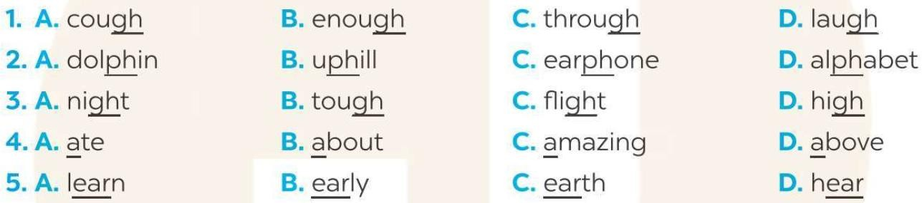
2. Find the word which has a different sound in the part underlined
1. A. thousand B. thick C. month D. then
2. A. tutor B. duck C. cube D. music
3. A. tiny B. light C. continue D. blind
4. A. island B. artist C. silent D. house
5. A. healthy B. system C. easy D. ugly

3. Odd one out
1. A. headache B. earache C. backache D. regular
2. A. exercise B. reduce C. problem D. limit
3. A. vegetable B. computer C. junk food D. sweet
4. A. important B. sunburn C. allergy D. cough
5. A. spots B. sore throat C. toothache D. medicine
6. A. flu B. cold C. hot D. fever
7. A. strong B. vegetarian C. healthy D. weak
8. A. vitamin B. cousin C. children D. adult

4: Choose the best answer
1. Does your father like photos?
A. doing B. making C taking D. having
2. The children love being with the trees and flowers.
A. indoors B. outdoors C. inside D. outside
3. My father a lot of fish from the river this afternoon.
A. has B. brings C. carries D. catches
4. Nick prefers making models to wood.
A. carving B. using C. cutting D. doing
5. What do they about making pottery?
A. have B. worry C. think D. take
6. My daughter is She can make new things easily.
A. creative B. careful C. serious D. happy
7. The man up this hobby when he returned to his country.
A. added B. had C. took D. saw
8. We the rubbish and put it into the bin over there.
A. get B. collect C. use D. provide
9. Carved eggshells can be as gifts for your family and friends.
A. taken B. bought C. sold D. used 10.My mum does exercise every day to fit.
A. keep B. do C. take D. turn

Find the word which has a different sound in the part underlined. (vbt)
1. A. allergy B. calorie C. coordinate D. triathlon
2. A. compound B. concentrate C. monopoly D. melody
3. A. essential B. attention C. vegetarian D. depression
4. A. sick B. swimming C. itchy D. riding
5. A. really B. healthy C. regularly D. identify

Find the odd one out A, B, C or D.
1. A. cough B. weak C. headache D. sore throat
2. A. sunburn B. toothache C. earache D. unhealthy
3. A. sick B. temperature C. tired D. weak
4. A. flu B. stomachache C. allergy D. fat
5. A. sleep B. happy C. live D. smile

UNIT3: COMMUNITY SERVICE TIẾNG ANH 7 GLOBAL SUCCESS GETTING STARTED
board game /bɔːd ɡeɪm / (n): trò chơi bàn cờ
meet up /miːt ʌp/ (phr.v): gặp
community activity /kəˈmjuːnɪti ækˈtɪvɪti/ (n.phr): hoạt động cộng đồng
pick up litter /pɪk ʌp ˈliːtə/ (v.phr): nhặt rác
donate books /dəʊˈneɪt bʊks/ (v.phr): quyên góp sách plant vegetables /plɑːnt ˈvɛʤtəb(ə)lz/ (v.phr): trồng rau fantastic /fænˈtæstɪk/ (adj): tuyệt
nursing home /ˈnɜːsɪŋ həʊm/ (n): viện dưỡng lão homeless children /ˈhəʊmlɪs ˈʧɪldrən/ (n): trẻ em vô gia cư recycle /ˌriːˈsaɪkl/ (v): tái chế
playground /ˈpleɪɡraʊnd/ (n): sân chơi
primary student /ˈpraɪməri ˈstjuːdənt/ (n): học sinh tiểu học
old people /əʊld ˈpiːpl/ (n.phr): người già

A CLOSER LOOK 1
exchange /ɪksˈtʃeɪndʒ/ (v): trao đổi tutor /ˈtjuːtə(r)/ (v): dạy kèm water /ˈwɔːtə(r)/ (v): tưới cây collect /kəˈlekt/ (v): thu nhặt
volunteer /ˌvɒlənˈtɪə(r)/ (v): tình nguyện
provide /prəˈvaɪd/ / (v): cung cấp

A CLOSER LOOK 2
orphanage /ˈɔːfənɪdʒ/ (n): trại trẻ mồ côi
glove /ɡlʌv/ (n): găng tay
reuse /ˌriːˈjuːz/ (v): tái sử dụng
rural village /ˈrʊərəl ˈvɪlɪʤ/ (n): miền quê patient /ˈpeɪʃnt/ (n, adj): bệnh nhân rubbish /ˈrʌbɪʃ/ (n): rác
thank-you cards /θæŋk-juː kɑːdz/ (n.phr): thiệp cảm ơn flooded area /ˈflʌdɪd ˈeərɪə/ (n): khu vực nước ngập COMMUNICATION
mountainous area /ˈmaʊntɪnəs ˈeərɪə/ (n.phr): miền núi
raise money /reiz 'mʌni/ (v.phr): ủng hộ tiền
decorate /ˈdekəreɪt/ (v): trang trí
street children / stri:t 'tʃɪldrən / (n.phr): trẻ em cơ nhỡ

SKILLS 1
allow someone to do something /laʊ ˈsʌmwʌn tuː duː ˈsʌmθɪŋ/ (v.phr): cho phép ai đó làm việc gì
give and receive /gɪv ænd rɪˈsiːv/ (v.phr): cho và nhận
podcast /ˈpɒdkɑːst/ (n): chương trình âm thanh
be good at /biː gʊd æt (v.phr): giỏi về
nature /ˈneɪtʃə(r)/ (n): thiên nhiên
programme /ˈprəʊɡræm/ (n): chương trình TV

SKILLS 2
proud /praʊd/ (adj): tự hào
grow up /grəʊ ʌp/ (phr.v): phát triền, lớn lên have fun /hæv/ /fʌn/ (v.phr): vui vẻ LOOKING BACK
sell /sel/ (v): bán
famous /ˈfeɪməs/ (adj): nổi tiếng bamboo /ˌbæmˈbuː/ (n): tre bring /brɪŋ/ (v): mang lại
set up /sɛt ʌp/ (phr.v): thành lập

PROJECT
solution /səˈluːʃn/ (n): giải pháp
environmental problems /ɪnˌvaɪərənˈmɛntl/ /ˈprɒbləmz/ (n.phr): vấn đề môi trường
solve /sɒlv/ (v): giải quyết

EX2: Viết các câu sau ở thể khẳng định (+), thể phủ định (-), thể nghi vấn (?) ở thì quá khứ đơn.
1. (+) They decided to leave soon.
(-) .
(?) ?
2. (+) .
(-) There were not many homeless people here ten years ago.
(?) ?
3. (+) .
(-) .

(?) Did Tom’s grandfather use to be a soldier?
4. (+) My teacher started teaching here 6 years ago.
(-) .
(?) ?

5. (+) Jane often went to school on foot 3 years ago.
(-) .

(?) ?
6. (+) .
(-) The cat didn’t want to eat yesterday.
(?) ?

7. (+) .
(-) .
(?) Did the train arrive late yesterday?
8. (+) .
(-) There wasn’t anything left in the fridge.
(?) ?

EX3. Chia các động từ trong ngoặc ở thì quá khứ đơn.
1. Last week, my mother (take) me to the zoo.
2. When we (arrive) at the party, there (not be) many people there.
3. My mother (say) that she (buy) me a new dress.
4. Last summer, my father (teach) me to drive.
5. I (start) doing charity when I (be) a first year student.
6. Many rich people (donate) money for this volunteer program.
7. My friend (ring) me yesterday and (invite) me to his party.
8. What (you/ watch) on TV last night?
9. When my father (be) young, he (use to) be the most handsome boy in the village.
10. (you/ go) to see the concert yesterday?
11. My performance (not be) really good. I (not feel) happy about it.
12. Jim (spend) the whole day taking after his brother.
13. I (write) a letter to my foreign friend but he (not write) back.
14. (they/ be) students of our school?
15. Yesterday, I (see) Jim at a bookstore.

EX4. Gạch lỗi sai trong các câu sau rồi sửa lại cho đúng.
1. My friend and I was at the hairdresser’s yesterday.

2. My sister in law used to had long hair but now she has short hair.

3. Did your father worked in a tobacco factory before he retired?

4. Why you didn’t come to the meeting last week?

5. My best friend and I use to hated each other when we first met.

6. Was Anna be successful with her project last week?

7. Yesterday morning I readed several chapters of the book “The little prince”.

8. Last summer we involved in community service in our neighborhood, so we did go on holiday.

EX6. Sắp xếp các từ cho sẵn thành câu hoàn chỉnh.
1. many/ went/ to/ volunteer/ ,/ Last year/ the/ and/ flooded area/ free food/ people/ gave to/./

2. rebuild/ helped/ houses/ They/ trees/ also/ plant/ and/ people/./

3. people/ donated/ generous/ for/ people/ Many/ poor/ money/./

4. I/ joined/ a student/ ,/ was/ When/ charitable work/ I/ often/ in/./

5. my friends/ used to/ remoted areas/ travel/ help/ to/ to/ people there/ I/ with/./

6. mountainous/ for/ areas/ weeks/ We/ in/ stayed/ the/./

7. the chidren/ read/ there/ We/ taught/ and/ write/ to/./

8. a volunteer/ was/ a/ experience/ wonderful/ Being/./

9. I/ busy/ graduated/ was/ After/ ,/ I/ very/./

10. I/ Now/ do/ still/ charity/ my/ in/ hometown/./

1. Choose the word whose underlined part is pronounced differently from the others
1. A. arrived | B. believed | C. received | D. hoped
2. A. opened | B. knocked | C. played | D. occurred
3. A. rubbed | B. tugged | C. stopped | D. filled
4. A. dimmed | B. travelled | C. passed | D. stirred
5. A. tipped | B. begged | C. quarrelled | D. carried
6. A. tried | B. obeyed | C. cleaned | D. asked
7. A. packed | B. added | C. worked | D. pronounced
8. A. watched | B. phoned | C. referred | D. followed
9. A. agreed | B. succeeded | C. smiled | D. loved
10. A. laughed | B. washed | C. helped | D. weighed
2. Find the word which has a different sound in the part underlined
1. A. carrot B. candy C. patience D. cook
2. A. keep B. know C. knife D. knight
3. A. watch B. chemistry C. change D. children
4. A. healthy B. weather C. together D. these
5. A. invite B. find C. mind D. chin
6. A. luck B. trumpet C. curious D. hug
7. A. rubbish B. huge C. mug D. sum
8. A. horror B. actor C. lorry D. mirror
9. A. recycle B. elderly C. daily D. dizzy
10. A. kangaroo B. goose C. choose D. flood

3. Choose one word that has different word form from others
1. A. environment B. protect C. encourage D. donate
2. A. rubbish B. litter C. recycle D. garbage
3. A. benefit B. service C. program D. provide
4. A. community B. charitable C. project D. service
5. A. clothes B. money C. donate D. medicine
6. A. amazing B. organization C. individual D. member
7. A. careful B. transport C. homeless D. disabled
4. Find the word which has a different sound in the part underlined. (vbt)
1.A. blanket | B. calorie | C. donate | D. allergy
2.A. help | B. benefit | C. elderly | D. garden
3.a. volunteer | b. collage | C. community | D. doctor
4.A. provide | B. individual | C. situation | D. children
5.A. tutor | B. student | C. university | D. discuss

5. Find the odd one out A, B, C or D.
1.A. donate | B. provide | C. encourage | D. benefit
2.A. clean | B. street | C. house | D. wall
3.A. individual | B. industrial | C. essential | D. environment
4.A. graffiti | B. draw | C. painting | D. collage
5.A. homeless | B. elderly | C. people | D. disabled
6. Choose the best answer
1. Community service is the work you do for the of the community.
A. problems B. solutions C. benefits D. causes
2. I’m a member of a that helps street children.
A. organization B. show C. talk D. programme
3. I’m sure that the project will a big difference.
A. make B. have C. do D. take
4. It is a non-profit organization that the environment.
A. provides B. protects C. helps D. supports
5. My classmates and I have books and old clothes for street children.
A. used B. had C. collected D. carried
6. There are many activities that individuals or organizations to benefit the community.
A. do B. have C. take D. make
7. The young people love doing volunteer… in the countryside.
A. task B. job C. work D. responsibility
8. My brother sometimes blood at a local hospital.
A. raises B. provides C. helps D. donates
9. Traditional volunteer activities include money for people in need.
A. raising B. helping C. making D. borrowing
10. She loves postcards and selling them in the market.
A. having B. giving C. cutting D. making

4. Complete each of the sentences with a suitable word or phrase from the box.
1. We (pick up) litter at the local park every Sunday.
2. Children in our village exchange (use) paper for notebooks last school year.
3. Tom and his friends (water) the plants in their neighbourhood yesterday.
4. She (donate) old textbooks to children in rural areas.
5. Minh often (tutor) small children in their village.

5. Rewrite complete sentences
1. Minh /books /to /is /reading /the /elderly.
……………………………………………………………
2. Nam and Lan /are /to /old /giving /gifts /people.
……………………………………………………………
3. We /are /exchanging/ used /paper /for /notebooks.
……………………………………………………………
4. They /clothes /to /poor /are /donating /children.
……………………………………………………………
5. Nga /is /in /planting/ trees/ the /park.
……………………………………………………………

6. Circle the correct answer A, B or C to complete each sentence.
1. Green School vegetables for an orphanage last spring.
A. grow B. grew C. growing D. grown
2. Children plastic bottles for recycling a month ago.
A. collected B. collectted C. collecting D. collect
3. We English to children in a primary school last summer.
A. teaching B. teached C. teach D. taught
4. Our school club gloves for old people in nursing homes last winter.
A. madeed B. making C. make D. made
5. We bottles to help the environment last month.
A. reusing B. reuse C. reused B. reusem

7. Complete the sentences with the past simple form of the given verbs.
1. Care for Animals (take) care of thousands of homeless dogs and cats last year.
2. Many teenagers (join) Lending Hand in 2015.
3. We (help) the elderly in a village last summer.
4. Last year, we (send) textbooks to help children in a rural village.
5. Tom (volunteer) to teach English in our village last winter.
6. The club members (cook) food for patients every Sunday.
7. We (plant) those trees in the playground two years ago.
3. Nick and his friends (be pick up) rubbish on the beach now.
4. Tom (recycl) the plastic bottles, and now he has some nice vases.
5. We often (read) books to old people in a nursing home.

8. Write complete sentences from the prompts.
1. Last year / our club / donate/ books / children in rural areas.
……………………………………………………………………..
2. Children / send / thank-you cards / us / a week ago.
……………………………………………………………………..
3. I / teach / two children in grade 2 / last summer.
……………………………………………………………………..
4. Last spring / we/ help / the elderly / nursing home.
……………………………………………………………………..
5. We / help / people / in flooded areas / last year.
……………………………………………………………………..

9. Remember to use the correct forms of the verbs.
1. The club (donat) food to some poor farmers last week.
2. Yesterday, we (pick up) bottles around our area and recycled them.
3. We (help) the elderly do the cleaning last summer.
4. Last month, our club (donat) books to the community library.
5. In our recent project, we (help) homeless children learn to (read) and (write)

10. Fill in the blanks with the correct tense of the verbs in brackets.
1. He often (read) books in dim light, so his eyes hurt.
2. you (do) the gardening at the weekend?
3. Ordinary people (need) about 2,000 calories a day to stay healthy.
4. I (cannot) ride a bicycle when I was 6.
5. Last summer Phong (not volunteer) to teach maths to street children.
6. We (join) the project Plant a Tree in 2019 to make our area green.

11. Turn the sentences into negative statements or questions.
1. She liked exercising. (not)
=> She
2. My family always spends time doing housework together on Sundays. (not)
=> My family
3. I used a lot of suncream during my holiday. (not)
=> I
4. My community organised a fair to raise money for the homeless last week. (?)
=>
5. Tim makes beautiful pieces of art from dry leaves and sticks. (?)
=>

12. Write complete sentences to make a passage describing community activities.
1. we / join / community activities / once a month.
……………………………………………………………………..
2. last month / we / plant / trees / park.
……………………………………………………………………..
3. we / dig / holes / put / young trees / in.
……………………………………………………………………..
4. then / we / water / them / two or three weeks.
……………………………………………………………………..
5. now / trees / grow / very well.
……………………………………………………………………..
6. they / make / park / greener / air / fresher.
……………………………………………………………………..

1. Khoanh tròn từ mà phần gạch chân được phát âm khác.

1. A. proverb  2. A. learn  3. A. collected  4. A. listened  5. A. laugh | B. together  B. earn  B. cleaned  B. helped  B. ghost | C. exercise  C. hear  C. donated  C. watched  C. rough
2. Fill in the blanks with the correct tense of the verbs in brackets.
1. He often (read) books in dim light, so his eyes hurt.
2. you (do) the gardening at the weekend?
3. Ordinary people (need) about 2,000 calories a day to stay healthy.
4. I (cannot) ride a bicycle when I was 6.
5. Last summer Phong (not volunteer) to teach maths to street children.
6. We (join) the project Plant a Tree in 2019 to make our area green.

3. Chuyển câu thành câu phủ định hoặc câu hỏi.)
1. She liked exercising. (not)
=> She
2. My family always spends time doing housework together on Sundays. (not)
=> My family
3. I used a lot of suncream during my holiday. (not)
=> I
4. My community organised a fair to raise money for the homeless last week. (?)
=>
5. Tim makes beautiful pieces of art from dry leaves and sticks. (?)
=>
EX1. Circle the word in which the underlined part is pronounced differently.
1. | A. decision | B. vision | C. measure | D. sure
2. | A. ocean | B. cinema | C. musician | D. delicious
3. | A. hot | B. cottage | C. compose | D. lot
4. | A. chicken | B. architect | C. cheap | D. chair
5. | A. condition | B. attention | C. question | D. addition
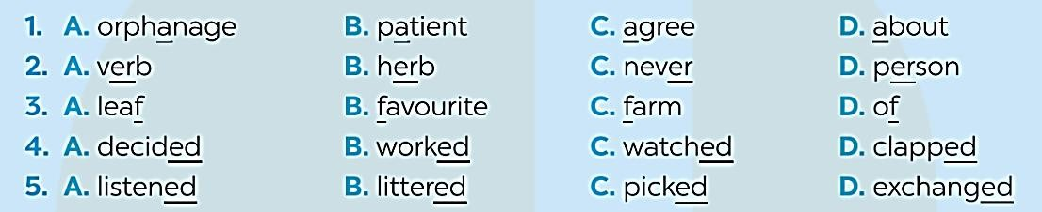
Find the word which has a different sound in the part underlined

Find the word which has a different sound in the part underlined

1. A. photo | B. favour | C. volleyball | D. laugh
2. A. cinema | B. comic | C.cake | D. cool
3. A. guess | B. big | C. sign | D. again
4. A. picture | B. sure | C. nurture | D. nature

5. A. rehearse | B. return | C.first | D. collector
Choose A, B, C, or D for each gap in the following sentences.
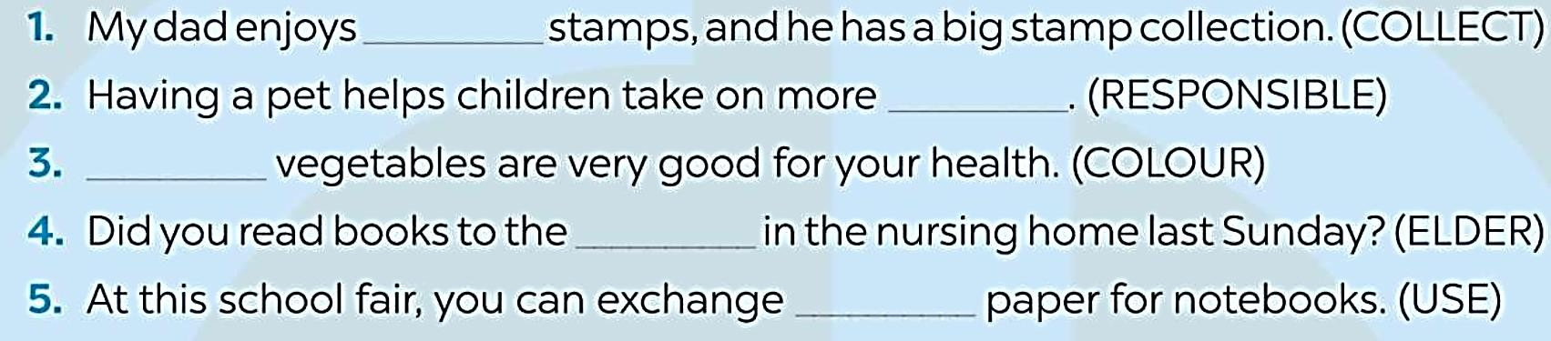
Choose A, B, C, or D for each gap in the following sentences.
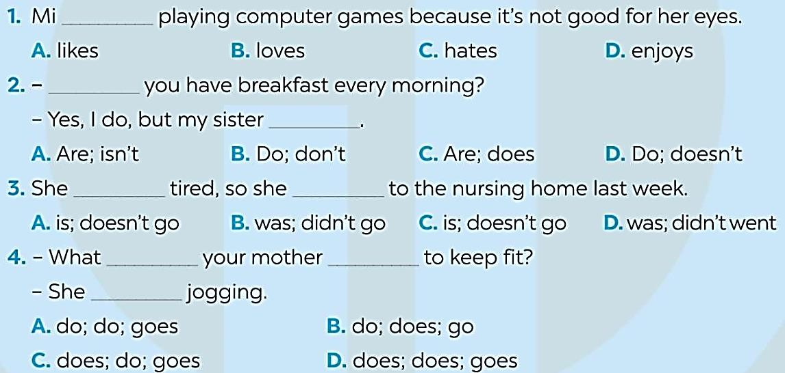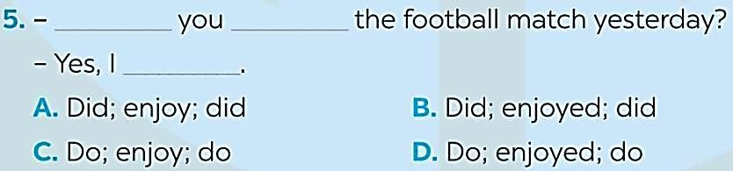
Complete each sentence below by filling each blank with the correct form of the word provided
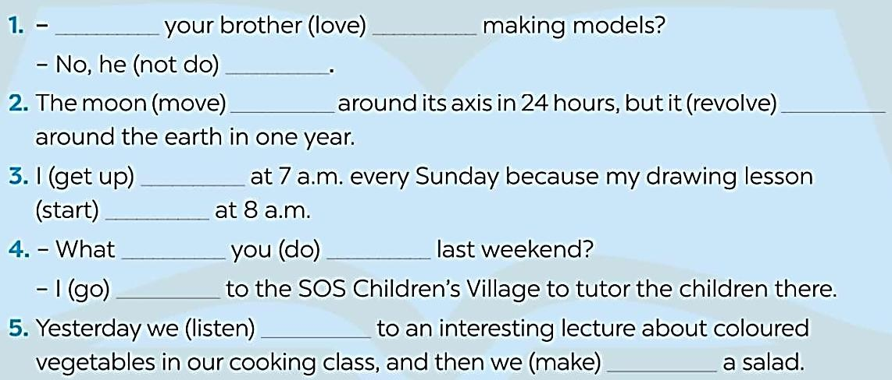
Write full sentences using the suggested words and phrases given
