Unit 10 | SPACE TRAVEL


PART 1: GRAMMAR REVIEW

- SIMPLE PAST (QUÁ KHỨ ĐƠN)
  - Với động từ “to be”:

Form:
(+) S + was/ were + O
(-) S + wasn’t/ weren’t + O (?) Was/ were (not) + S + O?
  - Với động từ “to do”:

Form:
(+) S + Ved + O
(-) S + didn’t + V + O
(?) Did (not) + S + V + O?
  - Uses (Cách sử dụng)
- Diễn tả hành động đã xảy ra và chấm dứt hoàn toàn trong quá khứ.
Ex: - I saw a movie yesterday.
- Last year, I traveled to Japan.
- Diễn tả một chuỗi các hành động liên tiếp xảy ra trong quá khứ.
Ex: - Did you add flour, pour the milk and then add the eggs?
  - Advs (Trạng ngữ nhận biết)
- Yesterday, ago, upon a time, in 1945 (in a specific year in the past....), last...
  - Một số lƣu ý đối với thì quá khứ đơn:
- Quy tắc thêm “ed” với động từ thường:
- Hầu hết động từ được thêm “ed” để biến thành động từ dạng quá khứ
Ex: work – worked, visit – visited
- Một vài động từ kết thúc bằng phụ âm “y” thì biến “y” thành “i” rồi thêm “ed” để biến thành dạng động từ quá khứ.
Ex: study – studied, carry – carried
- Một vài động từ có dạng 1:1:1 (1 phụ âm + 1 nguyên âm + 1 phụ âm) thì ta gấp đôi phụ âm cuối rồi thêm “ed”.
Ex: plan – planned, fit – fitted

- Cách phát âm đối với động từ có đuôi “ed”:
- Đúng nhất: Theo phiên âm quốc tế, khi –ED đứng sau các âm sau sẽ được phát âm như sau:
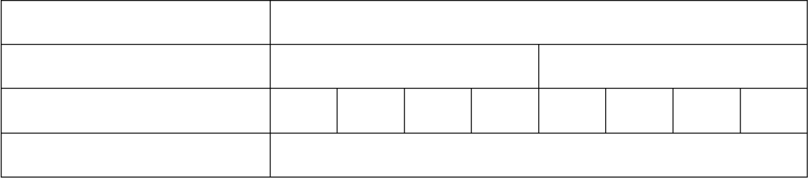
Phát âm của -ED
/id/
/t/
/d/
/t/
/k/
Các âm trƣớc -ED
/d/
/f/
/p/
/ʃ/
/tʃ/
/s/
/t/
θ
Các nguyên âm và phụ âm còn lại
- Mẹo vặt (Không đúng 100%): Theo hình vị tự:

Phát âm của -ED | Các âm trƣớc -ED
/id/  /t/  /d/ | t d  p x ce f ch sh gh  Các nguyên âm và phụ âm còn lại | s | ph | k

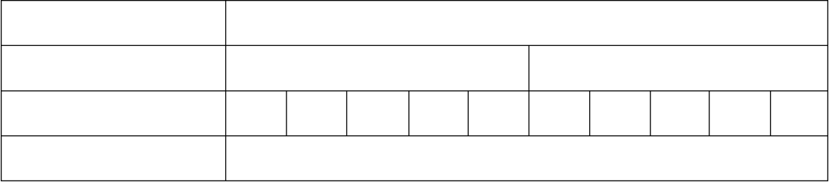
  - Đọc chơi cho dễ nhớ: Pà xã, có fải chú sháu ghé sang Thuận Phước không?
  - Bạn có thể đặt thành câu khác cho riêng mình để dễ nhớ. Ex:
/id/ wanted, needed, demanded, suggested, mended, hated, visited, ...
/t/ walked , liked, stopped, raped, washed, watched, laughed, sentenced, rated, breathed, stated, looked, cooked, sniffed, missed, mixed, ...
/d/ played, studied, changed, matched, decreed, ...
Notes:
- Khi *th phát âm là / θ / thì –ed mới phát âm là / t / như breathed, ...
- Khi *th phát âm là / ð / thì –ed phát âm là / d / như bathed, ...
- Khi *gh phát âm là / f / thì –ed phát âm là / t / như laughed, coughed, ...
- Khi *gh là âm câm thì –ed phát âm là / d / như ploughed, ...
- Nguyên âm + S + ED thì –ed thường được phát âm là / d / như praised, chased, raised,...
- Có một chữ có –ed tận cùng được phát âm là /id/. Chữ đó là hundred /ˈhʌn.drəd/

- PAST PERFECT (QUÁ KHỨ HOÀN THÀNH)
  - Form:
(+) S + had + Vp2/ed + O
(-) S + hadn’t + Vp2/ed + O
(?) Had (not) + S + Vp2/ed + O?
  - Uses (Cách sử dụng)
- Diễn tả một hành động xảy ra trước 1 hành động khác trong QK (hành động xảy ra trước dùng QKHT; hành động xảy ra sau dùng QKĐ)
Ex: I had never seen such a beautiful beach before I went to Kauai.

- Hành động xảy ra trước 1 thời điểm xác định trong quá khứ.
Ex: I had worked as a librarian before 2010. (Trước năm 2010, tôi là một quản thư)
  - Advs (Trạng ngữ nhận biết)
- When, before, after

ĐỊNH LÝ BÙI VĂN VINH

WHEN = AS = AS SOON AS = UNTIL = BY THE TIME

TLĐ/ TLHT/ HTĐ + | WHEN | + HTĐ
QK + | WHEN | + QKĐ
QKĐ/ QKTD + | WHEN | + QKTD
TLĐ/ TLHT/ TLHTTD + | BEFORE | + HTĐ
QKHT + | BEFORE | + QKĐ
 | HTHT | + BEFORE
QKĐ + | AFTER | + QKHT

- DEFINING/ NON-DEFINING RELATIVE CLAUSE (Mệnh đề quan hệ xác định và không xác định)
- Defining relative clause (Mệnh đề quan hệ xác định)
- Đây là mệnh đề cần thiết vì danh từ mà nó bổ nghĩa là không xác định.
- Mệnh đề quan hệ bổ nghĩa cho danh từ trước nó, làm cho người đọc và người nghe được danh từ được đề cập là ai, là cái gì.
- Không có nó câu sẽ không đủ nghĩa.
- Không sử dụng dấu phẩy.
Ex: - The man who lives next door to me is very friendly.
  - The book which I bought yesterday is very interesting.
- Non-defining relative clause (Mệnh đề quan hệ không xác định)
- Đây là mệnh đề không cần thiết vì danh từ mà nó bổ nghĩa đã được xác định cụ thể.
- Không có nó câu vẫn đủ nghĩa.
- Mệnh đề quan hệ không xác định được ngăn cách với mệnh đề chính bằng dấu phẩy.
- Trước danh từ thường có: this, that, these, those, my, his, her... và danh từ riêng.
Ex: - Mr. Thanh, who is from Ha Tinh province, is a friendly English teacher.
  - Ha Noi, which is the capital of Vietnam, is in the north of Vietnam.


PART 2: PRACTICE
  - PHONETICS AND PHONOLOGY
- Choose a word in each line that has different stress pattern.

1. A. commercial | B. surface | C. approach | D. impressive
2. A. descend | B. explore | C. profession | D. altitude
3. A. astronomical | B. emergency | C. experiment | D. collaborate

4. A. simulated | B. trainee | C. missionary | D. spacewalk
5. A. observatory | B. historical | C. activity | D. parabolic

- Find the word which has a different sound in the underlined part.

1. A. astronomy | B. astronomer | C. astrology | D. astronaut
2. A. telescope | B. microgravity | C. cooperate | D. rocket
3. A. mission | B. universe | C. sense | D. space
4. A. meteorite | B. satellite | C. microgravity | D. orbit
5. A. museum | B. miss | C. hopeless | D. guess

  - VOCABULARY AND GRAMMAR
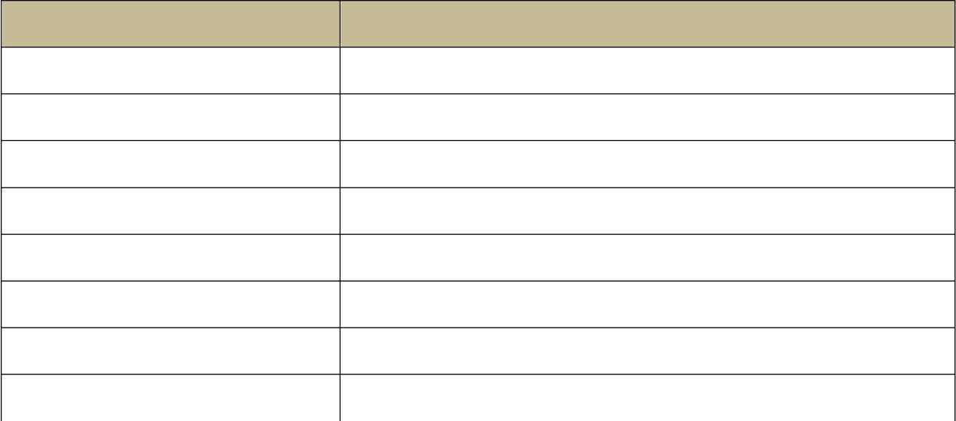
- Match the words/ expressions in column A with their meanings in column B.

1. take off | A |  | B  a. fight, argument
2. a face-off |  |  | b. an agreement
- spaceship  - a deal  - a foothold  - spaceport  - well-to-do |  |  | - a strong position in business  - rich  - becoming known  - a spacecraft that carries people through space  - departure point for space flights
8 emerging |  |  | h. leave the ground and start flying
Your answers:
1. |  | 2. | 3. 4.
5. |  | 6. | 7. 8.


- Put the verbs in brackets into the correct tense.
- In 1543, Nicolaus Copernicus (publish) “On the Revolutions of the Heaven Spheres” claiming that the Earth and the planets (orbit) the Su.
- Galileo (use) the telescope to view the stars and planets before Isaac Newton (invent) the first reflecting telescope.
- In 1686, Isaac Newton (publish) the Mathematical Principles of Natural Philosophy where he (lay) the foundations for universal gravitation and (describe) the motion of the Sun and the planets.
- After Robert Goddard (work) on the rocket technology, he (invent)
and (launch) the first liquid-fueled rocket in 1926.
- On November 3, 1957, the Russian dog Laika (become) the first animal in orbit after fruit flies (be sent) to outer space by the United States.

- In 1983, Sally Ride (become) the first American woman in space after Russian cosmonaut Valentina Tereshkova (be sent) in space twenty years earlier.
- France (launch) its first satellite before Japan (put) its test satellite into orbit.
- In 1971, the United Kingdom successfully (launch) its satellite into orbit after China (do) that one year earlier.

- Do word search
WORD BANK: Earth, Jupiter, Mercury, moons, rings, star, surface, system, telescope, Venus.
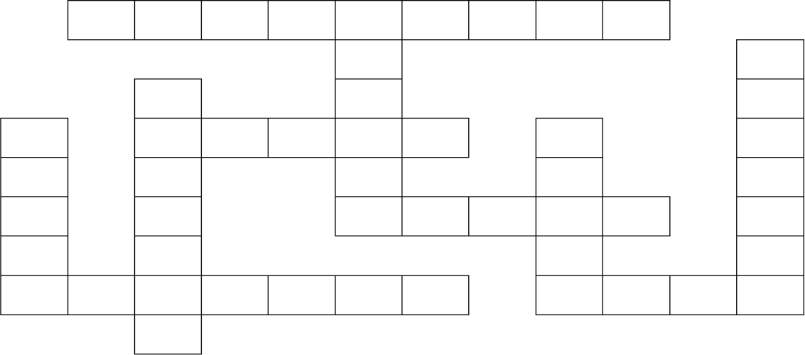
1
2
3
5
4
6
7
8
9
10

ACROSS
1. All nine planets can be seen through a .
6. The planet that we call home.
- A Jupiter has about 69 different ; the biggest one being Ganymede.
- The of Mars is red and rocky.
- The sun is the biggest in our Solar System.

DOWN
- Our Solar has nine known planets.
- The largest planet in our Solar System.
- The closest planet to the Sun.
- In 1610, Galileo discovered that Saturn has many .
7. The second planet from the sun and is known as Earth‟s sister planet.

- The word in brackets at the end of each of the following sentences can be used to form a word that fits suitably in the blank.

  - On the ISS, have to attach themselves so they don‟t float around.
  - It is cheaper to build an unmanned than the one that is manned.
  - In 2015 NASA discovered an Earth-like planet which might be because it has „just the right‟ conditions to support liquid water and possibly even life.

ASTRONOMY SPACE HABITAT

  - One of the largest found on Earth is the Hoba from southwest Africa, which weighs about 54,000 kg.
  - Experiencing microgravity on a flight is part of astronaut training programmes.
  - It takes 365.256 days for Earth to the Sun.
  - Have you ever experienced ?
  - The spacecraft was last week.
  - In 2014 a robot named Philae, part of the Rosetta , successfully landed on a comet.
  - The training often takes place in a water tank laboratory so that trainees become familiar with crew activities in simulated in order to perform spacewalks.

METEORIC PARABOLIZE
ORBITAL WEIGHT LAUNCH MISS

GRAVITY

- Complete the sentences with the words from the box. Use each word once only.

orbit | operate | comet | float | microgravity
launch | mission | astronomy | astronaut | spacesuit
- The mission not only taught NASA about Venus, but also how to a spacecraft far from Earth.
- The tail of a can extend over 84 million miles, nearly the distance between the earth and the sun.
- The of Apollo 11 was to land two men on the lunar surface and return them safely to Earth.
- Sally Ride became the first American woman to fly in space in 1983 when she was 32 years old.
- People in space because there is no gravity to pull them towards anything.
- In , astronauts can move things that weigh hundreds of pounds with just the tips of their fingers.
- The of Apollo 13 was delayed from March 12th to April 11th, 1970 to give the new prime crew more time to train.
- Was Viet Nam‟s first telecom satellite Vinasat-1 put into on April 18th, 2008?
- This was worn by astronaut Neil Armstrong, the first human to set foot on the Moon.
- Quang is interested in . He can spend hours studying the sun, moon, stars and planets.

  - READING
- Choose the word or phrase among A, B, C or D that best fits the blank space in the following passage.
How old (1) you be on Friday 13, 2029? That is how old you will be when a large asteroid, called Apophis, comes very, very close to (2) planet. Asteroids are rocks that circle the sun in space and sometimes (3) close to Earth and even hit it. Most asteroids are very small and, if you are lucky, you can sometimes see (4) in the night

sky as „falling stars‟. However, most scientists (5) ) one large asteroid, about six to twelve kilometers across, hit the earth and killed all the dinosaurs about 65 million years ago. Apophis is also big. Scientists (6) it (7) 2004 and they say that it is about
300 meters across. That‟s about the size of a large sports stadium. An asteroid this size, according to scientists, is (8) ) large enough to destroy our world, but it is large enough to destroy several cities. It will probably miss the earth, they say, but not by very much – it will miss (9) ) by about only 35,000 kilometers – that‟s much closer than our moon which is about 240,000 kilometers away. Another way of thinking about it is that it will
(10) ) us by only a few minutes.

1. A. are | B. will | C. do | D. can
2. A. our | B. us | C. ours | D. we
3. A. came | B. comes | C. coming | D. come
4. A. they | B. their | C. them | D. they‟re
5. A. believe | B. believed | C. believes | D. believing
6. A. discovering | B. discovered | C. discover | D. discovers
7. A. on | B. at | C. in | D. to
8. A. no | B. don‟t | C. isn‟t | D. not
9. A. we | B. us | C. our | D. ours
10. A. missed | B. misses | C. missing | D. miss

- Read the text. Use the information in the story to answer the questions below by choosing the best answer A, B, C or D.
COMETS
Andy heard from his friends that a comet was coming. He knew that a comet was a space rock. Space rocks seemed exciting. He wanted to watch it at night. All he had to do was go outside and watch. That was easy enough.
That night, he put on a jacket and went outside. He looked around. He saw the moon, but he did not see anything else. There were only a couple clouds, so that was not the problem. He could see some stars, but nothing new or special. Where was the comet?
He called his friend on the phone. They talked about it. His friend told him where to look, but he still didn‟t see it. What was going on? Was he not special enough to see it? Were his eyes going bad? What was he doing wrong?
Andy went to get his dad. Together, they looked up in the sky where it was supposed to be. Finally, after several minutes of looking, he saw a fuzzy thing, brighter and bigger than a star, but nowhere near what he expected.
“I thought it‟d be like an extra moon or something.” Andy complained.
“It‟s not big enough for that, and it still might be very far away.” Dad explained. “I still wish I could see it better.”
Dad nodded and went inside. When he came back out, he had a telescope. Together, they focused in and saw the comet a little better. It wasn‟t much, but it helped.
“What else can we see?” Andy wondered.
Dad smiled and aimed the telescope over at the moon instead. That was cool. Seeing the craters and the details of the moon up closer was nice.
Astronomy was interesting. Andy made sure to read more about it at school!

- What was Andy excited to see in the sky?
  - rainbows B. clouds C. the moon D. a comet
- What problem did Andy have when he tries to look at the comet?
  - There were too many and he couldn‟t find the right one.
  - He couldn‟t see it.
  - It was too bright to see anything.
  - The sky was very cloudy.
- When he couldn‟t find the comet, what did Andy do first?
  - Called a friend B. Asked dad for help
C. Got a telescope D. Checked the Internet
- When he still couldn‟t find the comet, what did Andy do next?
  - Called a friend B. Asked dad for help
C. Got a telescope D. Checked the Internet
- When he was disappointed by the comet, what did Andy‟s father show Andy?
  - constellations B. a planet C. the moon D. a comet

- Read the text and do the task below.
SATURN
Saturn is the second-largest planet and is a gas giant like Jupiter. Under clouds of methane, hydrogen, and helium, the sky slowly turns into a giant ocean of liquid chemicals. Saturn is the least dense planet in our solar system; it is made mostly of hydrogen and helium. Because it is so lightweight and spins so quickly, Saturn is not perfectly round like the other planets. Saturn is surrounded by thousands of small rings made of rocks and ice. It also has 140 natural satellites, like moons and pieces of debris.
  - Answer the following questions:
- How is Saturn similar to Jupiter?

- What are the clouds made of?

- Describe the surface of Saturn.

- Why is Saturn not perfectly round?

- Describe some of the things surrounding Saturn.

- Read the text and answer the following questions.
The Earth was formed about 4.7 billion years ago. The Earth‟s shape is very close to that of a sphere, not perfectly spherical. The Earth‟s equatorial diameter is about 12,756 km, which is slightly larger than the polar diameter; about 12,714 km Surface Area of the Earth is 510,065,600 km² of which 148,939,100 km² (29.2%) is land and 361,126,400 km² (70.8 %) is water.

The Earth rotates on its axis, an imaginary straight line through its centre. The two points where the axis of rotation intersects the Earth‟s surface are called as the poles, one of them is called the North Pole and the other is known as the South Pole. One rotation with respect to Sun is completed in 24 hours, called a solar day.
- When was the Earth created?

- How is the Earth?

- What main elements does the Earth include?

- What are the places of the axis of rotation intersects the Earth‟s surface called?

- How long is a solar day completed?

D. WRITING
- Finish each of the following sentences in such a way that it is as similar as possible in meaning to the original sentences. Use the word given and other words as necessary.
- The class watched a film yesterday. The film was about the Apollo 13 space mission.
➔ The film
- We are meeting an astronomer tonight. This astronomer has discovered three Earth-like planets.
➔ The astronomer
- We read about an astronaut. The astronaut travelled into space in 1961.
➔ We read about
- Dennis Tito became the first space tourist in 2001. Anousheh Ansari travelled into space as a tourist in 2006.
➔ When Anousheh Ansari
- This is the man. He works for NASA.
➔ The is the
- I‟m reading an article. The article is about NASA‟s plans to return humans to the moon.
➔ I‟m reading

- Rewriting the following sentences using a relative pronoun.
  - This is the astronaut. He visited our school last week.
=>

  - This is the village. Helen Sharman, the first British astronaut, was born there.
=>

  - Can you talk more about the parabolic flights. You took them for your training?
=>

  - This is the museum. It has some of the best rock collections in the country.
=>
  - We‟ll explore inland Sweden and visit the summer house. Carin and Ola have built it themselves.
=>
  - This is the year. The first human walked on the moon on that day.
=>

- Write complete sentences, using the words/ phrases given in their correct forms. You can add some more necessary words, but you have to use all the words given.
- Pham Tuan/ Viet Nam‟s/ astronaut, and Christer Fuglesang/ Sweden‟s first astronaut.
=>
- He found/ Earth didn‟t look/ big as he thought, no boundaries/ Earth could be seen from/ we should cooperate/ take care of it.
=>
- It seemed/ he/ not enjoy it much/ since/ wasn‟t fresh.
=>
- They talked/ him when he/ in space/ that made him happy.
=>
- They think/ the chance/ fly to space/ equal for everyone.
=>
- He/ think teamwork, social skills/ foreign languages/ important/ an astronaut.
=>


PART 3: TEST YOURSELF
  - Choose a word in each line that has different stress pattern.

1. A. commercial | B. galaxy | C. spacecraft | D. telescope
2. A. astronomy | B. immune | C. astronomer | D. parabolic
3. A. object | B. experiment | C. private | D. habitable
4. A. maintenance | B. satellite | C. meteorite | D. adventure
5. A. universe | B. satellite | C. experience | D. meteorite

  - Fill in future continuous or future perfect to complete the sentences below.
- This time tomorrow morning Captain Neil Armstrong and his crew (leave) earth and (head) for the planet Mars.
- On the first day of their voyage, they (orbit) the earth every 20 seconds.
- Crew members Yuri Gagarin and Sally Ride (check) all the instrument all day long to make sure they are working properly. They (not/take) it easy.
- By the end of the year 2044 they (arrive) on the planet Mars. They
(go) 100 million light years and yet they (not/age) even one year. Miraculous!

- What (do/they) about as they zip through space? Will they be frightened? I doubt it. They will be too busy.
- The captain says that by the end of the first week, they (discover) many interesting things about space and alien beings.
- By the end of the first month aboard the spaceship, the Martian Explorer, the crew
(get used to) living without gravity and to eating their food out of tubes. On a normal day they (float) around the cabin.
- Scientists claim that within the next 50 years, they (find out) whether life on Mars exists or not and they (meet) those little green men, Martians.
- In the meantime, let us wish good luck to Captain Armstrong and his crew. They
(explore) the outer reaches of the universe.
- By 2044 (they/expand) our knowledge of new frontiers and deep space.

  - Choose the best one (A, B, C or D) to complete the sentence.
    - Experiencing microgravity on a flight is a part of astronaut training programmes.
      - orbit B. ship C. mission D. parabolic
    - As soon as the spacecraft into space, the crew started to observe the sun.
      - has travelled B. had travelled C. travelled D. was travelling
    - Europe‟s biggest ISS project is the Columbus science laboratory astronauts can carry out scientific experiments in weightless conditions.
      - there B. which C. where D. when
    - A is an enormous system of stars in outer space.
      - comet B. galaxy C. universe D. solar system
    - In July of 1975, the first US-Soviet joint occurred with the Apollo-Soyuz project.
      - company B. relation C. mission D. performance
    - The Astronauts Memorial Foundation honours all American astronauts have lost their lives on missions or in training.
      - whom B. X C. which D. who
    - He‟s so brilliant and he can do anything - .
      - out of this world B. the sky‟s the limit
C. it‟s over the moon D. once in a blue
    - I down to earth on my first Monday back to school after my holiday in Nha Trang.
      - come over B. come back C. come in D. come on
    - Yuri Gagarin made the first space flight success attracted worldwide attention.
      - which B. when C. whose D. where
    - Aircraft flying in arcs create microgravity for tests and simulations that last 20-25 seconds.
      - straight B. oval C. circular D. parabolic
    - The launch of the Space Shuttle Endeavour broadcast live this morning.
      - hats been B. was being C. was D. had been

    - Dan: Do you like to drink tea? Ben: I love coffee, but I only drink tea in a blue moon.
      - one B. once C. first D. only
    - To walk on the moon, the astronauts had to carry a suitcase contained oxygen.
      - which B. it C. having D. where
    - Yuri Gagarin became the first person to eat and drink in .
      - weightless B. gravity C. specific gravity D. microgravity
    - I passed all my exam – I'm !
      - out of this world B. the sky‟s the limit
C. over the moon D. once in a blue moon
    - The mission they are talking about plans to send humans to Mars by2030.
      - where B. X C. who D. when
    - “That‟s the coolest thing I‟ve ever seen. It‟s really this world.”
      - into B. out of C. over D. on
    - In 2010, Naoko Yamazaki, the second female Japanese astronaut, on Discovery space shuttle to the ISS alter she her training at the Johnson Space Center.
      - had flown – completed B. flew – had completed
C. flew – was completing D. was flying – was completing
    - Do you want to meet my colleague son is training to be an astronaut?
      - that B. whom C. whose D. X
    - For people work hard at this company, the sky‟s the limit.
      - which B. who C. whom D. X
    - Vinasat-1 is Viet Nam‟s first telecommunication , which was launched in 2008.
      - spacesuit B. astronomy C. microgravity D. satellite
    - The first was done by Alexei Leonov, a Russia cosmonaut on March 18th, 1965. It was 10 minutes long.
      - spaceward B. spacesuit C. spacewalk D. spaceship
    - Pham Tuan said everything quite strange although he when he was on the ground.
      - was – had prepared B. had been – prepared
C. was – prepared D. was – has prepared
    - At night the ISS can easily be seen from the Earth, as it flies at the of 320 kilometres above us.
      - attitude B. height C. level D. altitude
    - She‟s very intelligent and knowledgeable. She can everything under the sun.
      - talk to B. talk about C. talk with D. talk of
    - The Milky Way is just a in the universe and it contains our Solar System.
      - galaxy B. planet C. comet D. meteorite
    - Virgin Galactic is the world‟s first commercial .
      - spaceship B. exploration C. space D. spaceline

    - If you the stars, all of your dreams will come true!
      - reach at B. reach for C. reach in D. reach for
    - Christer Fuglesang said he enjoyed floating around in the environment.
      - weightless B. quiet C. homesick D. heavy
    - Mukai Chiaki, the first female Japanese astronaut, 15 days aboard the space shuttle Columbia in space before it to the Earth on July 23, 1994.
      - was spending – was returning B. spent – was returning
C. spent – had returned D. had spent – returned

  - Fill in the blank with a suitable word in the box.

fuel | another | means | carry | demand/ need
possible | because | many | on | that/ which
Space exploration is the investigation of the universe beyond the Earth‟s atmosphere, by (1)
of manned and unmanned spacecraft. Despite the technological advancements achieved in the past, space exploration was only (2) until the 20th century. The first successful orbital launch was made by the Soviet Union in 1957 which was called “Sputnik”. When the topic “SPACE EXPLORATION” is put (3) the table, a question has often been asked: “Why should we spend money on NASA while there are so (4)
problems here on Earth?” However, this might be partially wrong since exploring the unknown may help us progress.
The advantages of space exploration include the materials (5) can be obtained from outer space. For instance, asteroids have iron and nickel which could be utilized to satisfy the (6) for metal. Therefore, numerous commercial companies have invested in developing technology for asteroid mining. Several comets and asteroids (7) solid water in them. This water can be used for astronauts and scientists in space stations. The water can also be broken down to hydrogen which can be used as (8) for the rockets. Scientists also believe that dinosaurs disappeared because they couldn‟t go to (9) planet. Sooner or later a killer comet will again cross Earth‟s path, threatening all life. Fortunately, (10)
we have knowledge about comets and space science, we will be able to survive.

  - Read the following passage and choose the best option for each numbered blank.
Neil Armstrong was the first person (1) on the moon. He was born in Ohio on August 5, 1930. While he was in college, he left to serve in the U.S. Navy. He flew planes during the Korean War. Then he came back to college and finished the degree he (2) . He later (3) a master‟s degree too.
Armstrong became an astronaut in 1962. He was the commander of Gemini 8 in 1966. Neil Armstrong (4) the first successful connection of two vehicles in space.
Armstrong‟s second flight was Apollo 11 in 1969, and he was the mission commander. He flew with Buzz Aldrin and Michael Collins. Armstrong and Aldrin landed on the moon in a lunar module named “Eagle”. With more than half a billion people (5) on television, Armstrong (6) the ladder and said, “That‟s one small step for a man, one giant leap for mankind.” and Aldrin (7) him shortly. They explored the surface for two and a half hours, collecting samples and taking photographs.

They left behind an American flag, and a plaque reading, “Here men from the planet Earth first (8) upon the moon. July 1969 A. D. We came in (9) for all mankind.”
After almost a day, they blasted off. They docked with Collins in (10) around the moon. All three then flew back to the Earth.

1. A. to walk | B. walked | C. walk | D. walking
2. A. had started | B. starts | C. started | D. would start
3. A. earned | B. scored | C. took | D. make
4. A. operated | B. functioned | C. carried | D. performed
5. A. to watch | B. watching | C. watch | D. watched
6. A. descended | B. stepped | C. lowered | D. climbed down
7. A. joined in | B. involved | C. joined | D. connected
8. A. set foot | B. set feet | C. went | D set a foot
9. A. silence | B. peace | C. freedom | D. communication
10. A. height | B. distance | C. space | D. orbit

  - Read the passage, and choose the correct answer A, B, C or D for each question.
A MISSION TO MARS
Have you ever had a dream about traveling to another planet in our solar system? If you have, there is an actual programme that is happening right now, and it hopes to send people to Mars in 2023. Known as the Mars One Mission, it will send a crew of four people on a one-way mission to colonize Mars. Those chosen people will have to be ready to say good-bye to the earth forever, as there will not be a return trip.
For the people chosen, they will have to learn to do many different things. First of all, they will be living the rest of their lives with just a handful of other people, so they all must have personalities that allow them to get along. Second, the living quarters that they will have won‟t be very spacious, so they will have to deal with that condition as well. If they feel homesick, they will only be able to communicate with people back on the earth via e-mail and videos and audio sent back and forth. However, there won‟t be any real-time communication. Even at the speed of light, communication between the earth and Mars takes about 20 minutes.
Whether the Mars One Mission will actually happen is the big question that a lot of people are asking. There is an enormous skepticism in the science community, and Wired magazine gave the mission a miserable score of two out of ten on its probability scale. However, for those who dream to go to Mars, at least they can say there is a possibility that it could happen.
    - Who might like to go on this mission?
      - People who get along with others
      - People who get homesick easily
      - People with angry personalities
      - People who don't like to communicate
    - What will NOT happen to the people who go on the Mars One Mission?
      - They will communicate with people on the earth.
      - They will have to live with other people.
      - They will live in quarters that don‟t have a lot of space inside.
      - They will return to do the earth.

    - What will NOT be spacious?
      - The spaceship B. The magazines
C. The mission D. The living quarters
    - Which of the following is considered miserable?
      - A crew on board of the Mars One Mission.
      - A score of the programme on the probability scale.
      - A personality of people taking part in the programme.
      - A mission of astronauts to the ISS.
    - How long will it take for a message to come back from Mars?
      - Around 20 minutes B. Only a few seconds
C. Almost immediately D. About an hour

  - Complete each of the following sentences using relatives or not relatives.
- The student was selected to join the space program is my brother‟s friend.
- They showed me the place the spaceship landed last week.
- David introduced me to the woman husband is working for NASA.
- The astronomer you want to meet is going to present a paper at the conference next Friday.
- The twenty-ninth of May is the day our astronauts will be returning home.
- The man with Mr. Khoa is talking has flown into space three times.
- The satellite was launched into space yesterday belongs to Viet Nam.
- The space age began in 1957 the Soviet Union launched Sputnik 1, the world‟s first man-made satellite.
- An astronaut is a person travels in a spacecraft into outer space.
- The book I‟m reading is about the history of space exploration.

  - Underline the one mistake in each sentence and then correct it.

No.
1.
2.

3.
4.
5.

6.
7.

8.
Sentences
Venus is the second planet of the sun.
Unlike most of the other planets in the solar system, Venus have no moons.
This is because they are similar into size, gravity and density. Venus is also very different in the Earth.
These clouds trap the sun‟s heat, make Venus the hottest planet in the solar system.
Venus has sometimes called the “Morning star” or the “Evening star”.
The atmosphere of Venus is mostly made up by carbon dioxide with clouds of sulphuric acid.
In Greek mythology, Venus is known as Aphrodite, the goddess of love
and beautiful.
Correction

  - Complete the second sentence in each pair so that it has similar meaning to the first sentence.
- The team plays on the left. The team has never won the championship.
=> The team

- Neil Armstrong and Buzz Aldrin planted an American flag on the moon. They spoke to President Richard Nixon after that.
=> Before Neil Armstrong and Buzz Aldrin

- This article describes a ground-breaking space mission to land on a comet. The mission is called Rosetta.
=> The ground-breaking space mission

- Last week they visited a museum. The first artificial satellite is on display there.
=> Last week they

- The Rosetta mission has a task. The task is comparable to a fly trying to land on a speeding bullet.
=> The task

  - Write complete sentences, using the words/ phrases given in their correct forms. You can add some more necessary words, but you have to use all the words given.
- Nhat Nam/ crazy / space.
=>

- He/ learnt about the universe/ had collected/ of books about space.
=>

- To show that there/ more things/ the list but that it‟s not necessary/ list everything.
=>

- He/ be not/ impressed/ because/ he thought the meteorite/ like an ordinary piece of rock.
=>

- He/ compare it/ a ride/ a rollercoaster.
=>

ĐÁP ÁN

PHONETICS AND PHONOLOGY
I. 1. B 2. D 3. A 4. B 5. D
II. 1. D 2. D 3. A 4. D 5. A

VOCABULARY AND GRAMMAR
I. 1. h 2. a 3. f 4. b
5. c 6. g 7. d 8. e
- 1. published – orbited 2. had used – invented
3. published – laid – described 4. had worked – invented – launched
5. became – had been sent 6. became – had been sent
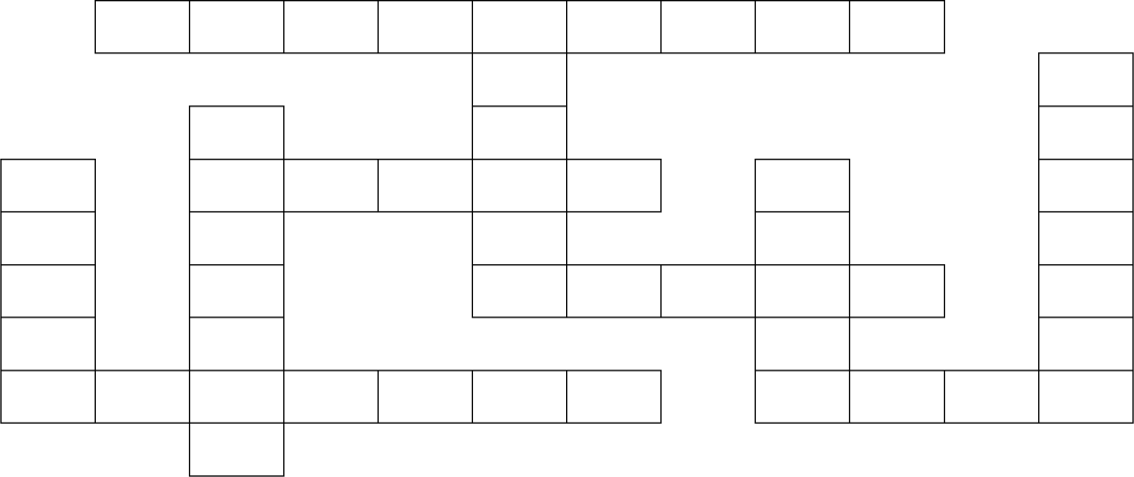
7. had launched – put 8. launched – had done

III.
 | 1. T | E | L | E | 2. S | C | O | P | E
 |  |  |  |  | Y |  |  |  |  |  | 3. J
 |  | 4. M |  |  | S |  |  |  |  |  | U
5. R |  | 6. E | A | R | T | H |  | 7. V |  |  | P
I |  | R |  |  | E |  |  | E |  |  | I
N |  | C |  |  | 8. M | O | O | N | S |  | T
G |  | U |  |  |  |  |  | U |  |  | E
9. S | U | R  Y | F | A | C | E |  | 10. S | T | A | R

IV. 1. astronauts | 2. spacecraft | 3. habitable | 4. meteorites
5. parabolic | 6. orbit | 7. weightlessness | 8. launched
9. mission | 10. microgravity
V. 1. operate | 2. comet | 3. mission | 4. astronaut
5. float | 6. microgravity | 7. launch | 8. orbit
9. spacesuit | 10. astronomy

READING
I. 1. B 2. A 3. D 4. C 5. A
6. B 7. C 8. D 9. B 10. D
II. 1. D 2. B 3. A 4. B 5. C

- 1. It is a gas giant like Jupiter.
- Clouds are made of methane, hydrogen, and helium.
- Saturn is the least dense planet in our solar system and is made mostly of hydrogen and helium.
- Because it is so lightweight and spins so quickly.
- Saturn is surrounded by thousands of small rings made of rocks and rice.
- 1. It was created about 4.7 billion years ago.
- Its shape is very close to that of a sphere, not perfectly spherical.
- They are land and water.
- They are the North Pole and the South Pole.
- It‟s in 24 hours.

WRITING
- 1. The film (which / that) the class watched yesterday was about the Apollo 13 space mission.
- The astronomer (who / whom / that) we are meeting tonight has discovered three Earth-like planets.
- We read about an astronaut who travelled into space in 1961.
- When Anousheh Ansari travelled into space as a tourist in 2006, Dennis Tito had become the first space tourist in 2001.
- This is the man who works for NASA.
- I‟m reading an article which is about NASA‟s plans to return humans to the moon.
- 1. This is the astronaut who visited our school last week.
- This is the village where Helen Sharman, the first British astronaut, was born.
- Can you talk more about the parabolic flights which / that you took for your training?
- This is the museum which / that has some of the best rock collections in the country.
- We‟ll explore inland Sweden and visit the summer house which / that Carin and Ola have built themselves.
- This is the year when the first human walked on the moon.
- 1. Pham Tuan is Viet Nam‟s first astronaut, and Christer Fuglesang is Sweden‟s first astronaut.
- He found that Earth didn‟t look as big as he thought, no boundaries on Earth could be seen from space we should cooperate to take care of it.
- It seemed he didn‟t enjoy it much since it wasn‟t fresh.
- They talked to him when he was in space and that made him happy.
- They think the chance to fly to space is equal for everyone.
- He thinks teamwork, social skills, and foreign languages are important for an astronaut.

TEST YOURSELF

I. | 1. A | 2. D | 3. B | 4. D | 5. C
II. | 1. will | be leaving - will be heading
 | 2. they | will be orbiting

- will be checking - will not be taking
- will have arrived - will have gone - won‟t have aged
- will they be doing
- will have discovered
- will have got used to - they will be floating
- will have found out - will have met
- will be exploring
- they will have expanded

III. 1. D | 2. B | 3. C | 4. B | 5. C
6. D | 7. B | 8. B | 9. C | 10. D
11. C | 12. B | 13. A | 14. D | 15. C
16. B | 17. B | 18. B | 19. C | 20. B
21. D | 22. C | 23. A | 24. D | 25. B
26. A | 27. D | 28. B | 29. A | 30. D
IV. 1. means | 2. possible | 3. on | 4. many
5. that / which | 6. demand / need | 7.carry | 8. fuel
9. another | 10. because
V. 1. A | 2. A | 3. A | 4. D | 5. B
6. D | 7. C | 8. A | 9. B | 10. D
VI. 1. A | 2. D | 3. D | 4. B | 5. A
VII. 1. who | 2. where | 3. whose | 4. whom | 5. when
6. whom | 7. that | 8. when | 9. that | 10. which
VIII. 1. of => from |  | 2. have => has
3. into => to |  | 4. in => from
5. make => making 6. has => is
7. by => of 8. beautiful => beauty
- 1. The team who / that plays on the left has never won the championship.
- Before Neil Armstrong and Buzz Aldrin spoke to President Richard Nixon, they had planted an American flag on the moon.
- The ground-breaking space mission (which / that) this article describes is called Rosetta.
- Last week they visited a museum where the first artificial satellite is on display.
- The task (which / that) the Rosetta mission has is comparable to a fly trying to land on a speeding bullet.
- 1. Nhat Nam was crazy about space.
- He had learnt about the universe and had collected lots of books about space.
- To show that there are more things in the list but that it‟s not necessary to list everything.
- He wasn‟t very impressed because he thought the meteorite was like an ordinary piece of rock.
5. He compares it to a ride on a rollercoaster.

