UNIT 3 TEEN STRESS AND PRESSURE

- PHONETICS

Look at the verb form of be in bold in each pair of sentences. Tick (✓) Stressed or Unstressed.

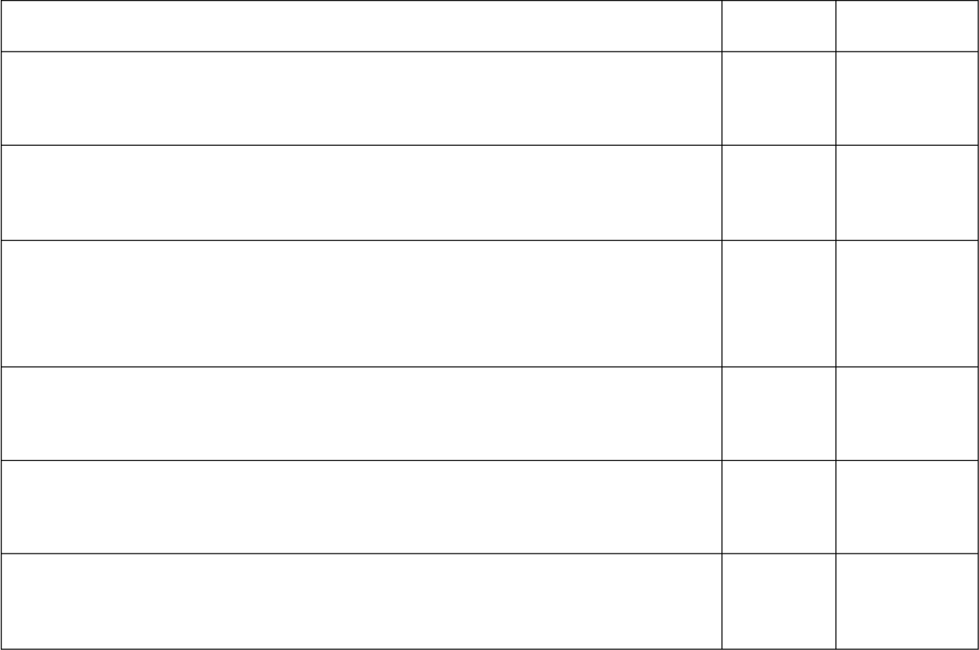
Stressed Unstressed
  - - Isn’t too late to say sorry?
    - No, it isn’t.
  - - Was he busy with his schoolwork?
    - Yes, he was.
  - - Isn’t fried chicken your favorite food?
    - Yes, fried chicken is my favorite food, but it can make me fatter and fatter.
  - - Is it your mobile phone?
    - Yes, it is my mobile phone.
  - - Do you think they are on the way here?
    - They are on the way. Don‟t worry.
  - - You aren’t working this weekend?
    - I am, but I can‟t spend some time meeting you.

Place a mark over the verb form of be that should be stressed in the following sentences.
  - She is interested in Korean films but her husband isn‟t.
  - A: Are you reading this book? B: Yes, I am.
  - A: Isn‟t it the best way to release stress? B: Yes, it is.
  - A: Do you think he is a great actor? B: He is. But he‟s quite reserved.
  - A: Is she confident that she will get the job?
B: Yes, she is. She has prepared for the interview very well.
  - A: Will Hoa visit you this summer? B: Yes, she will fly here on her own. A: But she is too young!
B: She is. But she can take care of herself.

- VOCABULARY AND GRAMMAR

Complete the sentences with the words from the box. There are two words that you do not need to use.

confident | grateful | frustrated | tense | delighted
calm | worried | appreciated | depressed | relaxed

- He gets when people don‟t understand what he‟s trying to say.
- I‟m not about her - she can take care of herself.
- She was very as she waited for the interview.
- The teacher wants the children to feel about asking questions when they don‟t understand.
- Anna got 10 marks for her English test. She felt absolutely about that result.
- She‟s terribly about losing her job.
- He told himself to stay whenever he was put into a harsh situation.
- As soon as I had made the final decision, I felt a lot more .

Match the beginnings to the correct endings.

A B

  - It might be a good idea to resolve
  - Have you ever thought about breaking

  - If I were you, I would try to overcome

  - I don‟t think you should take
  - If I were you, I would ask

  - Have you ever thought of developing

  - You should manage

  - It might help to give students advice so they can make more

Put the skills in their category.
- a big risk by going skiing.
- for support from friends when I am under pressure.
- your budget to have enough money for the things you need.
- serious conflicts between neighbors.
- a healthy habit of doing exercises regularly?
- informed decisions about their
occupational goals.
- stress by maintaining a healthy lifestyle and staying healthy.
- the habit of staying up late for better concentration?

stay calm with others, feel sympathy for others, follow directions or rules, cope with loneliness, comprehend reading materials, determine the problems you’re facing, listen to others, go to sleep early, clean your room, fix the light bulb, ask for help, take out the trash, be grateful, determine the symptom of common diseases, use appropriate words in certain circumstances, drink enough water
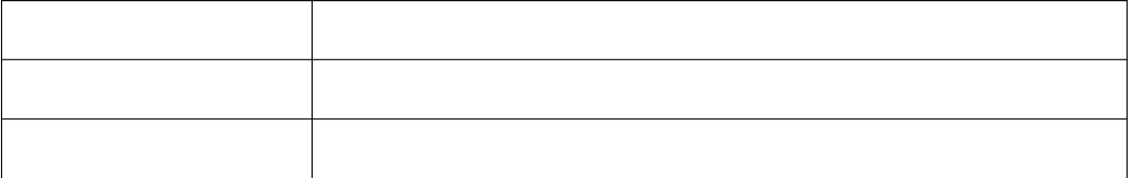
Social skills Cognitive skills
Housekeeping skills

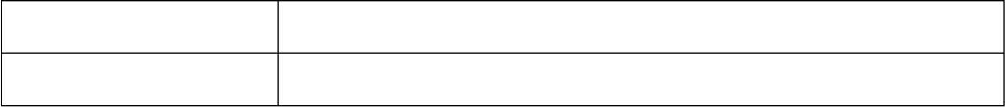
Emotion control skills
Self-care skills

Turn the following sentences into reported speech.
  - “Our daughter wants to study abroad for a year,” they said.

  - “Have you ever experienced school pressures?” she asked me.

  - “Yesterday I couldn‟t watch my favourite cartoon on Disney Channel,” he said.

  - “Is the weather good in Shanghai in the summer?” Jane asked me.

  - “What are the skills that you find the most difficult to learn?” she asked me.

  - “Would you bring me a cup of coffee, please?” she told me.

  - “I‟ll come and help you on Saturday,” Joana told me.

  - “When will you come back home?” my mom asked me.

  - “Do you need any help on this assignment?” the teacher asked me.

  - “My friend got engaged to a German last month,” Danny told Ann.

Complete the sentences with correct tense of verbs.
  - The interviewer asked me what I (can) do if I were offered the job.
  - Mandy asked me if the boys (read) the book at present.
  - The manager told me that I (travel) from place to place the following month.
  - They said they (never/ be) to Scotland until last year.
  - Jason and Victoria told me they (do) their best in the exams the following day.
  - I wondered why Nick (not go) to New York the summer before.
  - John told me that there (may) not be dessert after dinner.
  - She asked me if everyone (must) contact the Magic Number in emergency situations.
  - My mom said she (be) going to visit a friend of hers in London.
  - Shannon said that she (need) to take care of her baby.

Complete the sentences with suitable question words.
  - He doesn‟t know to ask for advice about this situation.
  - Be sure to eat when you arrive in Vietnam.
  - They are going to tell me to do to survive in a storm.
  - I asked Jane to show me to deal with bullying at school.
  - He wondered to start revising for the final exam.
  - The rules didn‟t specify to speak to in case of an emergency.
  - You need to find out to overcome stress and worry.
  - I don‟t know to turn for help.
  - I had no idea to write my home paper about.
  - Tell me to press the button.

Rewrite the following sentences using question words before to-infinitives.
  - I don‟t know where I should visit this summer vacation.

  - Could you tell me who I should ask for advice?

  - She wondered what she should write in the final essay.

  - I have no idea who I should contact in case of emergency.

  - They can‟t decide when they leave for America.

  - I‟m not sure what I should cook for my son‟s birthday party.

  - Could you tell me where I should put my umbrella?

  - He asked himself what he should send her as a present.

  - I have no idea when I should leave for Japan.

  - She wondered how she should resolve the conflict.

Rewrite the following questions in reported speech, using question words before to-infinitives.
- “What should we do to help her overcome stress?”
They didn‟t know
- “Should I discuss this matter with my teammates?”
Jonas wondered

- “Where should I register for a course on life skills?”
An asked Mary
- “How should we find a support center for the homeless?”
James and Lily couldn‟t tell
- “When should we start our campaign?”
They had no idea
- “Mom, who should I call upon arriving at the airport?”
Trang asked her mother
- “Should I dial 18001567 to ask for advice about family problems?"
Phong was not sure
- “What should we do to help those disadvantaged children?”
They wondered
- “When should I start teaching my children to cook?”
She couldn‟t decide
- “How should I deal with negative emotions and stress?”
Hoa asked Nam

Fill in each blank with a suitable preposition.
  - He felt that they were making fun him, though he could not understand why.
  - He wasn‟t able to cope the stresses and strains of the job.
  - We have to improve and increase mass participation sports.
  - This goes beyond the boundaries what is accepted.
  - My parents never put any pressure me to get a job.
  - You can dial 114 in case of fire dealing area codes.
  - She gave up German in order to concentrate her French.
  - Parents need to continue to empathize the child.
- SPEAKING

Complete the conversation with the sentences from the box. Write the letters of the sentences.
- Are you worried about the upcoming exam?
- Well, have you thought of solving this problem?
- So, what makes you stressed out?
- It will. After starting the conversation, remember to apologize her for the argument and present your ideas once more time with calmness if you want.
- What‟s wrong with you?
E. Seriously?
G. If I were you, I would smile at her, then choose a common topic to talk about.

Mom: (1) Hoa: I‟m not sure but I think I am stressed.
Mom: (2) Hoa: No, I‟m not. I have prepared for it, so I can tackle it easily.
Mom: (3) Hoa: Well, I argued with my best friend yesterday.
Mom: (4) Hoa: Yes. We discussed how to set up a camp for our group and we couldn‟t agree on any plans. Mom: (5) Hoa: Yes, I have. However, I don‟t know how to start a conversation with her.
Mom: (6) Hoa: Will it work?
Mom: (7) Hoa: Oh, great! Thank you, mom! I will try.

Put the dialogue into the correct order.
United States I think, but I‟m so worried about myself.
1 I‟m planning to study abroad next year.
What are you worried about?
Oh dear. It may cause you a lot of problems then. I think you should prepare for your trip from now.
I mean, I don‟t know how to cook, study by myself or manage my budget.
What should I do?
What else can I do?
Cool! Which country will you set foot on?
What do you mean?
I think you should share your thoughts with your parents when you are tense. They can give you some useful advice.
Right. Thank you very much!
I don‟t think I have enough skills to live far away from my family.
You can register for a soft skill course at the Youth Cultural House , KDI or Vietskills, etc.
After that, try to practice as much as possible.
- READING

Complete the passage with words from the box.
conflict refers less most through ambitions with studying
The term “Life Skills” (1) to the skills you need to make the most out of life. Life skills are usually associated with managing and living a better quality of life. They help us to accomplish our (2) and live to our full potential. Any skill that is useful in your life can be considered a life skill. Different life skills will be more or (3) relevant at different times in your life, for example:

  - When at school or university, you‟ll need (4) skills.
  - When you have a job, leadership and presentation skills may be useful, along with a whole host of other skills.
  - There will be times throughout your life when you‟ll need (5) resolution, stress management and problem solving skills too.
However, perhaps the (6) important life skill is the ability and willingness to learn. By learning new skills we increase our understanding of the world around us and equip ourselves with the tools we need to live a more productive and fulfilling life, finding ways to cope (7) the challenges that life, inevitably, throws at us. Life skills are not always taught directly but often learned indirectly (8) experience and practice.

Read the text carefully. Then do the tasks.
Stress isn‟t just a problem for adults. Young people, however, are also suffering from stress with different causes. Below are some factors that contribute to those youngsters‟ unhealthy levels of stress.

School Pressure
Teenagers often feel stressed about academic and extracurricular demands. Students feel pressure to complete daily homework, finish projects and study for exams. In addition to the quest for good grades, teens may also participate in extracurricular activities, such as sports, student council, cheerleading and clubs. The added pastimes may contribute to teenage stress and anxiety if the activities arc competitive and require scheduling that cuts into study and relaxation time.

Peer Pressure
Although teens may have a solid group of friends, their peers may pressure them to hang out instead of studying or experiment with drugs, alcohol or sexual activities that go against their morals or family rules. Peer pressure, bullying on campus and harassment may distract teens from studying, leading them to feel additional stress and anxiety.

Family Problems
Teenagers can also feel stress at home because of family pressures and problems. Arguments with siblings, disagreements with parents over rules and expectations and the need to consistently care for younger siblings may also contribute to teen stress.

Sense of Loss
Teens may also feel stress and anxiety when experiencing a sense of loss. “Loss” can mean the end of a relationship, friendship or cherished extracurricular activity. Breaking up with a boyfriend or best friend, for example, may lead them to doubt their self-worth or feel anxious about attending school or social functions because of their change in social status.

Decide whether the following sentences are true (T) or false (F).
  - Stress is a problem of both adults and young people.
  - Youngsters can‟t be stressed if they do well in their classes.
  - Peer pressure can make teens unable to concentrate on studying.
  - The family is always the best place, so it doesn‟t cause stress for teenagers.
  - Some problems in the social relationship can lead teens to doubt or anxiety.

Answer the questions.
- What can the added pastimes cause to teens?

- What can distract teens from studying?

- What are family problems that put teens under pressure?

- What can “loss” mean?

- Why can teens doubt their self-worth after a broken relationship?

E. WRITING

Write sentences, using the clues given.
  - it/ be/ important/ keep/ calm/ emergency.

  - the schools/ nationwide/ experience/ teacher shortages/ at present.

  - he/ said/ he/ send/ us/ postcard/ following day.

  - Jane/ find/ it/ easy/ empathize/ characters/ the books.

  - they/ cannot/ make/ final decision/ where/ visit/ Malaysia.

  - if/ I/ be/ you, I/ call/ the helpline/ help.

  - after/ live/ France/ a year, I/ feel/ much/ more/ confident/ my French.

  - she/ wondered/ whether/ tell/ her/ best friend/ what/ she/ think.

II Complete the second sentence so that it has a similar meaning to the first sentence.
1. “Where did you meet him?” Jimmy asked.
→ Jimmy asked
2 “When should I register for the new course on Chinese?” Jim asked his teacher.
→ Jim asked his teacher
- Joana couldn‟t decide when she should start her journey.
→ Joana couldn‟t decide
- “You must stay in bed until next Monday!” the doctor said.
→ The doctor said
- I have no idea who I should call for help in this situation.
→ I have no idea

- “Should I tell her the truth about her misery?” she asked herself.
→ She wondered
- I‟m not sure what I should do to help her overcome her mom‟s death.
→ I‟m not sure
- “I am going to work for a new company next week,” John said.
→ John said

TEST FOR UNIT 3

Choose the word whose underlined part is pronounced differently from the others.

1. a. treasure | b. pleasure | c. ensure | d. measure
2. a. daughter | b. author | c. laundry | d. sausage
3. a. dials | b. calls | c. says | d. plays
4. a. education | b. graduate | c. individual | d. confident
5. a. embarrassed | b. awareness | c. abandoned | d. captain
II. Choose the word that has the main stress placed differently from the others.
1. a. frustrated | b. confident | c. delighted | d. embarrassed
2. a. assure | b. pressure | c. figure | d. leisure
3. a. concentration | b. favorable | c. adolescence | d. relaxation
4. a. recognize | b. concentrate | c. assignment | d. cognitive
5. a. teenager | b. vehicle | c. activate | d. nationwide

Underline the verb forms of be which should be stressed in the following sentences.
  - - Isn‟t he your best friend?
    - Yes, he is.
  - - Oh my God! We are late for the wedding.
    - Actually, we aren‟t. The card says it begins at 7pm. It‟s just 6.30 now.
  - - You aren‟t happy about your test?
    - I am happy! But I don‟t want to be overexcited.
  - Who are they?
  - - Where are you? You aren‟t in front of the cinema.
    - I am in front of the cinema, but I can‟t see you.
  - - Are you going out now?
    - Yes, I am. Can you wait for me for a while?

Choose the best answer a, b, c or d to complete the sentence.
  - Did you forget your purse purpose so you wouldn‟t have to pay?
a. on b. of c. in d. for
  - He was sentenced to ten years in prison on charges of drug .
a. charging b. stealing c. trafficking d. trading

  - In recent years, there has been thousands of victims of sexual and physical .
a. sentence b. crime c. abuse d. conduct
  - Harrison‟s greatest attribute is his ability to work pressure.
a. within b. under c. in d. on
  - My parents always criticize me for not getting good grades at school. I wish they put themselves in my .
a. pants b. legs c. hands d. shoes
  - He wondered to tell the news to his parents.
a. why b. how c. what d. which
  - He a bachelor‟s degree in computer information systems in 1951.
a. forced b. sent c. took d. gained
  - “You must come to my party,” she told me.
a. She told me I come to her party. b. She told me to come her party.
c. She told me I had to come to her party. d. She told me I came to her party.
  - “My life‟s got stuck these days. I am so depressed and unable to think of anything.” “ ”
a. You will be tired. b. Stay stuck there,
c. Stay calm. Everything will be alright. d. No, thanks.
  - “Mom, I‟ve got the first rank in class this semester!” “ ”
a. Well done! b. Thank you! c. Never mind! d. Let‟s go!

Write the correct form or tense of the verbs in brackets.
  - She asked him where he (spend) his money so far.
  - She (ask) me the same question three times since yesterday.
  - His doctor advised him (not take) any strenuous exercise.
  - He asked me what I (want) to eat that night.
  - I am driving John to the airport tomorrow. His own car (repair).
  - Would you mind (take) the book back to the library for me?
  - The new teaching methods encourage children (think) for themselves.
  - He (work) as a research and development chemist for 10 years, then he retired.

Write the correct form of the words in brackets.
  - Nowadays young people want to leave home as soon as they reach . (adult)
  - A good night‟s sleep will improve your . (concentrate)
  - Teens should learn to be when making a presentation. (confidence)
  - Going away to college has made me much more . (depend)
  - A lot of people eat too much when they‟re . (depress)
  - I have a bad habit of taking on more than I can handle. (responsible)
  - Students have spoken of their growing with school administrators. (frustrate)
  - Ann suffered from depression and a number of other problems. (emotion)

  - Have you thought of talking to a marriage guidance ? (counsel)
  - Her networking and skills came in handy for a charity boxing event she hosted. (organize)

Mark the letter A, B, C or D to indicate the underlined part that needs correction in each of the following sentences.
- At the moment, aid agencies are focusing their efforts of women and children. A B C D
- They said the support service will be set up the next month.
A B C D
- Sarah wondered if to attend the life skills workshop that weekend. A B C D
- Robert told me that his father had flown to Dallas last year.
A B C D
- He always feels left off when his friends talk about sports. A B C D
- For more information, call our free-toll number and speak to a customer service representative.
A B C D
- He asked his father where to cope with negative emotions. A B C D
- Joan made the laundry, washing up, and housework holding her with one arm. A B C D

Match a sentence in column A to a response in column B.

A B

  - What should I do if I were bullied at school?

  - I am so depressed about the upcoming exam. If you were me, what would you do?
  - How long have you been sleepless?

  - Could you give me some advice about how
to make new friends?
  - Why do we need to talk to the counselor?
  - How do you feel now?
  - Who do you share with when you‟re depressed?
  - When will you attend the conference on
human rights?
- Hmm, I think you should smile with them at first and say something fun to attract their attention.
- Because they have enough knowledge to give us the most suitable advice.
- My best friend. She understands me much more than anyone else in this world.
- You should tell your teacher about the
situation.
- This Sunday at 3pm.
- For a week.
- If I were you, I would share my feelings with my mom.
- Very terrible. I don‟t know how to
overcome it.

Choose the correct answers to complete the passage.
When we feel anxious, we often give ourselves negative messages like: “I can‟t do this”, “I‟m useless” and “I‟m going to fail”.

It can be difficult but (1) to replace these with positive thoughts such as: „this is just anxiety, it can‟t harm me‟ and, „relax, concentrate - it‟s going to be okay‟.
Picturing how you‟d like things to go can help you feel more (2) . Try to imagine yourself (3) up to an exam feeling confident and relaxed. You turn over your paper, write down what you do know and come away knowing you tried your best on the day.
It can sometimes feel like your whole future depends on (4) grades you get. There can be a lot of pressure (5) young people to do well in exams which can cause a lot of stress and anxiety. You might have (6) certain grades or put into a higher set, and feel if you don‟t get the grade you‟ll let your teachers or parents (7) .
Remember, exams are important – but they‟re not the only way to a successful future. Lots of people (8) success in life without doing well in school exams.

1. a. afford | b. allow | c. let | d. try
2. a. positive | b. negative | c. tense | d. stressful
3. a. to turn | b. turning | c. turn | d. turned
4. a. why | b. when | c. what | d. how
5. a. about | b. with | c. on | d. for
6. a. been predict | b. predicted | c. be predicted | d. been predicted
7. a. down | b. up | c. on | d. off
8. a. take | b. achieve | c. go | d. seek

Read the text then choose the correct answers.
Practical stress management can help students deal with their worries and become more productive, competent and efficient. First of all, students must be able to design and stick to a timetable. Choose a relaxing break between work and study, even if it‟s just taking out time to breathe. In addition, a healthy lifestyle is essential for students. Let‟s drink more water as well as take out time to get some air and exercise. Furthermore, organization is very important in academic life for dealing with stress. By keeping academic notes organized, turning in assignments on time, and keeping track of all deadlines, stress can be reduced to a great extent. Stress can also get worse if a person feels lonely. Therefore, by letting out all your thoughts to someone you trust, you immediately feel a lot better. However, if you feel extremely stressed out, take a break and do something you love. Whether it is painting or listening to music, doing something you enjoy can cheer up your mood and distract you from a stressor. It‟s about time that we students accept that we can achieve just as much in life without all the stress.
- Practical stress management can help students .
  - deal with stress b. have more time
c. face up to the worst situation d. think critically
- What should students pay attention to when designing a timetable?
  - They have to arrange time to breathe.
  - They need to set time for relaxation.
  - They don‟t need to take notice of certain tasks.
  - They should stop working and studying.

- What can students do to lead a healthy lifestyle?
  - Visit their doctor as scheduled.
  - Not to put much pressure on time management.
  - Follow the timetable strictly.
  - Go outside for fresh air, do regular exercises and drink more water.
- Why is organization important in academic life?
  - Because it can help students get good grades.
  - Because it is a must for all students.
  - Because it can help students reduce stress.
  - Because it leads to better results.
- Which of the following sentences is true?
  - You should stay alone when being under pressure.
  - When you feel lonely, you should grab someone to talk.
  - The more lonely you are, the more stress you can have.
  - It is believed that stress can control itself.
- What should you do when you are feeling stressed?
  - Take time for reflection on your progress.
  - Ease your soul and your mind.
  - Stay away from other people.
  - Take a break and do what you enjoy.

Complete the second sentence so that it has a similar meaning to the first sentence, using the word in capital.
- He said he wouldn‟t have enough time to finish the job. (WILL)

- When did your friends eat that chocolate cake? (WAS)

- “What are the skills you concern most?” my teacher asked. (I)

- I have never read such as interesting novel as The Little Prince. (MOST)

- Finish your homework or you can‟t go out with your friend. (IF)

- They‟re not sure how they should operate the new system. (TO)

- It took me 4 hours to read the first chapter of the book. (SPENT)

- Snowboarding is more dangerous than tennis. (AS)

Read the following tips for time management and rewrite them in form of advice. Use the phrases for giving advice you have learnt.
Examples: Encourage the group to reach their goals
→ I think you should encourage the group to reach their goals.
- Set goal

- Keep a to-do list

- Prioritize your tasks

- Avoid distractions and interactions to your work

- Learn how to take a positive attitude towards frustration and failure

- Organize your work to meet deadline

- Review your progress

TEST YOURSELF 1

Choose the word whose underlined part is pronounced differently from the others.
    - a. concentration b. question c. attraction d. emotion
    - a. exist b. exchange c. extreme d. expect
    - a. recognize b. opinion c. adolescence d. conflict
    - a. urban b. craft c. organize d. Canada
    - a. artisan b. handicraft c. machine d. heritage

Choose the word that has the main stress placed differently from the others.
    - a. encourage b. volunteer c. overcome d. understand
    - a. informed b. worried c. relaxed d. depressed
    - a. recognition b. affordable c. independent d. adolescence
    - a. artisan b. frustration c. emotion d. forbidden
    - a. recreational b. university c. individual d. communicator

Underline the bold words that should be stressed in the following sentences.
    - What can I do to control my anger?
    - A: Aren’t you writing the application letter? B: Yes, I am.
    - A: Can you come to my home and give me a lift? B: OK, wait for me.
    - You should discuss with your classmate during the lesson.
    - A: Are they working on the project? B: She is, but he isn‟t.
    - A: Who sent you this email ? B: She did.
    - The air is cleaner in the countryside.
    - A: My father is always a mystery to me. B: Is he? Mine is a good friend of mine.

Complete the sentences with the words from the box.
lacquerware abandoned metropolitan
sprawl multicultural embarrassed
emergency self-discipline
adolescence lanterns
    - The charity‟s work involves finding foster homes for children.
    - We try to teach the children self-reliance and .
    - During , boys are sometimes very shy and lacking of self-confidence.
    - The chair broke when Tim sat on it – he was pretty .
    - The services in this area simply couldn‟t cope if there were a major accident or terrorist attack.

    - Urban is caused in part by the need to accommodate a rising urban population.
    - Singapore‟s mix of cultures – mostly Chinese, Indian, and Malay – makes it a society.
    - Vietnamese believe that hanging a couple of in front of their houses will bring the warmth and happiness to the family.
    - Duck eggshell is especially applied in Vietnamese .
    - San Francisco tops the list of the 25 largest areas by household income.

Choose the best answer a, b, c or d to complete the sentence.
- Studies show that having good conflict skills is associated with various positive outcomes.
  - resolutional b. resolving c. resolve d. resolution
- For most of us, however, positive thinking and can be learned.
  - self-awareness b. self-abuse c. self-access d. self-analysis
- He asked her to marry him but she .
  - carry him out b. turned him down c. took him out d. let him in
- The cost living in Singapore is higher than any countries in South East Asia.
  - for b. on c. of d. in
- I met James in a restaurant on Friday and he said that he had seen Caroline there .
  - the day before b. this day c. today d. that day
- Jane said that she come and look after the children the following day.
a. can b. will c. could d. should
- The weather was in England than in Spain last week.
  - most warmer b. by far warmer c. more warmer d. much warmer
- all our efforts to save the school, the authorities decided to close it.
  - Since b. Despite c. Although d. Because
- He still doesn‟t know his budget when living alone in the city.
  - when to manage b. how to manage c. where to manage d. what to manage
- A: “I really don‟t like shopping around the holidays.” B: “ . It‟s always so busy.”
  - I couldn‟t agree with you more. b. I like it.
c. I don‟t like it. d. No, it‟s not that.

Write the correct form of the words in brackets.
    - Many people enjoy the pleasures and of living in a city center. (convenient)
    - Cigarette smoking is for about 90% of deaths from lung cancer, (respond)
    - He went on to work in film and shared a flat with his father. (produce)
    - John changed from a friendly and cheerful young boy into a confused . (adolescence)
    - The weather was , so we arrived earlier than expected. (favor)

    - Schools must try to make science more to youngsters. (attract)
    - She managed to find a job immediately after . (graduate)
    - Parents need to continue to with the child. (empathy)
    - During the 19th century, Britain became the world‟s first modern society. (urban)
    - She got into difficulties after her parents had passed away. (finance)

Write the correct form or tense of the verbs in brackets.
    - He told them again that they (must) learn to love each other.
    - When I woke up this morning, it was raining and my father (sing) in the kitchen.
    - I wondered where (get) my pre-paid train ticket.
    - (you/ travel) to Paris tomorrow?
    - Dana admitted (feel) hurt by what I had said.
    - She said she (write) three books and she was working on another one.
    - She was made (work) on Saturday, even though she hated working at weekends.
    - If I (find) her address, I would send her an invitation.
    - Japanese (become) one of the most popular courses at the university since the Asian studies program was established.
    - Look at those black clouds. I think it (rain).

Mark the letter a, b, c or d to indicate that underlined part that needs correction in each of the following questions.
- By mistake the candidate wrote all her answers on pencil despite the instructions. A B C D
- They‟d pulled the registry office out, which then left an open space.
A B C D
- A lot of modern art is showing at the exhibition which lasts until next Monday. A B C D
- The new manager wondered if to adopt a new technology from their partner in the UK.
A B C D
- If you have a lot of information about the different universities you can make a more
A B C
informative decision.
D
- Based on computer statistics, what is the less greatest profession in the world? A B C D
- Despite they said construction was completed, there were builders working on the hotel when A B C D
we arrived.

- Do you think the Harry Potter films are by far better than the books? A B C D
- She said that she doesn‟t want to see any of them and asked them to go away.
A B C D
- Tom managed to convince Mary to make the laundry for him. A B C D

Match sentences.

A B

    - What is the function of the Magic Number?
    - I wonder whether to encourage him to follow his dream.
    - Was she delighted to take a course on medicine as her parents wished?
    - Artisans have to follow 15 stages to make a
conical hat, don‟t they?
    - Shall we try making a lantern when visiting Hoi An?
    - Sherry, getting over the jet lag?

    - Why did you turn down his invitation to the party?
    - How can we reduce the pollution in urban area?
- That‟s cool.
- We can use public transportation instead of cars or motorbikes.
- I had an appointment with my doctor. I suffered from stomachache those days.
- I think you should do it.

- No, she wasn‟t.

- It is a service for counseling and protecting children and young adults in Vietnam.
- Yes, I slept like a log right after arriving home.
- Yes, they do.

Choose the correct answers to complete the passage.
Living in a city has a (1) of drawbacks. Firstly, there is the problem of traffic (2) and traffic accidents. The increase (3) population and the increasing number of vehicles have (4) many accidents to happen every day. Secondly, air pollution (5) affects people‟s health, and is also has a bad (6) on the environment. More and more city dwellers suffer from coughing or breathing problems. Thirdly, the city is noisy, even at night. (7) pollution comes from the traffic and from construction sites. Buildings are always being knocked down and rebuilt. These factors contribute to making city life (8) difficult for its residents.

1. a. amount | b. large | c. number | d. quantity
2. a. calm | b. jams | c. light | d. legacy
3. a. with | b. on | c. for | d. in
4. a. caused | b. made | c. done | d. got
5. a. actively | b. negatively | c. positively | d. weakly
6. a. pressure | b. consequence | c. influence | d. result
7. a. Noise | b. Air | c. Water | d. Soil
8. a. mostly | b. very | c. much | d. more

Read the text carefully then decide whether the statements are true (T) or false (F) and choose the correct answers.
Spending your free time on the Internet can be fun. You can chat, share photos with friends, and play online games. But some people are addicted to the Internet. They just can‟t turn it off.
Being online for many hours at a time does not mean you have a problem. The Internet is very useful. Online, you can pay your bills, buy clothes, and read the news. There are many good reasons to spend time online. However, people with an Internet addiction are online too much. They don‟t spend time with their friends and family. Instead, they spend their time chatting with their Internet friends, people they have never met in real life. Some also play online games all day or night. Some people with Internet addictions even leave their jobs so they can spend even more time online! People with Internet addictions don‟t just go online to shop, have fun, or do work. People who have this problem often go online because they want to escape the stress and problems in their lives. Many internet addicts stop caring about their real lives, and focus only on their online lives.
One way Internet addicts can get help is by using special software. This software controls how much time someone can spend online. It tells the computer to turn off the internet after a certain amount time. This helps people focus on real life. The software‟s goal is to teach people to use the Internet for good reasons and not just as an escape.
- People with Internet addiction spend most of their free time on the Internet.
- Paying bills online is a useful way to use the Internet.
- Internet addiction causes problems in one‟s daily life.
- Most Internet addicts play online games all day or night.
- Using special software is a way of helping people stop their Internet addiction.
- What is the main idea of the article?
  - People should not spend time on the Internet.
  - The Internet is very good for people.
  - Spending too much time online is not good.
  - Families should use the Internet together.
- Which is NOT a problem for people with Internet addiction?
  - They stop spending time with their family.
  - They learn to type very fast.
  - They might lose their jobs.
  - They stop caring about their real lives.
- According to the passage, a person is most likely to become an Internet addict if .
  - their life is stressful and has problems b. their job is boring
c. they enjoy online gaming d. they have a lot of online friends

Complete the second sentence so that it has a similar meaning to the first sentence.
    - The wounded persons were taken to hospital by the police.
→ The police
    - “Don‟t leave your luggage unattended.”
→ He asked me

    - The salary of a professor is higher than that of a secretary.
→ The salary of a secretary is
    - He felt very miserable, so he looked for someone to share his life with.
→ He looked
    - I didn‟t realize how late it was and I didn‟t stop studying till after midnight.
→ I didn‟t realize how late it was and I went
    - When did you start working on the project?
→ How long
    - I am leaving now so that I won‟t be late for work.
→ I am leaving now in
    - New York City is the busier than any other city in the world.
→ New York City
    - Dina is like her mother‟s side of the family.
→ Dina takes
    - “How long have you been standing here?” he asked me.
→ He asked me

ĐÁP ÁN

- PHONETICS

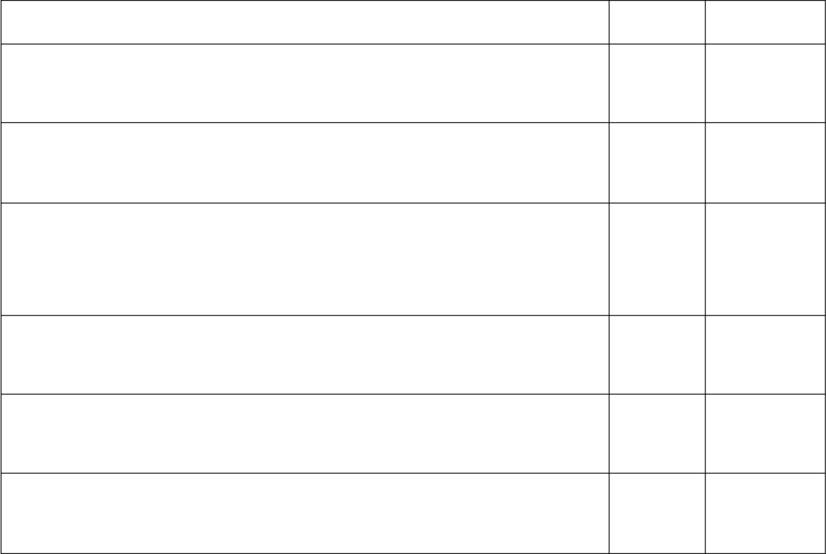I.
and fatter.
4.
- Is it your mobile phone?
- Yes, it is my mobile phone.
- Do you think they are on the way here?
- They are on the way. Don‟t worry.
✓
✓
5.
✓
✓
6.
- You aren’t working this weekend?
- I am, but I can‟t spend some time meeting you.
✓
✓

1. - Isn’t too late to say sorry? | Stressed  ✓ | Unstressed
- No, it isn’t. |  | ✓
2. - Was he busy with his schoolwork? |  | ✓
- Yes, he was. | ✓
3. - Isn’t fried chicken your favorite food?  - Yes, fried chicken is my favorite food, but it can make me fatter | ✓  ✓

II. 1. She is interested in Korean films but her husband 'isn‟t.
- A: Are you reading this book? B: Yes, I 'am.
- A: 'Isn‟t it the best way to release stress? B: Yes, it 'is.
- A: Do you think he is a great actor? B: He 'is. But he‟s quite reserved.
- A: Is she confident that she will get the job?
B: Yes, she 'is. She has prepared for the interview very well.
- A: Will Hoa visit you this summer? B: Yes, she will fly here on her own. A: But she is too young!
B: She 'is. But she can take care of herself.
- VOCABULARY AND GRAMMAR

I. 1. frustrated  5. delighted | 2. worried  6. depressed | 3. tense  7. calm | 4. confident  8. relaxed
II. 1. d 2. h | 3. g 4. a | 5. b 6. e | 7. c 8. f

III.
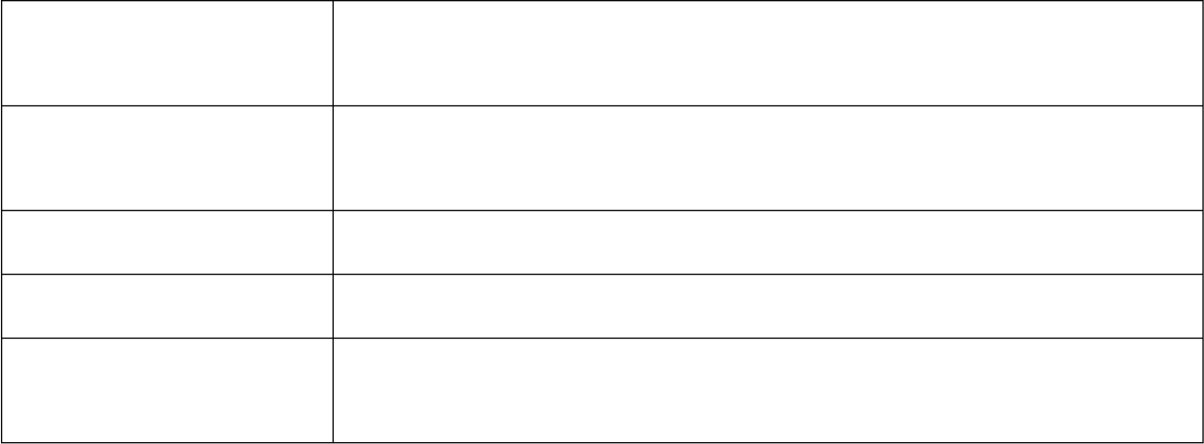
Social skills
stay calm with others, listen to others, ask for help, follow
directions or rules
Cognitive skills

Housekeeping skills Emotion control skills
Self-care skills
comprehend reading materials, use appropriate words in certain
circumstances, determine the problems you‟re facing
clean your room, fix the light bulb, take out the trash cope with loneliness, feel sympathy for others, be grateful
determine the symptom of common diseases, go to sleep early,
drink enough water
IV. 1. They said their daughter wanted to study abroad for a year.
  - She asked me if I had ever experienced school pressures.
  - He said he couldn‟t watch his favourite cartoon on Disney Channel the previous day.
  - Jane asked me if the weather was good in Shanghai in the summer.
  - She asked me what the skills that I found the most difficult to learn were.
  - She told me to bring her a cup of coffee.
  - Joana told me she would come and help me on Saturday.
  - My mom asked me when I would come back home.
  - The teacher asked me if I needed any help on that assignment.
  - Danny told Ann his friend had got engaged to a German the previous month.

V. 1. could  5. would do  9. was | 2. were reading 3. would travel  6. hadn‟t gone 7. might  10. needed | 4. had never been  8. had to/ must
VI. 1. who | 2. where 3. what 4. how | 5. when
6. who | 7. how 8. where 9. what | 10. when
- 1. I don‟t know where to visit this summer vacation.
- Could you tell me who to ask for advice?
- She wondered what to write in the final essay.
- I have no idea who to contact in case of emergency.
- They can‟t decide when to leave for America.
- I‟m not sure what to cook for my son‟s birthday party.
- Could you tell me where to put my umbrella?
- He asked himself what to send her as a present.
- I have no idea when to leave for Japan.
- She wondered how to resolve the conflict.
- 1. They didn‟t know what to do to help her overcome stress.
- Jonas wondered whether to discuss that matter with his teammates.
- An asked Mary where to register for a course on life skills.
- James and Lily couldn‟t tell how to find a support center for the homeless.
- They had no idea when to start their campaign.
- Trang asked her mother who to call upon arriving at the airport.
- Phong was not sure whether to dial 18001567 to ask for advice about family problems.
- They wondered what to do to help those disadvantaged children.
- She couldn‟t decide when to start teaching her children to cook.
- Hoa asked Nam how to deal with negative emotions and stress.
- 1. of 2. with 3. in 4. of 5. on 6. without 7. on 8. with
- SPEAKING
I. 1. E 2. A 3. C 4. F 5. B 6. G 7. D
- - I‟m planning to study abroad next year.
  - Cool! Which country will you set foot on?
  - United States I think, but I‟m so worried about myself.
  - What are you worried about?
  - I don‟t think I have enough skills to live far away from my family.
  - What do you mean?
  - I mean, I don‟t know how to cook, study by myself or manage my budget.
  - Oh dear. It may cause you a lot of problems then. I think you should prepare for your trip from now.
  - What should I do?
  - You can register for a soft skill course at the Youth Cultural House , KDI or Vietskills, etc. After that, try to practice as much as possible.
  - What else can I do?
  - I think you should share your thoughts with your parents when you are tense. They can give you some useful advice.
  - Right. Thank you very much!

D. READING
I. 1. refers | 2. ambitions | 3. less | 4. studying
5. conflict  II. A. 1.T 2. F | 6. most  3. T 4. F | 7. with  5. T | 8. through
B. 6. The added pastimes can contribute to teenage stress and anxiety.
  - Peer pressure, bullying on campus and harassment can distract teens from studying.
  - Arguments with siblings, disagreements with parents over rules and expectations and the need to consistently care for younger siblings put teen under pressure.
  - “loss” can mean the end of a relationship, friendship or cherished extracurricular activity.
  - Teens can doubt their self-worth after a broken relationship because of their change in social status.
E. WRITING
- 1. It is important to keep calm in an emergency.
- The schools nationwide are experiencing teacher shortages at present.
- He said that he would send us a postcard the following day.
- Jane found it easy to empathize with the characters in the books.
- They can‟t make the final decision on where to visit in Malaysia.
- If I were you, I would call the helpline for help.
- After living in France for a year, I felt much more confident about my French.
- She wondered whether to tell her best friend what she was thinking.
- 1. Jimmy asked me where I had met him.
- Jim asked his teacher when to register for the new course on Chinese.
- Joana couldn‟t decide when to start her Journey.
- The doctor said that I had to/ must stay in bed until the following Monday.
- I have no idea who to call for help in this situation.
- She wondered whether to tell her the truth about her misery.
- I‟m not sure what to do to help her overcome her mom‟s death.
- John said he was going to work for a new company the following week.
TEST FOR UNIT 3
I. 1. c 2. d 3. c 4. d 5. b
II. 1. b 2. a 3. b 4. c 5. d
III. 1. - Isn‟t he your best friend?
- Yes, he is.
- - Oh my God! We are late for the wedding.
  - Actually, we aren‟t. The card says it begins at 7pm. It‟s just 6.30 now.
- - You aren‟t happy about your test?
  - I am happy! But I don‟t want to be overexcited.
- Who are they?
- - Where are you? You aren‟t in front of the cinema.
  - I am in front of the cinema, but I can‟t see you.
- - Are you going out now?
  - Yes, I am. Can you wait for me for a while?
IV. 1. a 2. c 3. c 4. b 5. d 6. b 7. d 8. c 9. c 10. a
- 1. had spent 2. has asked 3. not to take 4. wanted
- is being repaired 6. taking 7. to think 8. worked
- 1. adulthood 2. concentration 3. confident 4. independent 5. depressed
- responsibilities 7. frustration 8. emotional 9. counselor 10. organizational
- 1. D (on) 2. B (would) 3. A (whether) 4. D (the previous year)
5. B (left out) 6. A (toll-free) 7. B (how) 8. A (did)
VIII. 1. d | 2. g | 3. f | 4. a | 5. b | 6. h | 7. c | 8. e
IX. 1. d | 2. a | 3. b | 4. c | 5. c | 6. d | 7. a | 8. b
X. 1. a | 2. b | 3. d | 4. c | 5. c | 6. d
- 1. “I will not have enough time to finish the Job”, he said.
- When was that chocolate cake eaten by your friends?
- My teacher asked me what the skills I concerned most were.
- The Little Prince is the most interesting novel I have ever read.
- If you don‟t finish your homework, you can‟t go out with your friend.
- They‟re not sure how to operate the new system.
- I spent 4 hours reading the first chapter of the book.
- Tennis is not as dangerous as snowboarding.

Đáp án gợi ý
  - I think you should set goal.
  - It might help to keep a to-do list.
  - It might be a good idea to prioritize your tasks.
  - If I were you, I would avoid distractions and interactions to my work.
  - Have you ever thought about learning how to take a positive attitude towards frustration and failure?
  - It might be a good idea to organize your work to meet deadline.
  - I think you should review your progress.
TEST YOURSELF 1
I. 1. b 2. a 3. d 4. b 5. c
II. 1. a 2. b 3. b 4. a 5. d
III. 1. What can I do to control my anger?
- A: Aren’t you writing the application letter? B: Yes, I am.
- A: Can you come to my home and give me a lift? B: OK, wait for me.
- You should discuss with your classmate during the lesson.
- A: Are they working on the project? B: She is, but he isn‟t.
- A: Who sent you this email ? B: She did.
- The air is cleaner in the countryside.
- A: My father is always a mystery to me. B: Is he? Mine is a good friend of mine.
IV. 1. abandoned  6. sprawl |  |  | 2. self-discipline  7. multicultural |  |  |  | 3. adolescence  8. lanterns |  |  |  | 4. embarrassed  9. lacquerware |  |  | 5. emergency  10. metropolitan
V. 1. d | 2. a |  | 3. b |  | 4. c |  | 5. d |  | 6. c |  | 7. d | 8. b |  | 9. b | 10. a
VI. 1. convenience  6. attractive |  |  |  | 2. responsible  7. graduation |  |  |  | 3. production  8. empathize |  | 4. adolescent  9. urbanized |  |  |  | 5. favorable  10. financial
VII. 1. had to/must |  |  |  | 2. was singing |  |  |  | 3. to get 4. Are you traveling 5. feeling
6. had written |  |  |  | 7. to work |  |  |  | 8. found 9. has become 10. is going to rain
VIII. 1. C (in) |  |  |  | 2. B (down) |  |  |  | 3. B (being shown) 4. A (whether) 5. D (informed)
6. C (least) |  |  |  | 7. A (Although) |  |  |  | 8. C (far/ much/ a lot) 9. A (didn‟t) 10. C (do)
IX. 1. f |  | 2. d |  | 3. e |  | 4. h |  | 5. a |  | 6. g |  |  | 7. c | 8. b
X. 1. c |  | 2. b |  | 3. d |  | 4. a |  | 5. b |  | 6. c |  |  | 7. a | 8. d
XI. 1. F |  | 2. T |  | 3. T |  | 4. F |  | 5. T |  | 6. c |  |  | 7. b | 8. a
XII. 1. The police took the wounded persons to hospital.
- He asked me not to leave my luggage unattended.
- The salary of a secretary is not as high as that of a professor./ is lower than that of a professor.
- He looked for someone to share his life with because he felt very miserable.
- I didn‟t realize how late it was and I went on studying till after midnight.
- How long have you worked on the project?
- I am leaving now in order not to be late for work./ order that I won‟t be late for work.
- New York City is the busiest city in the world.
- Dina takes after her mother‟s side of the family.
- He asked me how long I had been standing there.

