ĐỀ 1 | ĐỀ THI THỬ HỌC KỲ II  Môn Tiếng Anh 6  Thời gian: 45 phút

I. Choose the word that has the underlined part pronounced differently
from the others.(Chọn từ có cách phát âm khác với những từ còn lại)
1. A. twice B. swim C. skip D. picnic
2. A. hat B. lake C. cat D. man
3. A. usually B. hungry C. family D. my
4. A. cook B. book C. door D. look
II. Choose the best answer: (Chọn câu trả lời đúng)
1. The Mekong River is ....................................river in the world
A. longer B. long C. longest D. the longest
2. ..................... language do you speak? - I speak English.
A. which B. where C. when D. how
3. My brother .................... our grandmother next weekend.
A. visit B. are going to visit C. is going to visit D. am visiting
4. How ........... do you watch television? – Every evening.
A. many B. often C. much D. old
5. It’s very hot. Why ...................................go swimming?
A. don’t we B. not we C. let us not D. we don’t
6. What about .............................................by bus?
A. we go B. going C. to go D. go
7. How……………… is a sandwich? - It's 2,000 dong.
A. many B. much C. old D. often
8………….. is the weather like in the summer?
A. What B. Which C. How D. When
III. Give the correct form of each verb in brackets: (Chia động từ trong ngoặc cho đúng)
1. She (watch)……….............…………. TV at the moment
2. Let’s (play)……….............…………. Video games.
3. My mother (not listen)……….............…………. to the radio in the morning.
4. What she (do)……….............…………. now?
IV. Choose the best word or phrase for each numbered blank: (Chọn cụm từ, từ đúng nhất để điền vào chỗ trống)

Our country (1) ………. small and very beautiful. It has four seasons in a year. They are spring, summer, fall and winter. It is warm in spring, hot in summer, cool in fall and cold in winter. When (2)………. weather is warm, we often play volleyball, tennis or go fishing. When it is hot, we often (3) ………. camping or go swimming. When it is cool we often play football or go jogging. When the weather is cold, we often play basketball, skip or play video game. Our (4)……….season is autumn because the weather is cool, so it is very good (5)………. our health.
1. A. is B. are C. has D. have
2. A. a B. it C. the D. an
3. A. goes B. to go C. go D. going
4. A. beautiful B. favorite C. like D. good
5. A. at B. to C. with D. for
V. Put the words in their correct orders: (Sắp xếp lại các từ sau để thành câu hoàn chỉnh)
1. hot / often / when / I/ go swimming / it / is
……………………………………………………………………………
2. camping / often / do / how / you / go?
……………………………………………………………………………
3. like / the / weather / spring/ what / is / the / in?
……………………………………………………………………………
4. trash / in / don’t / country / the / throw
……………………………………………………………………………
5. to / let’s / zoo / go/ the /
……………………………………………………………………………

ĐÁP ÁN KIỂM TRA HỌC KỲ II
MÔN: TIẾNG ANH LỚP 6
Năm học 2015 - 2016

I. Choose the word that has the underlined part pronounced differently
from the others: 2 điểm (Mỗi ý đúng 0,5 đ)
1. A. twice
2. B. lake
3. D. my
4. C. door
II. Choose the best answer: 2 điểm (Mỗi ý đúng 0,25 đ)
1. D. The longest  2. A. which  3. C. is going to visit  4. B. often | 5. A. don’t we  6. B. going  7. B. much  8.A. What
III. Give the correct form of each verb in brackets: 1 điểm (Mỗi ý đúng 0,25 đ)
1. is watching
2. play
3. doesn’t listen
4. is she doing
IV. Choose the best word or phrase for each numbered blank: 2,5 điểm (Mỗi ý đúng 0,5 điểm)
1. A. is
2. C. the
3. C. go
4. B. favorite
5. A. at
V. Put the words in their correct order: 2,5 điểm (Mỗi ý đúng 0,5 điểm)

1. When it is hot, I often go swimming
2. How often do you go camping?
3. What is the weather like in the spring?
4. Don’t throw trash in the country
5. Let’s go to the zoo./.

ĐỀ 2 | ĐỀ THI THỬ HỌC KỲ II  Môn Tiếng Anh 6  Thời gian: 45 phút

Xuan Hong B- TEST – GRADE 5 – 2nd TERM
Skill | Listening | Reading | Writing | Speaking | Total
Mark

PART 1: Question 1-4: Listen and number.
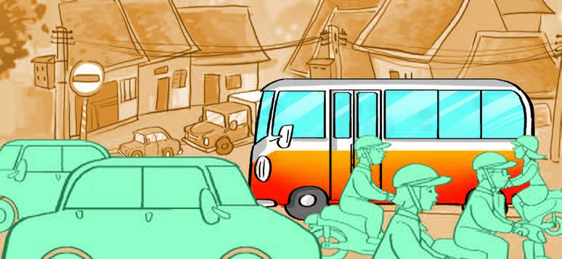

A. B. C. D.

PART 2: Question 5- 7: Listen and choose the words to fill in the blank
Underground train beautiful takes make

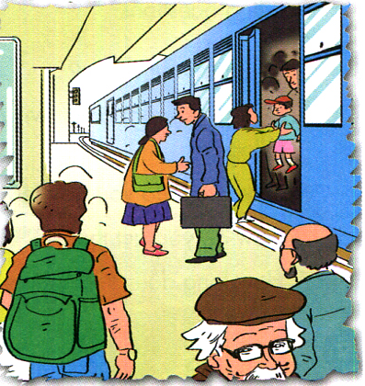 | My Hometown  Hello. My name is Lisa. I live in London. I often go back to my (0)…hometown… to visit my grandparents. They live in the north of England. First, I go to London King’s Cross railway station by (5)………………... It takes me about half an hour. After that, I take a train to my hometown. It (6) …………. me four hours to get there. I prefer travelling by train because I can enjoy the (7)……………..... scenery on the way. I always have a wonderful time in my hometown.
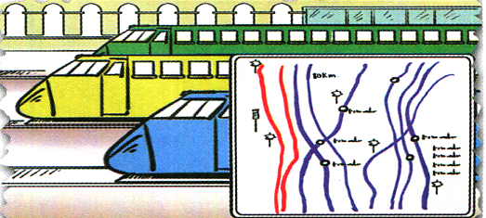

PART 3: Question 8- 11: Listen and tick the box.
Example:
0. Where are you going?

√
A B C
8. How many bananas do you eat every day?

A B C
9. What’s spring like in your country?

A B C

10. How can I get to the post office?

A. B. C.

11. Which place do you like to visit?
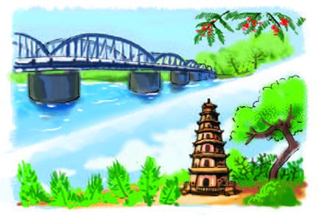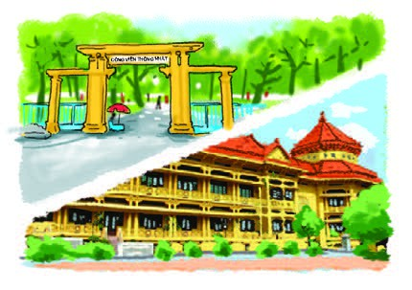
A. B. C.
PART 4: Question 12- 14: Listen and tick right or wrong.
RIGHT WRONG
√
v vvXxv
Example: It’s cool and windy in Hue.
12. It’s hot and cloudy in Ho Chi Minh City
13. It’ll be cold and rainy in Hanoi.

14. It’s warm and foggy in Hue

READING
PART 1: Question 1-3
Look and read. Write the correct words next to their descriptions. There is one example.
  Ha Long Bay |   Orange juice |   Summer | 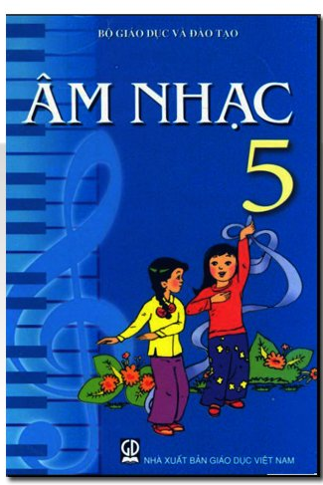  Music |   farmer

0. The people work in a field, grow vegetables and raise pigs. a farmer
1. I learn to sing songs in during this lesson. ______
2. It’s hot and sunny in this season. _______
3. There are many caves here.__________
PART 2: Question 4- 6
Read the text carefully. Tick (v) True or false. There is an example (0).
Hello. My name’s Tony. I come from Sydney, a big city in. There are lots of big modern buildings and it’s very noisy. There are often traffic jams during the rush hour. But it’s a very exciting place and I like living there.
TRUE FALSE
√

- Tony comes from Australia.
- Sydney’s very noisy.
- Sydney’s a modern city.
- He dislikes living in Sydney.
PART 3: Question 7- 10
Read the passage, choose correct word in the box and complete the sentences.
south picnic wind November two

My name is Quang. I live in Can Tho. It is in the (0) ___ south ___ of Viet Nam. There are only (7) __________ seasons here. They are the dry season and the rainy season. The dry season lasts from (8) ___________ to April. It is usually cool and dry in this time of the year. This is my favourite season because I can go for a (9) _________________with my friends. The rainy season lasts from May to October. It is usually hot and wet. There is a lot of (10) ___________ too.

WRITING
PART 1: Questions 1-3: Look at the pictures and the example (0).
Example: I like fish and  orange juice.
My name is Tony. I often (1) __________ science books and do
sports in the gym. I want to be strong and good at science because I would like to be a (2) __________. I want to fly(3) 
____________.

PART 2: Questions 4- 6. Order the words.
Example: 0. are / going / they / swim / to / the / in / sea 
They are going to swim in the sea.
4. would/ like/ to/ eat/ what/?
________________________________
5. of/ think/ what/ do / you/ Thu Le/ zoo/ ?
_________________________________

6. New York City/ bigger/ than/ is/ Hanoi/.
__________________________________
The end

SPEAKING SAMPLE TEST – GRADE 5- 2ND TERM
Greeting and test taker’s name check.
The examiner says: My name is….. It’s nice to talk to you to day.
Part 1: Getting to know eachother below:
1. What your name?
2. How do you spell your name?
3. How are you today?
Part 2: Talking about actions
The test talker is given a card in which there is a set actions. The examiner tells the test talker to pick one and answer the following questions
1. who’re they?
2. What are they doing?
3. What do you do in your free time?
4. Where do you ................?
Part 3: Describing the picture.
The examiner says: Now you have 30 seconds to look at one picture.
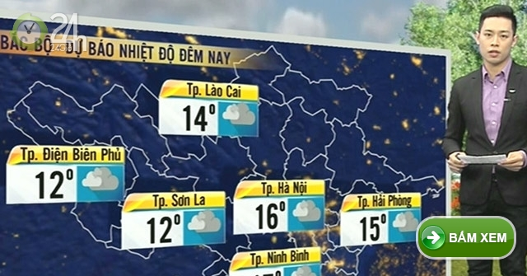
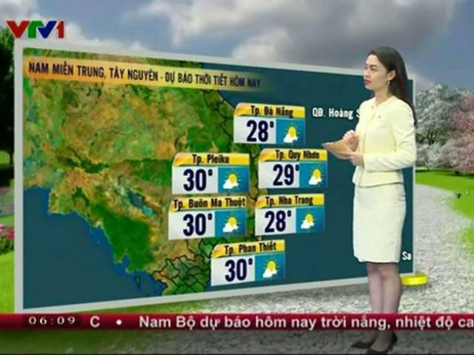
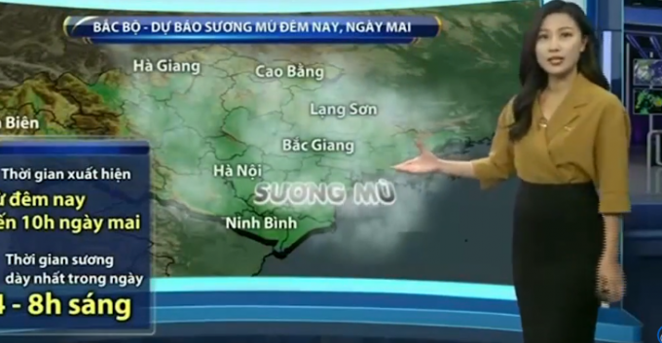

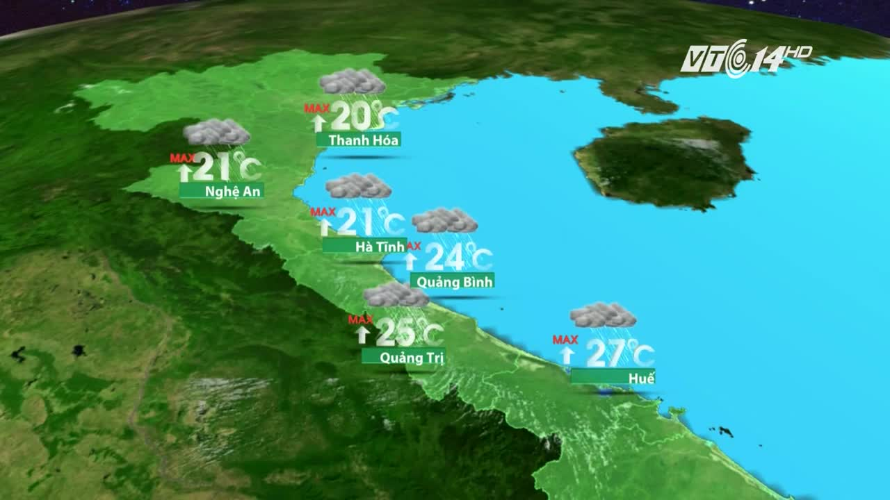
The examiner asks 3 questions below:
1. Who is she/ he?
2. What’ll the weather be like in……?
3. What’s your favourite weather?
Follow – up question: Where will you go on nice days?

KEYS TO TEST – GRADE 5- 2ND TERM
PART 1: A. 2 B. 1 C. 4 D. 3
- How can I get to the post office.
- What’s summer like in your city?- It’s often hot.
- How can I get there? – you can take a bus from here
- I went to the zoo.
PART 2: 5. underground. 6. takes 7. beautiful
Hello. My name is Lisa. I live in London. I often go back to my (0)…hometown… to visit my grandparents. They live in the north of England. First, I go to London King’s Cross railway station by (5)…underground... It takes me about half an hour. After that, I take a train to my hometown. It (6)… takes…. me four hours to get there. I prefer travelling by train because I can enjoy the (7)… beautiful ... scenery on the way. I always have a wonderful time in my hometown.
day.
PART 3: 8. A 9. C 10. A 11. C
- I have three bananas
- It’s usually cold. There is a lot of wind
- You can walk for 5 minutes.
- I’d like to visit Thong Nhat Park.
PART 4: 12 R 13 W 14 W
Good evening and welcome to the weatherforecast. Let’s take a look at the weather today.
It’s cold and cloudy in Ha Noi. It’s cool and windy in Hue. It’s hot and sunny in Ho Chi Minh City. What will the weather be like tomorrow? Well, it will be cold and rainy in Ha Noi. It will be warm and foggy in Hue. In Ho ChiMinh City, it will be hot and sunny. That’s theweather forecast for tomorrow.
READING
PART 1: 1. Music 2. spring 3. HaLong Bay.
PART 2: 4. T 5. T 6. F
PART 3: 7. two 8. November 9.picnic 10. wind.
WRITING
PART 1: 1. read 2. pilot 3. planes
PART 2: 4. What would you like?
5. What do you think of Thu Le Zoo?
6. New York City is bigger than Hanoi.

Ghi chú về mức độ các câu hỏi của đề minh họa
Listening:
Part 1: mức 2( câu 1, 2, 3, 4)
Part 2: Mức 2(câu 7), mức 3( câu 5, 6)
Part 3: Mức 2( câu 9, 10, 11), mức 1( câu 8)
Part 4 : Mức 2 ( câu 12,14), mức 3( câu 13)
Reading :
Part 1 : Mức 2( câu 2) , mức 3( câu1, 3)
Part 2 : Mức 2( câu 4) , mức 3( câu 5, 6)
Part 3 : Mức 2(câu 7, 9), mức 3( câu 8, 10),
Writing : Part 1 : Mức 2( câu 1, 2, 3)
Part 2 : Mức 2( câu 4, 5), mức 3( 6)
Speaking :
Part 1: Mức 1( câu 1, 2, 3)
Part 2: Mức 3( câu 1, 2, 3), mức 4( câu 4)
Part 3 : Mức 3( câu 1, 2), mức 4( câu 3)

Kỹ năng | Nhiệm vụ đánh giá/kiến thức cần đánh giá | Mức/Điểm |  |  |  | Tổng số câu, số điểm, tỷ lệ  %
Nghe | Nhiệm vụ đánh giá/kiến thức cần đánh giá | M1 | M2 | M3 | M4 | 14 câu  3,5 điểm  35%
Nghe | Part 1 |  | 4  1đ |  |  | 14 câu  3,5 điểm  35%

 | Part 2 |  | 1  0,25đ | 2  0,5đ
 | Part 3 | 1  0,25đ | 3  0,75đ
 | Part 4 |  | 2  0,5đ | 1  0,25đ
Đọc | Part 1 |  | 1  0,25đ | 2  0,5đ |  | 10 câu  2,5 điểm  25%
Đọc | Part 2 |  | 1  0,25đ | 2  0,5đ |  | 10 câu  2,5 điểm  25%
Đọc | Part 3 |  |  | 2  0,5đ | 2  0,5đ | 10 câu  2,5 điểm  25%
Viết | Part 1 |  | 3  0,75đ |  |  | 6 câu  1,5 điểm  15%
Viết | Part 2 |  | 2  0,5đ | 1  0,25đ |  | 6 câu  1,5 điểm  15%
Nói | Part 1 | 3  0,75đ |  |  |  | 10 câu  2,5 điểm  25%
Nói | Part 2 |  |  | 3  0,75đ | 1  0,25đ | 10 câu  2,5 điểm  25%
Nói | Part 3 |  |  | 2  0,5đ | 1  0,25đ | 10 câu  2,5 điểm  25%
Tổng |  | 4 –  10% | 17–  42,5% | 15 –  37,5% | 4 –  10%

ĐỀ 3 | ĐỀ THI THỬ HỌC KỲ II  Môn Tiếng Anh 6  Thời gian: 45 phút

I. Listen and complete the dialouge: (1m)
where citadel summer long go

Ba: What are you going to do this ..........(1).............. vacation?
Lan: I am going to Hue.
Ba: ............(2).............. are you going to stay?
Lan: I’m going to stay with my aunt and uncle.
Ba : How ............(3)............. are you going to stay?
Lan: For a week.
Ba: What are you going to do in Hue?
Lan: I’m going to visit the ..............(4)............

Answer: 1...................., 2........................., 3............................, 4............................

II. Choose the word whose underlined part is pronounced differently from that of the others: (1m)
1. A.spring B. swimming C. badminton D. like
2. A. stay B. basketball C. activity D. black
3. A. teachers B. doctors C. students D. workers
4. A. brown B. now C. bowl D. How

Answer: 1....................., 2.........................., 3........................, 4........................

III.Choose the best answer: (2ms)
1. The population _______ the world is growing. ( about / at / in / of)
2._______ collecting the empty bottles ? - Good idea. ( Let's / What / What about / Why don't we)
3._______ milk does Mr. Hai produce every day? ( How / How many / How much / How far)
4. There is _______ water in the glass.( a / any / some / a few)
5. Ba would like some fruit juice. He's _______. ( happy / hungry / thirsty / well)
6. That building is the_______ of the four. ( /tall/ bigger /taller / tallest )
7. We_______ recycle waste things in the factory. (should / not ought / shouldn't to / ought)
8. Let's go fishing _______ the morning.( at / in / on / to)

IV. Put the verb in brackets in the correct tense: (2ms)

1. There (not be) _______any cooking oil in the bottle.
2. Her sister ( read ) _______a book now .
3. Lan often (do) _______aerobics after school.
4. He (visit ) _______ Da Lat this summer vacation.

V.Read the following passage and complete it. Then answer the questions: (2,5ms)
A. Read and complete.(1m)

with jogs for jogging is

Phong likes jogging very much. Every morning he (1) ______ with his father. When it is warm, Phong sometimes goes jogging with his uncle. Phong travels a lot. This summer, he (2) _______ going to visit Ha Long Bay (3) ________ his family. He is going to stay in a small hotel (4) ________ two weeks.
B. Answer the questions: (1,5ms)
1. What does Phong like?
……………………………………………………………………………
2. Is he going to visit Ha Long Bay ?
…………………………………………………………………………….
3. Where is he going to stay?
……………………………………………………………………………
VI.Arrange the words given to make meaningful sentences (1,5ms)
1. read / I /books /it’s / when /cool.
……………………………..………………………………………………………..
2. often / helps / Mai / me / her / in / freetime .
………………………………………………………………………………………
3. I / Can / you /help/ ?
…………………………………………………………………..…………………..

The end!

THE KEY :ENGLISH 6
A.: Objective
After this period pupils are able to remember old lesson
Remember old structures and tenses
B. Form: test and foreword
C. Matrix frame
Chủ đề | Nhận biết | Thông hiểu | Vận dụng | Tổng
Chủ đề | TL | TL | TL
I. Listening(30%)  (pronunciation) | 8  2.0 |  |  | 8  2,0
II. Reading( 10%) | 4  1,0 | 3  1,5 |  | 7  2,5
III. L F(30%) |  | 8  2,0 | 4  2,0 | 12  4,0
IV. Writing(30%) |  | 3  1,5 |  | 3  1,5
Tổng | 12  3,0 | 14  5,0 | 4  2,0 | 30  10
D. The possible answer:

I. Listen and complete the dialouge(1m)
Mỗi câu đúng được 0,25 đ
1. summer 2. where 3. long 4. citadel
II. Choose the word whose underlined part is pronounced differently from that of the others: (1m)
Mỗi câu đúng được 0,25 đ
1. D 2. A 3. C 4. C

III.Choose the best answer: ( 2ms)
Mỗi câu đúng được 0,25 đ
1. of 2. What about 3. How much 4. some 5. thirsty 6. tallest 7. should 8. in
IV. Put the verb in brackets in the correct tense: (2ms)
Mỗi câu đúng được 0,5 đ
1. is not 2. is reading 3. does 4. is going to visit

V.Read the following passage and complete it. Then answer the questions:
A. Read and complete.(1m) Mỗi câu đúng được 0,25 đ
1. jogs 2. is 3.with 4. for
B. Answer the questions: (1,5ms) Mỗi câu đúng được 0,5 đ
1. He likes jogging.
2. Yes, he is.
3. He is going to stay in a small hotel.

VI.Arrange the words given to make meaningful sentences (1,5ms)
Mỗi câu đúng được 0,5 đ
1. I read books when it’s cool.
2. Mai often helps me in her freetime.
3. Can I help you?
ĐỀ 4 | ĐỀ THI THỬ HỌC KỲ II  Môn Tiếng Anh 6  Thời gian: 45 phút

A. MA TRẬN ĐỀ KIỂM TRA:
Ma trix

Mức độ  Chủ đề |  | Nhận biết |  | Thông hiểu |  | Vận dụng |  | Vận dụng cao
 |  | TN | TL | TN | TL | TN | TL | TN | TL
1.Phonetic |  | I(1,2)  0.4Đ |  | I(3,4,5)  0.6Đ
2.Language Knowledge |  |  |  | II(6,7,8,9,10  11,13,14,15)  2Đ
3.Reading |  |  |  |  |  | III(16,17,18,19  20,21,22,23)  1.6 Đ |  |  | III(24,25)
4.Writing |  |  |  |  | IV(26,27,28)  0.6Đ |  |  |  | V(29,30)  0.8Đ
5.Listening |  |  | VI(31,32,33,  34,35,36,37,  38)  2Đ
Tổng cộng | Số câu | 2 | 8 | 13 | 3 | 8 |  |  | 4
Tổng cộng | Số điểm | 0.4 | 2 | 2.6 | 0.6 | 1.6 |  |  | 0.8
Tổng cộng | Tỉ lệ | 30% |  | 40% |  | 20% |  | 10%

B. NỘI DUNG ĐỀ KIỂM TRA:
I/. Choose the word
A/ that has different meaning from the others: (0.4m)
1. A. cool B.sunny C. spring D. rainy
2. A. football B.volleyball C. tennis D. kite
B/ that has the underlined part pronounced differently from the others:(0.6m)
3. A.finger B. lip C. light D. thin
4. A.fall B.cat C.fat D.can
5. A.thirsty B.thirteen C.thirty D.tired
II/. Choose the best answer a,b,c or d:( 2ms)
6. Let’s ______ badminton.
A. to play B. plays C. play D. played
7. Nga goes to the zoo three _________ a week.
A. time B.twice C. times D. once
8. We __________ at the moment.
A. is skip B.are skipping C. skip D. skips
9. _________ do you watch T.V?- Twice a week.
A. How B.How often C. How much D. How old
10. My brother ________ fishing on Sundays.
A. sometimes goes B.going C. go D.goes sometimes
11. Is it _____ in the summer? Yes, it is.
A. warm B. cool C. cold D. hot
12. There are _________ books on the table.
A.any B.some C.a D.an
13. She isn’t heavy.She is ________ .
A.thin B.fat C.strong D.light
14. Do you play soccer every day ?
A.Yes, I do. B.Yes, I play. C,No, I do. D.I play soccer.
15. They are ________ badminton now.
A.playing B.plays C.to play D.play
III/ Fill in the missing word then answer the questions:( 2ms)
Mrs Lien (16)_______ a nurse. She is thirty-five years old. She (17)_______ in a house near a park. She works (18)_______ a hospital. She goes to work by car. She goes home(19)_______ 5:00 pm. She is in her house and she is cooking now.
16.A. is B. will be C. am D. are
17.A. live B. lives C.to live D. living
18. A. on B. near C. in D. next
19.A. in B. for C. on D. at
* Choose True (T) or False (F):(Chọn đúng hay sai):
20. Mrs Lien is thirty years old . _______
21. She works in a hospital. _______
22. She goes to work by car. _______
23.She goes home at 6:00 pm _______
*Questions:
24. What does Mrs Lien do ?
…………………………………………………………………………………………
25. What time does she go home ?
…………………………………………………………………………………………
IV/. Complete the questions with: How many / How much / How often (0.6m)
26. ______________ do you go swimming? Once a week.
27. ______________ seasons are there in a year? Four
28. ______________ beef do you want ? -Two kilos.
V/.Do as directed:(0.4m)

29.The first season in the year. It’s the ________ . (Điền đúng từ chỉ mùa)

30.It / often / cool / fall. ( Viết câu từ những từ gợi ý)

................................................................................................................................
VI/. Listen and choose the correct answers:(1m)
31. What would Nhan like?
A. He’d like some apples B.He’d like some oranges juice and fish
C. He’d like some meat D.He’d like some rice
32. What would Huong like?
A. She’d like some milk B. She’d like a drink
C. She’d like a hot drink D. She’d like a cold drink
33. What would Mai like?
A. She’d like noodles B.She’d like some oranges juice and fish
C. She’d like some rice D.She’d like some apples
34. What would Tuan like?
A. He’d like some apples B.He’d like some oranges juice and fish
C. He’d like some meat D.He’d like some rice
Listen and match the names of the people with what they would like (1m)
A B
35. Nhan A. vegetables
36. Tuan B. chicken
37. Huong C. orange juice
38. Mai D. fruit
Answer: 35................36.................37.................38................

HƯỚNG DẪN CHẤM VÀ ĐÁP ÁN
ĐỀ THI KHẢO SÁT CHẤT LƯỢNG HKII - NĂM HỌC 2016 – 2017
Môn thi : Anh Văn - LỚP 6

SENTENCES | KEYS | MARKS
I  1  2  3  4  5  II  6  7  8  9  10  11  12  13  14  15  III  16  17  18  19  20  21  22  23  24  25  IV  26  27  28  V  29  30  VI  31  32  33  34  35  36  37  38 | Mỗi câu đúng 0.2điểm  C  D  C  A  D  Mỗi câu đúng 0.2điểm  C  C  B  B  A  D  B  D  A  A  Mỗi câu đúng 0.2điểm  A  B  C  D  F  T  T  F  - Mrs Lien is a nurse.  - She goes home at 5:00 pm.  Mỗi câu đúng 0.2điểm  How often  How many  How much  Mỗi câu đúng 0.2điểm  Spring.  It’s often cool in the fall.  Mỗi câu đúng 0.2điểm  D  A  B  C  B  A  D  C | 1  0,2  0,2  0,2  0,2  0.2  2  0,2  0,2  0,2  0,2  0,2  0,2  0,2  0,2  0,2  0,2  2  0,2  0,2  0,2  0,2  0,2  0,2  0,2  0,2  0,2  0,2  0.6  0,2  0,2  0,2  0.4  0,2  0,2  2  0,25  0,25  0,25  0,25  0,25  0,25  0,25  0,25

ĐỀ 5 | ĐỀ THI THỬ HỌC KỲ II  Môn Tiếng Anh 6  Thời gian: 45 phút

TOPIC 1
Sports.
- Tell the name of some sports do you play .
- Which sport do you like best ?
- How often do you play sports?
TOPIC 2
The seasons and the weather
- Tell the name of seasons in a year.
- What’s the weather like in the summer/ winter/ spring/ fall?
- What do you do when it’s cold/hot/warm/cool.
TOPIC 3
Vacation plans
- Tell the places are you going to go in your this summer vacation.
- What are you going to do ?
- Where are you going to stay?
- How long are you going to stay?

TOPIC 4
Countries.
-Tell the name of some countries in the world.
- Where are you from?
- What is your nationality?
- Which language do you speak?

TOPIC 5
Environment.
- Tell some reasons make the environment is polluted.
- Where does the pollution come from?
- What can you do to protect invironment?

- PART 1: PERSONAL INFORMATION:
- PART 2: INTERVIEW TOPICS:
- PART 3: INTERVIEW:

ĐÁP ÁN VÀ HƯỚNG DẪN CHẤM

PART 1: (0,5Đ)
- Phát âm chuẩn.
- Bài nói có sự liên tục.
- Yêu cầu học sinh nói đầy đủ nội dung .
PART 2: (1Đ)
- Nói đúng chủ đề đã chọn.
- Phải đầy đủ nội dung cần nói.
- Phát âm chuẩn, lưu loát.
- Phải có sự liên tục trong khi nói.
PART 3: (0,5Đ)
- Phát âm chuẩn, lưu loát.
- Trả lời đúng nội dung câu hỏi.

ĐỀ 6 | ĐỀ THI THỬ HỌC KỲ II  Môn Tiếng Anh 6  Thời gian: 45 phút

I. Listening (1.5ms)
Part 1: Listen to the conversation. Write the missing words. (0.7pt)
A: Fun party, isn’t?
B: Sure is. My (1................................is Emma, by the way.
A: It’s nice to meet you, Emma. I’m Justin.
B: (2) ................................to meet you, Justin. Do you (3) ................................ in L.A?
A: No. I’m (4) ................................ San Francisco. I’m visiting my sister here.
B: Oh, I love San Francisco. I go there sometimes for work.
A. Really? Call me next time you’re there. Let me give you my phone (5) ........................
B. Okay, hope to (6) ..........................you again! (7) .......................... a great time in L.A!
Part 2: What time is each person saying? Listen and write the correct time on each clock (0.5pt)
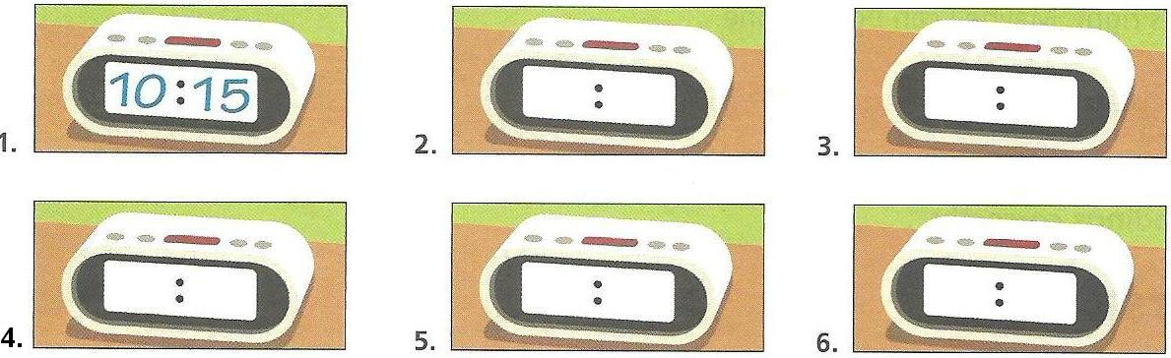
Part 2: Listen. Circle the ordinal number you hear. (0.3pt)
1. 5th / 6th / 9th 2. 2nd / 7th / 11th 3. 3rd / 11th / 30th 4. 7th / 10th / 11th

II. Choose the word whose underlined part is pronounced differently from that of the others (0.5pt)
1. A. factory B. neighborhood C. hospital D. policeman
2. A. stools B. doors C. boys D. clocks
III. Choose the word or phrase (A, B, C or D) that best fits the blank space in each sentence. (2.5pts)
1. Nga’s father is an engineer. He works in a.................................
A. drugstore B. restaurant C. school D. factory
2. The school is near his house, so he......................... there every day.
A. walks B. goes on foot C. travels on foot D. All are correct.
3. What do you have today? -................................................
A. Math, Literature and History B. Math at 7.45
C. Math on Monday and Wednesday D. Math from 7.45 am. to 8.30 am.
4. Where is your classroom? - It’s on ............................floor.
A. first B. the first C. one D. the one
5.............................students are there in your class? - Thirty-five.
A. How B. How old C. How many D. Who
6. Look at Sarah. She is our new Mend. She is sitting.......................Joey and Tina.
A. between B. on C. next D. in
7. Mr and Mrs Nguyen ...........................breakfast at the moment.
A. eats B. eat C. is eating D. are eating

8. “What do you do after school ?” -“I.................. after school.”
A. do the housework B. do my homework
C. play video games D- watch television

9. “What time is it ?” -“It’s .......................”
A. ten ten B. ten to ten C. ten past ten D. A and C are correct
10. To the left of my house, there are..................................
A. a vegetable garden B. a nice lake C. beautiful flowers D. a tall tree
IV. Fill in each gap with ONE suitable word from the box (2pts)
and, two, grade, quarter, twelve, house, works, gets, with, big

Nam is (1) .................. years old. He is in (2)................. 6. He lives in a big house (3)....................his parents and his sister, Thu. In the neighborhood, there are (4)................ restaurants, a market and a stadium. Nam’s father is a cook. He (5)...................in the restaurant. His mother works in the local supermarket. Every day, Nam gets up at a (6)................to six. He has a (7)..................breakfast then he leaves the (8).................at six forty-five. His classes start at seven and end at eleven fifteen.
V. Writing
A. Do as directed in brackets (1pt)
1. The bike is new. (Rewrite the sentences, beginning with the words provided)
→ It is
2. My house has five rooms. (Rewrite the sentences, beginning with the words provided)
→ There
3. They live in an apartment on Nguyen Du Street. (Change the sentence into the negative form)
→
4. Miss Phuong is twenty-four years old. (Make a question for the underlined part)
→ ?
B. Write meaningful sentences, using the words given (1pt)
1. Lien / listening / music / now
→
2. My grandfather / live / country
→
3. you have / Literature / Tuesday and Friday / ?
→
4. school / very beautiful
→

---------The end----------

ĐỀ 6 | ĐỀ THI THỬ HỌC KỲ II  Môn Tiếng Anh 6  Thời gian: 45 phút

A> PRONUNCIATION: ( 1 m)
I. Choose the word that has the underlined part pronounced differently from the others.
1. A. my B. country C. family D. every
2. A. house B. about C. country D. Our
3. A. big B. time C. sister D. family
4. A. doors B. lamps C. chairs D. books

B> LANGUAGE FOCUS ( 3ms)
Choose the correct word(s)/ phrase(s) to complete the sentences.
1. My brother and I …………….television every evening
A. watches B. listen C. are D. watch
2. “ How are you?” – “ I………….fine, thanks.”
A. am B. is C. are D. be
3. Our classes finish at …………………………
A. quarter eleven B. a quarter past eleven C. eleven to quarter D. All are correct
4. What ………..does Nga get up ?
A. class B. time C. grade D. city
5. The photocopy store is ____________ the restaurant and the bakery
A. near B. in front of C. between D. behind
6. How many…………………..are there in your family ?
A. teachers B. students C. people D. doctors
7. I have ................................... then I go to school in the morning.
A. breakfast B. lunch C. dinner D. classes
8. His father is a doctor. He works in a ………………..
A. hospital B. bookstore C. bakery D. Factory
9. ………………are you going to stay ? – In a hotel
A. What B. Where C. When D. Which
10. She …………..a doctor and her brothers……………. workers
A. is/are B. is/is C. are/is D. are/are
11. “ Does Lan play scoccer ?” - “ ………………….”
A. No, I don’t B. Yes, I do C. No, she doesn’t D. No, she isn’t
12. Are they _________ their homework ?
A. do B. does C. doing D. are doing
C> READING:((3ms)
I/ Complete the passage, using the words given in the box
eats takes house end near home school

Nam is a student. He gets up at half past five. He (1)………………..a shower and gets dressed. He (2)………………his breakfast then leaves the (3)……………….at half past six. The school is (4)……………….his house so he walks. Classes start at seven and (5)………………at half past eleven. He walks (6)………………..and has luch at twelve o’clock.
II/ True or False statements about Nam and You.
 | T/F
1. Nam gets up at five thirty.  2. He goes to school by bike.  3. You are a teacher  4. Your classes start at seven o’clock.  5. Your classes finish at ten to five.  6. You study English at school | ………………  ………………  ………………  ………………  ………………  ……………….

D> WRITING ( 3ms)
I/ Make complete sentences, using the given words.
1. I/ live/ a house / a lake.
……………………………………….
2. There/ thirty five students/ my class.
……………………………………….
II/ Answer the questions about you.
1. When do you have English ?
……………………………………….
2. What’s there, near your house ?

ĐÁP ÁN VÀ HƯỚNG DẪN CHẤM
A> PRONUNCIATION: Tổng số 1.0 điểm
Mỗi lựa chọn đúng 0,25 điểm
1. A 3. B
2. C 4. D
B> LANGUAGE FOCUS: Tổng số 3,0 điểm
Mỗi lựa chọn đúng 0,25 điểm
1. D 7. A
2. A 8. A
3. B 9. B
4. B 10. A
5. C 11. C
6. C 12. C
C> READING: Tổng số 3,0 điểm
I. Mỗi câu trả lời đúng 0,25
1. takes 2. eats 3. house 4. near 5. end 6. home
II. Mỗi câu trả lời đúng 0,25
1. T 4. T
2. F 5. F
3. F 6. T
D> WRITING: Tổng số 3,0 điểm
I/ Mỗi câu viết đúng 1
1. I live in a house near a lake.
2. There are thirty five students in my class.
II/ Mỗi câu viết đúng 0,5
( Ss’ writing)

MATRIX
LEVEL  SKILL | IDENTIFYING |  |  | UNDERSTANDING |  |  | APPLYING |  |  |  |  |  | TOTAL
LEVEL  SKILL |  |  |  |  |  |  | LOW LEVEL |  | HIGH LEVEL
LEVEL  SKILL | Multi  Test | Written Test |  | MultiTest |  | Written Test | Multi Test | Written Test | Multi  Test |  | Written Test
A
PRONUNCIATION

Number of sentences  Marks  Percent(%) | 4  1.0  10% |  |  |  |  |  |  |  |  |  |  |  |  | 4  1,0  10%
B LANGUAGE FOCUS | Preposition  Adverb & adjectives |  |  | Structures  & vocabulary
Number of sentences  Marks  Percent(%) | 4  1.0  10% |  |  | 4  1.0  10% |  | 4  1.0  10% |  |  |  |  |  |  | 12  3,0  30%
C  READING | Read and complete a passage about HochiMinh Communist Youth Union
Number of sentences  Marks  Percent(%) |  |  |  | 6  1,5  15% |  |  | 6  1,5  15% |  |  |  |  |  | 12  3  30%
D  WRITTING |  |  |  |  |  |  | Rewrite sentence |  | Sentence making with the cue words
Number of sentences  Marks  Percent(%) |  |  |  |  |  |  |  | 2  2  20% |  |  | 2  1  10% |  | 4  3  30%
Number of sentences  Marks  Percent(%) | 8  2.0  20% |  |  | 10  4.  40% |  | 4  1.0  10% | 6  1.5  15 | 2  2  20% |  |  | 2  1  10% |  | 32  10,0  100%

ĐỀ 7 | ĐỀ THI THỬ HỌC KỲ II  Môn Tiếng Anh 6  Thời gian: 45 phút

A/ LISTENING (2pts)
Part 1: Listen and order these words (1pt)
A. bread B. rice C. noodles D. meat
Part 2: Put True (T) for correct sentence and false (F) for incorrect sentence (1pt)
5. Lan usually has breakfast at home.
6. At school, Lan and her friends always have lunch at eleven o’clock.
7. Lan and her parents often have meat or fish, bread, chicken and vegetables for dinner.
8. her family goes out for dinner twice a month.
B. USE OF ENGLISH (2pts)
I. Choose the word that has the underlined part pronounced differently from the others
9. A. pea B. tea C. bread D. meat
10. A. can B. city C. cooking D. car
II. Circle the best option A, B, C or D to complete each of the following sentences
11. What’s he doing? – He …
A. swims B. swimming C. swim D. is swimming
12…. kilos of beef does Mrs. Lan want? – Two kilos.
A. How B. How many C. How much D. How often
13. It’s very … in the winter.
A. cold B. hot C. cool D. warm
14. We are free tonight. We … our Great Grandmother.
A. am going to visit B. are going to visit C. visiting D. visit
15. … do Huong and Ha go camping? – They never go camping.
A. How old B. How often C. How long D. How
16. How … is a sandwich? – It’s 2,000 dong.
A. many B. tall C. old D. much
C. READING
1. Fill in the blanks with the words from the box. These are two extra words in the box. (1pt)
much they jogging go tent sometimes

Huong and Hoa are close friends. They often (17) to the movie theater at the weekend. They (18) go to the zoo. They also have a picnic, but not always. They go to the countryside. They always take a (19), some water and a camping stove. Sometimes, they camp overnight. They like camping very much. (20) can enjoy the fresh air and the natural beauty.
II/ Read the passage and do the tasks that follow (1pt)
My uncle is an engineer. His name Hung. He is going on vacation this summer. First he is going to visit Ha Long Bay. He is going to visit Da Lat for three days. Finally, he is going to visit some friends in Ho Chi Minh City. He is going to stay there for one day. He is going to walk along Sai Gon River. He is going to fly home.
* Answer the questions
21. What is Hung going to do this summer?
22. Where is he going to stay in Ha Long Bay?
23. How long is he going stay in Da Lat?
24. Is he going to visit some friends in Ho Chi Minh City?
D/ WRITING
I. Rearrange these words to make meaningful sentences (0,5pt)
25. Mr./ face/ an / has/ oval/ Nhan/ and / teeth/ small / white / . /
A. Mr. Nhan has an oval teeth and small white white.
B. Mr. Nhan has an oval face and small teeth white.
C. Mr. Nhan has an oval white teeth and small face.
D. Mr. Nhan has an oval face and small teeth white.
26. Is / milk / breakfast / today / there / for / any /?/
A. Is there any milk for today breakfast?
B. Is there any milk breakfast for today?
C. Is there any milk for breakfast today?
D. There is any milk for breakfast today?
II. Complete the sentences, using the words given (1pt)
27. When / it/ warm / my brother / often fishing.
28. Nga / not / have / any / bananas / but / have / some/ oranges.
III. Answer about you: (0,5pt)
29. What do you usually do in the fall?
30. What are you going to do this summer vacation?

GOOD LUCK TO YOU

* ANSWET KEY
SENTENCE | CONTENT | MARKS
1 | C | 0,25pt
2 | A | 0,25pt
3 | D | 0,25pt
4 | B | 0,25pt
5 | T | 0,25pt
6 | F | 0,25pt
7 | T | 0,25pt
8 | F | 0,25pt
9 | C | 0,25pt
10 | B | 0,25pt
11 | D | 0,25pt
12 | B | 0,25pt
13 | A | 0,25pt
14 | B | 0,25pt
15 | B | 0,25pt
16 | D | 0,25pt
17 | go | 0,25pt
18 | sometimes | 0,25pt
19 | tent | 0,25pt
20 | They | 0,25pt
21 | He is going on vacation this summer. | 0,25pt
22 | He is going to stay in a small hotel near the bay. | 0,25pt
23 | He is going to stay in a small hotel for three days. | 0,25pt
24 | Yes, he is. | 0,25pt
25 | D | 0,25pt
26 | C | 0,25pt
27 | When it is warm, my brother often goes fishing. | 0,5pt
28 | Nga doesn’t have any bananas, but she has some oranges. | 0,5pt
29 | I usually … | 0,25pt
30 | I am going to …. This summer cavation. | 0,25pt

ĐỀ 8 | ĐỀ THI THỬ HỌC KỲ II  Môn Tiếng Anh 6  Thời gian: 45 phút

I. LISTENING (2.0 POINTS)
Part 1. Listen to the dialogue and decided whether the statements are True (T) or False (F) (1.0 point)
1. Minh doesn’t know what to do this weekend.
2. Lan is going to stay home and read this weekend.
3. Lan wants to play tennis.
4. Minh can swim well.
5. Minh and Lan will cook lunch at Minh’s house.
Part 2. Listen and give short answers to the following questions. (1.0 point)
1. When is she going on vacation?
2. Where is she going to?
3. Whom is she going with?
4. How long is she staying there?
5. How does she feel about the vacation?
II. LANGUAGE USE (3.2 POINTS)
Part 1. Find the word which the underlined part is pronounced differently from the others. (0.4 points)
1. A. full B. summer C. sunny D. sunday
2. A. hot B. not C. come D. on
Part 2. Give the correct form of the verbs in brackets. (0.8 points)
1 .They (play) __________________ in the yard now.
2. Lan’s brother (listen) __________________ to music every morning.
3. We shouldn’t (throw) __________________ trash on our street.
4. There (be) __________________ some books on the desk.
Part 3. Choose the letter (A, B, C, or B) as the best answer to complete the following sentences.(2.0 points)
1. The Mekong River is __________ river in the world
A. longer B. long C. longest D. the longest
2. How _________ do you watch television? - Every evening.
A. many B. often C. much D. old
3. It’s very hot. Why __________ go swimming?
A. don’t we B. not we C. let us not D. we don’t
4. What about __________ by bus?
A. we go B. going C. to go D. go
5. There are four ___________ in a year: spring, summer, fall and winter.
A. seasons B. weathers C. sports D. activities
6. What’s the ___________ like in the fall?
A. weather B. seasons C. sport D. free time
7. Nam is going __________ a new bicycle next week
A. to buying B. buying C. buys D. to buy
8. Which language do you speak? I speak __________
A. England B. Vietnamese C. language English D. China
9. I usually __________volleyball in my free time.
A. do B. make C. go D. play
10. We should put a __________ bin in every classroom.
A . reuse B. reduce C. recycling D. clean

III. READING (2.0 POINTS)
Part 1. Read the passage and then complete the answers.
Mr. Brown is a farmer. He has some paddy fields and he grows a lot of rice. He also has a small garden. He grows a few vegetables there. He has some animals. He has two cows and seven pigs. He also has a lot of chickens, two dogs and one cat. The cows produce a lot of milk. The dogs keep the house safe. The cat kills a lot of mice on the farm. The chickens produce a lot of eggs. The pigs produce a little pork and bacon. His animals are useful.
Answer the questions: (1.0 point)
1. What does Mr. Brown do?
- He is _______________________________________________________________________
2. What does he grow in the garden?
- He grows ____________________________________________________________________
3. How many cows does he have?
- He has ______________________________________________________________________
4. How many dogs does he have?
- He has ______________________________________________________________________
5. Are his animals useful?
- Yes, ________________________________________________________________________
Part 2. Read the following passage and choose the letter A, B, C, or D to indicate the correct word or phrase that best fits the blanks. (1.0 points)
Mr Hung is _______ (1) engineer. He works in a big factory in HCM city. He is tall and strong. He has _______ (2) black hair. Every morning, he gets up _______ (3) half past five. He has some bread and a glass _______ (4) milk for breakfast. _______ (5) favorite food is bread.Then he goes to work by bus.
1. A. a B. an C. the D. that
2. A. tall B. round C. short D. weak
3. A. in B. at C. on D. of
4. A. to B. with C. of D. on
5. A. He B. She C. His D. Her
IV. WRITING (2.8 POINTS)
Part 1: Rewrite the sentences, beginning with the words given. (1.2 points)
1. What about taking some photos?
- Why don’t ___________________________________________________________________
2. Nowhere is more comfortable than my home
- My home is the _______________________________________________________________
Part 2. Put the words given below in the correct order. (1.6 points)
1. I / going / Nha Trang / am / to / visit.
- ____________________________________________________________________________
2. usually / stay / with my grandmother / I.
- ____________________________________________________________________________
3. are / Chairs / There / the living-roomlsome / in.
- ____________________________________________________________________________
4. Hoa / What / does / do / in / her / free time?
- ____________________________________________________________________________

THE END

Answer key:

I. LISTENING (2.0 POINTS)
Part 1. Listen to the dialogue and decided whether the statements are True (T) or False (F) (1.0 point)
1. Minh doesn’t know what to do this weekend. T
2. Lan is going to stay home and read this weekend. T
3. Lan wants to play tennis. F
4. Minh can swim well. F
5. Minh and Lan will cook lunch at Minh’s house. F
Part 2. Listen and give short answers to the following questions. (1.0 point)
1. When is she going on vacation? - Next month
2. Where is she going to? - Canada
3. Whom is she going with? - Cousin and sister
4. How long is she staying there? - About two weeks
5. How does she feel about the vacation? - Excited
II. LANGUAGE USE (3.2 POINTS)
Part 1. Find the word which the underlined part is pronounced differently from the others. (0.4 points)
1. A. full B. summer C. sunny D. sunday
2. A. hot B. not C. come D. on
Part 2. Give the correct form of the verbs in brackets. (0.8 points)
1 .They (play) __________________ in the yard now. - are playing
2. Lan’s brother (listen) __________________ to music every morning. - listens
3. We shouldn’t (throw) __________________ trash on our street. - throw
4. There (be) __________________ some books on the desk. - are
Part 3. Choose the letter (A, B, C, or B) as the best answer to complete the following sentences.(2.0 points)
1. The Mekong River is __________ river in the world
A. longer B. long C. longest D. the longest
2. How _________ do you watch television? - Every evening.
A. many B. often C. much D. old
3. It’s very hot. Why __________ go swimming?
A. don’t we B. not we C. let us not D. we don’t
4. What about __________ by bus?
A. we go B. going C. to go D. go
5. There are four ___________ in a year: spring, summer, fall and winter.
A. seasons B. weathers C. sports D. activities
6. What’s the ___________ like in the fall?
A. weather B. seasons C. sport D. free time
7. Nam is going __________ a new bicycle next week
A. to buying B. buying C. buys D. to buy
8. Which language do you speak? I speak __________
A. England B. Vietnamese C. language English D. China
9. I usually __________volleyball in my free time.
A. do B. make C. go D. play
10. We should put a __________ bin in every classroom.
A . reuse B. reduce C. recycling D. clean

III. READING (2.0 POINTS)
Part 1. Read the passage and then complete the answers.
Mr. Brown is a farmer. He has some paddy fields and he grows a lot of rice. He also has a small garden. He grows a few vegetables there. He has some animals. He has two cows and seven pigs. He also has a lot of chickens, two dogs and one cat. The cows produce a lot of milk. The dogs keep the house safe. The cat kills a lot of mice on the farm. The chickens produce a lot of eggs. The pigs produce a little pork and bacon. His animals are useful.

Answer the questions: (1.0 point)
1. What does Mr. Brown do?
- He is a farmer. (0.2 P)
2. What does he grow in the garden?
- He grows a few vegetables in the garden. (0.2 P)
3. How many cows does he have?
- He has two cows. (0.2 P)
4. How many dogs does he have?
- He has two dogs. (0.2 P)
5. Are his animals useful?
- Yes, they are. (0.2 P)
Part 2. Read the following passage and choose the letter A, B, C, or D to indicate the correct word or phrase that best fits the blanks. (1.0 points)
Mr Hung is _______ (1) engineer. He works in a big factory in HCM city. He is tall and strong. He has _______ (2) black hair. Every morning, he gets up _______ (3) half past five. He has some bread and a glass _______ (4) milk for breakfast. _______ (5) favorite food is bread.Then he goes to work by bus.
1. A. a B. an C. the D. that
2. A. tall B. round C. short D. weak
3. A. in B. at C. on D. of
4. A. to B. with C. of D. on
5. A. He B. She C. His D. Her
IV. WRITING (2.8 POINTS)
Part 1: Rewrite the sentences, beginning with the words given. (1.2 points)
1. What about taking some photos?
- Why don’t we take some photos ? (0.6 P)
2. Nowhere is more comfortable than my home
- My home is the most comfortable. (0.6 P)
Part 2. Put the words given below in the correct order. (1.6 points)
1. I / going / Nha Trang / am / to / visit.
- I am going to visit Nha Trang. (0.4 P)
2. usually / stay / with my grandmother / I.
- I usually stay with my grandmother. (0.4 P)
3. are / Chairs / There / the living-roomlsome / in.
- There are some chairs in the living-room. (0.4 P)
4. Hoa / What / does / do / in / her / free time?
- What does Hoa do in her free time ? (0.4 P)

ĐỀ 9 | ĐỀ THI THỬ HỌC KỲ II  Môn Tiếng Anh 6  Thời gian: 45 phút

I. Listen the dialogues twice and complete (1,5 pts)
1. A: What’s the ____________with you?
B: I’ve got a headache.
2. A: What character do you like?
B: I like the fox. It’s very _________________.
3. A: What’s _________________ like in your country?
B: Well, it’s often cool. There are a lot of flowers
4. A: How _________________ does it take to get there by train?
B: Five hours.
5. A: What will the weather be like tomorrow?
B: It’ll be very _______________ and snowy.
II. Choose the word that has different pronunciation underlined part (1 pt)
- A. thank |  | B.that |  | C. this |  | D. those
- A. languages |  | B. classes |  | C.becomes |  | D. teaches
- A. arm |  | B. charm |  | C. farm |  | D. warm
- A.clear | B. dear |  | C. hear |  | D. pear
5. A. window | B. flow |  | C. how |  | D. know
III. Circle the letter A, B, C or D as your best choice to complete each sentence (2pts).
1. My sister is a nurse. She works in the ………
A. hospital B. factory C. farm D. School
2. How much _________do you want?
A. eggs B. tea C. oranges D. apples
3. How __________ do you go jogging? - Once a day.
A. usually B. often C. never D. always
4. There is __________bread on the table.
A. a B. an C. some D. two
5. I like _________ .I have a rope.
A. skip B. skips C. skiping D. skipping
6. __________________go to Da Lat?
A. Let's B. Why don’t we C. What about D. How about
7. I never go swimming in the winter because I don’t like _________weather.
A. hot B. warm C. cold D. cool
8. My mother _________ in the kitchen now.
A.cook B. is cooking C.cooked D. cooks
9. I often _________ tennis in the afternoon.
A. plays B. am playing C.play D. played
10. Let’s………… an English song.
A. singing B. to sing C. singsD. sing
IV. Read the following passage and then do the tasks that follow (2pts).
South Viet Nam enjoys a tropical climate, so there are two seasons all year round. They are known as the dry season and the rainy season. It’s very hot in the dry season, but it’s cool in the rainy season. In the dry season, we often go camping and swimming. In the rainy season we don’t often go out. We sometimes go fishing in the morning because it often rains in the afternoon.
A. Tick True or False.
FACTS |  | T | F
1. | There are two seasons in the south of Viet Nam.
2. | It’s very cold in the dry season.
3. | In the rainy season, they often go camping and swimming.
4. | In the rainy season, it often rains in the afternoon.

B. Answer the following sentences.
1. How many seasons are there in South Viet Nam?
................................................................................................................
2. What do they do in the dry season?
................................................................................................................
3. Is it cool in the dry season?
...............................................................................................................
4. Why do they go fishing in the morning?
....................................................................................................................
(PHẦN DÀNH CHO HỌC SINH HỌC TIẾNG ANH HỆ 7 NĂM (CHƯƠNG TRÌNH SGK CŨ)
V. Write complete sentences using the suggested words. (1,5pts)
1. Ba/always/walk/school.
.............................................................................................................................................
2. The Mekong River/long/than/the Red River.
.............................................................................................................................................
3. Ho Chi Minh City / big /city / in Vietnam.
.............................................................................................................................................
4. How / rice / he/ produce?
.............................................................................................................................................
5. She / visit / Ha Long Bay / this summer vacation.
.............................................................................................................................................
(PHẦN DÀNH CHO HỌC SINH HỌC TIẾNG ANH HỆ 10 NĂM (CHƯƠNG TRÌNH THI ĐIỂM)
V. Write complete sentences using the suggested words (1,5pts).
1. What / expensive car!
...................................................................................................................................................
2. My brother / go / Ho Chi Minh city/ since 2012
...................................................................................................................................................
3. If / you/ work hard, / you/ pass/ the exam.
...................................................................................................................................................
4. In the year 2030, / robots / be able to do all / housework /us.
…………...................................................................................................................................
5. Although/ I/be/ ill /yesterday/ I /go/school.
………………………………………………………………………………………………………………………………………………………………………………………………………………………………………………………………………………………

HƯỚNG DẪN CHẤM KIỂM TRA HỌC KÌ 2
Môn: Tiếng Anh - Lớp 6

(Tổng điểm toàn bài là 8 điểm)
I. (0,3 điểm/ 1 đáp án tổng điểm 1,5)
1. matter | 2. clever | 3. summer | 4. long | 5. cold
II. (0,2 điểm/ 1 đáp án tổng điểm 1,0)
- A | - C | - D | - D | - C
III. (0,2 điểm/ 1 đáp án tổng điểm 2,0)
1. A | 2. B | 3. B | 4. C | 5. D
6. B | 7. C | 8. B | 9. C | 10. D

IV. (0,25 điểm/ 1 đáp án tổng điểm 2,0)

- T | - F | - F | - T

1, There are two (seasons in the south of Viet Nam).
2.They often go camping and swimming.
3. No, it isn’t / No, It is hot in the dry season.
4. Because it often rains in the afternoon.
(PHẦN DÀNH CHO HỌC SINH HỌC TIẾNG ANH HỆ 7 NĂM (CHƯƠNG TRÌNH SGK CŨ)
V. (0,3 điểm/ 1 đáp án tổng điểm 1,5)
1 Ba always walks to school
2 The Mekong River is longer than the Red River.
3. Ho Chi Minh City is the biggest city in Vietnam.
4. How much rice does he produce?
5. She is going to visit Ha Long Bay this summer vacation.
(PHẦN DÀNH CHO HỌC SINH HỌC TIẾNG ANH HỆ 10 NĂM (CHƯƠNG TRÌNH THI ĐIỂM)
V. (0,3 điểm/ 1 đáp án tổng điểm 1,5)
1. What an expensive car!
2. My brother has gone to Ho Chi Minh City since 2012.
3. If you work hard, you will pass the exam.
4. In the year 2030, robots will be able to do all the housework for us.
5. Although I was ill yesterday, I went to school.

ĐỀ 10 | ĐỀ THI THỬ HỌC KỲ II  Môn Tiếng Anh 6  Thời gian: 45 phút

I/ Choose the best answer (2 ms):
1. What about …………………to music?
A. listen B. listening C. to listen D. listens
2. Laura is Canadian. She is from………………….
A. France B. China C. Canada D. England
3. What is there ................... breakfast? - Bread and milk.
A- in B- on C- at D- for
4. Do you have ......... bananas ?
A. a B. an C. any D. some
5. How .......... is a kilo of beef ?
A. many B. much money C. much D. often
6. She listens to music ............
A. three times week B. a week three times C. three times a week D. three time a week
7. Some people can speak many ...................
A. countries B. nationalities C. languages D. speeches
8. There are four ................... in a year: Spring, Summer, Fall and Winter.
A. activities B. pastimes C. weathers D. seasons
II/ Pronunciation (1m):
1. Which stressed syllable is different (chọn từ có trọng âm khác với từ còn lại):
A. badminton B. pagoda C. citadel D. camera
2. Which is different:
A. idea B. year C. near D. wear
3. Which is different:
A. vacation B. match C. badminton D. plan
4. Odd one out (chọn từ khác nhóm):
A. one B. two C. twice D. three
III. Supply the correct verb form (chia động từ trong ngoặc) (2ms):
1. We ( not do ) …………………………….our homework now.
2. I often ( play) ………………. soccer with my friends after school.
3. Nga (visit) …………………………………… Hue next week.
4. He wants (walk) …………………….. to school.
IV/ Fill one word for each gap (2ms):
Some people like Spring because it is ____(1)_____and there are many flowers in this _____(2)____. Then they can go for a walk in the park. Some people ____(3)_____Summer because they can go ______(4)______ . Others like Fall _____(5)_____it is cool and they can go _____(6)______or boating on the river. Many people don’t like ____(7)_____because it is usually _____(8)_____and wet .
V. Do as directed (2ms):
1. He plays video games once a week. (make question for the underlined words-đặt câu hỏi cho phần gạch chân)
…………………………………………………………………………
2. They listen to music in their free time. (change into interrogative form – đổi sang câu nghi vấn)
…………………………………………………………………………
3. They don’t visit Ha Long Bay on their vacation (usually).
…………………………………………………………………………
4. Let’s have a picnic. (Rewrite the sentence, beginning with “What about…”- viết lại câu, bắt đầu với “What about…”)………………………………………………………………………

ĐỀ 11 | ĐỀ THI THỬ HỌC KỲ II  Môn Tiếng Anh 6  Thời gian: 45 phút

PART A: LISTENING
Part 1: Listen and draw a line. There one example. (1.25pts)
0 – a: John is painting a rain bow.
B
A
Jim
Jane
Sally
Daisy
Peter
John

a. Painting a rain bow.
b. Standing on a box.
c. Taking photos of the children.
d. The girl with curly hair is having a drink.
e. With blue T-shirt and Jeans painting leaves.
f. Carrying box of drinks.
Part 2: Listen and write. There are two examples. (1.25 ms)
New start sports centre party time!
0. Kind of party: games in sports hall
1. Name of parent: Mrs ………………
2. Day of party: ………………. at 4. pm.
3. Number of children: ……………….
4. Food: ………………. and chips.
5. Drink: ………………..
PART B: VOCABULARY AND GRAMMAR
I. Choose the best answer (A, B, C or D) to complete these sentences. (2.0pts)
1. Many students …………….. aerobics to keep fit.
A. have B. go C. play D. do
2. We will have a …………….. to take care of our health.
A. home robot B. doctor robot C. teaching robot D. worker robot
3. In the future , I will live ………………….because I like swimming.
A. in the mountain B. on the Moon C. on the ocean D. under the ground
4. My future house will have a hi-tech robot to ……………………..the floors.
A. clean B. cleaning C. cleaned D to clean
5. We might have a ……………………. TV so we can watch TV programmes from space.
A. wire B. wireless C. wiring D . wires
6. Hoa has never ……………………… to London .
A. been B. is C. was D. be
7. If we throw trash on the road, we will_________our environment.
A. pollution B. pollute C. polluting D. to pollute
8. They couldn’t go on a picnic ______________the weather was bad.
A. because B. when C. but D. Or
II. Put the verbs in brackets in the correct tense form.(1.0 pt)
1. School (finish) ......... at 4.30 p.m every day.
2. Listen! ......... they (sing) ......... in the classroom?
3. ......... you often (eat) ......... lunch in the school canteen?
4. We ( visit ) ………… Ngoc Son Temple many times.
PART C: READING
I. Read, then complete the passage. Use the words provided (1.25 pts)
farm country morning with does sometimes
Hoa’s family live in the (1)__________ . Her father is a farmer. He grows rice, vegetable, and raises cattle, such as cows, buffalo and pigs. Her mother is a homemaker. She (2)_________ the housework, takes care of the family and (3)__________ helps on the farm. Both her father and mother are busy from (4)__________ till night. In her free time, Hoa helps her parents with the chores around the house. She loves farm work, too. Life on a (5)_________ is hard and busy, but in return, they enjoys fresh air and the quiet of the country.
II. Read the passage and then choose the best answer. (1.25 pts)
A robot cannot think or do things alone. People use a computer to control it. Today, robots are not very popular because they are too expensive, but they are very useful. They can help us save a lot of time and work. A robot can do the same work for 24 hours, and yet, it does not complain or get tired. In the US, people use robots to guard some important places. These robots can listen to certain noises and send signals for help if there’s trouble or danger. In Japan, people use robots in factories to build cars. In the future, scientists will design many types of intelligent robots. Their robots will be able to do many more complicated things. However, some people do not like robots. They fear that one day robots will be too powerful.
1. Why do people use a computer to control a robot?
A. Because it can save time and work. B. Because it cannot think or do things alone.
C. Because it is too expensive. D. Because it is very useful.
2. Which of the following statements is NOT TRUE according to the text?
A. People use computers to control robots. B. Robots cannot do the same work for 24 hours.
C. Robots do not get tired of working. D. People use robots to guard some important places in the US.
3. The word “it” in the text refers to __________.
A. a robot B. a computer C. work D. the US
4. In Japan, people use robots in factories to __________.
A. guard important places B. do many more complicated things
C. build cars D. listen to certain noises
5. Some people fear that one day robots __________.
A. will be busier than humans B. will be able to do complicated things
C. will have too much power D. will make too much noise
PART D: WRITTING
I. Arrange the words to make the correct sentences (0.5 pts)
1. Ocean / the/ my/ on / be/ house/ will/future/.
=>…………………………………………………………………………………………………
2. If/ polluted/ the/ will/ soil/the/plants/ die/is/.
=>…………………………………………………………………………………………………
II. Rewrite these sentences as directed in the brackets. (1.5 pts)
1. He was lazy, so he got a bad mark. (Rewrite this sentence with “because”)
=>…………………………………………………………………………………………………
2. It rained hard yesterday. I went to school on time. (Combine these sentences with “although”)
=>…………………………………………………………………………………………………
3. We make the air dirty because we use the car all the time. (Rewrite this sentence with “If”)
=>…………………………………………………………………………………………………

PART A: LISTENING

Part 1: Listen and draw a line. There one example. (1.25pts = 0.25 x 5)
0 – a: John is painting a rain bow.
1. b- Sally; 2. e- Peter ; 3. f- Daisy; 4. c- Jim ; 5. d - Jane
Part 2: Listen and write. There are two examples. (1.25 ms)
1. Clarke / ( C-L-A-R-K-E) 2. Sunday 3. 25/ twenty-five 4. Burger 5. lemonade

PART B: VOCABULARY AND GRAMMAR

I. Choose the best answer (A, B, C or D) to complete these sentences. (2.0pts)
1.D 2. B 3. C 4. A 5. B 6. A 7. B 8. A
II. Put the verbs in brakets in the correct tense form.(1.0 pt)

1. finishes 2. Are they singing 3. Do you often eat 4. Have visited

PART C: READING

I. Read, then complete the passage. Use the words provided (1.25 pts)
1. country 2. does 3. sometimes 4. morning 5. farm
II. Read the passage and then choose the best answer. (1.25 pts)
1. B 2.B 3. A 4. C 5. C

PART D: WRITING

I. Arrange the words to make the correct sentences (0.5 pts)
1. My future house will be on the ocean.
2. If the soil is polluted, the plants will die.
Or The plants will die If the soil is polluted.
II. Rewrite these sentences as directed in the brackets. (1.5 pts)
1. He got a bad mark because he was lazy.
Or Because he was lazy, he got a bad mark
2. Although It rained hard yesterday, I went to school on time
Or I went to school on time although It rained hard yesterday
3. If we use the car all the time, We’ll make the air dirty

